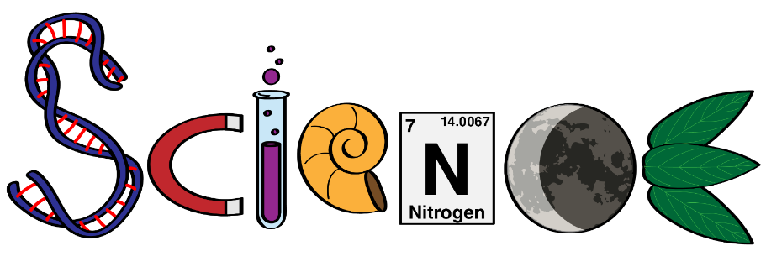
Pre-IB
9

Course Outline

Mr. Carroll | Room 1106 | dcarroll@sd35.bc.ca | carrollscaveofknowledge.weebly.com

Welcome to R.E. Mountain Secondary School! The following course outline explains the philosophies and expectations of the Science Department at REMSS, how the class will be structured, and how assessment looks this year. Please take time to read this over with your parents so that you know what you need to do in order to be successful!

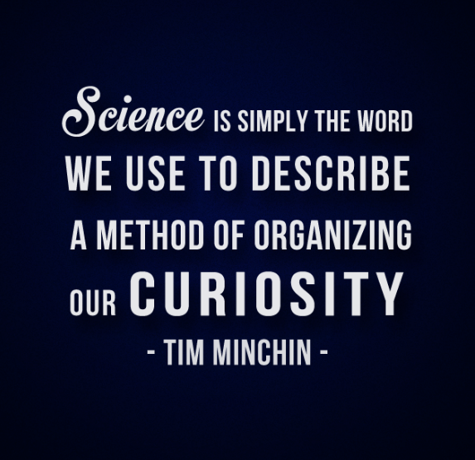
Thinking Like a Scientist
The R.E. Mountain Science Department is implementing an authentic experimentation theme in all classes at all levels. The unofficial slogan has been “Thinking Like a Scientist.” The primary focus of this initiative has been on Science processes, not only outcomes. We are trying to help students learn to work as a scientist, not simply use the results of the past. Labs are open-ended rather than followed like a recipe. Problems are presented and equipment provided. Students must use their scientific skills and knowledge to solve these problems. This differs significantly from providing students with a list of resources and an instruction sheet that might lead the into determining an outcome. As this is a new initiative for us and many of our students and many of our teachers have not done this in a class before there have been some successes, some things to work on and modifications along the way. We are working with rubrics that are trying to emphasize process and academic attitude. In addition, testing is done in a cumulative manner building on previous knowledge in each unit. (Credit: https://remss.sd35.bc.ca/our-school/school-plan/science/)

Pre-IB Science 9 Expectations
The Pre-IB Science 9 course is academically rigorous. Students can expect an increased workload compared to the Science 9 course, along with more open-ended learning goals. The pace is swifter, and students are expected to be self-driven and highly accountable. A big focus for our Pre-IB Science 9s is learning how to learn ; more focus will be on application of skills rather than reliance on rote memorization. This can be a challenging and at times frustrating learning curve for students who are used to being very successful. We encourage students to trust the process and embrace the fact that with the right attitude, areas of struggle and mistakes made are learning opportunities.

Course Content

Unit 1 – Scientific Skills
Big Ideas: The scientific method is a process for experimentation based on asking questions, making informed hypotheses, designing and carrying out a procedure to test hypotheses, collecting reliable data (qualitative and quantitative), analyzing data and drawing conclusions. Scientific skills such as measurement are important for collecting accurate and reliable data
(included by REMSS Science Dept as a foundational requirement)

Unit 2 – Chemistry
Big Idea: The electron arrangement of atoms impacts their chemical nature.
Content explored:
- element properties as organized in the periodic table
- the arrangement of electrons determines the compounds formed by elements

Unit 3 – Biology
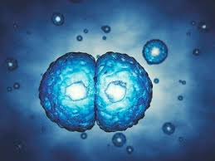
Big Idea: Cells are derived from cells.
Content explored:
- asexual reproduction:
  - mitosis
  - different forms
- sexual reproduction:
  - meiosis
  - human sexual reproduction

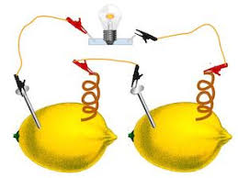
Unit 4 – Physics
Big Idea: Electric current is the flow of electric charge.
Content explored:
- circuits — must be complete for electrons to flow
- voltage, current, and resistance

Unit 5 – Earth Science
Big Idea: The biosphere, geosphere, hydrosphere, and atmosphere are interconnected, as matter cycles and energy flows through them.
Content explored:
- effects of solar radiation on the cycling of matter and energy
- matter cycles within biotic and abiotic components of ecosystems
- sustainability of systems
- First Peoples knowledge of interconnectedness and sustainability

Materials Needed

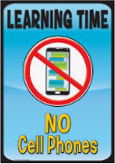
- Students will the following supplies: a binder, a composition book for labs (Staples has for under $5), pencils, blue pens, red pens, a ruler, lined paper, graph paper (minimal). Students will be assigned a textbook for the year.
- CELL PHONES ARE NOT PERMITTED DURING CLASS. Students will be asked to turn phones to silent and put away for duration of class.

General Procedures

- Attendance:
  - Students are expected to attend all classes ON TIME. If they are absent, they are responsible for seeking out missed assignments and ensuring that they comprehend what was covered. Attending FLEX the day following an absence is the best idea as it allows students to keep up with the class.
- Labs:
  - Students are expected to follow safety procedures at all times in Science class. This is of utmost importance during a lab.
  - Students must adhere to Lab Safety dress code for all labs. This includes long hair tied back, no loose or dangling items (jewellery/scarves), closed-toed shoes, shoelaces tied
  - If a student misses a lab, they will be required to make it up during a set FLEX time. The make-up opportunity will be offered once and will be posted on the website.

Assessment

Coursework will focus on development of the curricular competencies, with the content being the conversation to drive scientific thinking.

  - Formative assessment provides information for the teacher, student, and parent about the student’s process of learning. Formative marks are not reflected in the student’s grade. Formative assessment is intended to show the progression throughout the course.
  - Summative assessment (evaluation) provides evidence for the teacher, student, and parent about what the student has learned. Summative marks constitute the students’ end mark.

Students can expect to complete written assignments, projects and presentations, conduct labs and complete lab reports (formative leading up to summative), create study aids, and complete regular quizzes and tests (formative leading up to summative). Labs and tests will make up the majority of students’ marks.

Note: Testing in the Science department is CUMULATIVE.
This means that students are having to regularly review prior concepts and will be tested on previous material each time. This encourages students to work towards understanding versus memorizing and allows for a more genuine assessment of knowledge and skill building.

***Plagiarism will not be tolerated in any form and will have serious repercussions***

BC’s New Curriculum

Content (Know)
The Content learning standards — the “Know” of the Know-Do-Understand model of learning — detail the essential topics and knowledge at each grade level.
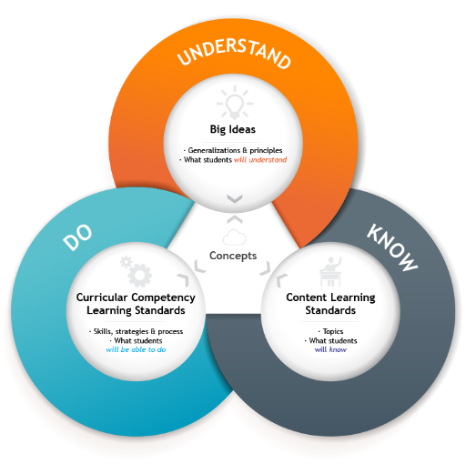
Curricular Competencies (Do)
The Curricular Competencies are the skills, strategies, and processes that students develop over time. They reflect the “Do” in the Know-Do-Understand model of learning. While Curricular Competencies are more subject-specific, they are connected to the Core Competencies.
Big Ideas (Understand)
The Big Ideas consist of generalizations and principles and the key concepts important in an area of learning. They reflect the “Understand” component of the Know-Do-Understand model of learning.
The big ideas represent what students will understand at the completion of the curriculum for their grade. They are intended to endure beyond a single grade and contribute to future understanding.

Concept-based, Competency-driven Curriculum
B.C.’s new curriculum brings together two features that most educators agree are essential for 21st-century learning: a concept-based approach to learning, and a focus on the development of competencies, to foster deeper, more transferable learning.

These approaches complement each other because of their common focus on active engagement of students. Deeper learning is better achieved through “doing” than through passive listening or reading. Similarly, both concept-based learning and the development of competencies engage students in authentic tasks that connect learning to the real world.

What and how we teach our students has been redesigned to provide greater flexibility for teachers, while allowing space and time for students to develop their skills and explore their passions and interests. The deep understanding and application of knowledge is at the centre of the new model, as opposed to the memory and recall of facts that previously shaped education around the globe for many decades. (credit: https://remss.sd35.bc.ca/programs-courses/course-planning/new-curriculum/)

Website & Remind
Be sure to bookmark the website and visit as needed. It will contain announcements, dates to note (tests, labs) and will have some resources. Content will be added as we progress through each unit.

Visit the website for your class code to join the Remind group. You’ll use your mobile phone to text a number with a message and you will be added to the course. Please use your first and last name for identification. You can message me directly if you have questions. I will be using this to send messages to the class as a whole or to you individually if needed. Your parents can also join if they wish. Please note that this will not be used often, just in cases of unit test or important reminders. The expectation is that you keep track of dates yourself and utilize the website.
If you do not have text capability you can also join remind via email by emailing and you will receive messages via email.

