### 1 — Electrostatic Forces

Electric charge is a property of protons (positive) and electrons (negative).

An electric charge is due to an excess of protons or electrons.

Like electric charges repel and unlike electric charges attract.

An electroscope is a simple devise that can detect charges.



Example 1:

Show how a charged balloon can be attracted to a neutral wall, or how neutral sawdust will attract to a charged object.

A charged electroscope can be neutralized by grounding it (earthing). The earth is considered to be able to donate or accept any number of electrons to neutralize any charge.

Example 1:

How can an object be charged by conduction and by induction?

The quantitative relationship for the force between two point charges is Coulomb’s Law:



*F* = force (N), *Q* = charge in coulombs (C),

*r* = distance between point charges (m).

k = 9.00 x 109 Nm2/C2

Example 3:

Find the electrostatic force between two stationary electrons 8.0 µm apart.

What is the instantaneous acceleration if one of the electrons is released?

What if the distance is increased to 40 µm?

2 — Combining Forces between Multiple Particles

Example 1:

Three protons are placed on a line at 0 m, 0.40 m, 0.90 m. Find the force on each proton.

Example 2:

Three 35 µC charges are placed on the corners of an equilateral triangle with sides of 15 cm. What is the force on each charge?

Example 3:

180 µC charges are placed at the corners of a 0.50 m square. The charges alternate from positive to negative. What is the force on each charge?

### 3 — Electric Fields

An electric field (**E**) represents the effect that an electric charge would have on an external charge at a specific point in space.



To determine the electric field, a very small positive test charge (*q*) is placed at a point and the force on that test charge is measured.

For a point charge, the electric field can be calculated from Coulomb’s Law:



The electric field depends on the size of the point charge and the distance from the charge.

The direction will depend on the sign of the charge.

Example 1:

Find the electric field 0.20 m above a small sphere with a net charge of 45 µC.

Find the force and instantaneous acceleration of a proton and an electron at that point.

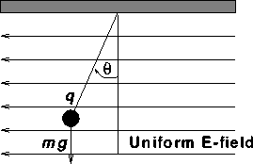

Example 2:

A 7.3 µC charged sphere has a mass or 22 mg. If the angle is 17°, what is the strength of the electric field?

Here is the electric field for a positive and a negative point charge. It is a radial field.



Larger charge:

4 — Electric Fields II

Electric fields from multiple sources can be added as vectors. The field from each source is determined, and the net field found by vector addition.

This is the field from two equal positively charged point charges.

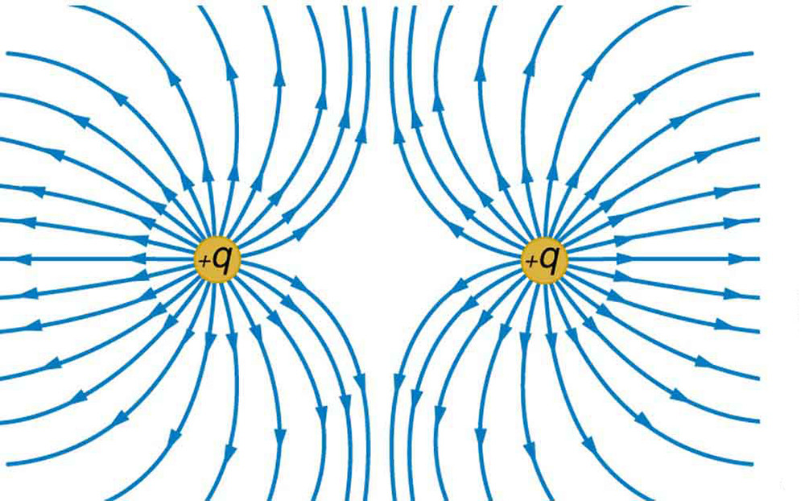

Example 1:

Draw the electric field lines for two equally charged negative charges.

Example 2:

Draw the electric field lines for two charges of equal magnitude but opposite charge.

Example 3:

Two 20 µC charges are 0.50 m apart on a horizontal line. Find the electric field:

1. Between the two charges
2. 0.10 m from the left charge.
3. 0.30 m above one of the charges.

The field between two parallel plates is nearly uniform between the plates (considered uniform).

It is distorted at the plate edges.

A uniform field makes many calculations easier.



Example 4:

Two parallel plates are 15 mm apart with a 200 N/C field between them. How much work would be required to move a proton from one plate to the other?

If the proton were then released, how fast would it be moving at the other plate?

### 5 — Electric Potential Energy

Electric Potential Energy for point charges is calculated very similarly to gravitational potential energy.



Zero energy is at infinite distance.

Because charges can be positive or negative, potential energy can be positive of negative.

Example 1:

Calculate the work required to bring a proton from far away to 1.0 mm from a 30 µC charge.

What is the work if the proton is replaced with an electron?

Example 2:

Two protons are held 5.0 mm apart. They are both released. How fast will they be moving when they are 1.0 m apart?

## 6 — Electric Potential

Electric potential (or potential) is a measure of the potential energy change as a charge is moved in space.



It is measured in Volts (V) or J/C.



From a point charge the voltage is:

As voltage is a scalar quantity. If there are more than one charge, find the voltage from each charge and add them to find the total voltage.

Example 1:

Find the potential difference from 1.0 m to 0.l0 m from a 200 µC charge.

What work would be required to move a proton through this difference?

Why can W = Fd not be used here?

Example 2:

Two 20 µC charges are 0.50 m apart on a horizontal line. Find the electric potential:

a) Between the two charges

b) 0.20 m above one of the charges.

Example 4:

An electron is accelerated in a T.V. tube by an 50,000 V potential difference. What is the speed of the electrons as they hit the screen of the T.V.?

To deal with very small amounts of energy the electron volt (eV) was invented. This is the energy an electron gains if it is moved through a one volt difference.

∆*PE* = *q*∆*V*

1 eV = 1.6 x 10-19J

It is often easiest to convert electron volts to joules for work in calculations.

In between two charged parallel plates, the electric field is uniform. The work to move a charge between the plates is:

*W = ∆PE*

*W = q∆V*

***Fd*** *= q∆V*

***E****q****d*** *= q∆V*

***E*** *= ∆V/****d***

The electric field can be expressed in Volts per meter (V/m) as well as N/C.

Example 5:

A 0.0040 kg mass is held stationary by two horizontal plates with a ∆V of 10,000V. If the plates are 25 cm apart, what must be the charge on the mass to hold it stationary?