## 1 - Magnetic Fields

Magnetic Field Lines represent the effect of a magnet into the space around the magnet. The direction of the magnetic field is the direction that the north end of a small magnet (compass) will point at that place.

Magnetic field (*B*) is measured in Teslas (T)

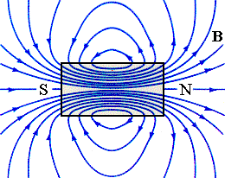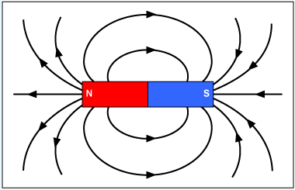

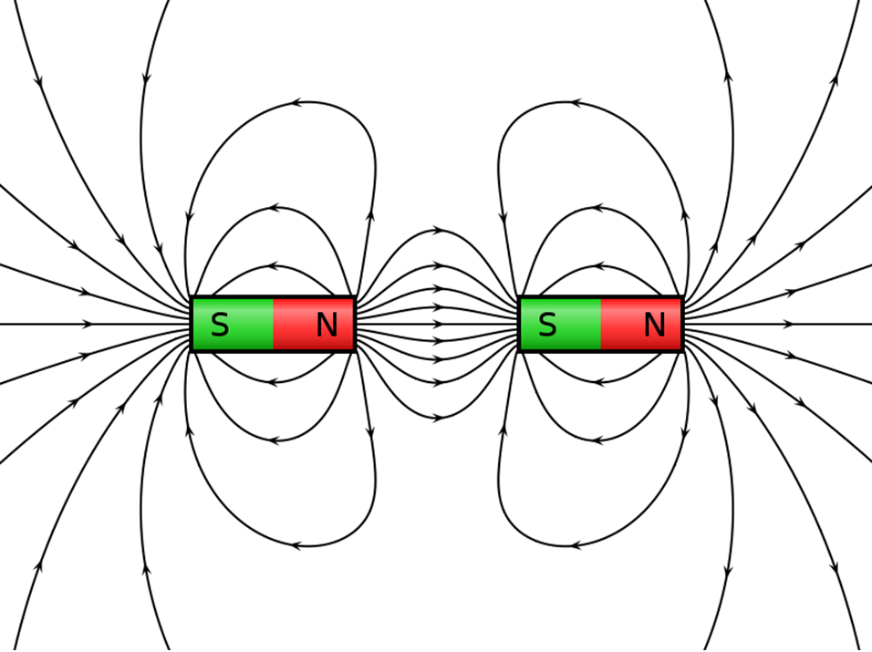If two magnetic fields can interact to combine their field lines, the resulting force will be attractive. If the magnetic field lines cannot combine the force will be repulsive.

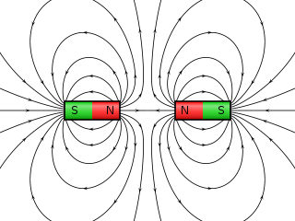

Magnetic fields are created by moving electrons. Magnetic elements have electronic configurations that produce a magnetic field.

Moving charges (currents) create circular magnetic

fields.

The direction of the magnetic field is determined by the right hand rule. With fingers curled, the thumb is placed in the direction of the current. The fingers curl in the direction of the magnetic field.

(For negative charges the direction can be reversed, or use the left hand.)

To draw three dimensional pictures on two dimensional paper we use some conventions:

* A dot represents a vector that is coming out of the paper (arrow’s point).
* An “x” represents a vector going into the paper (arrow’s feathers).
* Do not use “up” or “down”. Use “top of page” and “bottom of page”, “into the page” and “out of the page”.

##### Example 1:

Draw the magnetic field lines around a wire:

With current moving left to right.

With electron flow coming out of the page.

For a loop of wire the magnetic fields follow the loop.





If the loops are repeated to form a solenoid, the result is much like a bar magnet. [Magnetic field lines](faraday%20copy/faraday.jnlp) come out of the north end and into the south end.

The magnetic field inside the solenoid is close to uniform. The magnetic field strength is:

*N* - the number of turns in the solenoid



*l* - the length of the solenoid

*I* - the current in the solenoid

*n* - the number of turns per meter (*N/l*)

Example 2:

Draw a solenoid and draw the magnetic field lines for the solenoid.

## 2 - Magnetic Forces

For a current carrying wire in an external magnetic field, the magnetic field of the current and the external field create a force.

The magnitude of the force is:



*l* - the length of the wire in the field

To have a maximum force the magnetic field and the current must be perpendicular. If they are not perpendicular, the sin Ø produces the perpendicular component.



The angle must be between the direction of the current and the magnetic field.

The direction of the force is determined by the right hand motor rule.

Thumb is current (positive charge) direction. Fingers are field direction. Palm is force direction.

Reverse direction or use left hand for electron flow (negative charge).

##### Example 2 :

A 3.0 m long wire carries a 2.0 A current to the right in an external magnetic field of 0.35 T into the page. What is the force on the wire?

What is the force per unit length?

Example 3: A 1.0 m long wire carries a 1.0 A current in an external magnetic field of 0.85 T. The magnets create a field that is 0.50 m wide. What is the force on the wire if Ø = 40°?

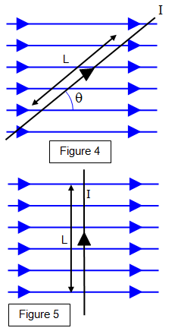

## 3 - Magnetic Forces

A freely moving charge experiences similar forces as charges on a wire.



The direction of the force is determined by the same right hand rule as before.

If the velocity and magnetic field are not perpendicular, the perpendicular component is used.



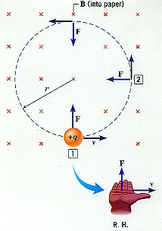

##### Example 1:

A proton is moving at 1500 m/s in a 135 T field as shown. What is the radius of its path?

## 4 - Applications of Magnetism

A conventional speaker converts electric energy into mechanical energy by using a current through a coil in an external magnetic field.



A galvanometer is a devise to measure current. It is based on the same principal as a motor, but with no commutator.

A spring resists the rotation of the armature. Greater current produces more rotation.

The most common application is an electric motor. A [direct current motor](ph14e/ph14e/electricmotor.htm) (DC) converts electric energy into mechanical energy.

## 5 – Applications of Magnetism

A velocity selector has an electric and magnetic field set so that FB=FE

What velocity particle will travel directly through the devise shown here?



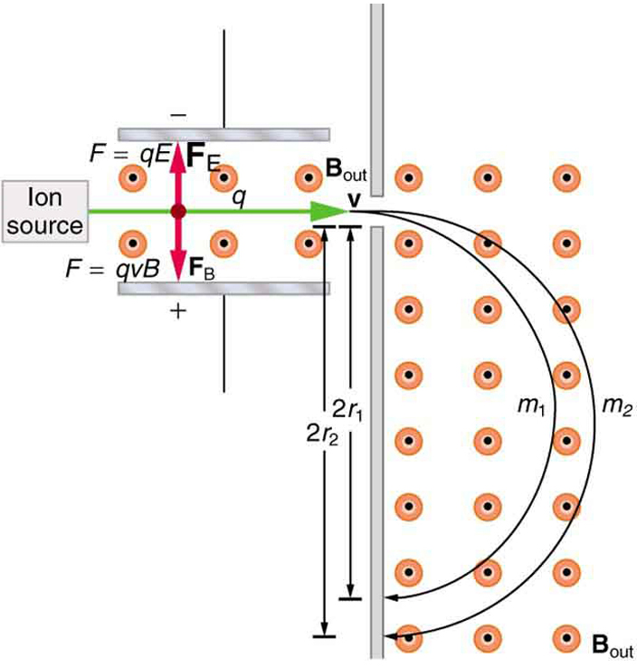

A mass spectrometer can measure the mass of individual atoms.

E = 10,000 V/m

B = 1.20 T

Find ∆r for Br-79 and Br-81

78.9 u and 80.9 u respectively.)