## 1 — 2D Circular Motion

Uniform circular motion involves an object that is moving in a circle with constant speed.

This motion requires acceleration because the direction of the velocity is changing as the object moves around the circle.

The acceleration is directed towards the center of the circle. The **net force** must also be directed towards the **center of the circle**.

If the force towards the center is removed, the object will move in a straight line.



For a stationary reference frame, the force required to keep an object moving in a circle is centripetal force.

There is no centrifugal force.

If you are in a car that is turning to the left, you feel pushed to the right. We call this a centrifugal force. Why is this force is fictitious.

The acceleration that keeps an object in uniform circular motion is:

*ac* centripetal acceleration



*v* = velocity

*r* = radius of circle



Therefore the **net force** is:

The force calculated with this formula is the **net force** needed to keep the object moving in a circle. This force can come from any combination of forces, but the net result must be this value towards the center of the circle.

##### Example 1:

A 780 kg car traveling at 35 m/s must turn a circular corner with a radius of 135 m.

1. Draw the FBD.
2. What is the centripetal acceleration and force of this car?
3. What coefficient of friction would be required between the tires and the road to allow the car to turn?

Because the object is moving in a circle with a uniform speed and a period of *T*, velocity can be expressed as:



##### Example 2:

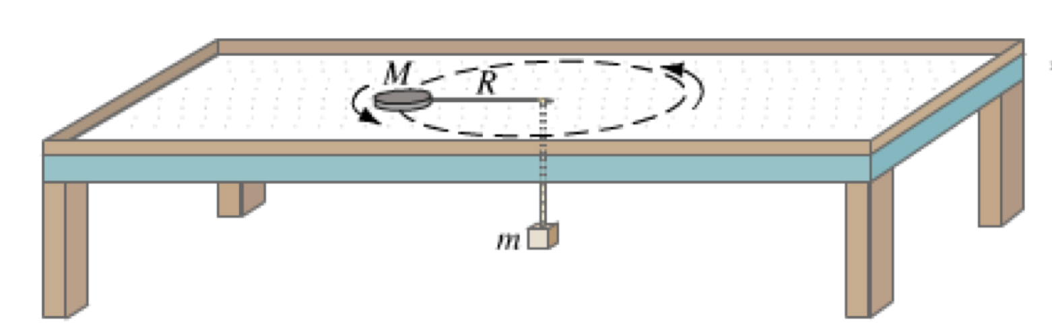A 0.30 kg mass (M) is swung with a 60 cm radius in a circle with a 0.20 kg mass (m) hanging from the string as shown. What is the tension in the string, and the period of rotation?

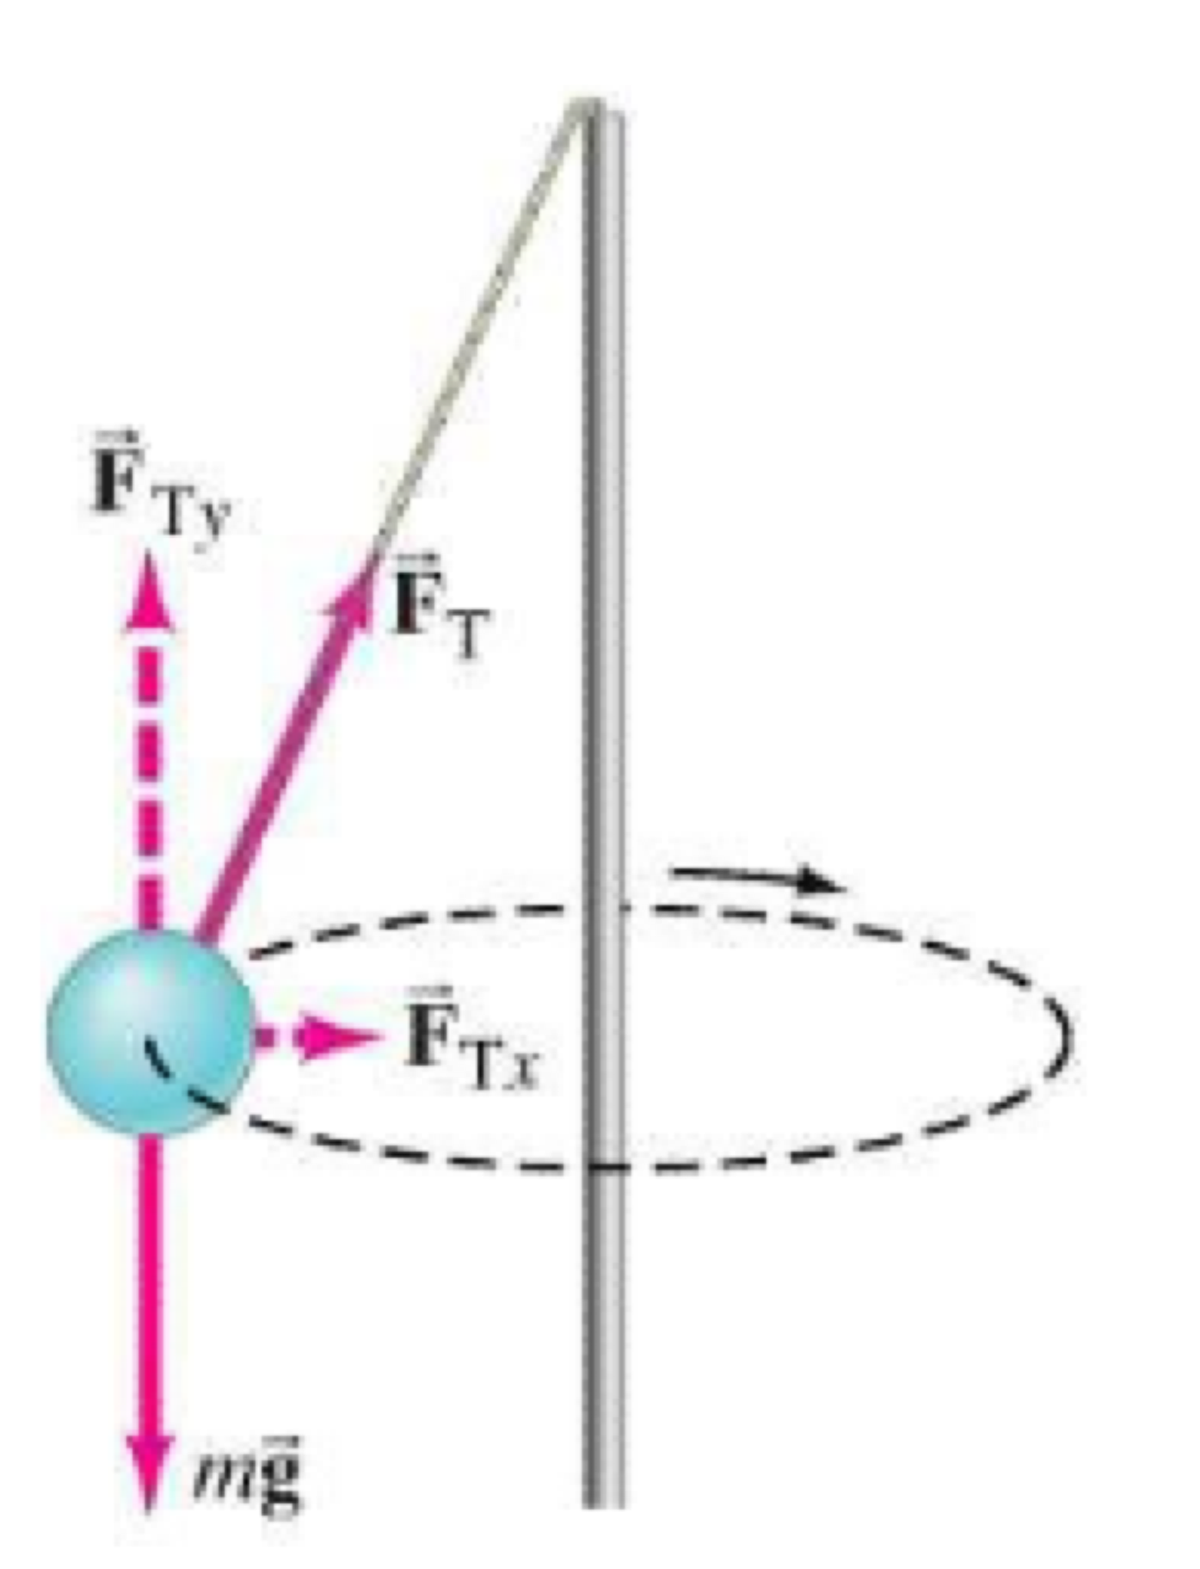

## 2 — 2D Circular Motion

Example 1:

A 0.30 kg mass is swung on a string in a circle so that the string is at an angle of 60° below the horizon and the radius is 20 cm. What is the tension in the string, and the period of rotation?

Example 2:

A car driving on a very icy road at 12 m/s can turn a corner with a radius of 65 m. What must be the angle of the banking in the corner to allow this to occur?

##### Example 3:

Example 3: Draw the FBD For a 12 kg car turning a 75 m radius circle aat 35 m/s on:

1. a road with a corner designed to allow a car to turn with no frictional force.
2. A car driving the same corner at 45 m/s. Find the coefficient of friction required.
3. A car driving the same corner at 25 m/s. Find the coefficient of friction required.

## 3 — Vertical Circular Motion

Vertical Circular motion calculations are identical to horizontal circular motion. The only consideration is that gravity can now be a part of the net force that provides the centripetal force.

Draw the FBD at the top, and bottom of the circle for a mass swung very quickly in a vertical circle.

##### Example 1:

A 75 kg student is swinging on a 9.5 m rope swing. At the bottom of the swing the speed is 8.3 m/s. What force does the student have to maintain to hold onto the rope?

Vertical motion is often not uniform. In moving up and down, potential energy changes result in kinetic energy changes. The speed of the object is not constant.

This is overcome by only considering the top and bottom of the swing, or having an object like a Farris Wheel where speed is constant.

##### Example 2:

A 65 kg student is on a Farris wheel. The radius of the wheel is 17 m and its period is 22 s. What is the normal force acting on the student at the top and bottom of the ride?

(Where do they feel heavier?)

An object moving in a vertical circle can experience apparent weightlessness. If we feel no normal force, we feel weightless.

If an object is moving over the top of a circle such that there is no normal force, there can be apparent weightlessness.

##### Example 3:

How fast must a bucket of water be moved swinging at the end of your arm (r = 0.90m) so that the water just does not spill?

Draw the FBD is the speed is increased above this speed.

##### Example 4:

A car is driving over a bump in the road with a radius of 12 m. What is the fastest the car can drive and not leave the road?

What speed should the car drive so the people feel only half of their normal weight.

## 4 — Satellites and Gravity

Satellites present an example of uniform circular motion. The orbits of most planets and moons are nearly circular, and the primary force involved is the gravitational attraction of the central mass.

The earth’s orbit only varies from 1.47 x 108 km to 1.52 x 108 km. This is almost circular.

The gravitational attraction between two objects is described by Newton’s Law of Universal Gravitation:



For an object in orbit, the gravitational force is providing the centripetal force.

Gravitational Field Strength (*g*) indicates the strength and direction of a gravitational field.

To determine the gravitational field strength a small test mass is used to determine the force of gravity. That force is divided by the mass of the test object.



Gravitational field strength is measured in N/kg.

It represents the force a mass would experience if it were placed in this field.

This value is also the acceleration an object would experience in this field given no other forces.

If this gravitational field is keeping another object in orbit, it is equal to centripetal acceleration: *Fg = Fc*; *g = ac*

##### Example 1:

What is the gravitational field strength on the surface of the moon? At one moon radius above the moon’s surface?

##### Example 2:

What is the velocity of the space shuttle if it orbits the earth 250 km above the earth’s surface?

##### Example 3:

What is the radius and altitude of a satellite in geosynchronous orbit?

##### Example 4:

A moon of planet X orbits in 4 days. Its mean distance from the planet is 3.4x107m. What is the mass of planet X?

## 5 — Gravitational Potential Energy

Gravitational potential energy is the work required to move something in a gravitational field.

*∆Ep = mg∆h* is a simple calculation only if *g* is a constant. As you start to move a significant distance from the earth’s surface, g is no longer constant.

We will examine the area under a Force distance graph.

To find the potential energy change we calculate the area under a Force distance graph.

To find the potential energy at a certain point requires calculus.

To find the difference in energy between two places, we calculate ∆Ep.

To maintain consistency, zero potential energy is at an infinite distance.

Example 1:

Calculate the Potential Energy of a 1.0 kg mass on the surface of the earth.

What will happen to its potential energy as it is lifted to a very high height?

##### Example 2:

How much work is required to lift a 100 kg mass to an altitude of 1000 km above the earth?

Ignoring friction, what speed would be required to allow the mass to reach this height?

Example 3:

A piece of Apollo 13 is stationary over the surface of the moon at 2 moon radii. What is its velocity as its lands on the moon’s surface?

## 6 — Mechanical Energy and Escape Velocity

The mechanical energy of an orbiting object is still the sum of its kinetic and gravitational potential energy.

##### Example 1:

Derive an expression for:

* Kinetic energy in orbit
* Mechanical energy in orbit

Sketch a graph of PE, KE, ME vs. orbital radii for the earth.

Escape velocity is the velocity required to allow an object to escape the gravitational pull of an central mass.

To do this the object will have to be able to move very far away where PE is zero.

This can occur if the kinetic energy (positive) is of greater magnitude than the potential energy (negative).

At escape velocity: KE + PE = 0

##### Example 2:

What is the escape velocity from the surface of the earth?

From 200 km above the surface of the earth?