Magnetic Fields and Forces
1. A compass is placed in each of the four locations around a permanent bar magnet as shown below.
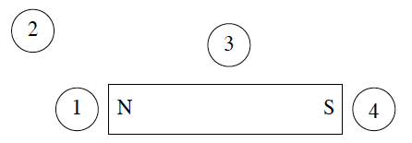
In which location would the North pole of the compass needle point to the right side of the page?
A. Location 1 B. Location 2 C. Location 3 D. Location 4

2. A charge X is placed in an electric field and a second charge Y is placed in a magnetic field. If both charges are initially held at rest, which one of the following best describes the motion of the charges after they are released? (Ignore gravitational effects.)
A. Charge X accelerates.
B. Charge Y accelerates.
C. Both charge X and charge Y accelerate.
D. Neither charge X nor charge Y accelerates.

3. Two straight parallel wires are separated by 1.60 m. The first wire carries a current of 95.0 A, and the magnetic field produced by this current exerts a force of 2.50 x 10^{–3} N on a 2.00 m length of the second wire. What is the current in the second wire?
A. 20.9 A B. 105 A C. 132 A D. 164 A

4. An electron moves in a circular orbit of radius r in a magnetic field. The electron moves in a path perpendicular to the magnetic field. If the kinetic energy of the electron is doubled, what is the new radius of its path?
A.$\frac{1}{2}r$ B. $\sqrt{r}$ C. 2 r D. 4 r

5. In which diagram below would the electron experience no magnetic force upon entering the field?
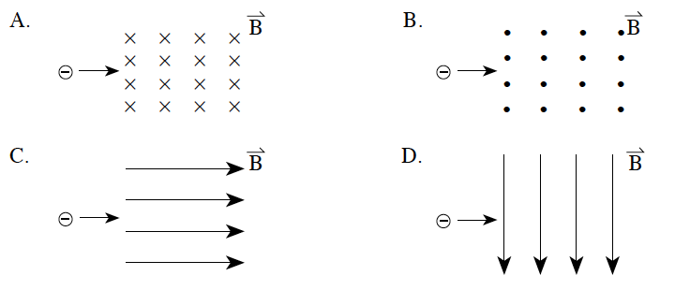

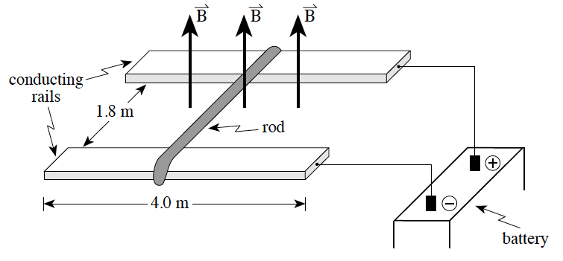
6. A metal rod is resting on top of two 4.0 m long conducting rails that are separated by 1.8 m. The force of friction between the rod and the rails is 1.2 N. A magnetic field of 5.2 x 10^{–2} T is directed upwards, as shown in the diagram below.

How much current must be sent through the rod before the rod begins to move and in what direction will the rod move?
CURRENT DIRECTION ROD WILL MOVE
A. 5.8 A Towards the battery
B. 5.8 A Away from the battery
C. 13 A Towards the battery
D. 13 A Away from the battery

7. In the situation below, an electron is moving at 1.9 x 10⁷ m/s through crossed electric and magnetic fields. When the electric force is equal to the magnetic force, as shown, the electron will travel in a straight line.
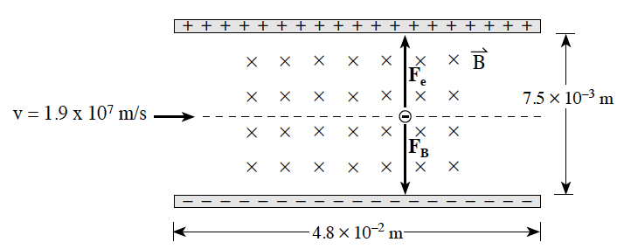
If the magnetic field strength is 5.2 x 10^{–3} T , what must be the potential difference between the plates for the electron to continue in a straight line?
A. 1.9 x 10^{–7} V B. 3.9 x 10^{–5} V C. 7.4 x 10² V D. 4.7 x 10³ V

8. Which of the following correctly shows the magnetic field between two opposite, magnetic poles?
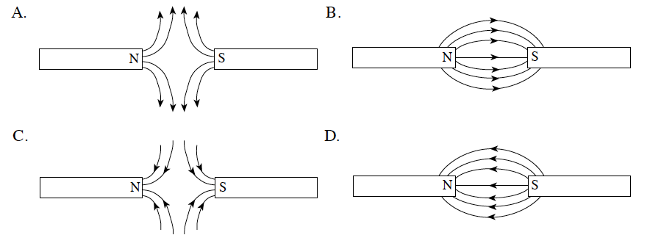

9. A proton moving parallel to a current-carrying wire will experience a force in what direction?
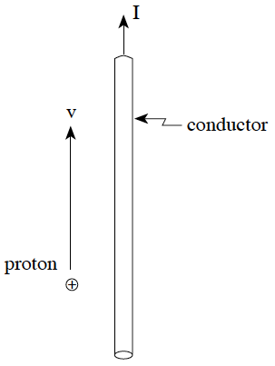
(The proton and the wire are both in the plane of the page.)

A. into the page
B. out of the page
C. toward the conductor (to the right)
D. away from the conductor (to the left)

10. A particle with a charge of 3.2 x 10^{–19} C is moving at 1.2 x 10⁶ m/s. This particle enters a 0.25 T magnetic field at right angles and travels in a circular path of 0.80 m radius. What is the mass of this particle?
A. 6.7 x 10^{–27} kg B. 5.3 x 10^{–26} kg C. 6.4 x 10^{–20} kg D. 7.7 x 10^{–14} kg

11. Four compasses are placed around a conductor carrying a current into the page, as shown below. Which compass correctly shows the direction of the magnetic field due to the current?
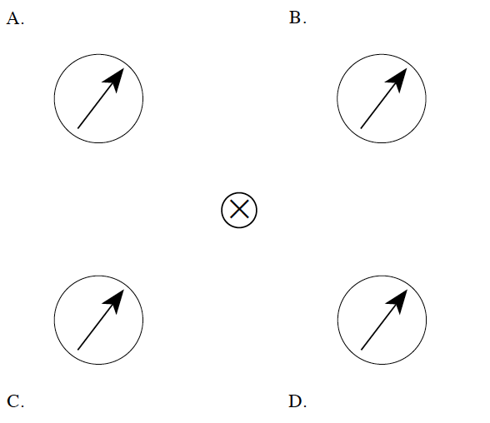

12. What is the radius of curvature of the path of a proton travelling at 4.7 ´105 m/s in a plane perpendicular to a 0.52 T magnetic field?
A. 2.0 x 10^{–8} m B. 5.1 x 10^{–6} m C. 9. 4 x 10^{–3} m D. 1.1 x 10² m

13. Two long, parallel conductors carry the same current I and exert an attractive force F on each other. If the current in both conductors is doubled, what is the new force?
A. 0.5 F B. 1 F C. 2 F D. 4 F

14. A solenoid of diameter 0.018 m is 0.30 m long. A current of 5.3 A is used to create a magnetic field of 0.25 T at the centre of the solenoid. How many turns of wire does this solenoid have?
A. 6.8 x 10² B. 2.1 x 10³ C. 1.1 x 10⁴ D. 3.8 x 10⁴

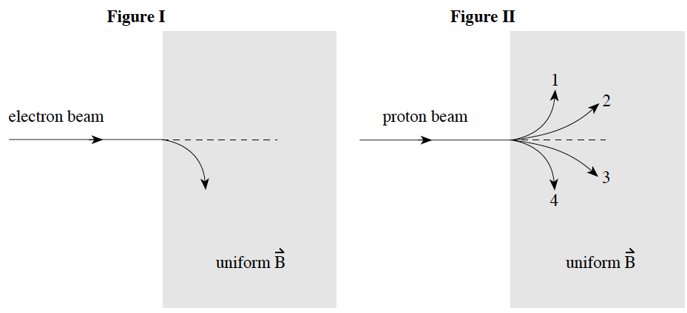
15. A beam of electrons is directed into a uniform magnetic field and deflects as shown in Figure I. If a beam of protons with the same speed were to enter this same magnetic field, which of the paths shown in Figure II would the protons take?

A. 1 B. 2
C. 3 D. 4

16. A 35 loop square coil 0.12 m on a side is positioned in a 0.050 T magnetic field. A 0.20 kg mass is suspended from one side of the coil as shown in the diagram below.
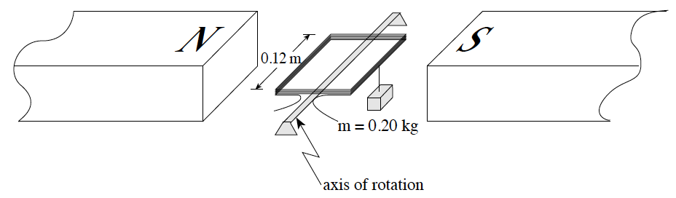
How much current must pass through the coil in order for the coil to remain horizontal?
A. 2.3 A B. 4.7 A C. 9.3 A D. 330 A

17. Which of the following diagrams shows the magnetic field produced by a long current-carrying wire?
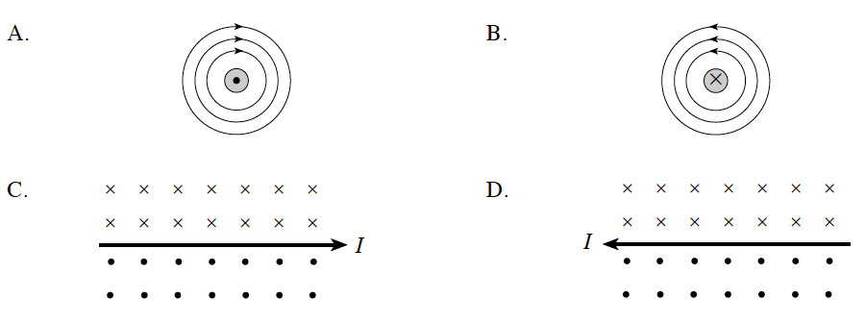
18. A doubly-ionized atom (Q = 2e) with a mass of 6.8x10⁻²⁷ kg enters a 3.0 T magnetic field with a speed of 5.0x10⁷ m/s. What is the radius of the circular path of the atom?
A. 0.35 m B. 0.71 m C. 1.4 m D. 2.8 m
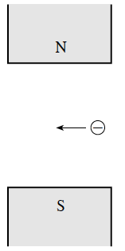
19. The diagram shows an electron travelling to the left in a magnetic field. In which direction will the electron be deflected?

A. into the page
B. out of the page
C. towards the north pole
D. towards the south pole

20. Which of the following diagrams best represents the magnetic field in the region between north and south poles of a pair of permanent magnets?
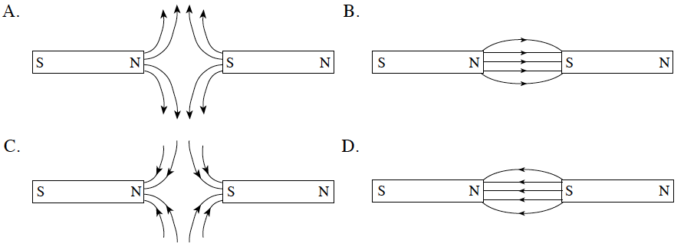
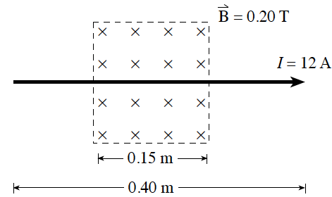
21. A long conductor is placed in a 0.20 T magnetic field as shown in the diagram. What are the magnitude and direction of the magnetic force on the conductor when it carries a current of 12 A?

 | Magnitude of Force | Direction of Force
A | 0.36 N | Top of Page
B | 0.36 N | Bottom of Page
C | 0.96 N | Top of Page
D | 0.96N | Bottom of Page
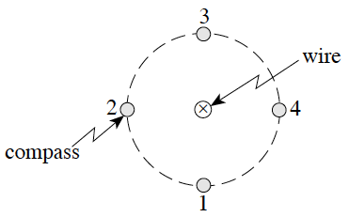
22. The magnetic field around a current-carrying wire is investigated with a compass. At which of the four positions shown in the diagram will the compass needle point towards the bottom of the page?

A. 1 B. 2 C. 3 D. 4

23. When a 15.0 A current flows through a 0.120 m long solenoid, the magnetic field along its centre is 8.00x10⁻² T. How many turns make up this solenoid?
A. 23 B. 162 C. 509 D. 4 240

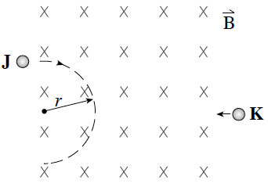
24. Charged particles J and K enter a magnetic field as show in the diagram. Particle J travels in a circular path of radius r. Particle K has twice the charge and half the momentum of particle J. How does the radius of particle K’s path compare to that of particle J?
A. ¼ r B. r C. 2r D. 4r

25. In the diagram, what is the direction of the magnetic field at point P due to the bar magnet?

A. top of the page B. bottom of the page C. towards the left D. towards the right

26. An ion with a charge of 1.6x10⁻¹⁹C enters a 0.075 T magnetic field. If the ion follows a circular path of radius 0.083 m, what is the momentum of the ion?
A. 2.7x10⁻²⁶ kg•m/s B. 1.0x10⁻²¹ kg•m/s C. 1.7x10⁻¹² kg•m/sD. 5.2x10⁻⁴ kg•m/s

27. A 525-turn solenoid has a diameter of 0.050 m and a length of 0.20 m. What current is needed to produce a 0.025 T field inside the solenoid?
A. 0.38 A B. 1.9 A C. 3.8 A D. 7.6 A

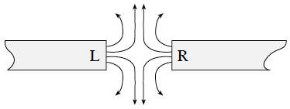
28. Identify the poles of the magnets shown.
 | Pole L | Pole R
A | North | North
B | North | South
C | South | North
D | South | South

29. A compass placed on a table points north. In which direction should a conductor, placed directly above the compass, carry current in order to reverse the direction of the compass needle?
A. east to west B. west to east C. north to south D. south to north

30. Which of the following shows the magnetic field produced by a current carrying conductor?
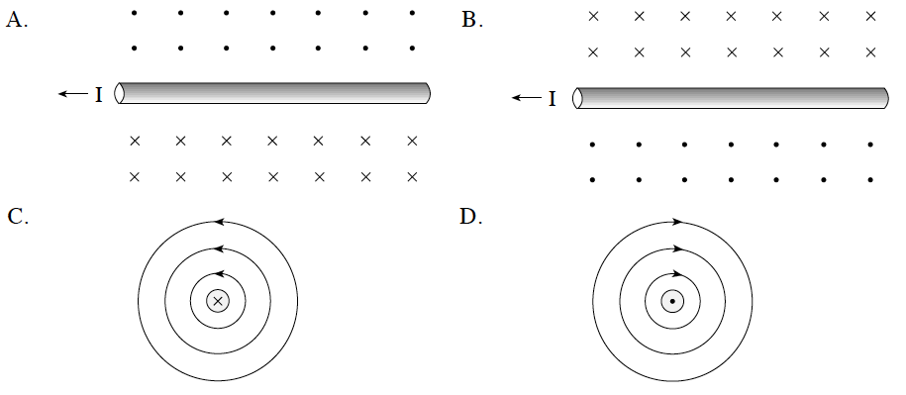

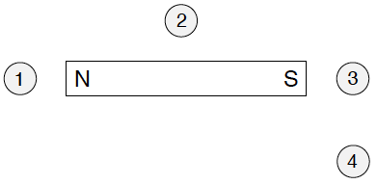
31. A compass is positioned at each of the following locations near a bar magnet. In which location will the compass needle point to the right-hand side of the page?

A. 1 B. 2 C. 3 D. 4

32. A conductor carryoing current to the right is placed in a uniform magnetic field coming out of the page. What is the direction of the magnetic force on this conductor?

A. Into the page B. Out of the page C. Top of the page D. Bottom of the page

33. A 5.0 A current flows through a 0.20 m long solenoid that contains 1 500 loops. What are the magnitude and direction of the magnetic field at the centre of the solenoid?
 | Magnitude | Direction
A | 9.4 x 10⁻³ T | left
B | 9.4 x 10⁻³ T | left
C | 4.7 x 10⁻² T | right
D | 4.7 x 10⁻² T | right
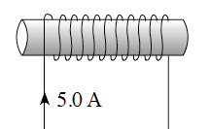

34. An electron enters a uniform magnetic field as shown below. The path of the electron upon entering the field would be
A. linear. B. circular.
C. parabolic. D. hyperbolic.

35. A solenoid of length 0.35 m and diameter 0.040 m carries a current of 5.0 A through its windings. If the magnetic field in the centre of the solenoid is 2.8 x 10⁻² T, what is the number of turns per metre for this solenoid?
A. 180 turns/m B. 780 turns/m C. 1600 turns/m D. 4500 turns/m

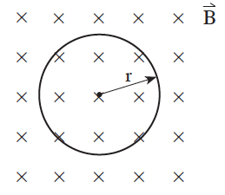
36. An electron circulates in a uniform 5.0 x 10⁻⁴ T magnetic field as shown. If the electron has 3.2 x 10⁻¹⁸ J of kinetic energy, what is its radius of orbit, r ?
A. 2.3x10⁻⁷ m B. 4.6x10⁻⁴ m
C. 2.5x10⁻³ m D. 3.0x10⁻² m

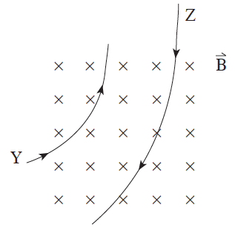
37. Two particles Y and Z with equal mass and speed enter a uniform magnetic field and follow the paths as shown. How do their magnitude and polarity of charge compare?

 | Magnitude of charge | polarity
A | Y < Z | Same charge
B | Y < Z | Opposite charge
C | Y > Z | Same charge
D | Y > Z | Opposite charge

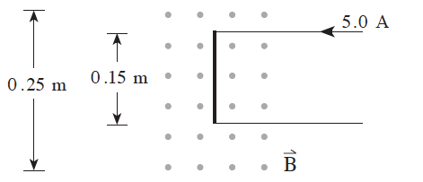
38. A wire carrying a current of 5.0 A is in a uniform 3.2 x 10⁻² T magnetic field as shown. What is the force on the 0.15 m length of wire?

A. 0 N B. 1.6x10⁻² N
C. 2.4x10⁻² N D. 4.0x10⁻² N

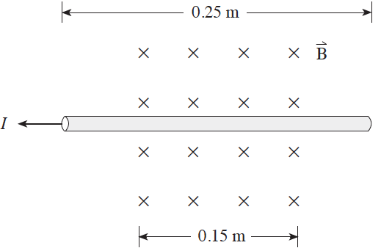
39. A wire carrying 12 A of current is placed in a magnetic field of strength 0.63 T. What are the magnitude and direction of the magnetic force acting on the wire?
 | Force | polarity
A | 1.1 N | Down the page
B | 1.1 N | up the page
C | 1.9 N | Down the page
D | 1.9 N | up the page

40. A particle having a charge of 3.2 x 10⁻¹⁹ C follows a circular path of 0. 45 m radius while travelling at a speed of 1.2 x 10⁴ m/s in a 0.78 T magnetic field. What is the mass of the particle?
A. 7.8x10⁻²⁸ kg B. 9. 4x10⁻²⁴ kg C. 1.1x10⁻¹⁹ kg D. 3.0x10⁻¹⁵ kg

41. A 460-turn solenoid having a diameter of 0.024 m is 0.14 m long. What is the magnetic field at the centre of the solenoid when a 13 A current flows through it?
A. 0 T B. 0.054 T C. 0.31 T D. 0.63 T

42. Which of the following diagrams best shows the magnetic field due to a long straight wire carrying a conventional current I as shown?
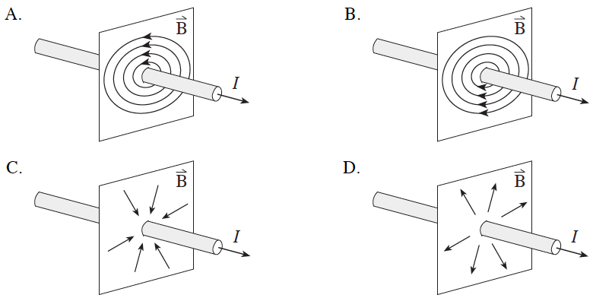

43. A proton is travelling at 2.3 x x10⁶ m/s in a circular path in a 0.75 T magnetic field. What is the magnitude of the force on the proton?
A. 1.6x10⁻²⁴ N B. 2.9x10⁻²¹ N C. 2.8x10⁻¹³ N D. 1.7 N

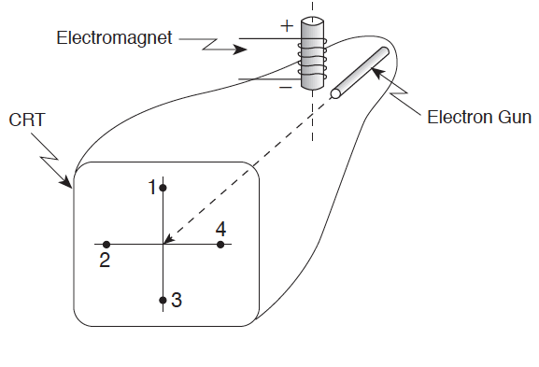
44. With the electromagnet turned off, electrons in a cathode ray tube strike the centre of the screen as shown. When the electromagnet is turned on, where will the electron beam now strike the screen?

A. 1 B. 2 C. 3 D. 4

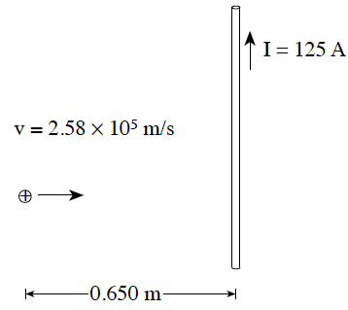
Written

1. A proton is traveling at 2.58 x 10⁵ m/s towards a conductor carrying a current of 125 A. What is the magnitude of the magnetic force acting on the proton 0.650 m from the conductor? (7 marks)

Magnetic field strength due to the wire is: $B=\frac{µ_{0}I}{2πd}$ where d is the perpendicular distance from the wire.

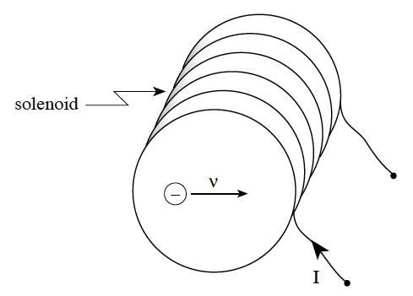
2. A 0.400 m long solenoid has 6 720 turns of wire. A current of 14.5 A flows in the solenoid. An electron inside the solenoid travels perpendicular to the axis of the solenoid with a speed of 6.50 x 10⁵ m/s . What is the magnitude of the magnetic force acting on the electron? (7 marks)

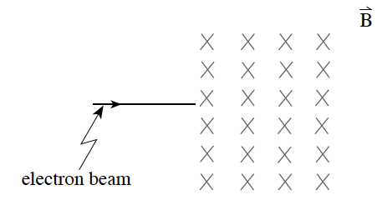
3. A beam of electrons travelling at 1.8 x 10⁸ m/s is directed towards a 0.014 T magnetic field as shown in the diagram.
a) Which of the following diagrams illustrates the path of the electron beam once in the magnetic field?
(1 mark)

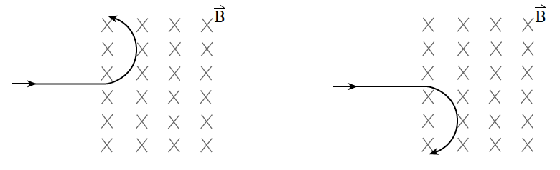
b) What is the radius of the path of the electron beam while in the magnetic field? (6 marks)

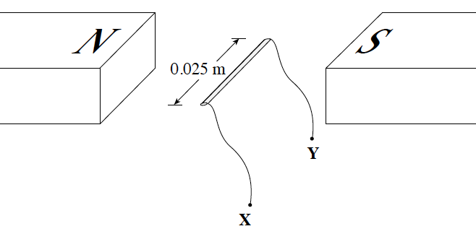
4. A 0.025 m wire segment is positioned in a 0.75 T magnetic field as shown in the diagram below. When a current is passed through this wire segment it experiences a 0.20 N force upwards.
What is the magnitude and direction of the current? (5 marks)

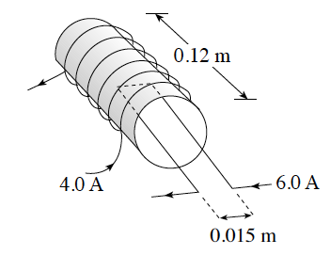
5. The diagram below shows a 650-turn solenoid carrying a 4.0 A current. What is the magnitude of the magnetic force on the 0.015 m segment of wire carrying a 6.0 A current inside the solenoid as shown? (7 marks)

6. A proton enters a magnetic field of magnitude 2.4x10⁻² T at a speed of 5.0x10⁵ m/s perpendicular to the field.
a) What magnetic force acts on the proton? (3 marks)
b) What is the radius of the proton’s circular path? (4 marks)

7. Electrons accelerated from rest through a potential difference of 300 V enter a 4.x10⁻² T magnetic field at right angles. What is the radius of curvature of the path taken by the electrons? (7 marks)

8. An electron is accelerated from rest through a potential difference of 750 V. It then enters a uniform 2.3 x 10⁻³ T magnetic field at right angles to the field.
a) What is the speed of the electron? (3 marks)
b) What is the radius of its path in the magnetic field? (4 marks)

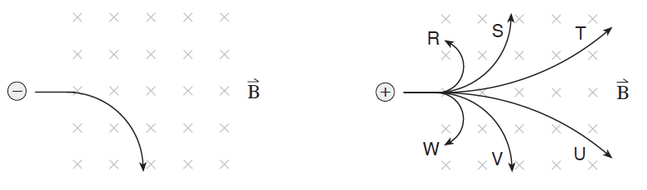
9. An electron travelling at a high speed enters a magnetic field as shown. A proton travelling at the same speed then enters the magnetic field.
a) Which of the six possible paths shown does the proton follow? (1 mark)
b) Using principles of physics, explain why the proton takes the path selected in a). (3 marks)

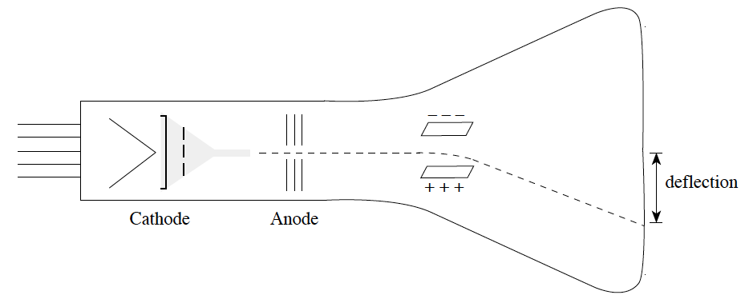
10. In a cathode-ray tube, electrons are accelerated from the cathode towards the anode by an accelerating voltage Va. After passing through the anode, the electrons are deflected by the two oppositely-charged parallel plates. If the accelerating voltage Va is increased, will the deflection increase, decrease, or remain the same? Using principles of physics, explain your answer. (4 marks)

1. C
2. A
3. B
4. B
5. C
6. D
7. C
8. B
9. C
10. B
11. A
12. C
13. D
14. C
15. B
16. B
17. D
18. A
19. A
20. B
21. A
22. D
23. C
24. A
25. D
26. B
27. D
28. A
29. A
30. B
31. B
32. D
33. C
34. A
35. D
36. D
37. D
38. C
39. A
40. B
41. B
42. A
43. C
44. D

1. 1.6 x 10^{–18}N
2. 3.2 x 10⁻¹⁴ N
3. a) Curving downward b) 0.073 m
4. 10.7 A, from Y to X
5. 2.4 x 10⁻³ N
6. a) 1.9 x 10⁻¹⁵ N b) 0.22 m
7. v = 1.0 x 10⁷ m/s; circle r = 1.4 x 10⁻³ m
8. a) 1.62 x 10⁷ m/s b) 4.0 x 10⁻² m
9. a) T b) Since a proton has a positive charge it will travel in the opposite direction as the electron. The proton is also more massive than the electron, therefore the F_{B} will cause a smaller a_{C} and hence a larger radius for its path.
10. The deflection y will decrease.
If V a is increased, the electrons are given a greater kinetic energy: e.g., Va = ∆Ek/q, Hence, the electrons are moving faster, so they spend less time between the plates. A force accelerates the electrons transversely between the plates; however, as the acceleration occurs for a shorter time, their deflection is reduced; e.g. y = ½ at²

