Forces and Fields
1. Which one of the following represents correct units for electric field strength?
A. T B. N/C C. J / C D. N • m² / C²

2. The diagram below shows two positive charges of magnitude Q and 2Q.

Which vector best represents the direction of the electric field at point P, which is equidistant from both charges?
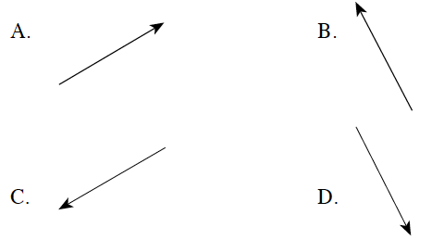

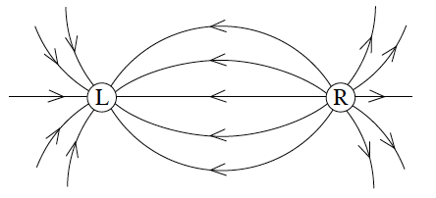
3. The diagram below shows the electric field near two point charges L and R.

What is the polarity of each charge?
CHARGE L CHARGE R
A. positive positive
B. positive negative
C. negative positive
D. negative negative

4. The electric field 2.0 m from a point charge has a magnitude of 8.0 x 10⁴ N/C. What is the strength of the electric field at a distance of 4.0 m?
A. 2.0 x 10⁴ N/C B. 4.0 x 10⁴ N/C C. 1.6 x 10⁵ N/C D. 3.2 x 10⁵ N/C

5. A negative charge in an electric field experiences a force accelerating it due south. What is the direction of the electric field?
A. east B. west C. north D. south

6. A − 2.3 x 10^{–6} C charge exerts a repulsive force of magnitude 0.35 N on an unknown charge 0.20 m away. What are the magnitude and polarity of the unknown charge?

MAGNITUDE POLARITY
A. 6.8 x 10^{–7} C Negative
B. 6.8 x 10^{–7} C Positive
C. 1.2 x 10^{–6} C Negative
D. 1.2 x 10^{–6} C Positive

7. Two point charges, 2.5 x 10^{–6} C and −5.0 x 10^{–6} C , are placed 3.0 m apart as shown below.
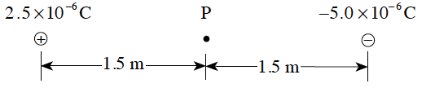
What is the magnitude of the electric field at point P, midway between the two charges?
A. 0 N /C B. 1. 0 x 10⁴ N /C C. 2.0 x 10⁴ N/C D. 3.0 x 10⁴ N/C

8. The diagram shows a positive point charge Q. Which describes the magnitude and direction of the electric field at points r and s?
Magnitude at r and s Direction at r and s
A. same away from Q
B. same towards Q
C. different away from Q
D. different towards Q

9. A 2.0 x 10^{–6} C charge is located halfway between an 8.0 x 10^{–6} C charge and a -5.0 x 10^{–6} C charge as shown below.
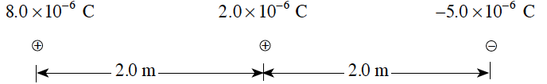
Find the net force on the 2.0 x 10^{–6} C charge.
A. 1.4 x 10^{–2} N towards the left B. 1.4 x 10^{–2} N towards the right
C. 5.9 x 10^{–2} N towards the left D. 5.9 x 10^{–2} N towards the right

10. Which of the following diagrams shows the electric field in the region of two equal but opposite point charges?
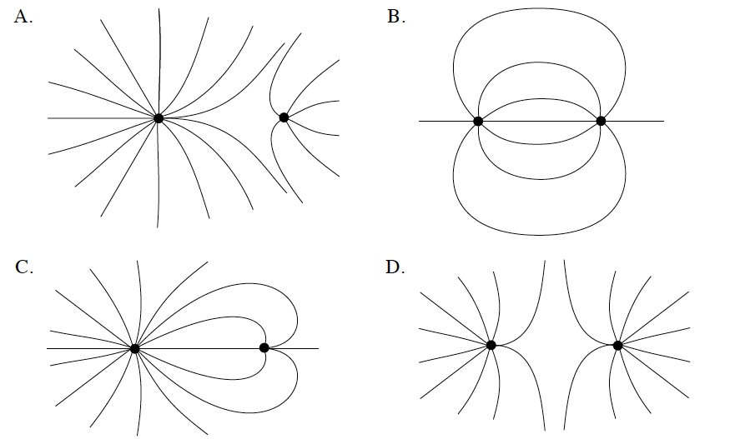
11. An electron experiences an electric force of 1.8x10⁻¹¹ N at a distance of 5.0x10⁻⁹ m from the nucleus of an ion. The electron is moved farther away, to a distance of 2.0x10⁻⁸m from the ion. What is the new electric force on the electron?
A. 1.1x10⁻¹²N B. 4.5x10⁻¹²N C. 7.2x10⁻¹¹N D. 2.9x10⁻¹⁰N

12. What is the magnitude of the electric field at point P due to the two fixed charges as shown?
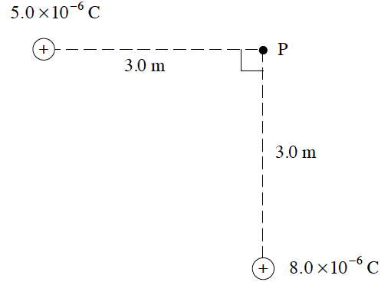
A. 3.0x10³ N/C
B. 9.4x10³ N/C
C. 1.3x10⁴ N/C
D. 3.9x10⁴ N/C

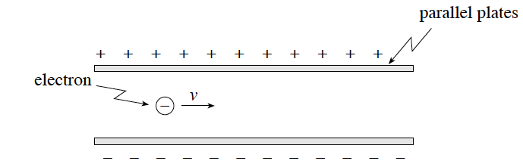
13. An electron is travelling in an electric field as shown. Describe the electrostatic force acting on the electron while in the field.

 | Magnitude of Force | Direction of Force
A | Changing | Upward
B | Changing | Downward
C | Constant | Upward
D | Constant | Downward

14. In a hydrogen atom, the electron and proton are separated by a distance of 5.3x10^{–11}m. What is the electric force exerted on the proton by the electron?
A. 0 N B. 4.4x10⁻¹⁸ N C. 8.2x10⁻⁸ N D. 1.0x10¹² N

15. Which of the following gives correct units for electric field strength?
A. V B. C C. N/m D. V/m

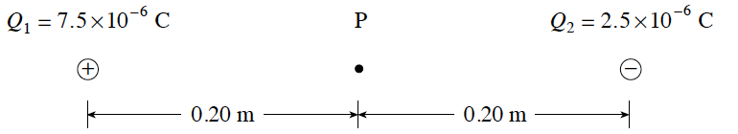
16. Electric charges are arranged as shown in the diagram. What is the electric field (E, magnitude and direction) at point P, midway between the charges?

 | Magnitude of E (N/C) | Direction of E
A | 1.1 x 10⁶ | Left
B | 1.1 x 10⁶ | Right
C | 2.3 x 10⁶ | Left
D | 2.3 x 10⁶ | Right

17. Which diagram shows the electric field between a pair of charged parallel plates?
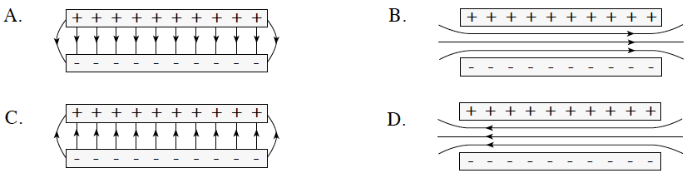

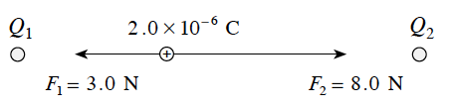
18. In the diagram below, a 2.0x10⁻⁶ C charge experiences forces of 3.0 N and 8.0 N at its location between charges Q₁ and Q₂ . Find the magnitude of the net electric field strength at the location of the 2.0x10⁻⁶ C charge.
A. 2.5x10⁶ N/C B. 2.8x10⁶ N/C C. 5.5x10⁶ N/C D. 1.2x10⁷ N/C

19. Which of the following shows the electric field between two opposite charges of unequal magnitude?
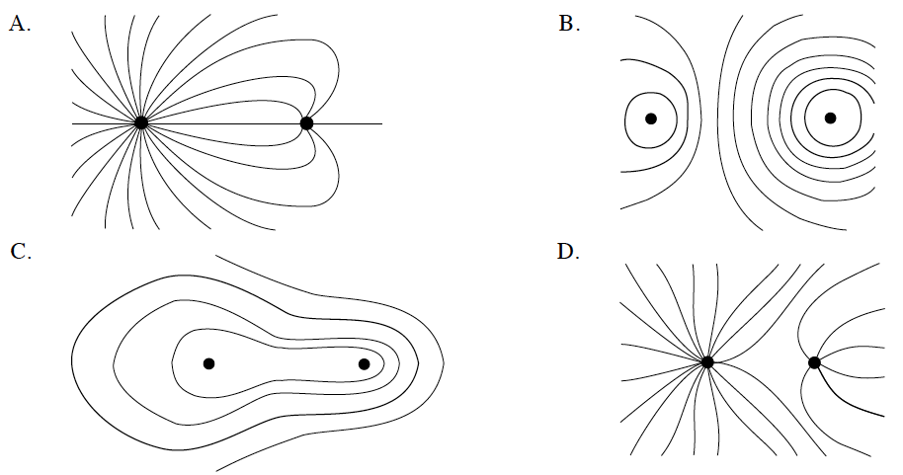

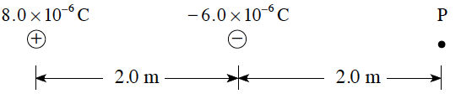
20. What is the magnitude of the electric field at point P due to the two charges shown?

A. 4.5x10³ N/C B. 9.0x10³ N/C
C. 1.4x10⁴ N/C D. 1.8x10⁴ N/C
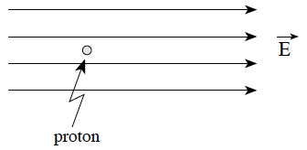
21. What is the acceleration of a proton in a uniform 2.5x10⁵ N/C electric field as shown?

 | Magnitude of acceleration | Direction of acceleration
A | 2.4 x 10¹³ m/s² | Right
B | 2.4 x 10¹³ m/s² | Left
C | 1.5 x 10³² m/s² | Right
D | 1.5 x 10³² m/s² | Left

22. Which of the following best represents the electric field between oppositely charged parallel plates?
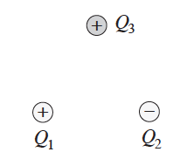
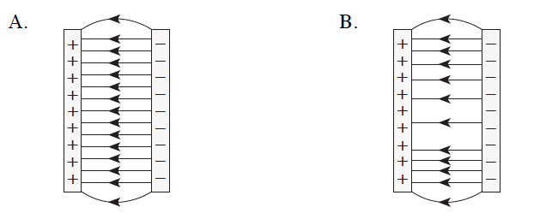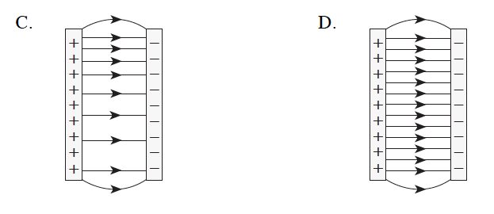

23. Three point charges of equal magnitude but opposite sign are arranged as shown in the diagram.
Which of the diagrams below best represents the electric forces acting on Q₃ due to the other two charges?

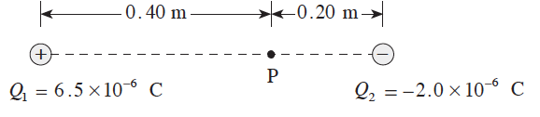
24. What is the magnitude of the electric field at point P due to the two charges positioned as shown in the diagram?
A. 5.6x10⁴ N/C B. 8. 4x10⁴ N/C
C. 2.4x10⁵ N/C D. 8.2x10⁵ N/C

25. Three positive charges are fixed as shown in the diagram. Calculate the net electric force on Q₂ due to Q₁ and Q₃.
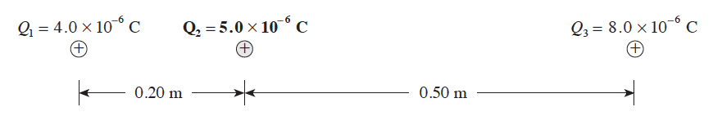

 | Magnitude of Force | Direction of Force
A | 3.1 N | Left
B | 3.1 N | Right
C | 5.9 N | Left
D | 5.9 N | Right
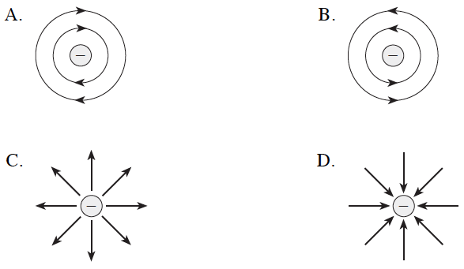
26. Which diagram shows the electric field near a negative point charge?

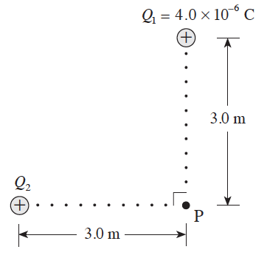
27. The magnitude of the net electric field at P in the diagram below is 5.0 x 10³ N/C. Find the magnitude of charge Q₂.

A. 1.0x10⁻⁶ C B. 3.0x10⁻⁶ C
C. 6.4x10⁻⁶ C D. 1.0x10⁻⁵ C

Written

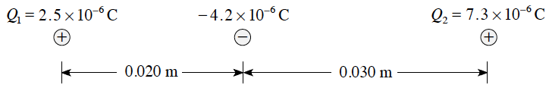
1. A -4.2 µC charge is placed between two stationary charges, Q1 and Q2 , as shown. What is the magnitude and direction of the net force on the -4.2 µC charge due to the two stationary charges? (7 marks)

2. Calculate the net electric field (magnitude and direction) at point P due to the two point charges shown in the diagram. (7 marks)
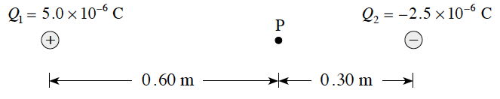

3. Two charges are positioned as shown in the diagram
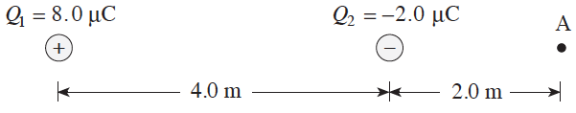
a) Find the magnitude and direction of the electric field at A. (4 marks)
b) A charge placed at A experiences a force of 4.0 x 10⁻³ N towards the right. What are the magnitude and polarity of this charge? (3 marks)

Energy and Potential
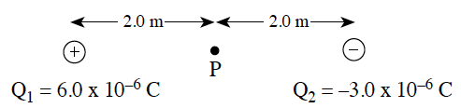
28. A 6.0 x 10^{–6} C charge is located 4.0 m from a –3.0 x 10^{–6} C charge.

What is the electric potential at P, halfway between the charges?
A. 4.1 x 10² V B. 6.8 x 10³ V C. 1.4 x 10⁴ V D. 4.1 x 10⁴ V

29. When a charge is accelerated through a potential difference of 500 V, its kinetic energy increases from 2.0 x 10^{–5} J to 6.0 x 10^{–5} J . What is the magnitude of the charge?
A. 4.0 x 10^{–8} C B. 8.0 x 10^{–8} C C. 1.2 x 10^{–7} C D. 1.6 x 10^{–7} C

30. A 4.0 x 10^{–9} C charge is initially located 3.0 m from a stationary 6.0 x 10^{–8} C charge. How much work is required to move the 4.0 x 10^{–9} C charge to a point 0.50 m from the stationary charge?
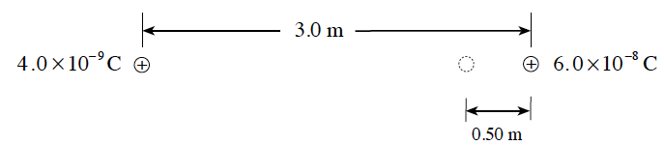
A. 6.0 x 10⁷ J B. 8.6 x 10⁷ J C. 3.6 x 10⁷ J D. 4.3 x 10⁷ J

31. Two parallel plates 4.0 x 10^{–2} m apart have a potential difference of 1 000 V. An electron is released from the negative plate at the same instant that a proton is released from the positive plate. Which of the following best compares their speed and kinetic energy as they strike the opposite plate?
SPEED KINETIC ENERGY
A. same same
B. same different
C. different same
D. different different

32. What is the electric potential energy of an electron located 5.3 x 10⁻¹¹ m from the proton in a hydrogen atom?
A. - 8.2 x 10^{–8} J B. - 4.3 x 10^{–18} J C. - 2.2 x 10^{–18} J D. -1.6 x 10^{–19} J

33. Two long, parallel plates are separated by 0.028 m and have a potential difference between them of 80 V, as shown below.
Point P is located midway between the plates. What is the potential difference between point P and one of the plates?
A. 0 V B. 40 V C. 80 V D. 160 V
34. Two positive charges, equal in magnitude, are separated as shown below.
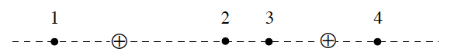
In which location would the electric field strength be zero?
A. 1 B. 2 C. 3 D. 4

35. An electron is positioned in an electric field. The force on the electron due to the electric field is equal to the force of gravity on the electron. What is the magnitude of this electric field?
A. 8.93x10⁻³⁰N/C B. 5.69x10⁻¹²N/C C. 5.58x10⁻¹¹N/C D. 1. 44x10⁻⁹N/C

36. Two parallel plates 6.0x10⁻²m long are separated by 2.5x10⁻²m and have a potential difference of 850 V. Point P is located midway between the two plates as shown below.
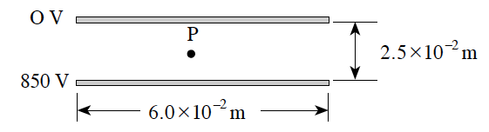
What is the magnitude of the electric field at point P?
A. 1.4x10⁴ V/m B. 1.7 x10⁴ V/m C. 3.4 x10⁴ V/m D. 6.8 x10⁴ V/m

37. A particle with a charge of 2.4 x10⁻⁵ C is accelerated from rest through a potential difference of 6.2 x10⁴ V. If the final speed of this particle is 9.3 x10³ m/s, what is the mass of the particle?
A. 7.7x10⁻¹⁰ kg B. 5.2x10⁻⁹ kg C. 3.4x10⁻⁸ kg D. 1.5x10⁻¹ kg

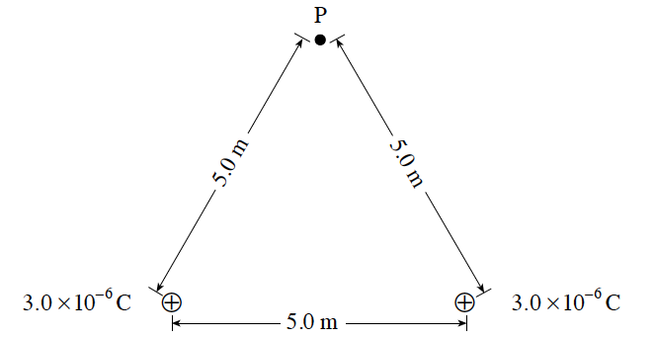
38. Two 3.0x10⁻⁶C point charges are placed 5.0 m apart as shown below.

What is the potential at point P due to the two charges?
A. O V B. 5.4x10³ V
C. 7.6x10³ V D. 1.1x10⁴ V

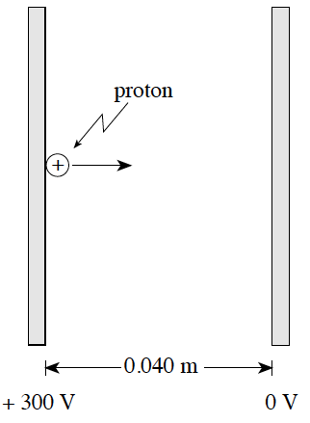
39. A proton initially at rest is accelerated between parallel plates through a potential difference of 300 V .

What is the maximum speed attained by the proton?
A. 7.5x10³m/s
B. 1.7x10⁵ m/s
C. 2.4x10⁵ m/s
D. 1.2x10⁶ m/s

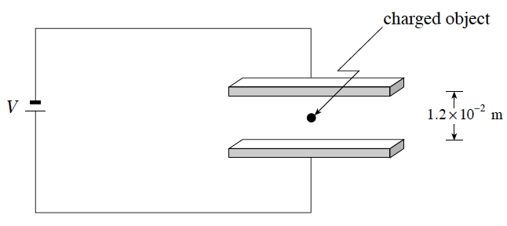
40. An object with a charge of + 4.0x10⁻¹⁸ C and a mass of 1.1x10⁻¹⁵ kg is held stationary by balanced gravitational and electric forces midway between horizontal charged plates as shown. What is the applied voltage V?

A. 16 V B. 32 V C. 65 V D. 270V

41. What is the electric potential energy of an electron at a distance of 5.3 x 10⁻¹¹ m from the proton in a hydrogen atom?
A. - 4.3x10⁻¹⁸ J B. - 8.2x10⁻⁸ J C. - 2.7x10¹ J D. - 5.1x10¹¹ J

42. What is the final speed of an electron accelerated from rest through a potential difference of 750 V ?
A. 3.8x10⁵ m/s B. 8.1x10⁶ m/s C. 1.6x10⁷ m/s D. 2.6x10¹⁴ m/s

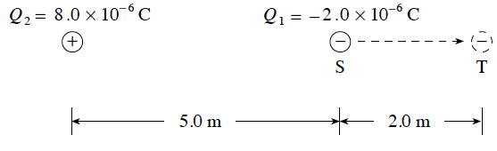
43. How much work is done moving the 2.0x10⁻⁶ C charge, Q₁, from S to T in the diagram shown?

A. 5.6x10⁻³ J B. 8.2x10⁻³ J
C. 1.2x10⁻² J D. 7.2x10⁻² J

44. A 1.60x10⁻¹⁹ C ion is accelerated from rest through a potential difference of 750 V reaching a maximum speed of 8.50x10⁴ m/s. What is the mass of this ion?
A. 9.11x10⁻³¹ kg B. 1.67x10⁻²⁷ kg C. 3.32x10⁻²⁶ kg D. 4.84x10⁻²⁰ kg

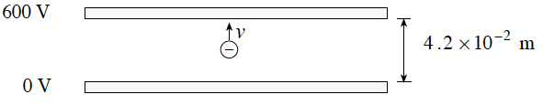
45. An electron, initially at rest, is accelerated through a potential difference of 600 V as shown. What is the maximum kinetic energy of the electron?

A. 3.7x10⁻³¹ J B. 9.6x10⁻¹⁷ J C. 6.0x10² J D. 1.4x10⁴ J
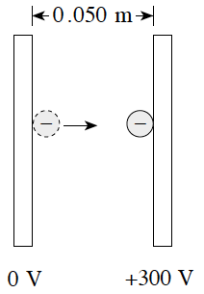
46. What is the change in kinetic energy of an electron that moves from the negative plate to the positive plate in the situation shown?

A. A gain of 4.8 x 10⁻¹⁷ J
B. A loss of 4.8 x 10⁻¹⁷ J
C. A gain of 9.6 x 10⁻¹⁶ J
D. A loss of 9.6 x 10⁻¹⁶ J

47. Two 2.0 x 10⁻⁶ C charges are positioned as shown in the diagram. What work must be done to move a 1.2x10⁻⁷ C charge from location X to location Y?
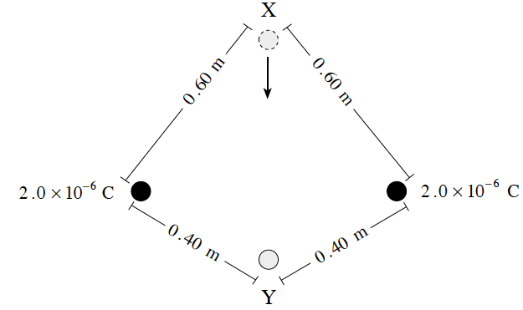
A. 3.6x10⁻³ J B. 1.5x10⁻² J
C. 1.8x10⁻² J D. 3.9x10⁻² J

48. An electron orbits a Carbon nucleus. If the electron’s orbital radius is 2.0 x 10⁻¹⁰ m, what is its electric potential energy?
A. -6.9 x 10⁻¹⁸ J B. -3.5 x 10⁻⁸ J C. 43 J D. 2.2 x 10¹¹ J

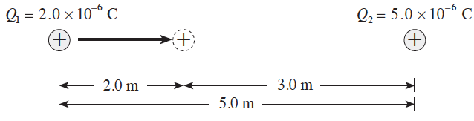
49. Charge Q₁ is located 5.0 m from charge Q₂ as shown. How much work must be done to move charge Q₁ 2.0 m closer to charge Q₂ ?

A. 7.2x10⁻³ J B. 1.1x10⁻² J
C. 1.2x10⁻² J D. 2.0x10⁻² J

Written

4. a) A 2.5 x 10^{–7} C charge is initially located 7.0 m from a fixed 8.0 x 10^{–6} C charge. What is the minimum amount of work required to move the 2.5 x 10^{–7} C charge 2.0 m closer as shown? (5 marks)
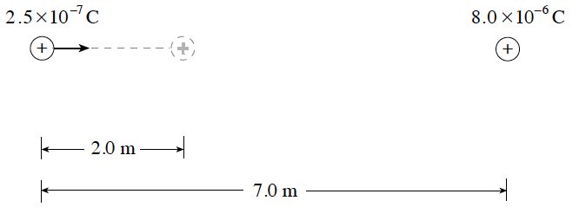
b) If the 2.5 x 10^{–7} C charge is moved a further 2.0 m closer to the 8.0 x 10^{–6} C charge, will the additional work required be less than, the same as or greater than the work required in (a)? Using principles of physics, explain your answer. (4 marks)

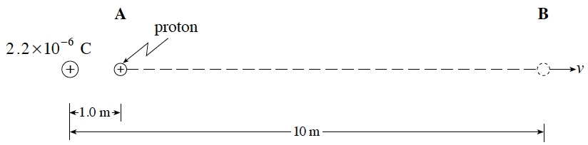
5. A proton is located at A, 1.0 m from a fixed +2.2x10⁻⁶C charge.
a) What is the change in potential energy of the proton as it moves to B, 10 m from the fixed charge? (5 marks)
b) If the proton started from rest at A, what would be its speed at B? (2 marks)
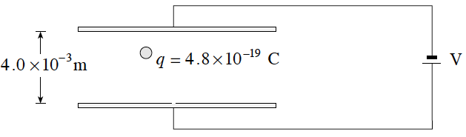
6. The diagram shows a small sphere of mass 1.5x10⁻¹⁴ kg held in equilibrium between two parallel plates by electrostatic and gravitational forces. What is the potential difference V between the plates? (7 marks)

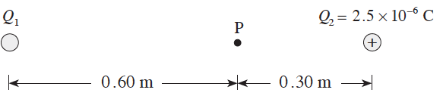
7. Two point charges Q₁ and Q₂ are arranged as shown in the diagram. The electric potential at point P due to these charges is found to be 1.9x10⁵ V. What are the magnitude and sign of charge Q₁? (7 marks)
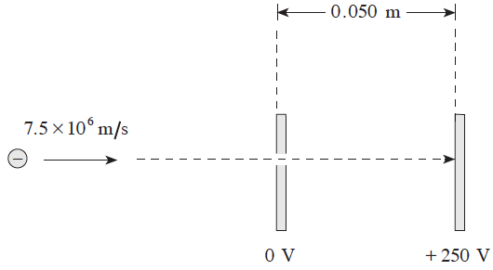

8. An electron moving at 7.5 x 10⁶ m s enters an electric field between parallel plates by passing through a small hole in one of the plates. What is the impact speed of the electron on the second plate? (7 marks)

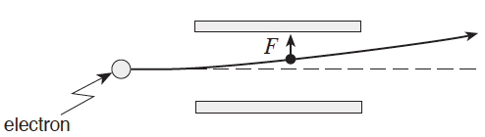
9. An electron passing between parallel plates 0.025 m apart experiences an upward electrostatic force of 5.1 x 10⁻¹⁶ N.
a) What is the magnitude of the electric field between the plates? (3 marks)
b) What is the potential difference between the plates? (2 marks)

10. a) Find the electric potential at point A and at point B. (3 marks)
b) What is the potential difference between A and B? (1 mark)
c) 0.036 J of work must be done to move a charge q from A to B. Find the magnitude and polarity of this charge. (3 marks)
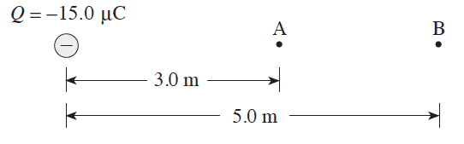

1. B
2. B
3. C
4. A
5. C
6. A
7. D
8. C
9. D
10. B
11. A
12. B
13. C
14. C
15. D
16. D
17. A
18. A
19. A
20. B
21. A
22. D
23. D
24. D
25. B
26. D
27. B

28. C
29. B
30. C
31. C
32. B
33. B
34. B
35. C
36. C
37. C
38. D
39. C
40. B
41. A
42. C
43. B
44. C
45. B
46. A
47. A
48. A
49. C

1. 70 N right
2. 3.8 x 10⁵ N/C
3. a) 2.5 x 10³ N/C left b) -1.6 µC

4. 1.0 x 10^{–3} J; b) The work required will be greater than in (a). The force acting on the moving charge is greater, therefore the work required to move the same distance will also be greater.
5. a) -2.9 x 10⁻¹⁵ J; b) 1.9 x 10⁶ m/s
6. 1200 V
7. + 7.7 x 10⁻⁶ C
8. 1.2 x 10⁷ m/s
9. a) 3 200 N/C b) 80 V
10 a) V_{A} = -45 000 V; V_{B} = -27 000 V b) ∆V = 18 000 V c) +2.0µC

