Circular Motion
1. A 0.055 kg puck is attached to a 0.150 kg mass M by a cord that passes through a hole in a frictionless table, as shown. The puck travels in a circular path with radius 0.25 m.
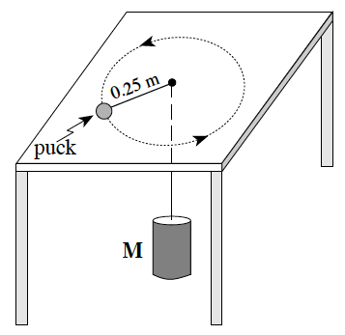
What is the speed of the puck?
A. 0.61 m/s B. 0.95 m/s
C. 1.6 m/s D. 2.6 m/s

2. A child is riding on a merry-go-round which is rotating at a constant rate. Which of the following describes the child’s speed, velocity, and magnitude of acceleration?
 | Speed | Velocity | Magnitude of acceleration
A. | constant | constant | constant
B. | constant | changing | constant
C. | changing | constant | changing
D. | changing | changing | changing

3. On Earth, the maximum speed without skidding for a car on a level circular curved track of radius 40 m is 15 m/s. This car and track are then transported to another planet for the Indy Galactic 500. The maximum speed without skidding is now 8.4 m/s. What is the value of the acceleration due to gravity on this other planet?
A. 1.8 m/s² B. 3.1 m/s² C. 4.3 m/s² D. 5.5 m/s²

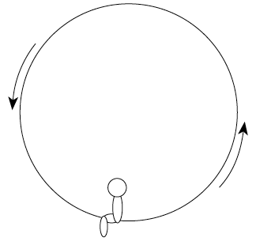
4. A 500 N child travels in a circular path on a Ferris wheel. Which free body diagram best shows the forces which could act on the child as she passes the lowest point?

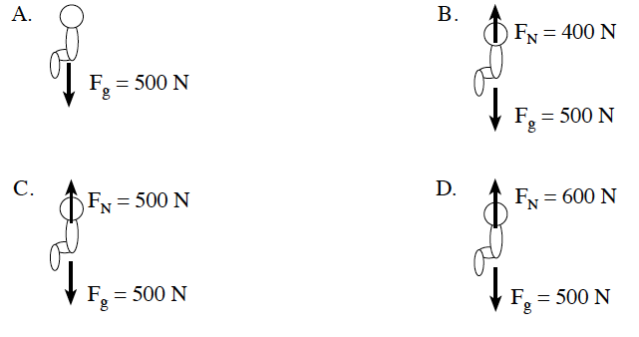
5. An object travels along a path at constant speed. There is a constant net force acting on the object that remains perpendicular to the direction of the motion. Describe the path of the object.

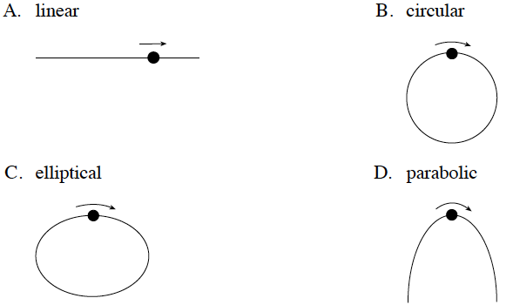

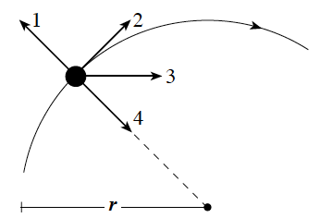
6. An object moves at a constant speed along a circular path as shown.

Which vector represents the velocity of the object at this particular point on the path?

A. 1 B. 2 C. 3 D. 4

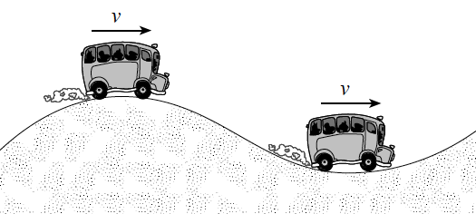
7. A bus of weight F_{g} is moving at a constant speed over a hill and a dip that have the same radius. When the bus passes over the crest of the hill the apparent weight of the bus is ¾ F_{g}. What is the apparent weight of the bus as it passes through the bottom of the dip?
A. ¼ F_{g} B. ¾ Fg C. ⁵/₄ F_{g} D. ⁷/₄ F_{g}

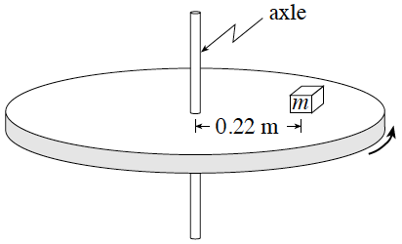
8. An object of mass m is on a horizontal rotating platform. The mass is located 0.22 m from the axle and makes one revolution every 0.74 s. The friction force needed to keep the mass from sliding is 13 N. What is the object’s mass?
A. 0.82 kg B. 1.3 kg C. 2.7 kg D. 5.2 kg

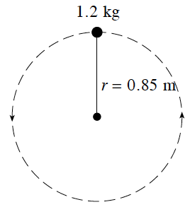
9. A 1.2 kg mass on the end of a string is rotated in a vertical circle of radius 0.85 m. If the speed of the mass at the top of the circle is 3.6 m/s, what is the tension in the string at this location?

A. 6.5 N B. 12 N C. 18 N D. 30 N

10. A person is on a horizontal rotating platform at a distance of 4.3 m from its centre. This person experiences a centripetal acceleration of 5.6 m/s². What centripetal acceleration is experienced by another person who is at a distance of 2.5 m from the centre of the platform?
A. 2.3 m/s² B. 3.3 m/s² C. 5.6 m/s² D. 9.6 m/s²

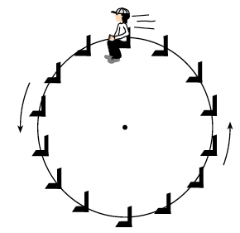
11. Hans, whose mass is 50 kg, rides on a ferris wheel in a circular path at constant speed. When he is at the top of the wheel, the seat exerts an upward force of 420 N on Hans. What is the centripetal force on Hans at the top of the wheel?

A. 70 N B. 420 N C. 490 N D. 910 N

12. Which of the following statements best applies to an object moving with uniform circular motion?
A. Acceleration is zero. B. Acceleration is directed outward.
C. Acceleration is tangent to the path. D. Magnitude of acceleration is constant.

13. A 1 200 kg car is travelling at 25 m s on a horizontal surface in a circular path of radius 85 m. What is the net force acting on this car?
A. 0 N B. 8.8x10³ N C. 1.2x10⁴ N D. 3.8x10⁵ N
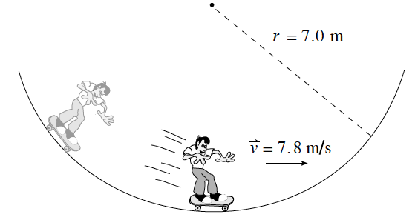
14. A 61 kg skateboarder is moving down a ramp with a 7.0 m radius of curvature. At the bottom of this ramp he reaches a speed of 7.8 m s. What upward force acts on the skateboarder at the bottom of the ramp?

A. 70 N B. 530 N
C. 600 N D. 1100 N

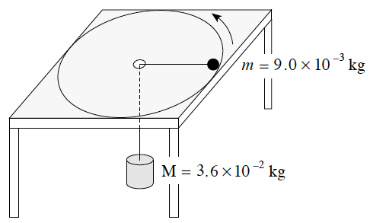
15. A 9.0 x 10⁻³ kg ball is attached to a 3.6 x 10⁻² kg mass M by a string that passes through a hole in a horizontal frictionless surface. The ball travels in a circular path of radius 0.35 m.
What is the speed of the ball?

A. 0.93 m/s B. 1.9 m/s C. 3.7 m/s D. 4.1 m/s
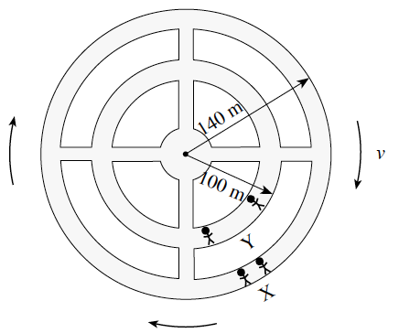

16. A space station has an outer radius of 140 m. The station rotates so that the occupants at X at the outer wall experience an acceleration of 9.8 m/s². What acceleration will the occupants at Y experience at the 100 m radius?

A. 7.0 m/s² B. 8.3 m/s² C. 9.8 m/s² D. 14 m/s²
17. An object travels with a constant speed in a circular path. The net force on the object is
A. zero. B. towards the centre. C. away from the centre. D. tangent to the path.

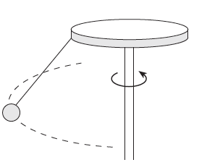
18. An object attached to a rotating table is moving in a circular path with a constant speed. Which is the correct free body diagram for the object?

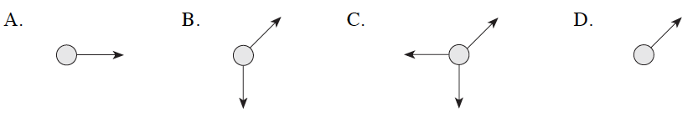

19. A 65 kg student is in a car travelling at 25 m s on a hill of radius 110 m. When the car is at the top of the hill, what upward force does the seat exert on the student?
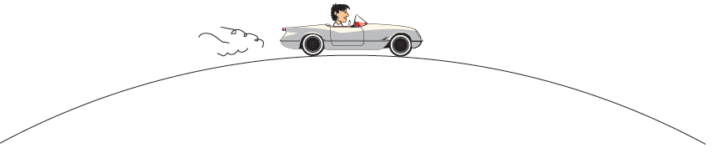
A. 270 N
B. 370 N
C. 640 N
D. 910 N

20. A 1 200 kg car can travel without slipping at a maximum speed of 28 m s in a circular path of radius 70 m on a dry horizontal surface. When it rains, the coefficient of friction is reduced to one half its original value. What is the maximum speed under this wet condition?
A. 7.0 m/s B. 14 m/s C. 20 m/s D. 28 m/s
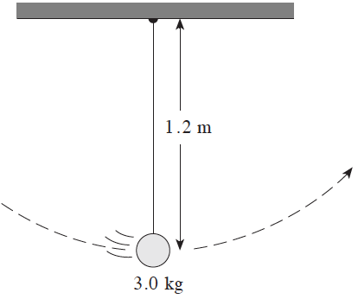
21. A 1.2 m long pendulum reaches a speed of 4.0 m s at the bottom of its swing. What is the tension in the string at this position?

A. 11 N B. 29 N
C. 40 N D. 69 N

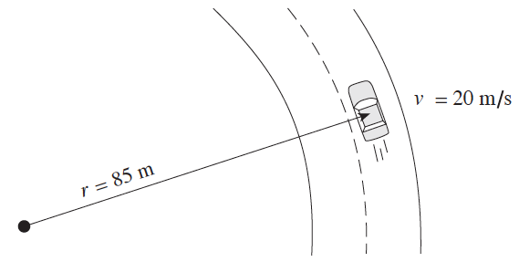
22. A 1 200 kg car rounds a flat circular section of road at 20 m s as shown in the diagram. The coefficient of friction between the car tires and the road surface is 0.65. What minimum friction force is required for the car to follow this curve?

A. 3 700 N B. 5 600 N
C. 7 600 N D. 12 000 N

23. A 2.5 kg object moves at a constant speed of 8.0 m/s in a 5.0 m radius circle. What is the object’s acceleration?
A. 0 m/s² B. 1.6 m/s² C. 13 m/s² D. 32 m/s²
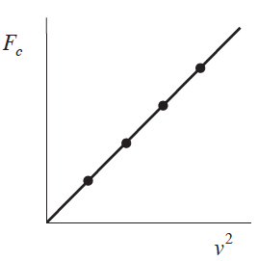
24. A student plots a graph of centripetal force Fc versus the square of velocity v2 for an object in uniform circular motion. What is the slope of this graph?
A. $\frac{m}{r}$ B.$\frac{r}{m}$ C.$\frac{4π^{2}r}{T^{2}}$ D. $\frac{T^{2}}{4π^{2}r}$

25. A 1.5 kg object is in uniform circular motion with a period of 3.0 s. If the radius of the path is 4.0 m, what is the centripetal force on the object?
A. 18 N B. 26 N C. 41 N D. 59 N
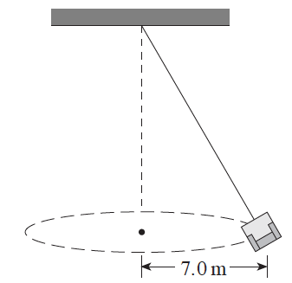

26. An empty 12 kg seat on a swing-type ride at the fairgrounds has a kinetic energy of 480 J. What is the centripetal force on the empty seat?
A. 120 N B. 140 N
C. 820 N D. 5 800 N

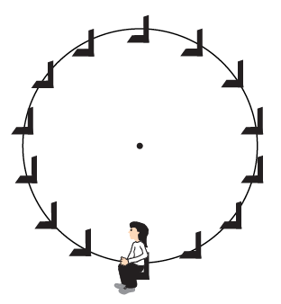
27. A 75 kg person rides a Ferris wheel which is rotating uniformly. The centripetal force acting on the person is 45N.

 | Force at Top | Force at Bottom
A | 690 N | 690 N
B | 690 N | 780 N
C | 780 N | 690 N
D | 780 N | 780 N

Written
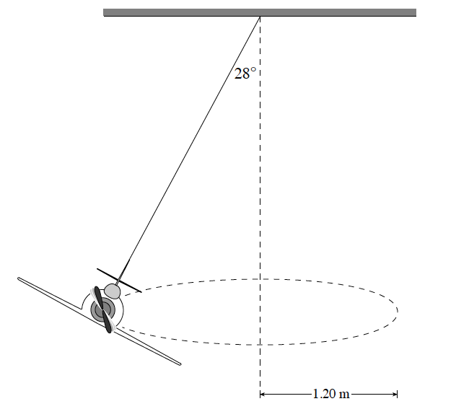
1. The diagram shows a toy plane flying in a circle of radius 1.20 m, supported by a string which makes an angle of 28° with the vertical. The tension in the string is 1.80 N.

a) What is the mass of the plane? (3 marks)
b) How long does the plane take to complete one orbit? (4 marks)

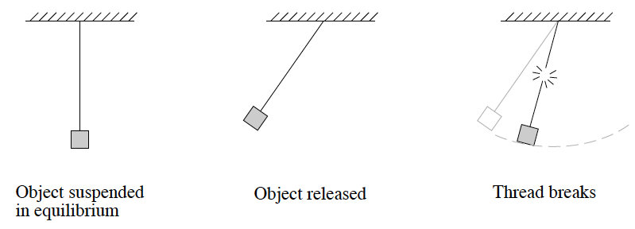
2. A heavy object initially hangs from a piece of thread. When the object is drawn aside and released, the thread is observed to break before the object reaches its lowest point. Using principles of physics, explain why the thread was strong enough to initially suspend the mass but not strong enough to support it when swinging. (4 marks)

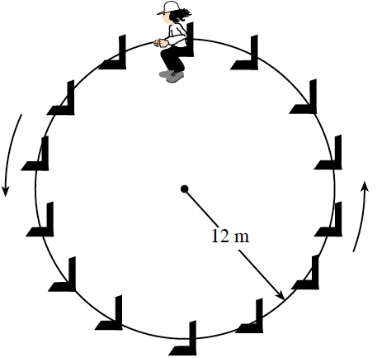
3. A 35 kg child rides a Ferris wheel of radius 12 m. The child moves in a vertical circle at a constant speed and completes one rotation every 9.0 s.

a) As the child travels over the top, what is the magnitude of the force that the seat exerts on the child? (5 marks)

b) How does the magnitude of the child’s acceleration at the top of the ride compare to her acceleration at the bottom?

The child’s acceleration at the top is:
i) less than at the bottom.
ii) greater than at the bottom.
iii) the same as at the bottom.
Explain your choice using principles of physics. (4 marks)

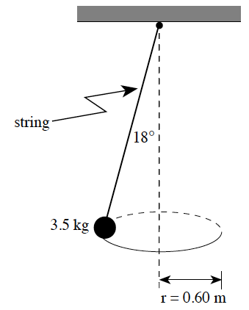
4. A 3.5 kg object is suspended by a string and moves in a horizontal circle of radius 0.60 m. The tension in the string is 36 N.

a) What is the magnitude of the net force on the object? (3 marks)
b) What is the period of revolution of the object? (4 marks)

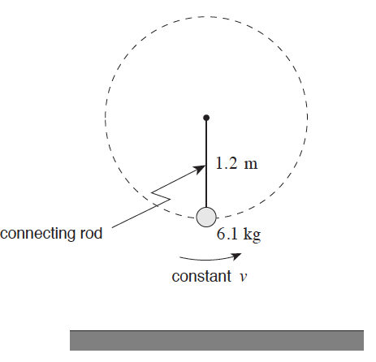
5. A 6.1 kg object on the end of a massless connecting rod moves in uniform circular motion in a vertical circle with radius 1.2 m. The period of revolution is 0.80 s.
a) Draw and label a free body diagram for the object at the bottom of the circular path. (2 marks)
b) Calculate the tension in the connecting rod at this position.
(5 marks)

Orbital Motion and Energy
28. What is the gravitational field strength at the surface of a star of mass 4.8 x 10³¹ kg and
radius 2.7 x 10⁸m?
A. 9.8 N/kg B. 4.4 x 10⁴ N/kg C. 4.9 x 10⁶ N/kg D. 1.2 x 10¹³ N/kg

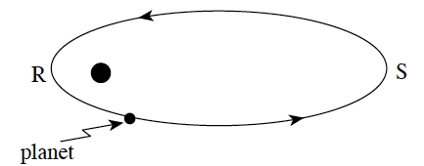
29. A planet is in orbit as shown in the diagram.

The planet’s gravitational potential energy will:
A. be constant throughout its orbit.
B. always be equal to its kinetic energy.
C. increase as the planet goes from point R to point S.
D. decrease as the planet goes from point R to point S.

30. The gravitational force of attraction between the Sun and an asteroid travelling in an orbit of radius 4.14 x 10¹¹ m is 4.62 x 10¹⁷ N. What is the mass of the asteroid?
A. 1.45 x 10⁹ kg B. 4.08 x 10⁹ kg C. 4.71 x 10¹⁶ kg D. 6.00 x 10²⁰ kg

31. What is the centripetal acceleration of the Moon in its orbit around the Earth?
A. 0 m/s² B. 2.7 x 10⁻³ m/s² C. 1.6 m/s² D. 9.8 m/s²
32. A satellite is travelling around the Earth in an orbit of radius 4.47 x 10⁷ m. What is the mass of the satellite if it experiences a gravitational force of 3.00 x 10³ N?
A. 4.37 x 10¹ kg B. 3.06 x 10² kg C. 2.14 x 10³ kg D. 1.50 x 10⁴ kg

33. A circular space station of radius 120 m is to be rotated so that its astronauts experience an effect similar to that of a gravitational field. If the field is to be 5.0 m/s² at this radius, what should be the period of rotation of the space station?
A. 0.32s B. 31 s C. 5100 s D. 86000 s

34. The work required to move an object in a planet’s gravitational field can be determined graphically by calculating
A. the slope of a graph of gravitational force versus separation distance.
B. the area under a graph of gravitational force versus separation distance.
C. the slope of a graph of gravitational potential energy versus separation distance.
D. the area under a graph of gravitational potential energy versus separation distance.

35. A satellite orbits a planet of mass 4.0 x 10²⁵ kg at a velocity of 5.8 x 10³ m/s. What is the radius of this orbit?
A. 6.4 x 10⁶ m B. 7.9 x 10⁷ m C. 1.6 x 10⁸ m D. 1.2 x 10¹⁹ m

36. What minimum kinetic energy would a spacecraft of mass 1.2 x 10⁴ kg need at the surface of the Earth so that it could escape to infinity?
A. 1.1 x 10⁴ J B. 1.2 x 10⁵ J C. 7.5 x 10¹¹ J D. An infinite amount

37. A satellite is placed in orbit around the Sun. The orbital radius of the satellite is twice the orbital radius of the Earth. What is the orbital period of this satellite?
A. 0.50 Earth years B. 1.6 Earth years C. 2.0 Earth years D. 2.8 Earth years

38. Find the gravitational force of attraction between a 75 kg physics student and her 1 500 kg car when their centres are 10 m apart.
A. 7.5 x 10^{–8} N B. 7.5 x 10^{–7} N C. 740 N D. 1.5 x 10³ N

39. A spacecraft of mass m is launched from the surface of a planet of mass M and radius r. Upon which of the variables, m, M and r, does the spacecraft’s escape velocity depend?
A. m and r B. M and r C. m and M D. m, M and r

40. A 120 kg astronaut stands on the surface of an asteroid of radius 600 m. The astronaut leaves the surface with 15 J of kinetic energy and reaches a maximum height of 300 m above the surface. What is the mass of the asteroid?
A. 5.6 x 10¹¹ kg B. 2.2 x 10¹² kg C. 3.4 x 10¹² kg D. 5.1 x 10¹² kg

41. Kepler’s third law (r³ $∝$ T²) can be derived from the law of
A. inertia. B. universal gravitation.
C. conservation of energy. D. conservation of momentum.

42. A planet travels in an elliptical path around a star as shown. Describe the magnitude of the velocity and the acceleration of the planet at X.
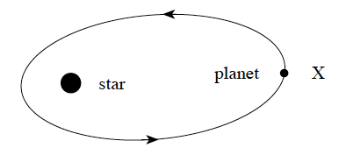
 | Magnitude of velocity | Magnitude of acceleration
A | minimum | minimum
B | minimum | maximum
C | maximum | minimum
D | maximum | maximum

43. A stationary object of mass m is on the surface of a planet of mass M and radius r. Which of the following gives the work required to move the object infinitely far away?
A. $W=\sqrt{\frac{GMm}{r}}$ B.$W=\frac{GMm}{r}$ C.$W=\frac{GMm}{2r}$ D.$W=\frac{GMm}{r^{2}}$
44. What is the centripetal acceleration of a satellite having an orbital period of 6.1x10³ s while in a circular orbit of radius 7.2x10⁶m?
A. 0 m/s² B. 5.2 m/s² C. 7.6 m/s² D. 9.8 m/s²

45. Two satellites, X and Y, are placed in orbit around a planet. Satellite X has a period of revolution of 3.6x10⁵ s and an orbital radius of 7.5x10⁸m. If the orbital radius of satellite Y is 3.0x10⁹m, what is its orbital period?
A. 9.1x10⁵ s B. 1.4 x10⁶ s C. 2.9 x10⁶ s D. 5.2 x10⁷ s

46. What is the escape velocity for an object on the surface of a 1.9x10²⁷ kg planet of radius 7.2x10⁷m?
A. 7.0 m/s B. 3.8x10⁴ m/s C. 4.2x10⁴ m/s D. 5.9x10⁴ m/s

47. A 1 500 kg spaceship circles a planet once every 4.0x10⁵ s with an orbital radius of 3.6x10⁷m. What is the mass of this planet?
A. 2.0x10¹¹ kg B. 1.2x10¹² kg C. 1.7x10²³ kg D. 2.6x10²⁶ kg

48. An object is located on the surface of a planet. The work required to remove this object from the planet’s gravitational field depends on which combination of the following three variables: mass of the planet, mass of the object, and radius of the planet?
 | Mass of Planet | Mass of Object | Radius of Planet
A | Yes | Yes | Yes
B | Yes | Yes | No
C | Yes | No | Yes
D | No | Yes | Yes

49. A certain planet has a mass of 3.3x10²³ kg and a radius of 2.6x10⁶m. What is the acceleration due to gravity on the surface of this planet?
A. 0.54 m/s² B. 3.3 m/s² C. 4.0 m/s² D. 9.8 m/s²

50. Relative to zero at infinity, what is the gravitational potential energy of a 7.2x10² kg satellite that is at a distance of 3.4x10⁷ m from earth’s centre?
A. -2.4x10¹¹ J B. -8.4x10⁹ J C. 8.4x10⁹ J D. 2.4x10¹¹ J

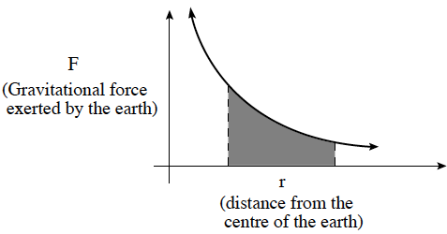
51. The shaded area shown in the diagram represents

A. the gravitational field strength near the earth.
B. the escape velocity from the surface of the earth.
C. the centripetal acceleration of an object orbiting the earth.
D. the work required to move an object in the earth’s gravitational field.

52. What is the magnitude of the centripetal acceleration of the earth as it orbits the sun?
A. 3.4x10⁻¹⁸ m/s² B. 1.8x10⁻⁸ m/s² C. 5.9x10⁻³ m/s² D. 9.8 m/s²

53. A certain planet with a radius of 7.0x10⁷ m has an escape velocity of 6.0x10⁴ m/s. What is the mass of this planet?
A. 6.6x10²⁵ kg B. 1.9x10²⁷ kg C. 3.8x10²⁷ kg D. 1.3x10³⁵ kg

54. Mars orbits the sun at 1.52 times Earth’s orbital radius. What is the orbital period of Mars in Earth years?
A. 1.23 years B. 1.52 years C. 1.87 years D. 2.31 years

55. A space shuttle orbits the earth at an altitude where the acceleration due to gravity is 8.70 m/s². What is the shuttle’s speed at this altitude?
A. 2.65x10³ m/s B. 7.45x10³ m/s C. 7.68x10³ m/s D. 7.91x10³ m/s

56. A satellite orbits the Earth with a speed of 5.2x10³ m/s. What is the satellite’s distance from the centre of the Earth?
A. 2.8x10⁶ m B. 1.5x10⁷ m C. 3.0x10⁷ m D. 7.2x10⁷ m

57. A satellite orbits the Sun with a period of 220 days. An asteroid orbits the Sun with twice the orbital radius of the satellite. What is the asteroid’s period?
A. 110 days B. 220 days C. 440 days D. 620 days

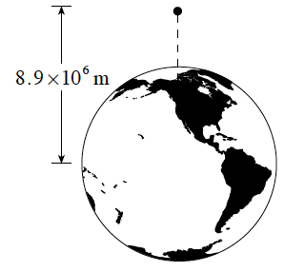
58. A stationary 25 kg object is released from a position 8.9x10⁶ m from the centre of the earth. 8.9x10⁶ m. What is the speed of the object just before impact? Ignore air resistance.

A. 6.0x10³ m s B. 7.0x10³ m s
C. 1.3x10⁴ m s D. 1.8x10⁴ m s

59. A planet of radius 7.0x10⁷ m has a gravitational field strength of 68 N/kg at its surface. What is the period of a satellite orbiting this planet at a radius of 1.4x10⁸ m (twice the planet’s radius)?
A. 9.0x10³ s B. 1.3x10⁴ s C. 1.8x10⁴ s D. 2.4x10⁴ s

60. Which of the following graphs shows how the gravitational field of a body varies with distance from its centre? (Assume d is greater than the radius of the body.)
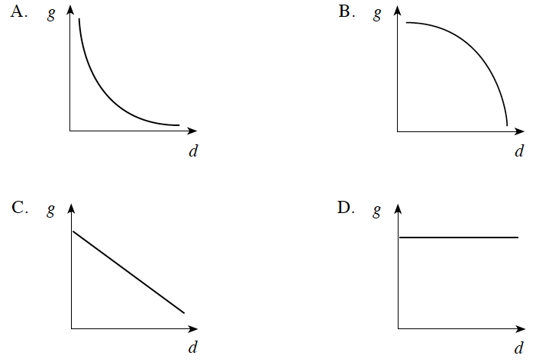

61. A 9.0 x 10³ kg satellite with an orbital radius of 3.20 x 10⁷ m orbits the earth at an altitude of 2.56 x 10⁷ m. What is the orbital period?
A. 1.1 x 10⁴ s B. 4.1 x 10⁴ s C. 5.7 x 10⁴ s D. 1.5 x 10¹⁵ s

62. Two masses m1 and m2 are separated by a distance d. Which of the following would increase the force of gravity acting on m1 due to m2 ?
A. Increasing d. B. Decreasing d. C. Decreasing m1. D. Decreasing m2 .

63. What is the magnitude of the centripetal acceleration of the moon as it orbits the earth?
A. 2.7 x 10⁻³ m/s² B. 0.16 m/s² C. 1.6 m/s² D. 9.8 m/s²

64. Oberon is a satellite of the planet Uranus. It has an orbital radius of 5.83 xx10⁸ m and an orbital period of 1.16 x 10⁶ s. What is the mass of Uranus?
A. 2.6x10⁸ kg B. 5.9x10¹⁴ kg C. 1.5x10¹⁷ kg D. 8.7x10²⁵ kg

65. A satellite orbits the earth with a kinetic energy of 2.0 x 10¹⁰ J . Its gravitational potential energy in this orbit is - 4.0 x 10¹⁰ J. What is the total energy of the satellite?
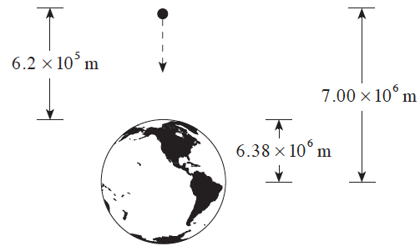
A. -6.0x10¹⁰ J B. -2.0x10¹⁰ J C. 2.0x10¹⁰ J D. 6.0x10¹⁰ J

66. A 450 kg piece of space debris initially at rest falls from an altitude of 6.2 x 10⁵ m above the earth’s surface. What is its kinetic energy just before impact with the surface? (Ignore air resistance.)

A. 2.5x10⁹ J B. 2.7x10⁹ J
C. 2.6x10¹⁰ J D. 2.9x10¹¹ J

67. A satellite travels around a planet at 9.0 x 10³ m/s with an orbital radius of 7. 4 x 10⁶ m. What would be the speed of an identical satellite orbiting at one half this radius?
A. 4.5x10³ m/s B. 9.0x10³ m/s C. 1.3x10⁴ m/s D. 1.8x10⁴ m/s

68. Which of the following graphs shows how the gravitational force varies with the distance of separation between two objects?
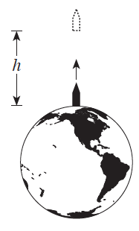
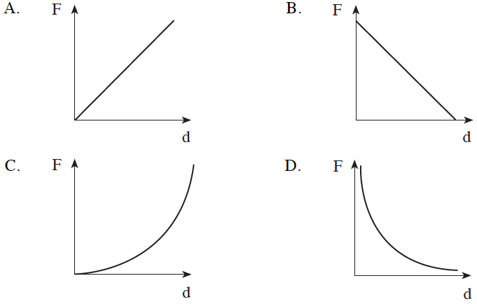

69. A 5.2 x 10⁴ kg rocket is initially at rest on the surface of the earth. If 3.0x10¹¹J of work is done on this rocket, what maximum altitude h will the rocket reach? (Assume the rocket’s mass does not change.)
A. 5.9x10⁵ m B. 6.5x10⁵ m C. 5.8x10⁶ m D. 6.9x10⁷ m

70. A satellite’s orbit is maintained by a
A. normal force. B. frictional force. C. centrifugal force. D. gravitational force.

71. What is the gravitational field strength on the surface of a planetoid with a mass of 7.4 x 10²² kg and a radius of 1.7 x 10⁶ m.
A. 0.69 N/kg B. 1.7 N/kg C. 9.8 N/kg D. 2.9 x 10⁶ N/kg

72. A 1 500 kg satellite is in a stable orbit at an altitude of 4.0 x 10⁵ m above Earth’s surface. What is the satellite’s total energy in this orbit?
A. -8.8x10¹⁰ J B. -4.4 x10¹⁰ J C. 4.4 x10¹⁰ J D. 5.0 x10¹⁰ J

73. A satellite is in a stable orbit around the earth at a constant altitude. Its gravitational potential energy is -1.5 x 10¹⁰ J . How much work is done on the satellite during one orbit?
A. -1.5x10¹⁰ J B. 0 J C. 7.5x10⁹ J D. 1.5x10¹⁰ J

74. What is the magnitude of Earth’s centripetal acceleration as it orbits the Sun?
A. 1.9x10⁻¹⁰ m/s² B. 4.2x10⁻⁴ m/s² C. 5.9x10⁻³ m/s² D. 9.8 m/s²

75. Which of the following is a correct expression for the total energy of the satellite m orbiting the central body M.
A. $E_{T}=-G\frac{Mm}{r}$ B. $E_{T}=G\frac{Mm}{r}$
C. $E_{T}=\frac{1}{2}mv^{2}+mgr$ D. $E_{T}=\frac{1}{2}mv^{2}+\left(-G\frac{Mm}{r}\right)$

76. A satellite orbits Earth at a velocity of 3.1 x 10³ m/s. What is the radius of this orbit?
A. 9.7x10³ m B. 6.4x10⁶ m C. 4.2x10⁷ m D. 8.3x10⁷ m

77. Which of the following illustrates the work required to move an object in a gravitational field?
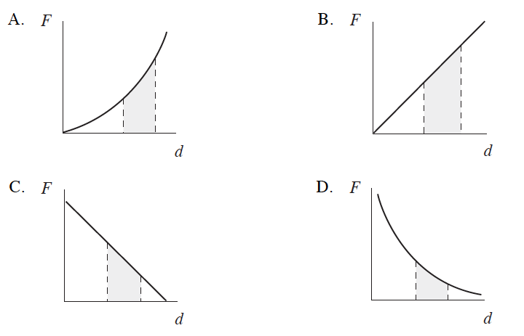

78. A 1 500 kg satellite orbits the earth at 2 500 m/s . What is the satellite’s centripetal acceleration?
A. 0.098 m/s² B. 0.98 m/s² C. 9.8 m/s² D. 150 m/s²

Written

1. A satellite travels in a circular orbit at a height of one Earth radius above the surface of the Earth. What is the satellite’s orbital period? (7 marks)

2. A 900 kg satellite which is travelling at 8 600 m/s around a planet of mass 8.1 x 10²⁵ kg has an orbital radius of 7.3 x 10⁷ m. What is the total orbital energy of this satellite relative to infinity? (7 marks)

3. A satellite is placed in circular orbit at an altitude of 4.8 x 10⁵ m above Earth’s surface.
a) What is the satellite’s orbital period? (5 marks)
b) (i) As shown in the diagram below, two satellites pass over the same point on Earth’s surface.
Satellite H is in a higher orbit than satellite L.
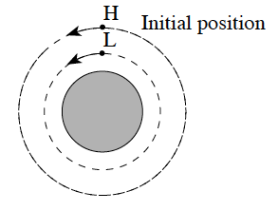
Which satellite, H or L, completes one orbit first? (Circle one) (1 mark)
A. satellite H
B. satellite L
(ii) Using principles of physics, explain your answer. (3 marks)

5. A 1 250 kg rocket rests on the surface of the Earth. To what maximum distance from the Earth’s centre would the rocket be lifted if 2.5 x 10¹⁰ J of work were done on it? (7 marks)

7. An astronaut stands on the surface of a planet of radius 2.6x10⁶m. An object dropped from the astronaut’s hand accelerates at 3.2 m/s².
a) What is the mass of this planet? (5 marks)
b) What is the force of gravity on an 18 kg mass located on the surface of this planet? (2 marks)

9. A 4.2x10³ kg spacecraft orbits a 5.6x10²⁶ kg planet. If it takes the spacecraft 8.9x10⁴ s to complete one orbit, how far is it from the planet’s centre? (7 marks)

10. The moon Deimos orbits the planet Mars at an orbital radius of 2.34x10⁷ m with an orbital period of 1.08x10⁵ s . What is the mass of Mars? (7 marks)

11. a) The space shuttle orbits the Earth in a circular path where the gravitational field strength is 8.68 N/kg. What is the shuttle’s orbital radius? (5 marks)
b) A space station that has 10 times the mass of the shuttle in a) orbits Earth at the same altitude. How does the orbital speed of the space station compare to that of the shuttle? (1 mark)
c) Using principles of physics, explain your answer to b). (3 marks)

13. A 1 200 kg space probe is in a circular orbit around the Sun. The orbital radius is 7.0 x 10⁹ m.
a) What is the orbital speed of this satellite? (5 marks)
b) If the Sun collapsed to one-tenth its present radius without a change to its mass, how will the space probe’s orbital radius change? (1 mark)
c) Using principles of physics, explain your answer to b). (3 marks)

15. A 650 kg satellite in circular orbit around Earth has an orbital period of 1.5 x 10⁴ s.
a) What is the satellite’s orbital radius? (5 marks)
b) What is the gravitational potential energy of this satellite? (2 marks)

16. The moon Titan orbits the planet Saturn with a period of 1. 4 x 10⁶ s. The average radius of this orbit is 1.2 x 10⁹ m.
a) What is Titan’s centripetal acceleration? (2 marks)
b) Calculate Saturn’s mass. (5 marks)

17. A 1 500 kg satellite travels in a stable circular orbit around the earth. The orbital radius is 4.2x10⁷m. What is the satellite’s kinetic energy? (7 marks)

18. A 1 500 kg satellite travels around the earth in a stable orbit with a radius of 1.3 x 10⁷ m.
a) What is the speed of the satellite in this orbit? (5 marks)
b) The satellite is then moved to a new orbit with twice the radius of the first orbit. How does the speed in the larger orbit compare to the original orbit. (1 mark)
c) Using principles of physics, explain your answer to b). (3 marks)

1. D
2. B
3. B
4. D
5. B
6. B
7. C
8. A
9. A
10. B
11. A
12. D
13. B
14. D
15. C
16. A
17. B
18. B
19. A
20. C
21. D
22. B
23. C
24. A
25. B
26. B
27. B
28. B
29. C
30. D
31. B
32. D
33. B
34. B
35. B
36. C
37. D
38. A
39. B
40. C
41. B
42. A
43. B
44. C
45. C
46. D
47. C
48. A
49. B
50. B
51. D
52. C
53. B
54. C
55. C
56. B
57. D
58. A
59. C
60. A
61. C
62. B
63. A
64. D
65. B
66. A
67. C
68. D
69. B
70. D
71. B
72. B
73. B
74. C
75. D
76. C
77. D
78. A

1. a) 0.16 kg; b) 3.0 s
2. Originally the thread exerts a force equal to the object’s weight. As it swings, however, the object travels along a circular arc, so the thread must exert a centripetal force also. The thread is unable to produce this larger force and therefore breaks.
3. a) 138 N b) same; Since this child is moving in uniform circular motion her net force must be a constant centripetal force. The magnitude of the acceleration must therefore be constant.
4. a) 11N b) 2.7 s
5. a) F_{T} up must be noticeably larger than F_{g} down. b) 510 N
6. 1.4 x 10⁴ s
7. -3.3 x 10¹⁰ J
8. a) 5.7 x 10³ s
b) (i) L (ii) L completes one orbit first. The stronger gravitational field lower down requires a higher velocity to maintain a stable orbit. Higher velocity with a smaller circumference will result in a shorter period.
9. 9.39 x 10⁶ m
10. a) 3.2x10²³ kg b) 58 N
11. 2.0 x 10⁸ m
12. 6.5 x 10²³ kg
13. a) 6.78 x 10⁶ m b) same speed c) The force of gravity is the only force that provides the centripetal acceleration. Since both the gravitational force and the centripetal force are proportional to mass, the acceleration remains the same, therefore the speeds must be the same. OR Since $F_{g}=F_{c} ,\frac{m_{1}v^{2}}{r}=\frac{Gm_{1}m_{earth}}{r}$ when you solve for v, the mass of the orbiting body cancels out. Speed is independent of the size of the orbiting mass.
14. a) 1.37 x 10⁵ m/s b) no change c) Since the mass of the sun has not changed and the distance between the two objects has not changed, then the force of gravity is still the same. The force of gravity is the net force; therefore the centripetal force must be the same.
15. a) 1.3 x 10⁷ m b) -2.0 x 10¹⁰ J
16. a) 0.024 m/s² b) 5.2 x 10²⁶ kg
17. 7.1 x 10⁹ J
18 a) 5.5 x 10³ m/s b) less than c) The satellite’s speed in a stable orbit is inversely proportional to the square root of orbit radius: $v∝\frac{1}{\sqrt{r}}$ .Therefore, in an orbit with twice the radius of the first, the satellite speed will be lower.

