Work and Energy
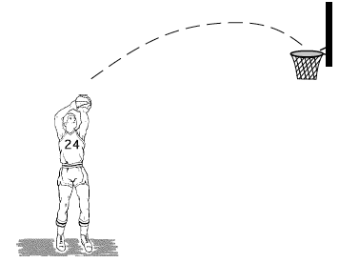
1. A basketball is thrown into the basket, as shown in the diagram. The ball leaves the player’s hand at t= 0 s and reaches the basket at t = 3 s.

Which of the following graphs best represents the ball’s kinetic energy Ek as a function of time?
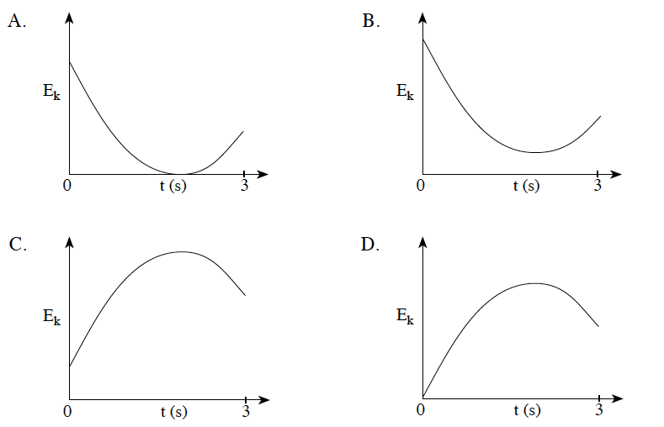

2. How much work must be done to stop an 1 800 kg vehicle travelling at 30 m/s?
A. 1.8 x 10⁴ J B. 5. 4 x 10⁴ J C. 5.3 x 10⁵ J D. 8.1 x 10⁵ J

3. Work is measured in which units?
A. J B. N C. J/s D. N•s

4. What is the minimum power exerted by a 75kg person climbing a set of stairs 4.5 m high in 5.0 s?
A. 6.8 x 10¹ W B. 6.6 x 10² W C. 1.7 x 10³ W D. 3.3 x 10³ W

5. Calculate the minimum power of a cyclist who can increase his kinetic energy from 480 J to 2 430 J by travelling 26 m in 4.0 s.
A. 75 W B. 360 W C. 490 W D. 730 W

6. The 2.0 kg head of an axe strikes a tree horizontally at 40 m/s. The blade penetrates 0.040 m into the tree. What is the average force exerted by the blade on this tree?
A. 20 N B. 2 000 N C. 20 000 N D. 40 000 N

7. A cyclist travelling at 10 m/s applies her brakes and stops in 25 m. The graph shows the magnitude of the braking force versus the distance travelled. What is the total mass of bike and cyclist?
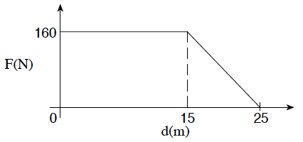
A. 20 kg B. 40 kg C. 64 kg D. 80 kg
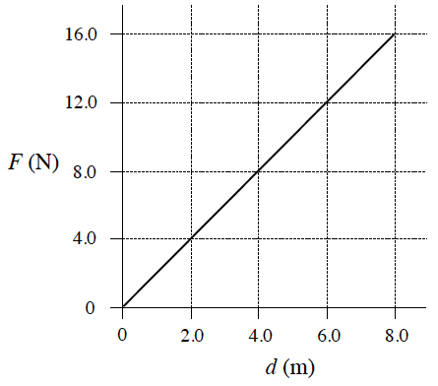

8. The graph below shows the relationship between the force applied and the distance moved for a 3.5kg object on a frictionless horizontal surface. If the object was initially at rest, what is its kinetic energy after travelling 8.0 m?

A. 2.0 J B. 32 J C. 64 J D. 130 J

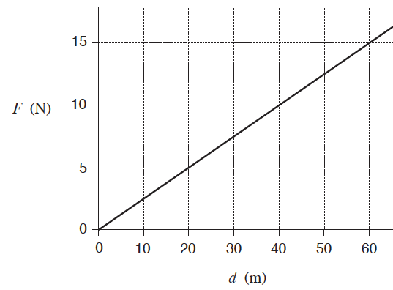

9. The graph shows how the force acting on an object varies with distance. What is the work done in moving the object from 20 m to 60 m?

A. 50 J B. 100 J C. 400 J D. 900 J

10. What is the minimum power output of a small electric motor that lifts a 0.050 kg mass through 2.0m in 30 s?
A. 0.0017 W B. 0.017 W C. 0.033 W D. 15 W

11. A net force of 20 N acts for 1.5 s on a 4.0 kg object initially at rest. What is the final kinetic energy of the object?
A. 30 J B. 110 J C. 230 J D. 440 J

12. A cyclist increases his kinetic energy from 1100 J to 5 200 J in 12 s. His power output during this time is
A. 92 W B. 260 W C. 340 W D. 430 W

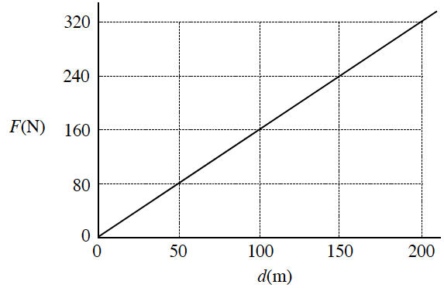
  - written

1. A 24 kg rocket car is initially at rest on a frictionless horizontal surface. The engine is ignited and the graph below shows thrust force, F, versus distance travelled, d, for the rocket car. Find the rocket car’s speed after it has travelled 200 m. (7 marks)
2. A 0.030 kg toy car is pushed back against a spring-based launcher as shown in Diagram 1.
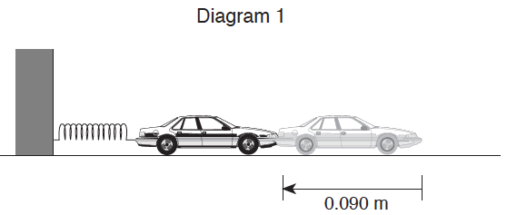
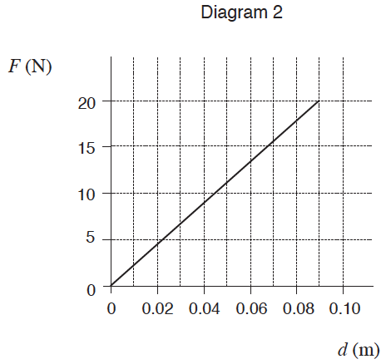

Diagram 2 shows a graph of the force required to compress the spring 0.090 m.
a) What is the work done in compressing the spring? (3 marks)
b) Assuming no losses due to heat, what maximum speed is reached by the toy car when it is released? (3 marks)
c) If in fact the maximum kinetic energy of the car is 0.18 J , what is the efficiency of the spring-based launcher? (1 mark)

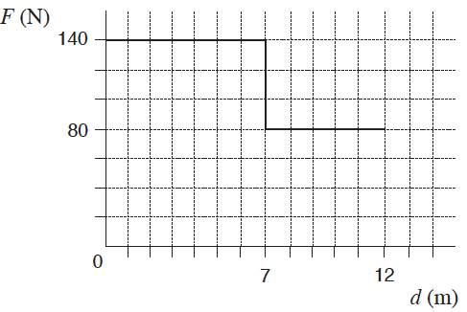
3. Starting from rest, a farmer pushed a cart 12 m. The graph shows the force F which he applied, plotted against the distance d.
a) How much work did the farmer do moving the cart 12 m? (3 marks)
b) After the farmer had pushed the 240 kg cart 12 m, it was moving with a velocity of
2.2 m/s. What was the cart’s kinetic energy? (2 marks)
c) What was the efficiency of this process? (2 marks)

4. A daredevil is attached by his ankles to a bungee cord and drops from the top of a bridge. The force exerted on the daredevil by the bungee cord is measured against the change in length, x , of the cord as the cord is stretched, slowing the daredevil’s fall.

Force (N) | 0 | 300 | 600 | 1 000 | 1 200 | 1 700 | 1 900
x (m) | 0 | 5 | 10 | 15 | 20 | 25 | 30

a) Plot a graph of force vs. change in length. (2 marks)
b) Use the graph to determine the work done by the bungee cord during its stretch. (3 marks)

5. A cyclist must do 1 000 J of work to speed up from 0 m/s to 5.0 m/s . The same cyclist must do 3 000 J of work to speed up from 5.0 m/s to 10.0 m/s. (In both instances friction has been ignored.) Using principles of physics, explain why more work must be done to speed up from 5.0 m/s to 10.0 m/s than from 0 m/s to 5.0 m/s . (Remember, friction plays no role in this problem.) (4 marks)

Conservation of energy

13. A 3.5 kg projectile was launched vertically at 75 m/s. The projectile reached a maximum height of 180 m. How much energy was lost to heat while the projectile was rising?
A. 0 J B. 3. 7 x 10³ J C. 6.2 x 10³ J D. 9.8 x 10³ J

14. As a skier descends a slope, her kinetic energy increases from 600 J to 3 200 J while her gravitational potential energy decreases by 5 900 J. How much heat energy is created due to friction?
A. 2 100 J B. 3 300 J C. 8 500 J D. 9 700 J

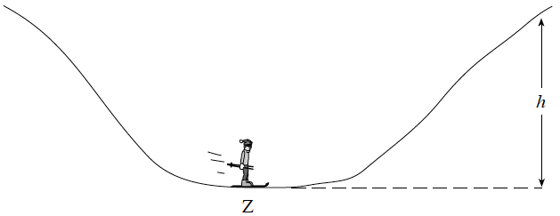
15. René, whose mass is 85 kg, skis down the hill, passing Z with a kinetic energy of 9 700 J. If friction is ignored, to what maximum height, h, can René ski?

A. 12 m B. 15 m
C. 1.1x10² m D. 6.6x10² m

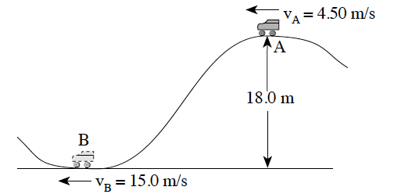
  - written

6. A 250 kg roller coaster car travels past points A and B with speeds shown in the diagram below. How much heat energy is produced between these points? (7 marks)

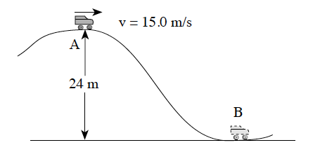
7. A 150 kg roller coaster car passes the crest of a hill at 15.0 m/s.

a) What is the speed of the car at point B at the bottom of the hill? (Neglect friction.)
(5 marks)

b) i) If the mass of the roller coaster car is increased by adding a passenger, how will the speed at B now compare to your answer for part a)? (1 mark)
A. equal to B. less than C. greater than
ii) Explain your answer using principles of physics. (3 marks)
8. As a 62 kg skier descends from A to B her velocity increases from 8.5 m/s to 23.3 m/s. Friction between A and B generates 8 700 J of heat energy. Through what vertical height, h, did the skier descend? (7 marks)
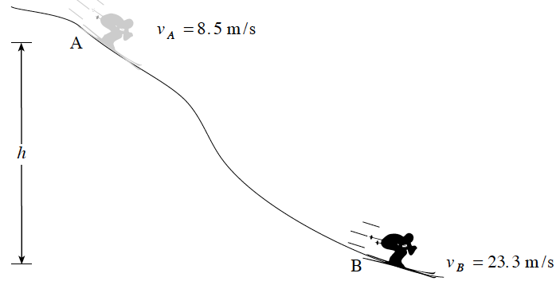

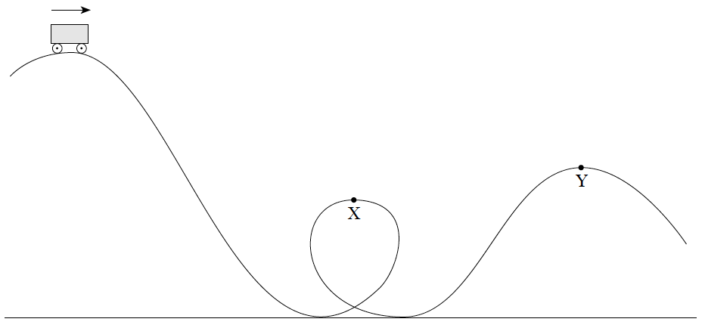
9. A roller coaster car is released from the crest of a hill.

a) How does the speed at Y compare to the speed at X? Ignore friction.
b) Using principles of physics, explain your answer
(3 marks)

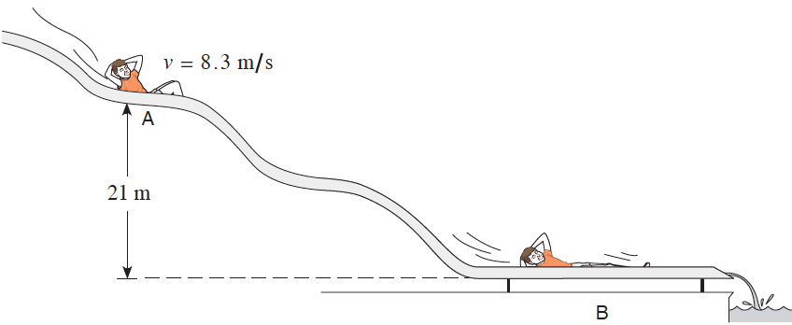

10. A 45 kg child on a water slide passes point A at 8.3 m/s. As the child descends from A to B, 3 600J of heat energy is created because of friction. What is his speed at B? (7 marks)

Momentum and Impulse
16. A 2.0 kg puck travelling due east at 2.5 m/s collides with a 1.0 kg puck travelling due south at 3.0m/s. They stick together on impact. What is the resultant direction of the combined pucks?
A. 31° S of E B. 40° S of E C. 50° S of E D. 59° S of E

17. A puck sliding on a frictionless table undergoes a change in momentum due to a constant force. Which of the following expressions could be used to determine the change in momentum?
A. F x ∆d B. F x ∆t C. F x ∆v D. F x (∆v/∆t)

18. Impulse is measured in which units?
A. J B. N C. N⋅m D. N⋅s

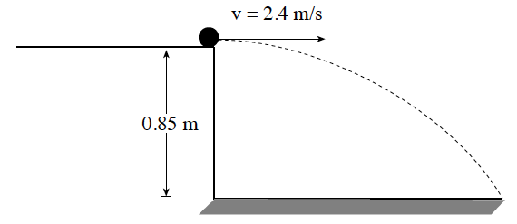
19. A 0.15 kg ball rolls off a bench at 2.4 m/s as shown in the diagram below. What is the vertical component of the ball’s momentum when it strikes the floor 0.85 m below?

A. 0.36 kg ⋅ m/s B. 0.61 kg ⋅ m/s
C. 0.71 kg ⋅ m/s D. 1.2 kg ⋅ m/s

20. Which of the following is not a vector?
A. mass B. impulse C. velocity D. momentum

21. A 0.15 kg ball moving at 40 m/s is struck by a bat. The bat reverses the ball’s direction and gives it a speed of 50 m/s. What average force does the bat apply to the ball if they are in contact for 6.0x10⁻³ s?
A. 14 N B. 2.5 x 10²N C. 1.3 x 10³N D. 2.3 x 10³N

22. In order to stop two sliding objects, the greater impulse must be given to the one having the greater
A. mass. B. speed. C. velocity. D. momentum.

23. Which expression is equal to the net force on an object?
A. ∆p/∆t B. W/∆t C. m∆v D. ∆E

24. Impulse is defined as:
A. total energy. B. total momentum. C. a change in energy. D. a change in momentum.

25. A small explosive device sliding to the right breaks into two pieces. The momentum of fragment 1 after the explosion is 23 kg•m/s. What is the momentum of fragment 2 after the explosion?
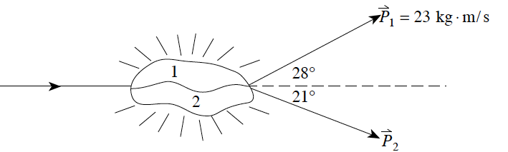
A. 22 kg•m/s B. 23 kg•m/s C. 30 kg•m/s D. 32 kg•m/s

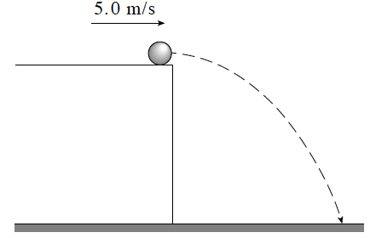
26. A 0.30 kg ball rolls off a horizontal surface as shown in the diagram. What is the magnitude of the impulse given to the ball by gravity during the 0.90 s it takes the ball to fall to the ground?

A. 1.5 N•s B. 2.6 N•s
C. 3.0 N•s D. 4.1 N•s

27. A 0.15 kg ball travelling at 25 m s strikes a wall and bounces back in the opposite direction at 15m/s. The ball is in contact with the wall for 0.030 seconds. What average force does the wall exert on the ball?
A. 25 N B. 50 N C. 1.0x10² N D. 2.0x10² N

28. A ball is thrown at 15 m s towards various barriers. In which case does the ball experience the greatest impulse?
A. The ball hits a wall and rebounds at 2.0 m/s.
B. The ball hits a wall and rebounds at 7.0 m/s.
C. The ball hits a wall, sticks to it and stops moving.
D. The ball breaks a window and continues moving at 10 m/s in the same direction.

29. Which of the following are equivalent units for change in momentum?
A. kg•m/s² B. N•s C. kg•s/m D. N/s

30. A 1.2 kg ball moving due east at 40 m/s strikes a stationary 6.0 kg object. The 1.2 kg ball rebounds to the west at 25 m/s. What is the speed of the 6.0 kg object after the collision?
A. 3.0 m/s B. 13 m/s C. 15 m/s D. 65 m/s

31. An object travelling due north experiences an impulse due east. The direction of the change in momentum of this object is
A. east. B. west. C. north. D. northeast.

32. A 1.5 kg ball falling vertically strikes the floor with a speed of 12 m/s and rebounds upward with a speed of 8.0 m/s . What is the magnitude and direction of the impulse given to the ball?
 | Impulse | direction
A | 6.0 N•s | upward
B | 6.0 N•s | downward
C | 30 N•s | upward
D | 30 N•s | downward

33. A 900 kg car travelling at 12 m/s due east collides with a 600 kg car travelling at 24 m/s due north. As a result of the collision, the two cars lock together and move in what final direction?
A. 45° N of E B. 53° N of E C. 63° N of E D. 69° N of E

34. Which of the following best represents the momentum of a small car travelling at a city speed limit?
A. 1 000 kg•m/s B. 10 000 kg•m/s C. 100 000 kg•m/s D. 1 000 000 kg•m/s

35. A 0.080 kg tennis ball travelling east at 15 m s is struck by a tennis racquet, giving it a velocity of 25 m s, west. What are the magnitude and direction of the impulse given to the ball?

 | magnitude | direction
A | 0.80 N•s | eastward
B | 0.80 N•s | westward
C | 3.2 N•s | eastward
D | 3.2 N•s | westward

36. A 1 000 kg vehicle travelling westward at 15 m s is subjected to a 1.0 x 10⁴ N•s impulse northward. What is the magnitude of the final momentum of the vehicle?
A. 5.0x10³ kg•m/s B. 1.5x10⁴ kg•m/s C. 1.8x10⁴ kg•m/s D. 2.5x10⁴ kg•m/s

  - written
11. Two gliders having equal masses, each travelling along a level frictionless track at the same speed, approach each other head on. They stick together on impact and remain stationary at the point of impact. Does this situation mean that momentum has been lost during this particular collision? State your answer with supporting arguments which use principles of physics. (4 marks)

12. A 4 000 kg space vehicle consists of a 2 500 kg main capsule and a 1 500 kg probe. The space vehicle is travelling at 120 m/s when an explosion occurs between the capsule and the probe. As a result, the probe moves forward at 140 m/s, as shown in the diagram below.
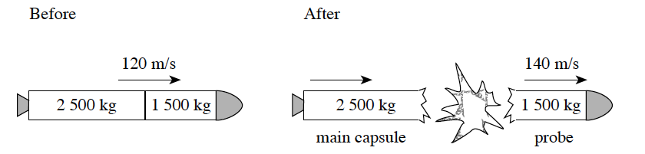
a) (i) What is the speed of the main capsule after the explosion? (3 marks)
(ii) What is the magnitude of the impulse given to the probe? (2 marks)
b) Define impulse and briefly explain why the impulse on the probe is equal in magnitude to the impulse on the main capsule. (4 marks)

13. A 2.0 kg bowling ball travelling 5.0 m/s collides with a stationary 0.30 kg bowling pin. After the collision, the pin moves at a speed of 6.5 m/s in the direction shown in the diagram. What is the velocity (magnitude and direction) of the bowling ball after the collision? (7 marks)
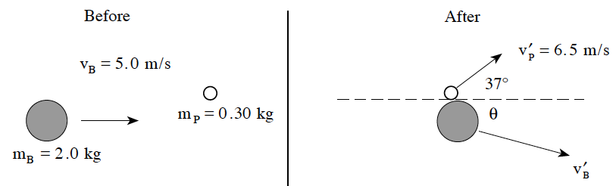
14. Two air pucks approach each other, stick together and then travel due east as shown below. Find the initial velocity (magnitude and direction) of puck A. (7 marks)
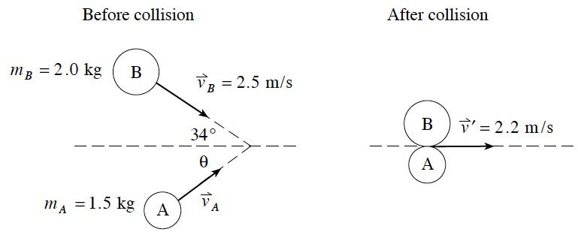

15. Two steel pucks collide as shown in the diagram below. Determine the speed and direction of the 0.30 kg puck after the collision. (7 marks)
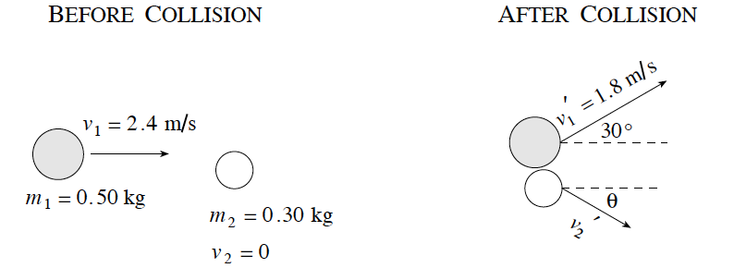

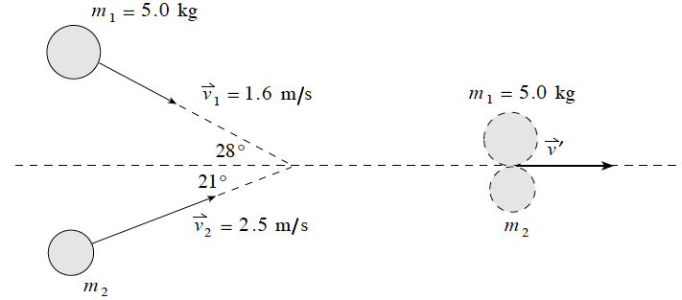
16. A 5.0 kg object travelling at 1.6 m/s collides with an object of unknown mass m₂ travelling at 2.5 m/s . The two objects stick together and move towards the right as shown in the diagram. Find the mass of object m₂ . (7 marks)

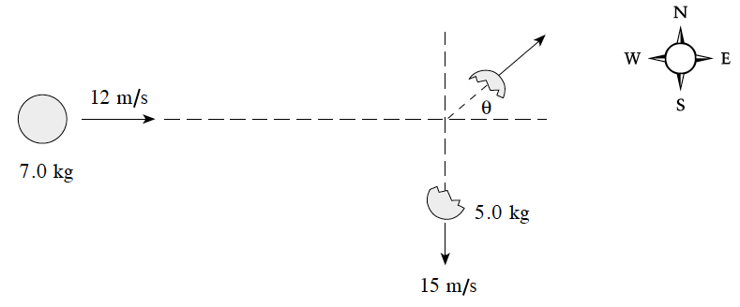
17. A 7.0 kg object moving at 12 m/s to the east explodes into two unequal fragments. The larger 5.0kg fragment moves at 15 m/s south.

What is the velocity (speed and direction) of the smaller 2.0 kg fragment? (7 marks)

Momentum and Energy

37. Two carts collide while travelling on a smooth surface. It is found that the sum of the kinetic energies of the carts after the collision is the same as before the collision. This collision must be
A. elastic. B. inelastic. C. between carts of equal mass. D. between carts that stick together.

38. The diagram shows a collision between a 4.0 kg toy car and a stationary 8.0 kg toy truck. After the collision, the car bounces back at 1.0 m/s while the truck goes forward at 2.0 m/s. Based on these values, are momentum and kinetic energy conserved?
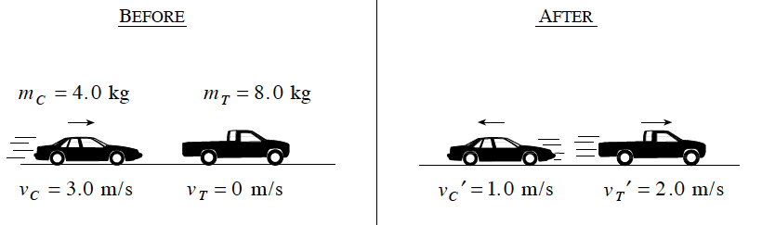
 | momentum | Kinetic Energy
A | Conserved | Conserved
B | Conserved | Not Conserved
C | Not Conserved | Conserved
D | Not Conserved | Not Conserved

39. A 60 kg girl and her 45 kg brother are at rest at the centre of a frozen pond. He pushes her so that she slides away at 2.4 m/s. How much total work is done? (Ignore friction.)
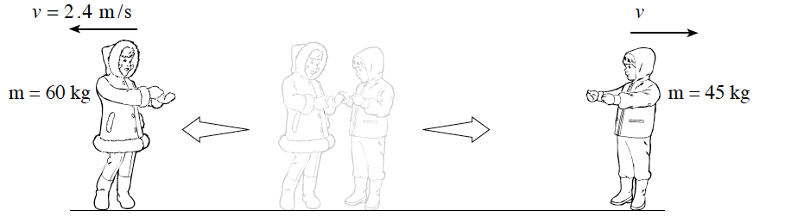
A. 58 J B. 170 J C. 350 J D. 400 J

40. Which set of conditions is true in all inelastic collisions?
 | momentum | Kinetic Energy | Total Energy
A | Conserved | Conserved | Conserved
B | Conserved | Not Conserved | Conserved
C | Not Conserved | Not Conserved | Conserved
D | Not Conserved | Conserved | Not Conserved

41. Two blocks are initially held together on a frictionless surface as shown in the diagram below.
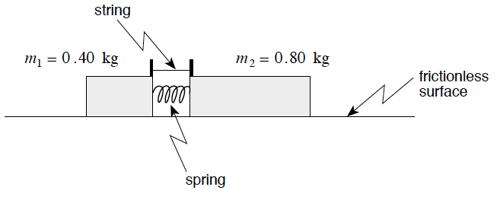
When the string is cut, the blocks fly apart as shown.
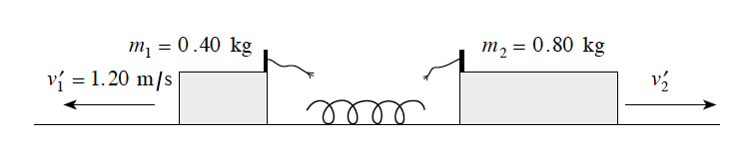
What work was done on the blocks by the spring?
A. 0 J B. 0.29 J C. 0. 43 J D. 0.58 J

42. A stationary object explodes into two fragments. A 4.0 kg fragment moves westwards at 3.0 m/s. What are the speed and kinetic energy of the remaining 2.0 kg fragment?
 | Speed | Kinetic Energy
A | 4.2 m/s | 18 J
B | 4.2 m/s | 36 J
C | 6.0 m/s | 18 J
D | 6.0 m/s | 36 J

  - written

18. A 5.20 kg block sliding at 9.40 m/s across a horizontal frictionless surface collides head on with a stationary 8.60 kg block. The 5.20 kg block rebounds at 1.80 m/s. How much kinetic energy is lost during this collision? (7 marks)

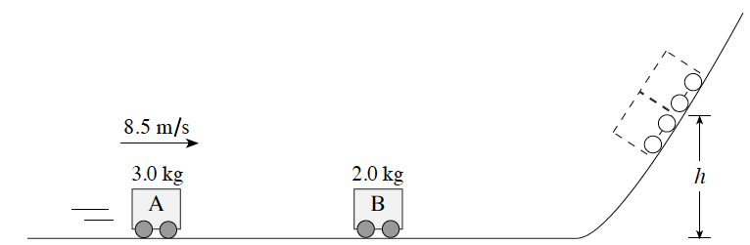
19. A 3.0 kg car A travelling 8.5 m s on a frictionless track collides and sticks on to a stationary 2.0 kg car B.
a) The combined cars will reach what height h? (5 marks)

b) The steepness of the slope is decreased as shown.
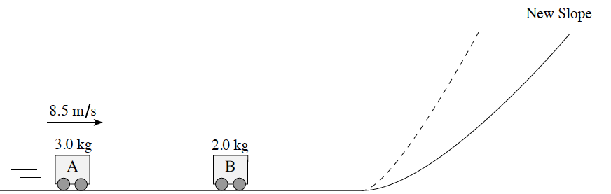
With this decreased slope, the combined cars will reach (a lesser/same/greater height) (1 mark)

c) Using principles of physics, explain your answer to b). (3 marks)
20. The front of an automobile is designed to crumple in a collision in order to reduce the injury to the occupants. Discuss briefly the physics of how this design feature improves safety for the occupants. (4 marks)
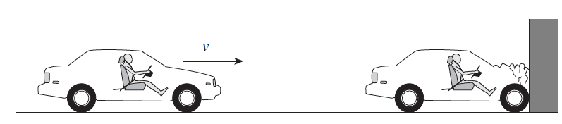

21. A 0.25 kg cart travelling at 3.0 m/s collides with and sticks to an identical stationary cart on a level track. (Ignore friction.) To what height h do the combined carts travel up the hill? (7 marks)

1. B
2. D
3. A
4. B
5. C
6. D
7. C
8. C
9. C
10. C
11. B
12. C
13. B
14. B
15. A
16. A
17. B
18. D
19. B
20. A
21. D
22. D
23. A
24. D
25. C
26. B
27. D
28. B
29. B
30. B
31. A
32. C
33. B
34. B
35. D
36. C
37. A
38. A
39. D
40. B
41. C
42. D

1. 52 m/s
2. a) Area under the graph = 0.90 J b) 7.7 m/s c) 20% or 0.2
3. a) 1380 J b) 580 J c) 0.42
4. a) First and last points should be close to the line, some points above and below the line.
b) area = 28 500 J
5. W = ∆E = ∆E_{k} (in this case) 1 mark
Ek = ½mv² (1 mark), so velocity changing by a factor of two will cause kinetic energy to change by a factor of four (1 mark) and so the work done will become ever greater as the velocity increases by uniform amounts. (1 mark)
OR
W = F•d (1 mark), but if the cyclist travels faster while exerting a constant force, for each uniform increment of velocity the distance travelled will become greater (1 mark) and greater. Hence W = F•d yields greater values for W as the distance becomes larger. (2 marks)
6. 1.85 x 10⁴ J
7. a) 26 m/s b) equal; This is a direct transfer of potential energy to kinetic energy. Both potential energy and kinetic energy have the mass term in them. If you increase the mass, both potential energy and kinetic energy increase by the same amount.
8. 38 m
9. a) speed at Y is less than the speed at X b) Point Y is at a higher location than X. ( ½ mark) The potential energy at Y is greater than the potential energy at X. (1 mark) Since total energy is constant (1 mark), the kinetic energy at Y is less than the kinetic energy at X. ( ½ mark)
10. 18 m/s
11. Conservation of momentum is a vector concept. As both of these gliders have the same mass and speed, the magnitude of their momentums is the same, but their directions are opposite. Thus one glider has a positive momentum, the other a negative. Therefore, the sum of the momentums before impact is ZERO. If momentum is conserved, then the sum of the momentums after the collision must also equal ZERO. After the collision, the two stationary gliders have a sum of ZERO momentum, and momentum has been conserved.
12. a) (i) 110 m/s (ii) 30 000 N•s b
b) Impulse is a force acting for a given time interval, or a change in momentum. (1 mark)
Newton’s Third Law states that for every force there is an equal and opposite reacting force. As the time of the explosion is equal for both the probe and the capsule, the impulse (F∆t) must be equal and opposite also. (3 marks)
OR
(ii) Impulse is equal to a change in momentum. As momentum is conserved, the momentum gained by the probe must equal the momentum lost by the capsule (3 marks)
13. 1 mark for diagram; 4.3 m/s; 7.9°
14. 3.0 m/s; 38° N of E
15. 2.1 m/s; 47°
16. 4.19 kg
17. 56 m/s; 42° N of E
18. 24.1 J
19. a) v_{(after the collision)} = 5.1 m/s; h = 1.3 m b) same height c) The steepness of the slope does not matter. All of the cars kinetic energy will be transferred to gravitational potential energy. Since the original kinetic energy of the cars has not changed, they must have the same potential. Therefore, they go to the same vertical height.

20. The crumpling of the automobile decreases the acceleration experienced by the occupants by increasing the distance to stop and/or increasing the time taken to stop. For increased distance: ∆E_{k} = F • d; increased distance deceases the F_{net}. For increases time: ∆p = F • ∆t; increased time deceases the F_{net}
21. 0.11 m

