Newton’s Laws
1. Unless acted on by an external net force, an object will stay at rest or
A. come to rest. B. decelerate at a constant rate.
C. slow down from a given speed. D. continue to move in a straight line at a constant speed.

2. A 65.0 kg block is being accelerated along a level surface. The applied force is 500 N and the friction force is 300 N. What is the coefficient of friction between the block and the surface?
A. 0.31 B. 0.47 C. 0.78 D. 1.30
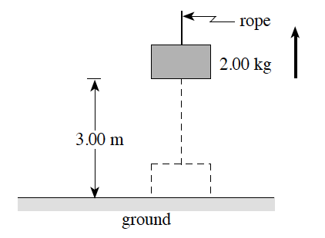
3. A 2.00 kg object, initially at rest on the ground, is accelerated vertically by a rope, as shown. The object reaches a height of 3.00 m in 1.50 s.

What is the tension in the rope during the acceleration?
A. 5.33 N B. 14.3 N
C. 23.6 N D. 24.9 N

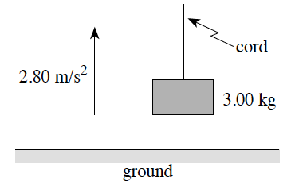
4. A 3.00 kg object is being accelerated vertically upwards at 2.80 m/s², as shown.

What is the tension in the cord?
A. 8.40 N B. 21.0 N
C. 29.4 N D. 37.8 N

5. An object is sliding down a smooth incline. If friction is negligible, the object has
A. constant velocity. B. constant momentum.
C. constant acceleration. D. constant displacement.

6. A constant force is applied to an object on a frictionless surface, as shown in the diagram below.

The resulting motion has
A. constant velocity. B. constant momentum.
C. constant acceleration. D. constant kinetic energy.

7. What is the frictional force due to air resistance on a 0.50 kg object falling vertically with an acceleration of 8.5 m/s² ?
A. 0.65 N B. 4.3 N C. 4.9 N D. 9.2 N
8. Force F gives mass m₁ an acceleration of 4.0 m/s². The same force F gives mass m₂ an acceleration of 2.0 m/s². What acceleration would force F give to the two masses m₁ and m₂ if they were glued together?
A. 1. 0 m/s² B. 1.3 m/s² C. 3.0 m/s² D. 6.0 m/s²

9. A 75 kg man stands on a scale while accelerating upwards in an elevator. If the scale reads 850 N, what is the magnitude of the acceleration of the elevator?
A. 1.2 m/s² B. 1.5 m/s² C. 9.8 m/s² D. 11 m/s²

10. A 45 kg toboggan and rider decelerate on level snow at 0.53 m/s². What is the coefficient of friction between the toboggan and the snow?
A. 0.012 B. 0.054 C. 0.22 D. 0.53

11. Which equation is a form of Newton’s second law?

A. ${\vec{F}}_{net}=\frac{\vec{∆p}}{∆t}$ B. W = ∆E C. E_{k} + E_{p} = E_{k}´+ E_{p}´ D. $ℇ=-N\frac{∆Φ}{∆t}$

12. Which of the following is not a statement of one of Newton’s laws of motion?
A. For every action force, there is an equal and opposite reaction force.
B. If no net force acts on an object, the object will remain at rest, or continue to move at a constant velocity.
C. The acceleration of freely falling objects is proportional to their mass.
D. If a net force does act on an object, the object will accelerate in the direction of the net force.
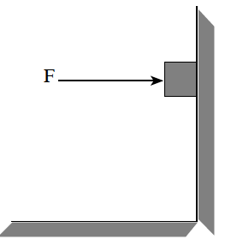
13. What minimum horizontal force F will just prevent the 5.0 kg block from sliding if the coefficient of friction between the wall and the block is 0.65?

A. 6.4 N B. 32 N
C. 49 N D. 75 N

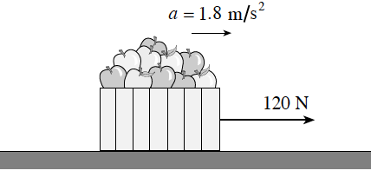
14. A student exerts a 120 N horizontal force on a 25 kg carton of apples, causing it to accelerate over level ground at 1.8 m/s².
Find the coefficient of friction between the carton and the ground.

A. 0.31 B. 0.38 C. 0.49 D. 0.67

15. A net force F acts on an object of mass m, causing it to accelerate at 4.0 m/s². If the same net force F acts on an object of mass 2m, its acceleration will be
A. 1.0 m/s² B. 2.0 m/s² C. 4.0 m/s² D. 8.0 m/s²

16. A 72 kg skydiver drops from a helicopter and is accelerating downwards at 8.6 m/s². Find the friction force acting on him.
A. 86 N B. 620 N C. 710 N D. 1 300 N
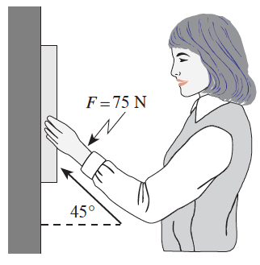
17. An artist must push with a minimum force of 75 N at an angle of 45° to a picture to hold it in equilibrium. The coefficient of friction between the wall and the picture frame is 0.30. What is the mass of the picture?

A. 1.6 kg B. 2.3 kg C. 3.8 kg D. 7.0 kg

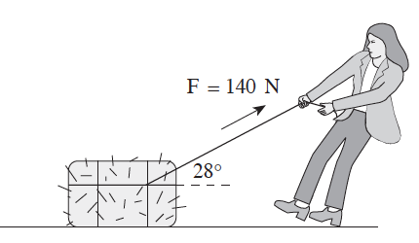
18. A girl applies a 140 N force to a 35 kg bale of hay at an angle of 28° above horizontal. The friction force acting on the bale is 55 N. What will be the horizontal acceleration of the bale?

A. 0.31 m/s² B. 2.0 m/s²
C. 2.4 m/s² D. 2.6 m/s²

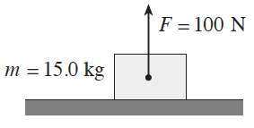
19. A 15 kg block on a horizontal surface has a 100 N force acting on it as shown. What is the normal force?

A. 47 N B. 100 N
C. 147 N D. 247 N

20. Which of the following graphs shows the relationship between acceleration and net force?
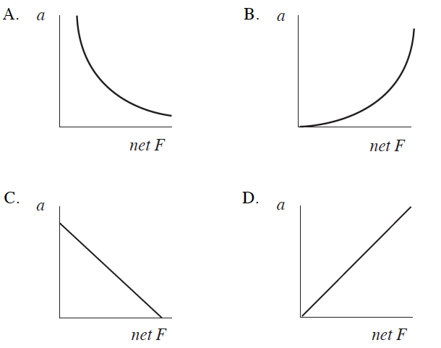

Written
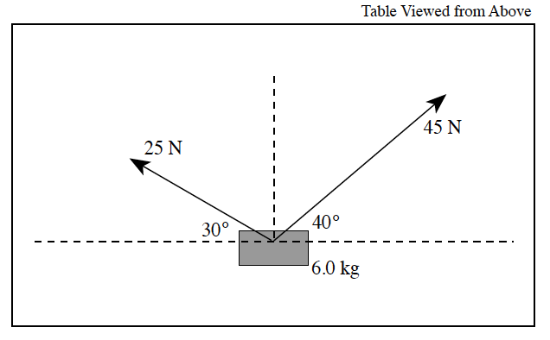
1. A 6.0 kg block is held at rest on a horizontal, frictionless air table. Two forces are pulling on this block in the directions shown in the diagram below.

What will be the magnitude of the acceleration on the 6.0 kg block at the moment it is released?
(7 marks)

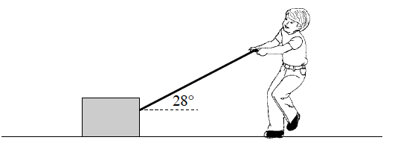
2. A 60 kg block rests on the ground. A student exerts a 320 N force on the block by pulling on a rope, but friction prevents the block from moving.

a) Draw and label a free body diagram showing all forces acting on the block. (2 marks)
b) Calculate the force of friction on the block. (2 marks)
c) Calculate the normal force exerted by the ground on the block. (2 marks)
d) Calculate the minimum coefficient of friction between the block and the ground. (1 mark)

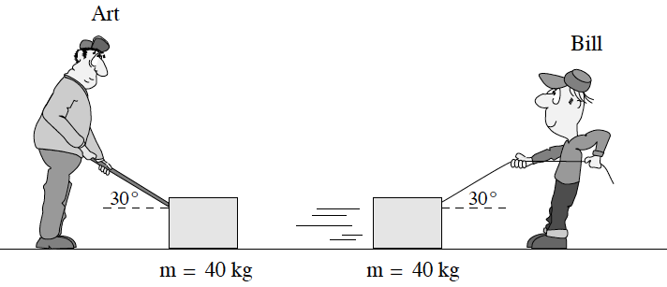
3. Art and Bill both attempt to move identical 40 kg crates across identical rough surfaces. Art exerts an 80 N force by pushing with a stick. Bill exerts an 80 N force by pulling on a cord. Bill’s crate slides across the ground, but Art’s will not move. Explain this observation, using principles of physics. (4 marks)

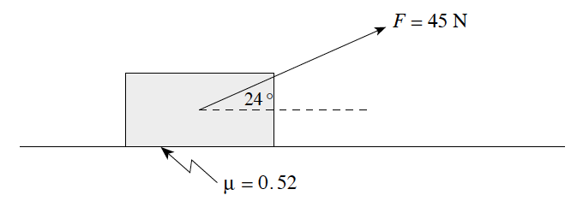
4. A student drags a 7.0 kg carton of apples across the floor by exerting a 45 N force in the direction shown. The coefficient of friction between the carton and the floor is 0.52.
a) What is the magnitude of the normal force acting on the carton? (2 marks)
b) What friction force acts on the carton? (2 marks)
c) What is the acceleration of the carton? (3 marks)

Inclines

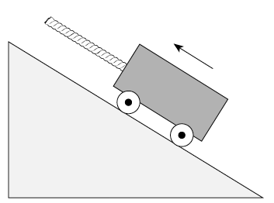
21. The diagram below shows a cart being pulled up a frictionless slope by a rope. Which of the following best represents the free body diagram for the cart?
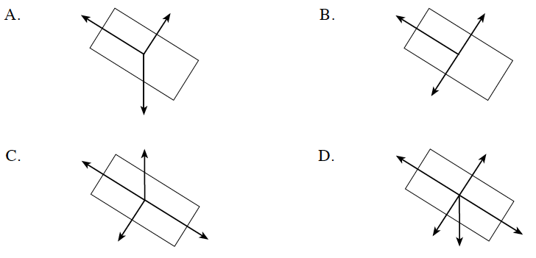

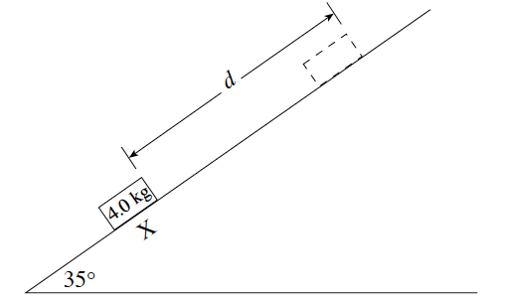
22. A 4.0 kg block has a speed of 9.0 m/s at X. What is the maximum distance, d, travelled by the block? Ignore friction.

A. 0.92 m B. 1.6 m
C. 4.1 m D. 7.2 m

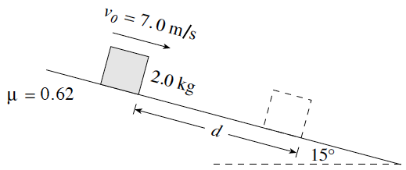
23. A 2.0 kg block is sliding down a 15° incline. The coefficient of friction is 0.62. At some position the block has a speed of 7.0 m s. What distance d will this block move before coming to rest?

A. 2.5 m B. 4.0 m C. 4.2 m D. 7.4 m
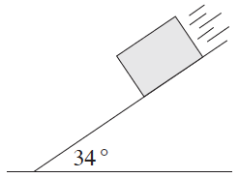

24. A 5.0 kg concrete block accelerates down a 34° slope at 4.2 m/s². Find the coefficient of friction between the block and the slope.

A. 0.13 B. 0.16 C. 0.43 D. 0.67

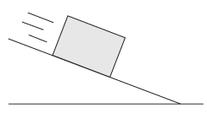
25. A block is on a frictionless incline. Which of the following is a correct free body diagram for the block?
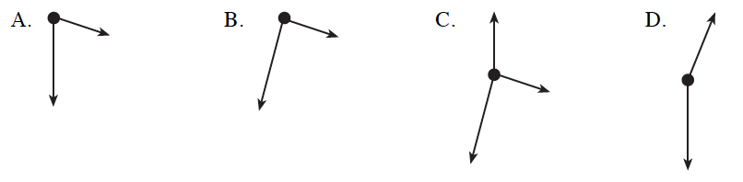

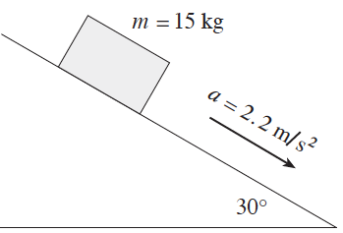
26. A 15 kg block has a constant acceleration of 2.2 m/s² down a 30° incline. What is the magnitude of the friction force on the block?

A. 33 N B. 41 N
C. 74 N D. 130 N

Written

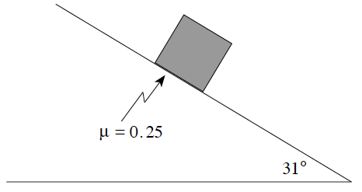
5. An 87 kg block slides down a 31° slope as shown in the diagram below. The coefficient of friction between the block and the surface is 0.25.

What is the acceleration of the block? (7 marks)

Connected Particles

27. Three masses connected by a light string are arranged on frictionless surfaces, as shown in the diagram below.
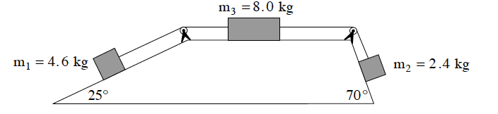
The strings pass over frictionless pulleys. Determine the acceleration of m₁ .
A. 0.20 m/s² up incline B. 0.20 m/s² down incline
C. 0.43 m/s² up incline D. 0.43 m/s² down incline
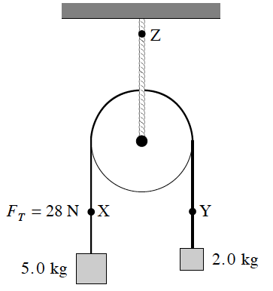
28. A massless, frictionless pulley is suspended by a rope. When the masses are allowed to accelerate, the tension in the string joining them is 28 N at X . What will the tension be at Y and at Z?
 | Tension at Y | Tension at Z
A | 20 N | 48 N
B | 20 N | 69 N
C | 28 N | 56 N
D | 28 N | 69 N
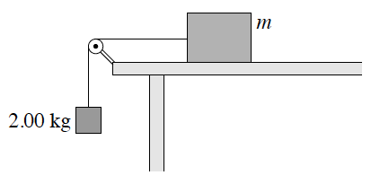

29. The frictionless system shown below accelerates at 1.60 m/s² when released. Find the tension in the string.
A. 3.20 N B. 16.4 N C. 19.6 N D. 22.8 N
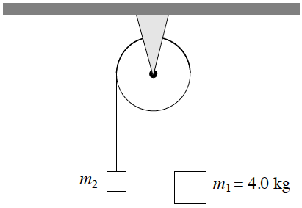
30. The tension in the string shown is 12 N. Find the acceleration of mass m₁.

A. 3.0 m/s² B. 6.4 m/s²
C. 6.8 m/s² D. 13 m/s²

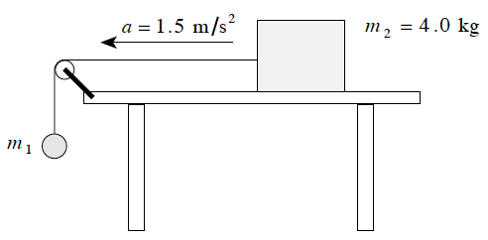
31. The 4.0 kg block shown accelerates across a frictionless horizontal table at 1.5 m/s².

Find the mass of object m₁.

A. 0.61 kg B. 0.72 kg
C. 6.0 kg D. 26 kg

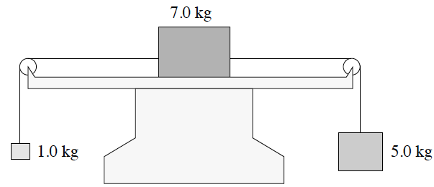
32. Three blocks have masses 1.0 kg, 7.0 kg and 5.0 kg as shown. The horizontal surface is frictionless. What is the magnitude of the acceleration of the system?

A. 3.0 m/s² B. 3.8 m/s²
C. 6.5 m/s² D. 7.8 m/s²

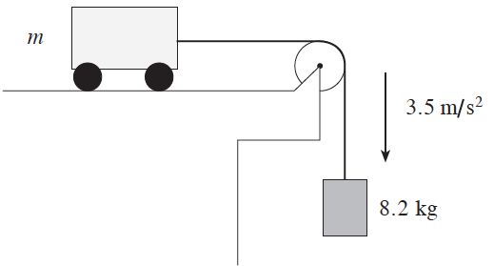
33. A cart on a frictionless surface is attached to a hanging mass of 8.2 kg. If this system accelerates at 3.5 m/s², what is the mass m of the cart?

A. 6.0 kg B. 15 kg
C. 23 kg D. 31 kg

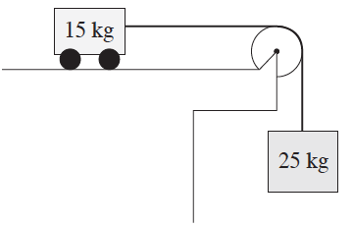
34. A 15 kg cart is attached to a hanging 25 kg mass. Friction is negligible. What is the acceleration of the 15kg cart?
A. 2.5 m/s² B. 6.1 m/s²
C. 6.5 m/s² D. 16 m/s²

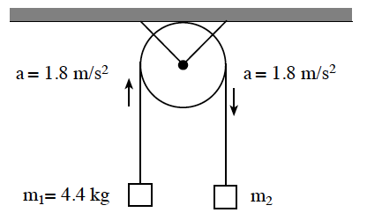
Written
6. The diagram shows a 4.4 kg mass connected by a string to an unknown mass over a frictionless pulley. The system accelerates at 1.8 m/s² in the direction shown.

a) Draw and label a free body diagram for the 4.4 kg mass. (2 marks)
b) Calculate the tension in the string. (2 marks)
c) Find mass m². (3 marks)

7. a) Amanda exerts a horizontal force of 180 N on a piece of rope causing two blocks of mass 20 kg and 40 kg to accelerate. Friction on the blocks is negligible. Find the tension force at X in the rope joining the two blocks together. (5 marks)
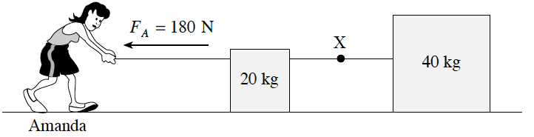
b) Bob exerts a force of equal magnitude in the opposite direction on an identical pair of blocks.
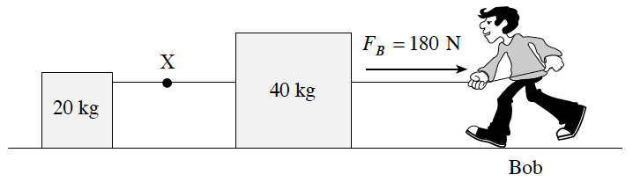
How does the tension force at X compare to the value in part a)? (1 mark)
The tension force is the same, greater than or less than.

c) Using principles of physics, explain your answer to part b). (3 marks)

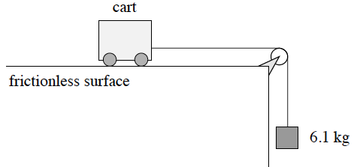
8. In the diagram shown, the tension in the cord connecting the hanging mass and cart is 43 N.
a) Draw and label a free body diagram for the cart and the hanging mass. (2 marks)
b) Determine the mass of the cart. (5 marks)

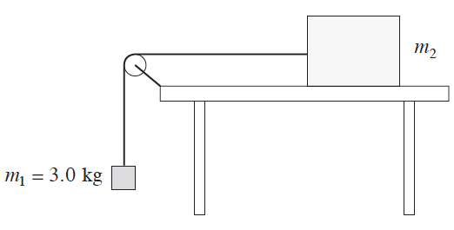
9. The diagram shows two objects connected by a light string over a frictionless pulley. Object m₂ is on a frictionless horizontal table. The tension in the string is 24 N.
a) Find the acceleration of the system. (4 marks)
b) Find the mass of m₂ . (3 marks)

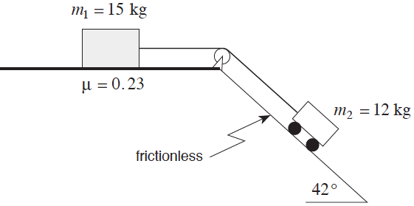
10. Two objects are connected as shown. The 12 kg cart is on a frictionless 42° incline while the 15 kg block is on a horizontal surface having a coefficient of friction µ = 0.23.
Determine the acceleration of the system of masses. (7 marks)

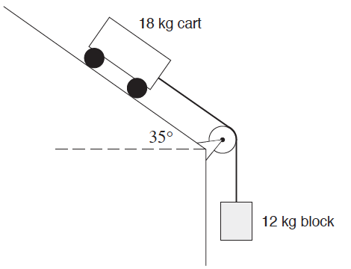
11. An 18 kg cart is connected to a 12 kg hanging block as shown. (Ignore friction.)

a) Draw and label a free body diagram for the 18 kg cart. (2 marks)

b) What is the magnitude of the acceleration of the cart? (5 marks)

Equilibrium
35. A 75 kg traffic light is held stationary midway between two supports, as shown in the diagram
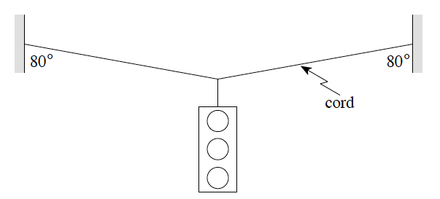
What is the tension in the cord?
A. 370 N B. 740 N C. 2100 N D. 4200 N

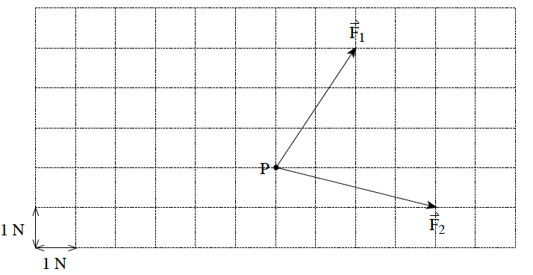
36. Two forces act at point P as shown.

Find the magnitude of the third force required to achieve equilibrium.

A. 4.5 N B. 5.5 N
C. 6.3 N D. 7.2 N

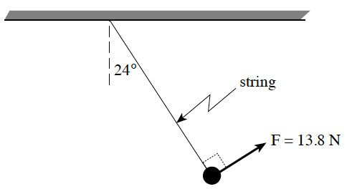
37. A mass suspended by a string is held 24° from vertical by a force of 13.8 N as shown. Find the mass.

A. 0.57 kg
B. 1.5 kg
C. 3.2 kg
D. 3.5 kg

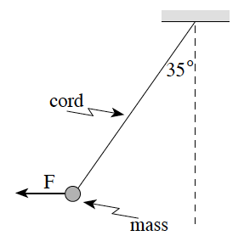
38. A mass of 5.0 kg is suspended from a cord as shown in the diagram below. What horizontal force F is necessary to hold the mass in the position shown?

A. 28 N B. 34 N
C. 40 N D. 70 N

39. Two forces, 12 N west and 5.0 N north, act on an object. What is the direction of a third force that would produce static equilibrium?
A. 23° south of east B. 23° north of west C. 67° south of east D. 67° north of west

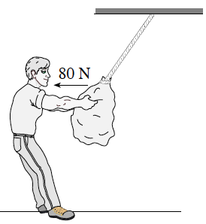
40. A 220 N bag of potatoes is suspended from a rope as shown in the diagram. A person pulls horizontally on the bag with a force of 80 N.
What is the tension in the rope?

A. 140 N B. 220 N
C. 230 N D. 300 N

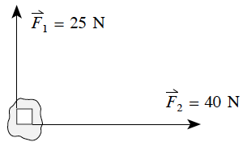
41. Two forces act on an object as shown. Find the magnitude of the third force required to achieve translational equilibrium.

A. 15 N B. 33 N C. 47 N D. 65 N

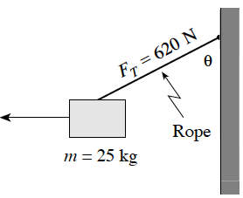
42. A 25 kg block is pulled by a horizontal force. The supporting rope can withstand a maximum tension force of 620 N. To what maximum angle, q, can the block be pulled without the rope breaking?

A. 22° B. 23° C. 67° D. 88°

43. An 85.0 kg mountaineer remains in equilibrium while climbing a vertical cliff. The tension force in the supporting rope is 745 N.
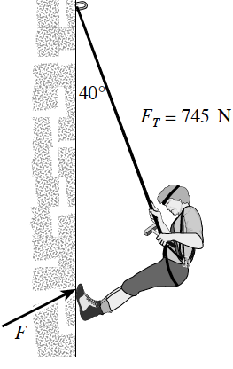
Find the magnitude of the reaction force, F, which the cliff exerts on the mountaineer’s feet.

A. 88.0 N B. 373 N C. 479 N D. 546 N

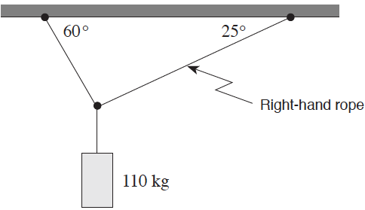
44. A 110 kg object is supported by two ropes attached to the ceiling. What is the tension T in the right-hand rope?

A. 460 N B. 540 N
C. 930 N D. 1 300 N

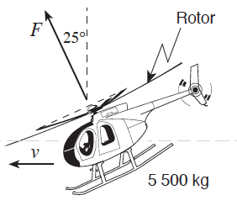

45. A 5 500 kg helicopter is travelling at constant speed in level flight. What is the force F provided by the rotor?

A. 4.9x10⁴ N B. 5.4 x10⁴ N
C. 5.9 x10⁴ N D. 1.2 x10⁵ N

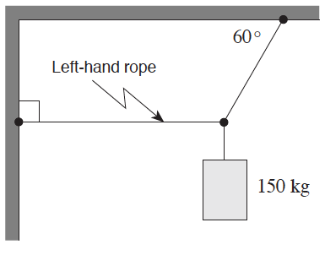
46. A 150 kg object is suspended from a ceiling and attached to a wall. What is the tension in the left-hand rope?

A. 7. 4x10² N B. 8.5x10² N
C. 1.3x10³ N D. 2.5x10³ N

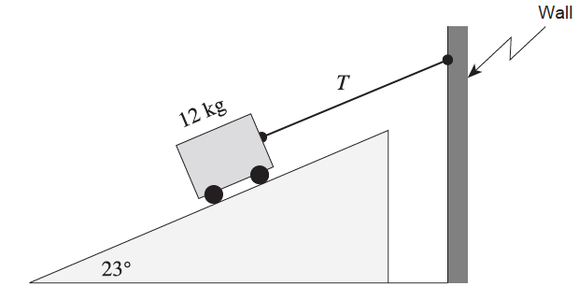

47. A 12 kg cart on a 23° frictionless incline is connected to a wall as shown. What is the tension T in the cord?

A. 46 N B. 50 N
C. 110 N D. 120 N
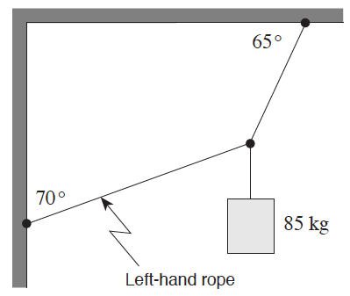
48. An 85 kg object is suspended from a ceiling and attached to a wall. What is the tension in the left-hand rope?

A. 280 N B. 350 N
C. 500 N D. 1 100 N

Written
12. A 750 N weight is supported by two ropes fastened together by a knot, as shown in the diagram below.
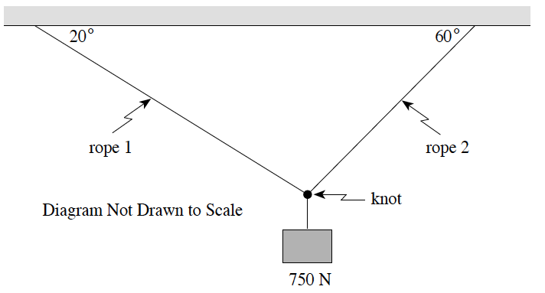
Diagram Not Drawn to Scale

a) Draw a free-body diagram showing the forces acting on the knot. (2 marks)
b) What is the tension in rope 1? (5 marks)

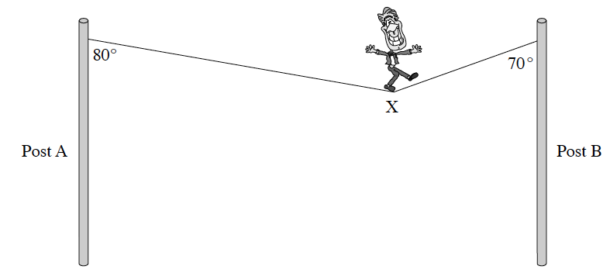
13. A circus performer walks across a wire stretched between two vertical posts. When the performer stands at position X as shown below, the tension in the short length of wire attached to post B is 1.8x10³ N .
a) Draw and label a free body diagram showing the forces acting at position X. (2 marks)
b) What is the mass of the circus performer? (5)
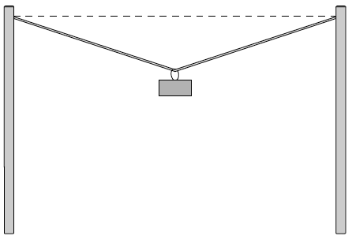

14. A wire is stretched between two posts. A mass is suspended near the centre as shown. If the tension in the wire were increased, is it possible to make the wire perfectly horizontal? Explain your answer in terms of forces. (4 marks)

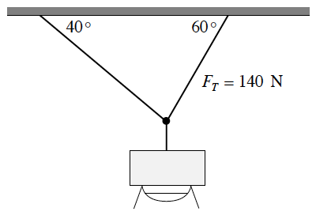
15. A floodlight is suspended from two cables as shown below. The tension in the right cable is 140N.

a) What is the tension in the left cable? (3 marks)
b) What is the mass of the floodlight? (4 marks)

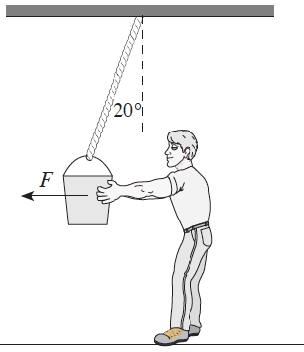
16. Peter exerts a horizontal force F on a 12 kg bucket of concrete so that the supporting rope makes an angle of 20° with the vertical.
a) Find the tension force in the supporting rope. (5 marks)
b) Peter now exerts a new force which causes the rope to make a greater angle with the vertical. How will the tension force in the supporting rope change? (1 mark)
c) Using principles of physics, explain your answer to b). (3 marks)

1. D
2. B
3. D
4. D
5. C
6. C
7. A
8. B
9. B
10. B
11. A
12. C
13. D
14. A
15. B
16. A
17. D
18. B
19. A
20. D
21. A
22. D
23. D
24. B
25. D
26. B
27. A
28. C
29. B
30. C
31. B
32. A
33. B
34. B
35. C
36. C
37. D
38. A
39. A
40. C
41. C
42. C
43. D
44. B
45. C
46. B
47. A
48. C

1. 7.2 m/s²
2. a) 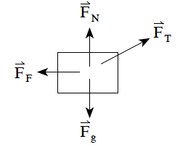 b) 283 N c) 438 N d) 0.65
3. When Art exerts a force on the crate there is a downward component which must be opposed; there is therefore a large normal reaction force. When Bill exerts a force there is an upward component which means the normal reaction force will be small. As the force of friction depends on the normal reaction force F_{F} = µF_{N}, Art encounters a large friction force and he is unable to move the crate. Bill, however, is able to move his crate because the friction force is small.
4. a) 50.3 N b) 26.2 N c) 2.1 m/s²
5. FBD (2 marks), 2.9 m/s²
6. a) 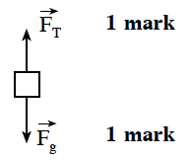 b) 51.0 N c) 6.38 kg
7. a) a = 3.0 m/s²; 120 N b) less than c) In both situations the total mass is the same so both systems accelerate at the same rate. In b) the tension must accelerate a smaller mass at the same rate hence, from Newton’s second law, F = ma, a smaller tension force will cause this.
8. a) 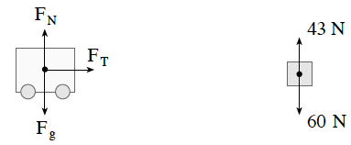 b) 16 kg
9. a) 1.8 m/s² b) 13.3 kg
10. 1.7 m/s²
11. a) 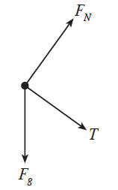 b) 7.3 m/s²
12. 381 N
13. a) 2 marks for vector triangle; b) 93 kg
14. No, it is not possible to make the wire perfectly horizontal. Since the mass has a vertical force of gravity acting on it, the tension in the wire must have an opposite vertical component. A horizontal tension has no vertical component; therefore, it is not possible to make the wire perfectly horizontal.
15. a) 91.4 N; b) 18.4 kg
16. a) 125 N b) Tension will increase c) The vertical component of the tension is equal to the weight and is unchanged. Peter’s horizontal force increases with a larger angle. The horizontal component of the tension is equal to Peter’s and therefore is also increased. Thus, the resultant tension is increased.

