Vectors

1. Which one of the following is a vector quantity?
A. time B. speed C. energy D. displacement

2. A car is travelling at a constant speed of 26.0 m/s down a slope which is 12.0° to the horizontal. What is the vertical component of the car’s velocity?
A. 5.41 m/s B. 9.80 m/s C. 25.4 m/s D. 26.0 m/s
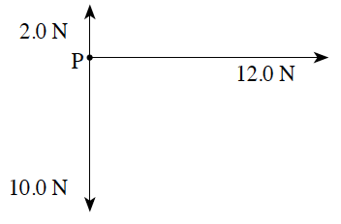
3. Three forces act at point P at the same time, as shown on the force vector diagram below.

What is the magnitude of the resultant force vector?
A. 14.4 N B. 17.0 N C. 20.0 N D. 24.0 N

4. Initial velocity vector ν0 and final velocity vector ν are shown below.
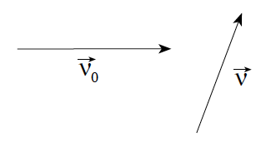
Which of the following represents the change in velocity Δν ?
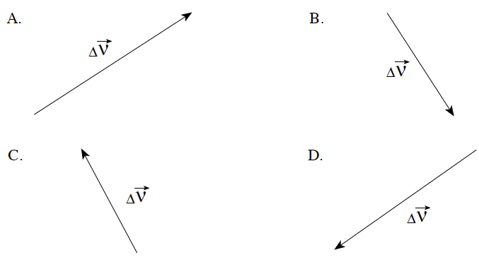

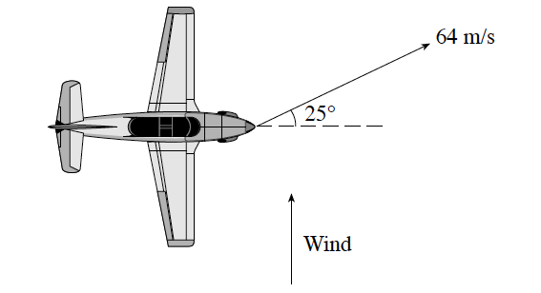
5. A pilot points an aircraft due east, while the wind blows from the south.

The resultant velocity of the aircraft over the ground is 64 m/s, 25° N of E . At what speed does the wind blow?

A. 2.6 m/s B. 27 m/s C. 30 m/s D. 58 m/s

6. An airplane which was flying eastward is later flying southward at the same speed. Which vector shows the airplane’s change in velocity?
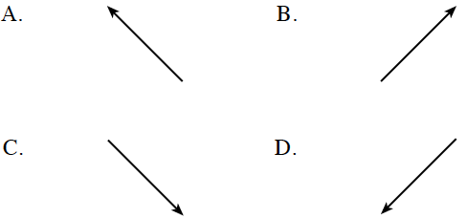
7. Two forces act on an object as shown in the diagram.
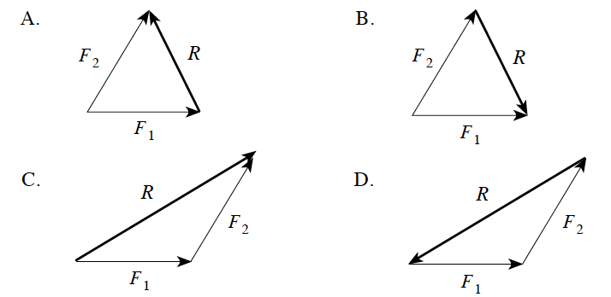
Which of the following best shows the resultant R of these forces?
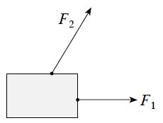

8. Pamela swims at 2.8 m/s relative to the water, heading west. The current flows south at 1.2 m/s. Find Pamela’s resultant direction.
A. 23° S of W B. 25° S of W C. 23° N of W D. 25° N of W

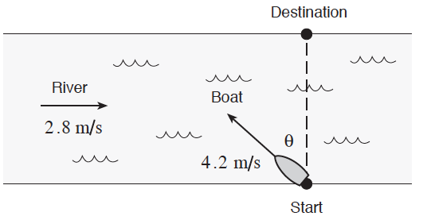
9. A boat shown below travels at 4.2 m/s relative to the water, in a river flowing at 2.8 m/s. At what angle Ø must the boat head to reach the destination directly across the river?

A. 34° B. 42° C. 48° D. 56°

10. A car travelling north at 20 m s is later travelling west at 30 m s. What is the direction of the change in velocity?
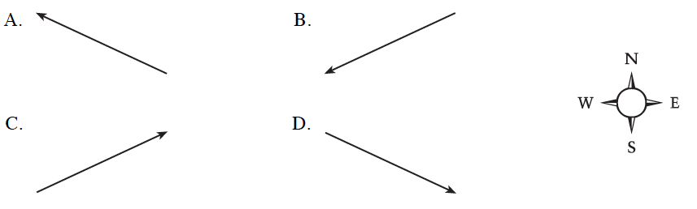

Written
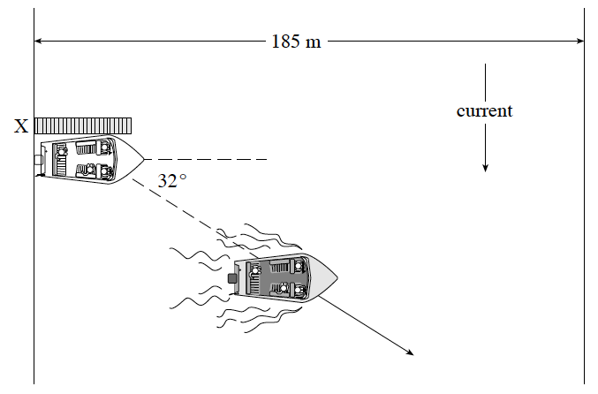
1. A boat which can travel at 5.6 m/s in still water heads due east across a river from a dock at X. The boat’s resultant path is 32° south of east.

a) What is the speed of the current (5 marks)

b) How long will it take the boat to reach the far shore if the river is 185 m wide? (2 marks)

Kinematics

11. A passenger jet needs to reach a speed of 100 m/s on the runway for takeoff. If the runway is 2.5 x 10³ m long, what minimum average acceleration from rest is needed?
A. 0.040 m/s² B. 2.0 m/s² C. 4.0 m/s² D. 10 m/s²

12. At what speed must a ball be thrown upwards to reach a maximum height of 25 m?
A. 2.6 m/s B. 22 m/s C. 2.5 x 10² m/s D. 3.1 10³m/s

13. A skier accelerates uniformly from 5.2 m/s to 12.8 m/s at 0.85 m/s². Find the distance she travels.
A. 7.7 m B. 8.9 m C. 11 m D. 80 m

14. Starting from rest, a jet takes 25 s and needs 1 500 m of runway to become airborne. What is its speed when it leaves the ground?
A. 60 m/s B. 120 m/s C. 250 m/s D. 1 500 m/s

15. When a 2.0 kg rock is dropped from a cliff it hits the beach at 24 m s. At what speed would a 4.0kg rock, dropped from the same cliff, hit the beach? Ignore friction.
A. 12 m/s B. 24 m/s C. 34 m/s D. 48 m/s

16. A motorcycle accelerates uniformly from 12 m/s to 30 m/s while travelling 420 m. Its acceleration is
A. 0.043 m/s² B. 0.050 m/s² C. 0.10 m/s² D. 0.90 m/s²

17. The slope of a velocity vs time graph represents the object’s
A. mass. B. momentum. C. acceleration. D. displacement.

18. A ball is thrown vertically upward at 20 m/s from a height of 30 m above the ground. What is its speed on impact with the ground below?
A. 14 m/s B. 24 m/s C. 31 m/s D. 44 m/s

Projectiles

19. Which one of the following best describes the motion of a projectile close to the surface of the Earth? (assume no friction)
 | Vertical Acceleration | Horizontal Speed
A. | constant | constant
B. | constant | changing
C. | changing | constant
D. | changing | changing

20. A ball is rolled off a horizontal roof at 16 m/s. After leaving the roof, how long will the ball take to reach a speed of 18 m/s?
A. 0.20 s B. 0.84 s C. 1.8 s D. 2.5 s

21. A projectile is launched over level ground with a speed of 240 m/s at 35° to the horizontal. If friction is negligible, what is the height of the projectile 17 s after launch?
A. 9.2×10² m B. 1.9×10³ m C. 2.7×10³ m D. 5.5×10³ m

22. If friction is negligible, which of the following is true for the velocity components of projectiles?
 | HORIZONTAL COMPONENT | VERTICAL COMPONENT
A | constant | constant
B | constant | changes
C | changes | constant
D | changes | changes

23. Which of the following graphs represents the horizontal velocity component (v_{x}) versus time for a projectile thrown horizontally off a cliff? (Ignore air resistance.)
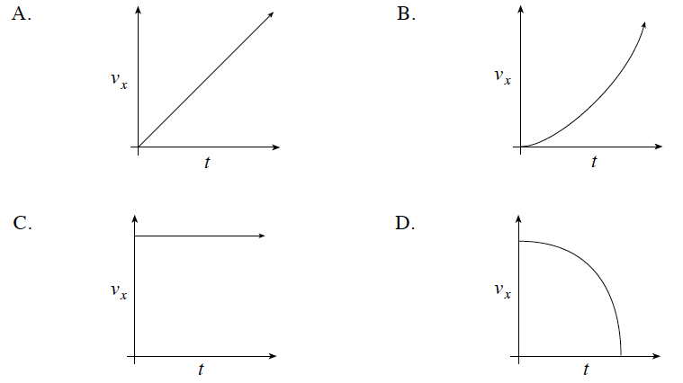

24. A projectile is launched over level ground at 35 m/s at an angle of 40° above the horizontal. What is the projectile’s time of flight?
A. 2.3 s B. 4.6 s C. 5.5 s D. 7.1 s

25. Which of the following remain(s) constant for a projectile: its horizontal velocity component, v_{H} , its vertical velocity component, v_{V} , its vertical acceleration, g?
A. v_{V} B. g and v_{V} C. g and v_{H} D. g, v_{H} and v_{V}
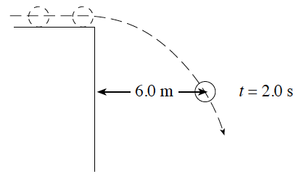
26. At t = 0 s a ball rolls off the edge of a vertical cliff. At t = 2.0 s the ball is 6.0 m from the cliff.
How far is the ball from the cliff at t = 4.0 s?

A. 6.0 m B. 9.0 m C. 12 m D. 24 m

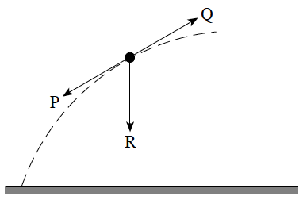
27. The projectile shown has an acceleration which is

A. zero.
B. in the direction of P.
C. in the direction of Q.
D. in the direction of R.

28. An object is launched at 65° to the horizontal with an initial speed of 25 m/s. What is the maximum height reached by this object?
A. 5.7 m B. 26 m C. 32 m D. 150 m

29. A ball is thrown from level ground at 24 m/s, 30° above horizontal. How much time will it take to reach its maximum height?
A. 1.2 s B. 2.1 s C. 2.4 s D. 7.3 s

30. A ball is kicked into the air from the surface of a playing field. If friction is negligible, the ball will follow a path that is
A. circular. B. elliptical. C. parabolic. D. hyperbolic.

31. A rock is thrown from ground level at 18 m/s, 25° above horizontal. What are the vertical and horizontal components of its launch velocity?
 | horizontal component | Vertical component
A | 7.6 m/s | 16 m/s
B | 16 m/s | 7.6 m/s
C | 9.3 m/s | 20 m/s
D | 20 m/s | 9.3 m/s

32. An object is launched over level ground at 35° above the horizontal with an initial speed of 52 m/s. What is the time of flight?
A. 5.3 s B. 6.1 s C. 8.7 s D. 11 s

Written
2. A 1.50 kg projectile is launched at 18.0 m/s from level ground. The launch angle is 26.0° above the horizontal. (Assume negligible friction.)
a) What is the maximum height reached by this projectile? (5 marks)
b) How fast will the projectile be travelling when it is at its maximum height? (2 marks)

3. The diagram below shows projectile motion in the absence of friction.
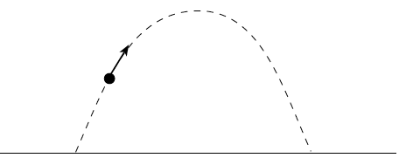
This motion can be analyzed in terms of horizontal and vertical velocity components. Explain the behavior of these velocity components, using principles of physics . (4 marks)

4. A projectile is launched over level ground at 35 m/s at an angle of 24° above the horizontal. Friction is negligible.
a) What is the time of flight of this projectile? (3 marks)
b) What is the velocity (magnitude and direction) of this projectile 2.5 s after launch? (4 marks)

5. A soccer ball is kicked over level ground with an initial velocity of 18 m/s, 24° above the horizontal.
a) How long does it take the ball to return to the ground? (4 marks)
b) What is the range of the ball? (3 marks)

6. A projectile is launched over level ground at 85 m s, 25° above the horizontal. Air resistance may be ignored.
a) Calculate the range (horizontal distance) of the projectile. (5 marks)
b) Using principles of physics, comment on the horizontal and vertical components of the projectile’s velocity and acceleration during the flight. (4 marks)
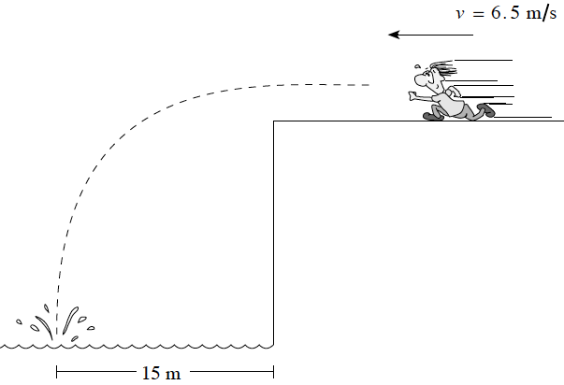

7. Mike runs horizontally off a cliff at 6.5 m s and lands in the water 15 m from the base of the cliff.

a) How long does it take Mike to hit the water? (3 marks)

b) How high is the cliff? (4 marks)

8. A rock is thrown from a clifftop at 18 m/s, 25° above the horizontal. It lands on the beach 4.2 s later.
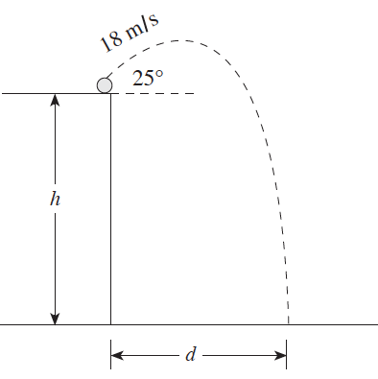

a) What is the height h of the cliff? (4 marks)
b) How far from the base of the cliff d did the rock land? (3 marks)

9. A student collects data from the path of a projectile similar to that shown in the diagram. The student records the following data for horizontal displacement from the initial launch position as a function of time.

a) Plot a graph of dx vs. t. (2 marks)
b) Calculate the slope of the line, expressing the answer in appropriate units. (2 marks)
c) Based on the graph, make a statement about the behaviour of projectiles. (1 mark)

dx (cm) | 0.0 | 0.5 | 0.9 | 1.5 | 1.9 | 2.5 | 3.1
t (s) | 0.000 | 0.020 | 0.040 | 0.060 | 0.080 | 0.100 | 0.120

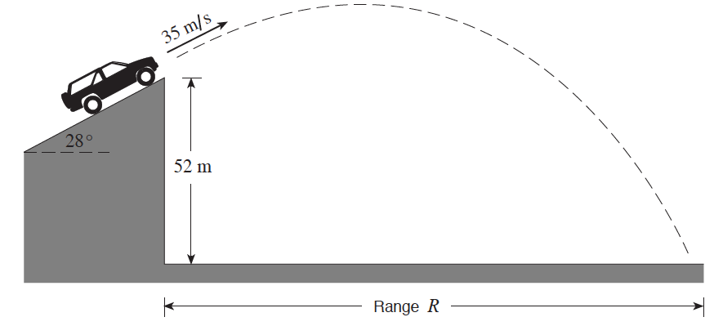
10. A stunt vehicle leaves an incline with a speed of 35 m s at a height of 52 m above level ground. Air resistance is negligible.

a) What are the vehicle’s vertical and horizontal velocity components as it leaves the incline? (1 mark)
b) What is the vehicle’s time of flight? (4 marks)
c) What is the vehicle’s range, R ? (2 marks)

Answers

1. D
2. A
3. A
4. C
5. B
6. D
7. C
8. A
9. B
10. B

11. B
12. B
13. D
14. B
15. B
16. D
17. C
18. C

19. A
20. B
21. A
22. B
23. C
24. B
25. C
26. C
27. D
28. B
29. A
30. C
31. B
32. B

1. a) 2 marks for vector triangle; 3.5 m/s b) 33 s
2. a) 3.18 m b) 16.2 m/s
3. The horizontal velocity component is constant. (1 mark) The vertical velocity component constantly changes. (1 mark) This vertical acceleration is caused by the force of gravity. (1 mark) The downward direction of the ∆ velocity / acceleration / force must be mentioned. (1 mark)
4. a) 2.9 s b) v_{x} = 32.0 m/s; v_{y} = 10.3 m/s down; v = 34 m/s; 18° below horizon
5. a) 1.49 s b) 25 m
6. a) 560 m b) The horizontal component of velocity remains constant. There is no horizontal acceleration (assuming air resistance is negligible). (2 marks) The vertical component of velocity changes continuously during the flight. (1 mark) The vertical acceleration is constant at 9.8 m/s², downward, throughout the flight. (1 mark)
7. a) 2.3 s b) 26 m
8. a) 54 m b) 69 m
9. a) some points must be above AND below the line. b) 25 cm/s c) straight line means horizontal speed is constant.
10. a) v_{0x} = 30.9 m/s, v_{0y} = 16.4 m/s b) 5.3 s c) 165 m

