Physics 11 — Kinematics

1.1 — Graphing Motion

Kinematics is the study of motion without reference to forces and masses.
We will need to learn some definitions:

A Scalar quantity is a measurement that has a magnitude only: mass, distance, speed, energy, time…

A vector quantity is a measurement that has a magnitude and a direction: position, displacement, velocity, acceleration, Force…

Distance (d) is a measure of the separation between two points. It does not include a direction, only the magnitude of the distance.
Distance (d) is a scalar quantity.

Distance (d) can also be a measure how far an object has moved over a period of time. This is also a scalar quantity.

Position (P or 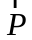)is a vector quantity.
(Note the use of bold or an arrow)
It is a measurement of the distance of an object from a reference point, and the direction of the object from the reference point.
The direction can be indicated with words or algebraic signs.
The position of -6 on the standard number line can be given as “-6” or “6 to the left”.

Displacement (d, or ) is a vector quantity.
(Note the use of bold or an arrow)
Displacement is a change in position. It is calculated by taking the final position of an object, and subtracting the initial position of the object.
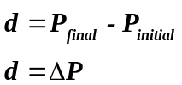
Example 1:
- 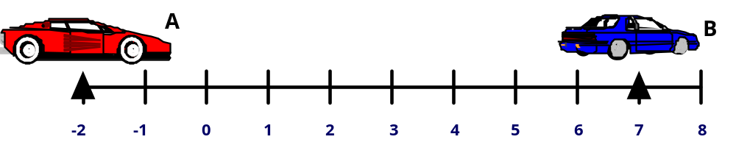What is the distance from the origin to A? From the origin to B?

- What is the distance from A to B? B to A?

- What is the position of A? of B?

- What is the displacement of A as measured from B? of B measured from A?

Motion can be described by graphing the position of an object on the y-axis, and the time for that position on the x-axis.
This is called a displacement time graph because it describes displacement over time.
(Note: most graphs involving displacement and time, and velocity and time have time on the x-axis.)

Ex 2: Find the position of the swimmer for the following times:
- 2 s

- 6 s
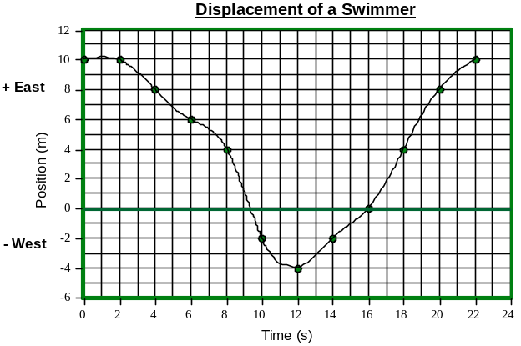

- 10 s

- 16 s

- 22 s
Ex 3: Find the distance traveled and the displacement for the following:
- 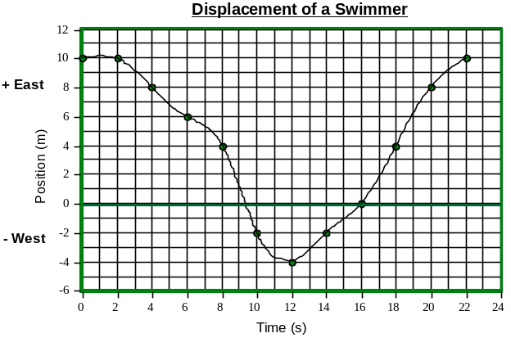2 s to 6 s

- 8 s to 18 s

- 12 s to 20 s

- 0 s to 22 s

Speed (v) is the rate of change of distance with time. It is a scalar quantity.
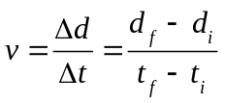
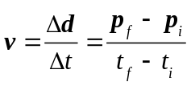Velocity is the rate of change of displacement with time. It is a vector quantity. The answer must include a direction.

Example 4:
For the times in example 3, calculate the speed and velocity of the swimmer.
Remember to include the direction in the velocities.

The slope of a displacement time graph is the velocity. (vector)
If the graph produces a straight line, the slope will be constant throughout the motion of the object.
This is uniform motion.
Uniform motion has a constant velocity, and produces a straight line on a displacement time graph.

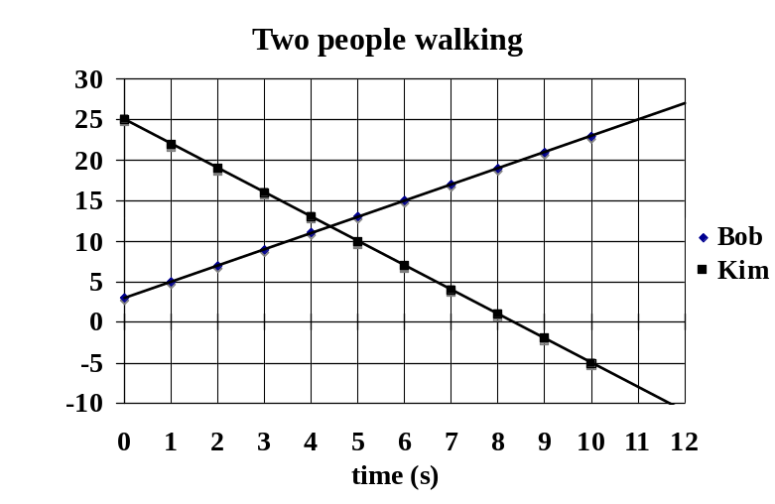Consider the graph shown:
Ex 5:
What are the velocities of Bob and Kim?

Describe what this motion would look like.

When do these two people pass each other?

Ex 6:

Sketch a graph that shows a person walking at 2.0 m/s towards a reference point. This person started walking 10.0 m away from the reference point.
Show another person walking half as fast, in the opposite direction that passes the first person at the reference point.

Assignment
p. 39: 9, 11, 13, 15, 17
p. 45: 25, 27
p. 47: 29, 31
pp. 52-53: 46, 47, 54, 56, 60, 64

1.2 Velocity Calculations
The slope of a position time graph is velocity. Velocity equals displacement divided by the time elapsed.
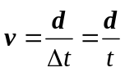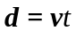
Speed is similar to velocity, however, it is a scalar quantity, and is the change in distance divided by elapsed time. Speed and velocity may be equal in magnitude.

Ex 1:
A runner completes one lap of a circular track (r = 85 m) in 135 s. What is the runners speed? Velocity?

Solving a problem mathematically is a logical process. Present logical steps in your solution that can be followed easily
- Use diagrams
- Choose a frame of reference.
- Write formulas you will use.
- State assumptions.
- Do not skip major steps.
- Include units in your work.
- Present your work clearly.

Ex 2:
A driver travels 250 m in 10.0 s, and then travels the next 250 m in 8.0 s. What is the velocity in each half of the trip? What is the average velocity?

Ex 3: The same needs to travel 5000 m with a velocity of 15 m/s. The first 2500 m is traveled at 10 m/s. What must the velocity of the second 2500 m be to average 15 m/s?

If the first half were completed at 8.0 m/s?
If the first half were completed at 5.0 m/s?

This relationship is most useful when velocity is constant. This would give us a straight line graph, with which we can perform simple calculations.

Ex 4:
What velocity must you maintain (in m/s) to travel 350 km in 4.5 hours?

Ex 5:
The speed of sound is 340 m/s. A person hears on echo of their voice 3.5 s after they speak. How far away is the barrier that is causing the echo?

Ex 6:
A farmer in a field is 750 m away is hammering nails. How much time will elapse from when the light from the strike and the sound from the strike reaches the observer?

Assignment:
pp. 53-54: 49-53, 55, 62

1.3 Velocity time graphs
A velocity vs. time graph is another tools to describe motion.
The y-axis is velocity and the x-axis is time.
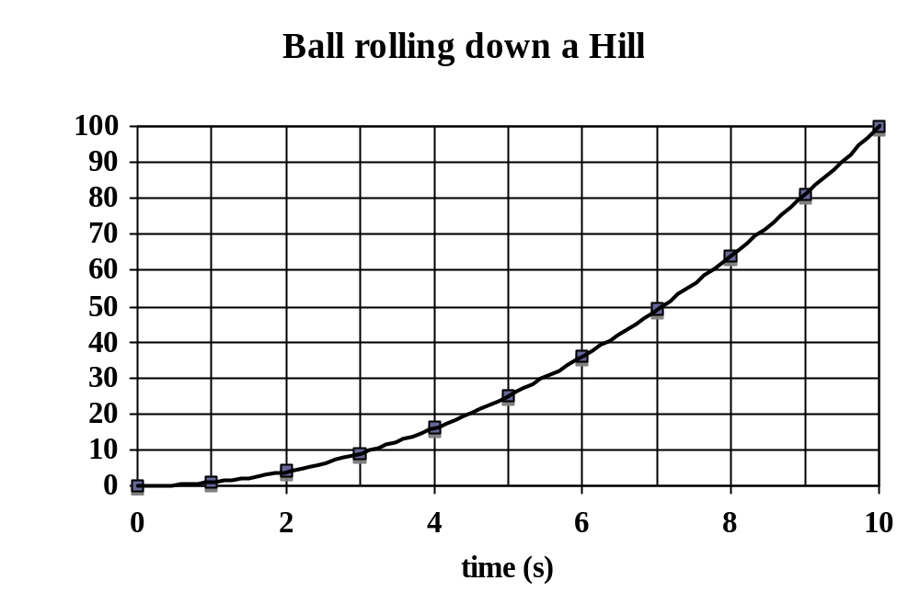We will examine one example of creating a velocity - time graph and how it is used to describe motion.

What is the velocity of this object?
Describe this motion.

To find the velocity at a specific time, we need to find the instantaneous velocity. To do this, we must draw a tangent to the curve at a certain time.
The slope of this tangent is the v_{inst.}

Find the instantaneous velocity at five different times on the graph shown.

Plot these five velocities, and their times on a new velocity time graph.
Find the slope of this graph.
The slope of this graph represents how the velocity is changing with time. This is called acceleration.


Acceleration is a vector quantity
measured in m/s^{2.}

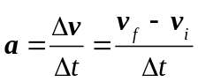

The slope of a graph can give us useful information from a graph.

The other operation we can perform on a graph is to find the area under the line. (The area from the x-axis to the line.)
For a velocity time graph this area represents displacement.
Find the area under the curve from t = 0 s to 8.0 s. Compare this displacement to the original curve.

Ex 1: Given the following position time data, construct a displacement time graph and a velocity time graph.
Find the displacement from the velocity time graph and compare to the data.
(Note: a line below the x-axis has a negative area.)
Position (m) | 2 | 2 | 2 | 3 | 4 | 5 | 6 | 4 | 2 | 0
Time (s) | 0 | 1 | 2 | 3 | 4 | 5 | 6 | 7 | 8 | 9



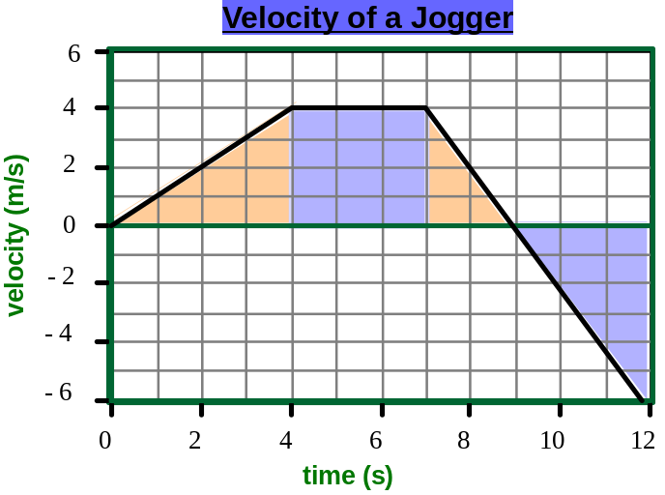
Ex 2: For the following graph, describe the motion, and calculate the displacement.
Ex 3: For the following graph, describe the motion, and calculate the displacement.

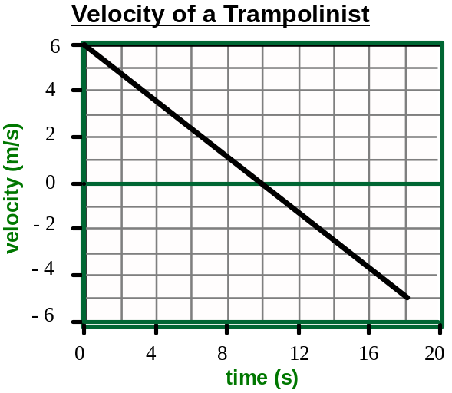
Straight line velocity time graphs represent uniform (constant) acceleration. A curved velocity time graph shows changing acceleration.

Instantaneous acceleration can be found through a tangent to the curve.
Ex 4: Describe the motion, and sketch a reasonably shaped velocity vs. time graph:
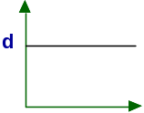a)

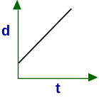b)

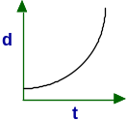c)

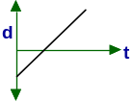d)

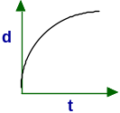
e)

Ex 5: Describe the motion, and sketch a reasonably shaped d vs. t graph:
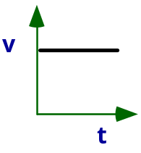a)

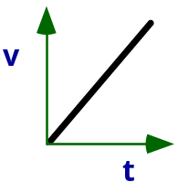b)

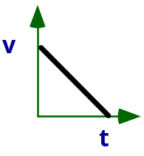c)

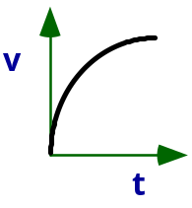
d)

Assignment:
p. 61, # 3, 5
p. 67, # 23-25
p. 71, # 31
pp. 80-82, # 56, 57, 71, 73, 74, 82, 83, 87

1.4 — Kinematics Calculations I
There are several kinematic equations that we will use to solve equations.
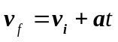Acceleration equals the slope of a velocity time graph.
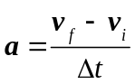
This relationship requires constant acceleration.

Ex 1:
A car can accelerate at a constant 2.5 m/s². How long will it take to accelerate from 10.0 km/h to 50.0 km/h?

A second relationship can be derived from the area under a velocity time graph.
The displacement is the area of the trapezoid.
v_{f}

v_{av}

v_{i}

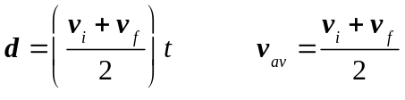

t

This relationship is only true because of constant acceleration.
Why does this calculation does not work for the average speed questions from the previous day? (10 km/h for first lap, 20 km/h for second lap)

What does this equation become if velocity is constant?
Ex 2:
What time is required for a car to accelerate from 25 m/s to 45 m/s over a distance of 280 m?

Ex 3:
A ball is rolled up an incline where the acceleration is 2.0 m/s² down the incline. The ball is rolled with an initial velocity of 5.5 m/s. What is its velocity as it reaches its highest position? How long does it take to get to this position?

Ex 4:
A Bike is pedaled at constant velocity of 18 km/h for 15 minutes. After that time, for 45 s the bike is accelerated until it hits a wall at a velocity of 25 km/h. What is the total displacement of the bike for this time?

Assignment:
pp. 64-65, # 7, 9, 11, 19, 21
p. 69, # 27, 29
pp. 80-82, # 55, 58, 80, 81, 84-86

1.5 — Kinematics Calculations II
The area under this velocity time graph can be calculated from
v_{f}
the area of a rectangle and the area of a triangle.

v_{i}

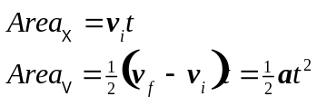

t

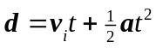These combine to make:

This equation assumes that the acceleration is constant.
It also is a vector equation with displacement, velocity, and acceleration all vector quantities.

Ex: 1
A car is traveling at 23 m/s. The driver presses the gas for 10.0 s to accelerate the car at 1.8 m/s². What is the displacement of the car during the 10 s ?

Ex 2:
The same car is traveling along a road at 50.0 km/h. A cat runs into the road. The driver takes 0.75 s to react and press the brake. The car decelerates at 6.5 m/s². How far does the car travel in 2.00 s. (from the time the cat ran into the road.)
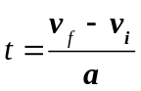If is substituted into:

The equation can be manipulated to give:
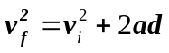This derivation will probably show up as a bonus question somewhere.

This equation must be used carefully.
A vector that is squared loses its directional information. Therefore, you must be aware of directional information when this equation is used to solve a question.
(We will come upon a better source for this equation.)

Ex 3:
An airplane must reach a velocity of 135 m/s to take off. If It can accelerate uniformly at 3.7 m/s², what length of runway is required?

Ex 4:
A ball is rolled up an incline with an initial velocity of 3.5 m/s. The acceleration of the ball is 1.5 m/s² down the ramp. What is the velocity of the ball when it it 2.0 along the ramp from its initial position?

We will solve this using two approaches.

Ex 5:
A motorcycle is sitting at a red light. Just as the motorcycle starts to accelerate, a car passes it traveling at a constant 35 m/s. If the motorcycle can accelerate at a constant 6.5 m/s², how long does it take for the motorcycle to pass the car?

p. 71, # 33
pp. 82-83, # 88-95, 109-114

1.5 — Vertical Motion
A special subset of kinematics is motion of objects near the surface of the earth.
The earth exerts a gravitational field due to its mass. At the earth’s surface, this gravitational field will accelerate objects at 9.8 m/s². The direction of this acceleration is towards the center of the earth.
For now, we will restrict ourselves to very simplified examples.
Our simplifying assumptions:
- Near the surface of the earth.
- No air resistance or other friction.
- No initial velocity in a horizontal direction. (explored later)
- Only force acting on the object during the time in question is gravity (so acceleration = 9.8 m/s²)
Ex 1:
Sketch a velocity time graph and a displacement time graph for:
Object dropped from a stationary start.
Object tosses vertically in the air with a positive initial velocity and lands at the same height.

For (b), what are the implications for initial and final velocity and time?
Ex 2:
Estimate the time that Dwayne Wade (a basketball player) spends in the air if he jumps vertically straight up as high as he can.
How high would be have to jump to stay in the air that amount of time?

Ex 3:
A stone is dropped from a bridge. It falls for 2.35 s before hitting the water. How high is the bridge? What is the velocity of the stone just as it hits the water?

Ex 4:
A ball is thrown vertically upwards from a 10.0 m tall building with a velocity of 5.0 m/s. How much time passes before the ball hits the ground? What is its velocity just before it hits the ground?

What is the final velocity if it is thrown downward at 5.0 m/s?

Ex 5:
A balloon is released and rises at a constant velocity of 3.0 m/s. 10.0 second later, a stone is fired with a slingshot, at 35 m/s straight up at the balloon. The stone misses the balloon. When is the stone at the same height as the balloon?

Assignment
p.74, # 43, 45
pp. 81, # 76, 77, 96-102, 107, 115

