Lab Safety and Equipment

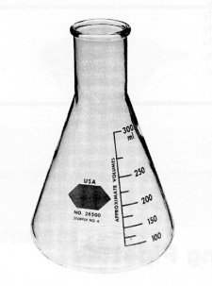 | 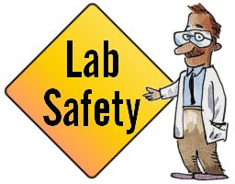 | 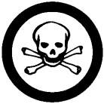

Name: ____________________
Block: _____
WHMIS Symbols

WHMIS stands for Workplace Hazardous Materials Information System

1) Compressed ____________  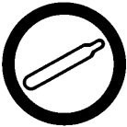 |  | 2) Flammable and ____________ Material  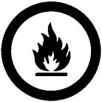
3) ____________ Material  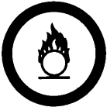 |  | 4) Materials Causing ____________ and Serious Toxic Effect
5) Materials Causing ____________ Toxic Effects |  | 6) ____________ Infectious Material  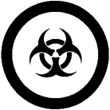
7) ____________ Material  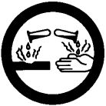 |  | 8) Dangerously ____________ Material

Match the WHMIS symbol with the correct definition:

1) | _______ |  | a) These materials contain harmful micro-organisms.  b) These materials increase the risk of fire if they come in contact with flammable or combustible materials.  c) These materials can destroy the skin or eat through metals.  d) These materials are capable of catching fire in the presence of a spark or open flame.  e) These materials can cause death or immediate injury when a person is exposed to small amounts.  f) These materials include compressed gases, dissolved gases, and gases liquefied by compression or refrigeration.  g) These materials may self-react dangerously.  h) These materials can cause life-threatening and serious long-term health problems.
2) | _______
3) | _______
4) | _______
5) | _______
6) | _______
7) | _______
8) | _______

Consumer Hazard Labels

 | 1) ____________________________
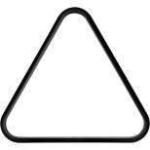 | 2) ____________________________
 | 3) ____________________________
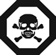 | 4) ____________________________
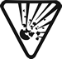 | 5) ____________________________
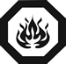 | 6) ____________________________

National Fire Protection Association (NFPA) Labels

The NFPA diamond is subdivided into four general categories:

2) _______________
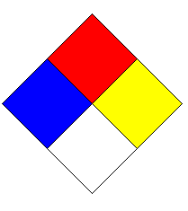
4) _______________
3) _______________
1) _______________

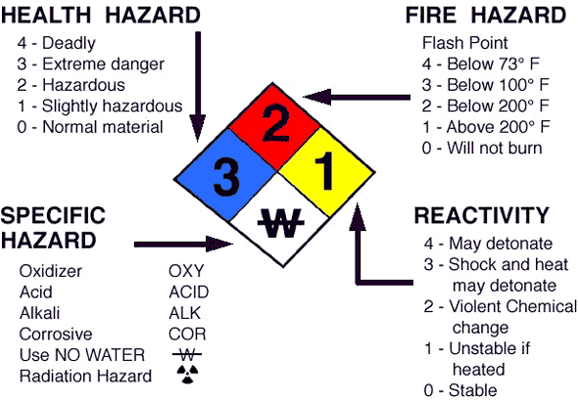
Safety Practices

Briefly describe the proper safety practices in regards to the following:

1) Food and drink in the lab ____________________________________

2) Proper attire during a lab ____________________________________

3) People with contacts ____________________________________

4) People with long hair ____________________________________

5) An accident occurs _________________________________________

6) A fire occurs ______________________________________________

7) Somebody’s clothes catches on fire ___________________________

8) Disposing of chemicals ____________________________________

9) Mercury is spilt _________________________________________

10) Acid is spilt ______________________________________________

11) Base is spilt ______________________________________________

12) Glassware breaks or chips ________________________________

13) Heating a test tube with a Bunsen burner _______________________

14) Smelling chemicals _________________________________________

15) Mixing acid and water ____________________________________

16) Chemical gets spilt on your skin ___________________________

17) Chemical gets in your eyes ________________________________

18) The fire alarm goes off ____________________________________

19) You have completed your experiment _______________________

20) Testing hot objects ________________________________________

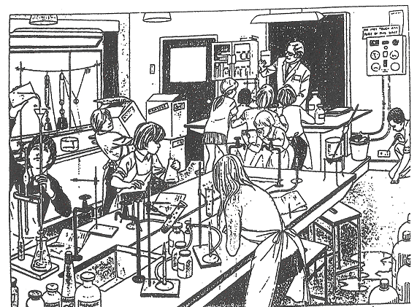

Identify unsafe lab practices:

1) __________________________________________________________

2) __________________________________________________________

3) __________________________________________________________

4) __________________________________________________________

5) __________________________________________________________

6) __________________________________________________________

7) __________________________________________________________

8) __________________________________________________________

9) __________________________________________________________

10) _________________________________________________________
Safety Equipment

Name the following safety equipment.

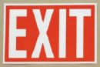 | 1) ____________________ | Marked above doors that can be used as an exit route.
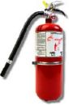 | 2) ____________________ | Puts out fires.
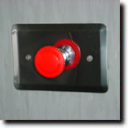 | 3)_____________________ | Shuts off gas main.
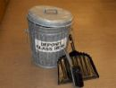 | 4) ____________________ | Used to dispose of broken or chipped glassware.
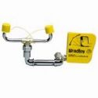 | 5) ____________________ | Rinses off any substance that has come in contact with the eyes.
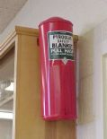 | 6) ____________________ | Helps smother flames.
 | 7) ____________________ | Contents of kit allow for treatment of minor injuries.
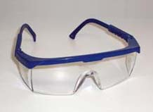 | 8) ____________________ | Protects the eyes from chemicals.
 | 9) ____________________ | Used to neutralize acids and bases.
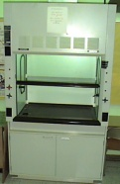  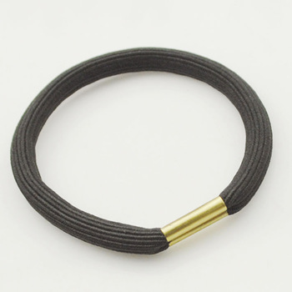 11) ___________________ Used to tie back long hair. | 10) ___________________ | Used to vent harmful fumes.
Safety Map

Make a safety map of your classroom. Be sure to include all safety equipment: 1) fire exits, 2) fire extinguisher, 3) gas main shutoff, 4) broken glass container, 5) eye wash station, 6) fire blanket, 7) first aid kit, 8) goggles, 9) chemical spill kit, and 10) fume hood.

Lab Equipment

 | 1) _________________ | A glass tube closed at one end, used to heat, mix and examine chemicals.
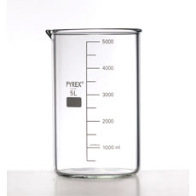 | 2) _________________ | A glass container with a pouring spout, used to store, mix, heat and examine chemicals.
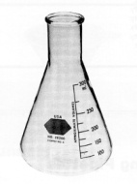 | 3) _________________ | An inverted cone shaped glass bottle used to store, heat, mix, and hold liquids.
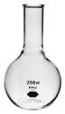 | 4) _________________ | A round bottle with a flat bottom used for boiling liquids.
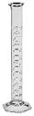 | 5) _________________ | A glass cylinder marked in milliliters, used for measuring volume of liquids.
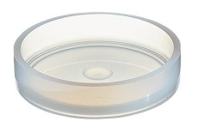 | 6) _________________ | A round shallow dish used to examine materials and to grow bacterial cultures.
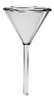 | 7) _________________ | A tube with a wide cone shaped mouth, used to pour liquids into small openings.
 | 8) _________________ | A curved circular piece of glass, used for holding and examining specimens.
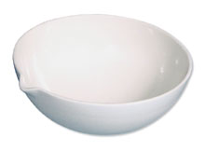 | 9) _________________ | A porcelain dish used to evaporate liquids.
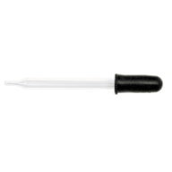 | 10) ________________ | Used to transport small amounts of liquids.
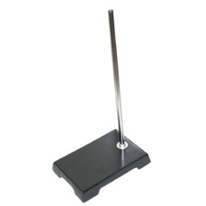 | 11) ________________ | A metal rod fastened to a sturdy base to which ring clamps and burette clamps may be attached.
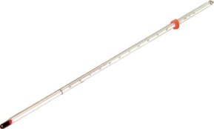 | 12) ________________ | A sealed tube containing alcohol, used to measure temperature.
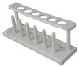 | 13) ________________ | A rack used to support test tubes.
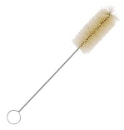 | 14) ________________ | A narrow brush used to clean test tubes.
 | 15) ________________ | A metal scoop used to place chemicals into test tubes.
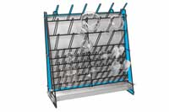 | 16) ________________ | A metal rack used to support glassware while drying it.
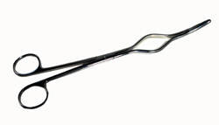 | 17) ________________ | A tool used for picking up or holding hot objects.
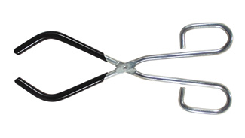 | 18) ________________ | A tool used to hold hot beakers.
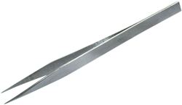 | 19) ________________ | A pair of small tongs used to grasp small items.
 | 20) ________________ | A solid glass rod used for stirring liquids.
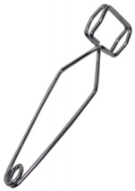 | 21) ________________ | A clamp used to hold a test tube with the hand.
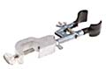 | 22) ________________ | A clamp used to hold test tubes, mounted on a support stand.
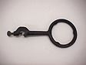 | 23) ________________ | A clamp which is mounted on a support stand, used to support beakers and flasks.
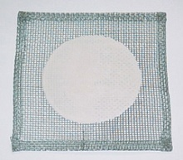 | 24) ________________ | A wire screen used with a ring clamp to support beakers and flasks
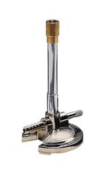 | 25) ________________ | A device used to produce a flame.
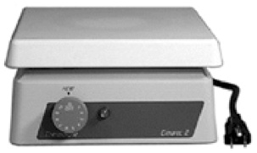 | 26) ________________ | A device used to heat beakers and flasks.
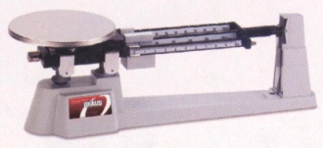 | 27) ________________ | Used to find the mass of objects or chemicals.
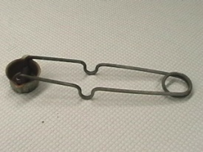  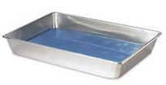  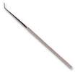  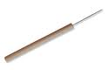  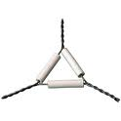  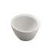  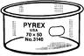  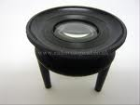  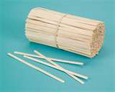 | 28) ________________  29) ________________  30) ________________  31) ________________  32) ________________  33) ________________  34) ________________  35) ________________  36) ________________ | Used to light Bunsen burners.  Specimen is placed inside when dissecting.

Flashcards

1) | 2)
3) | 4)
5) | 6)
7) | 8)

9) | 10)
11) | 12)
13) | 14)
15) | 16)

17) | 18)
19) | 20)
21) | 22)
23) | 24)

25) | 26)
27) | 28)
29) | 30)
31) | 32)

33) | 34)
35) | 36)
37) | 38)
39) | 40)

41) | 42)
43) | 44)
45) | 46)
47) | 48)

49) | 50)
51) | 52)
53) | 54)

