## I - 1 — Vector Addition- Geometry

A scalar is a quantity that has magnitude only. It does not have a direction. (mass, speed, distance, work, energy…)

A vector is a quantity that has a magnitude and a direction. If a question asks for a vector quantity, you must provide magnitude and direction. (velocity, displacement, acceleration, force, momentum…)

A 2-dimensional vector must have two pieces of information to indicate its magnitude and direction:

* 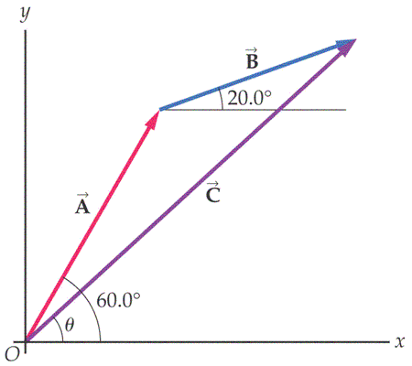25 m/s 18° E of N (read 18° to the East from North, angle at base of the vector.)
* 4.0 m West and 3.0 m South.
* 7**x** + 3**y**
* 2.7 m/s2 235° (standard position)
* A labeled arrow (scale diagram)

Graphically, vectors can be added by the “tip to tail” method.

The vector sum (resultant) is drawn from the original starting point to the final end point.

**C** = **A** + **B**

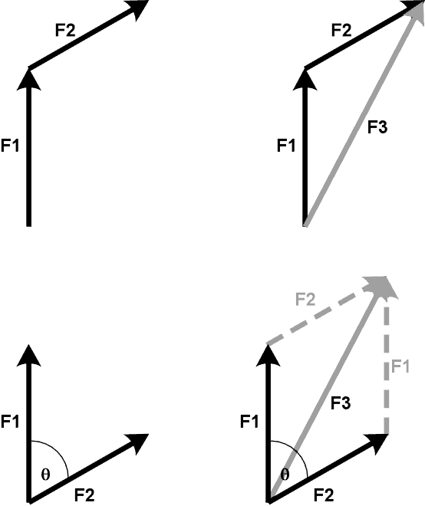

Adding two vectors graphically will often produce a triangle.

##### Example 1:

Add the following vectors by using a sketch and triangle properties:

7.0 m [S] and 9.0 m [E]

17m/s 30°S of E and 12m/s 10°W of N

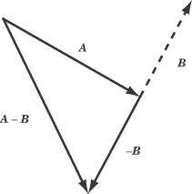Subtraction of vectors is the addition of the negative of the subtracted vector.

The negative of a vector has the same magnitude, but the opposite direction.

**A** - **B** = **A** + (-**B**)

##### Example 2:

Find the resultant of:

15 m East minus 12 m 20° South of East.

## 5th Ed: p. 70: 1, 2, 5, 11, 12, 13

## 6th Ed: p. 65: 1, 2, 5, 10, 11, 12 I - 2 — Vector Addition- Components

A vector can be equated by two vectors that sum to the original vector.

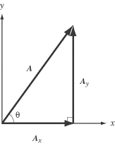Any two vectors can do this; we can choose these vectors carefully.

Orthogonal vectors that sum to a third vector are called components of the third vector.

##### Example 1:

Find the components of 250 m/s 30° W of S

Find the x and y components of 37 m at 290°

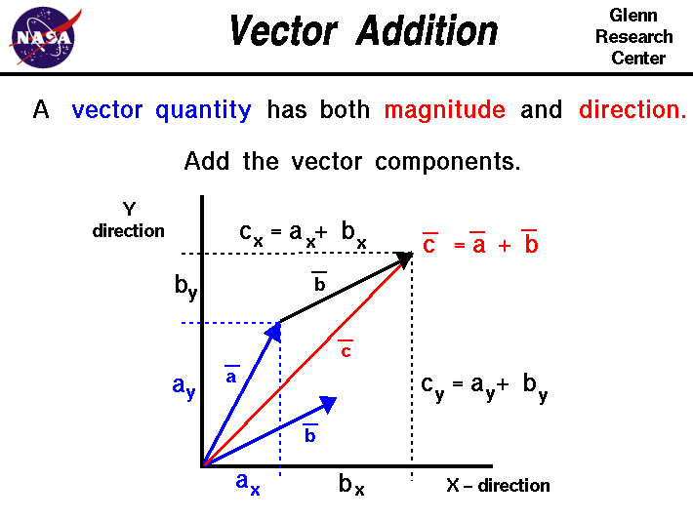Vectors can be added by adding their components.

For **R** = **A** + **B**

**R**x = **A**x + **B**x

**R**y = **A**y + **B**y

For **R** = **A** - **B**

**R**x = **A**x - **B**x

**R**y = **A**y - **B**y

##### Example 2:

**A** = 55 m 20° S of W

**B** = 75 m 60° N of E

1. Find **A** + **B**
2. Find **A** – **B**
3. Find 2**A** + 3**B**

5th Ed: p. 70: 4, 8, 11, 14, 15

6th Ed: p. 65: 4, 7, 8, 10, 13, 14

## I - 3 — Navigation

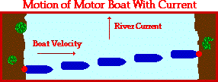In most considerations of position a frame of reference is chosen that is considered stationary: usually the earth.

If the motion of an object is a combination of two or more motions (person swimming across a flowing stream) the total motion is determined through an application of vectors.

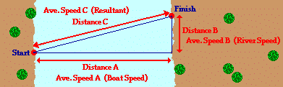  
Consider a boat crossing a river. To an observer on the shore the boat will be moving at an angle. The velocity of the boat is a combination of the velocity of the boat is still water and the velocity of the water.

Notes on navigation problems:

1. The given speed of a plane or boat is in the direction they are pointing (unless explicitly stated otherwise).
2. Be aware of your frame of reference.
3. Label the vectors carefully and clearly in your diagram.

##### Example 1:

Find the velocity (relative to the shore) of a boat that can travel at 6.0 m/s through still water that is aimed directly across a river that is moving at 2.0 m/s.

Example 2:

The same boat as in example 1 must end up directly across the river. What is its velocity and at what angle must it aim to accomplish this?

Example 3:

A plane flying at 250 km/h with a heading of due North experiences a 75 km/h NW wind. What is the planes velocity?

What must its heading be to result in a velocity that is due North.

## 

5th Ed: p. 70: 40-43, 45, 46, 49-53

6th Ed: p. 65: 36-39, 41, 42, 45-49

## I - 4 —Relative Velocity

If the frame of reference is uncommon, care must be taken to draw careful vector diagrams.

Consider two cars traveling orthogonally that will collide at a corner.

##### Example 1:

Draw this situation with the frame of reference as:

1. Earth
2. Car A
3. Car B

If a situation is described in a common way, with the frame of reference the earth, it can be converted to a different frame of reference by subtracting the velocity (relative to the earth) of the object that is to be the new frame.

##### Example 2:

Boat A is moving at 15 m/s North on a lake. Boat B is moving at 12 m/s west on the same lake. What is the velocity of Boat A relative to boat B?

## 5th Ed: p. 70: 44, 55, 65, 56

## 6th Ed: p. 65: 40, 52, 59, 50

## I - 5 One Dimensional Kinematics



All vectors must be in the same dimension.

All formulas assume constant acceleration (zero acceleration is constant).

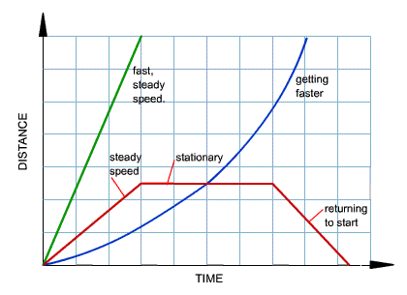Displacement time graphs:

* Slope is velocity
* Curved line — acceleration
* Tangent is instantaneous velocity
* Straight line — uniform motion (constant velocity)

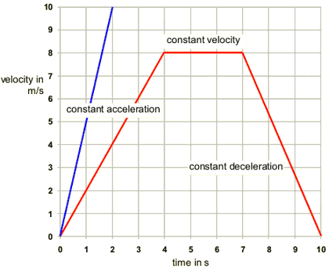

Velocity time graphs:

* Slope is acceleration
* Horizontal line — zero acceleration, constant velocity
* Area under curve is displacement
* Area below the axis — negative displacement

Problem solving steps:

1. Sketch a diagram
2. Choose a frame of reference
3. Write information given is question
4. Write formulas
5. Solve showing steps
6. State answer. Note vector requirements in question. Watch significant figures (2 or 3)

Example 1:

An airplane must be traveling at 75 m/s to take off. If the runway is 800 m long, what must be the airplane’s acceleration to take off?

Vertical motion on the earth undergoes the acceleration of gravity.

Near the surface of the earth, the acceleration of gravity is 9.8 m/s2 downward.

Unless stated explicitly, friction is ignored in our kinematic calculations.

##### Example 2:

A rock is dropped from a bridge and lands 3.0 s later. How high is the bridge?

##### Example 3:

A rock is thrown upwards at 20 m/s. What is its velocity at a height of 10 m?

##### Example 4:

A physics text is thrown upwards at 8.0 m/s from the top of the school (12 m). How long does it take for the book to hit the ground? What is its final velocity?

5th Ed: p. 42: 15, 16, 21, 38, 41, 46

6th Ed: p. 39: 17, 19, 23, 37, 39, 44

Try it out: Go to <http://phet.colorado.edu/sims/projectile-motion/projectile-motion_en.html>

See what affects range. (try to hit the target with two different angles with the same initial velocity)I - 6 Projectile Motion- Horizontal and Level Ground

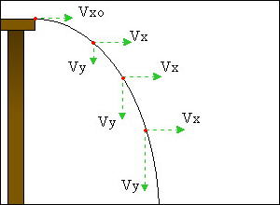Projectile motion is the motion of an object that is only accelerated by gravity (we will ignore air friction).

The motion of the object is separated into the horizontal (x) and vertical (y) components.

The only variable that is in both components is time. The time to get to a specific point in the path is the same in both dimensions.

The acceleration is only in the vertical component. The horizontal component of velocity is constant.

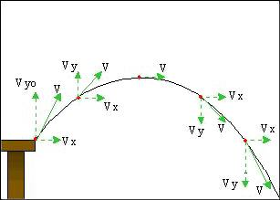Final velocity is a combination of the x and y components.

This motion is parabolic.

##### Example 1:

A stone is thrown horizontally at 15 m/s from the top of a 12m hill. What is the velocity of the stone just before it hits the ground?

##### Example 2:

A baseball is thrown a 22 m/s at 20° above the horizon.

How much time does the ball spend in the air?

How high is it at its maximum height?

How far does it travel (range)?

What is its final velocity?

5th Ed: p. 70: 19, 20, 22, 24, 26, 27, 30, 31, 35

6th Ed: p. 65: 17, 18, 20-24, 27, 30

I - 7 Projectile Motion- Non-Level Ground Projectiles

Example 1:

A student satisfied that their textbook will hit the ground with acceptable force tries to hit Mr. Friesen’s car from the edge of the Gym roof (17 m). The book is thrown at 12 m/s at an angle of 25° above the horizon. How far from the base of the gym does the book land? What is its final velocity?

5th Ed: p. 70: 36, 28, 38, 71, 73

6th Ed: p. 65: 31, 32, 35, 65, 67, 70

I - 8 Projectile Motion- Range Formula Extension

Example 1:

Based on a projectile on level ground thrown with velocity **v**o and an angle Ø, derive a formula for the range of the projectile.

##### Example 2:

An arrow is fired at 38 m/s. If it is to hit a target 25 m away, at what angle should it be fired?

5th Ed: p. 70: 21, 32, + “At what angle(s) will the range of a projectile equal its maximum height?”

6th Ed: p. 65: 19, 26, 33