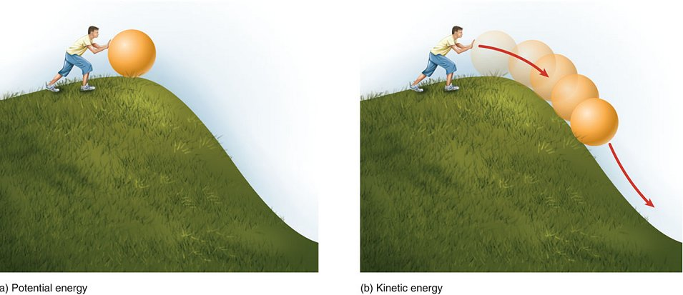
8.1 Electric Potential Energy
- __________________ is the ability to do work.
- ___________________________ is energy a
moving object has because of its motion.
- ______________________________ is the
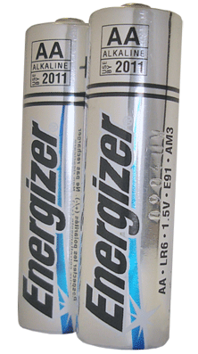
energy stored in an object.
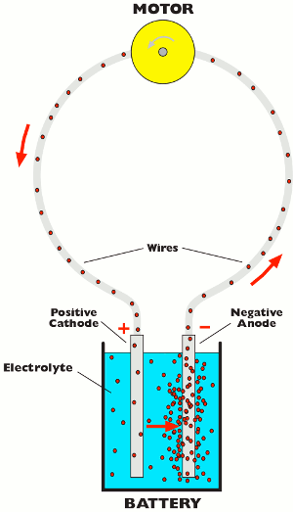
- Electric Potential Energy
- Electric energy can do work.
- Electric energy that is stored is potential energy; when
it is moving it is kinetic energy.
- Electrochemical cells convert ___________________________
into________________________. Connecting cells together
forms ______________.
- The ends of batteries are _________________.
- Extra electrons accumulate on one terminal, making it
______________________________________________.
- The other terminal has lost these electrons, making it ______________________________________________.
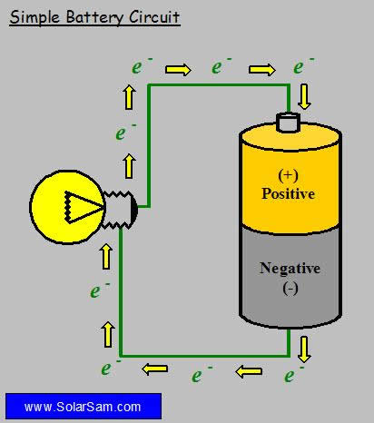
- Connecting a device (ex. lightbulb) to the terminals can allow electrons to ____________, and converts electric energy into different forms (ex. heat, light).
- The amount of electric potential energy per one coulomb
of charge is called the _____________________________
or ______________________.
- This can be measured with a _________________________.

Comparing Potential Energy and Potential Difference.
- The potential energy in a battery depends on the _______________
____________________________ and the amount of
________________________________________________.

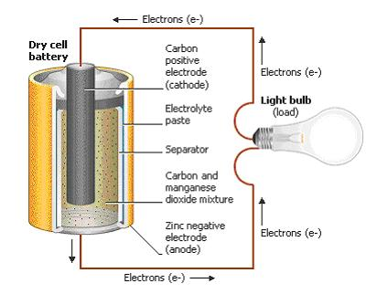
Producing Voltage.
- We can classify batteries into two groups.:
- ________________________ are batteries in devices
like flashlights, portable CD players, and watches.
- __________________________ are commonly used
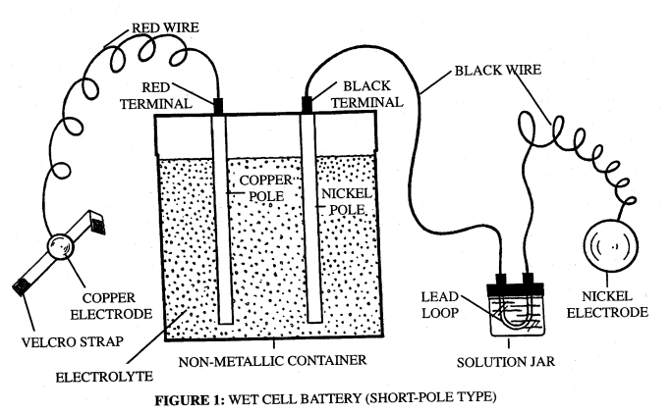
in cars, motorcycles and electric golf carts.
- A battery has two terminals called ___________________.
- The electrodes are made up of two different metals.
- The electrodes are in an _____________________,
which is a substance that conducts electricity.
- In a dry cell the electrolyte is a _______________________
and it is a __________________ in wet cells.
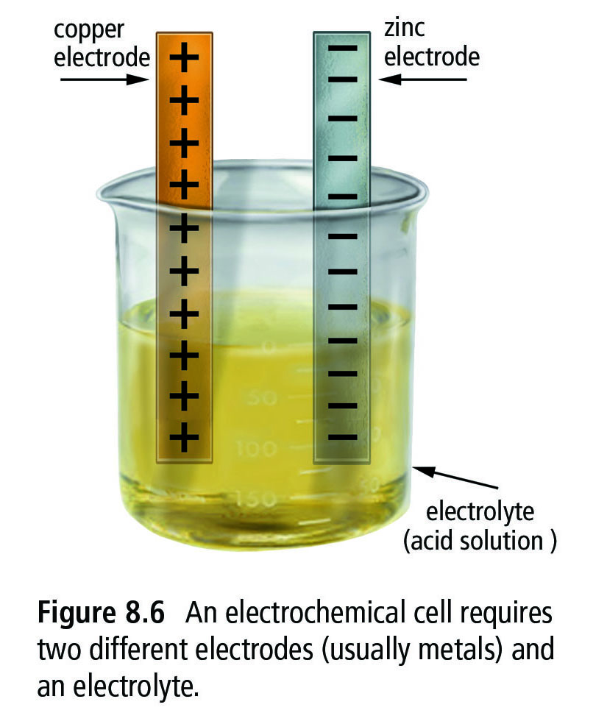
- In this electrochemical cell, ___________________
are transferred from the copper electrode (which becomes ____________________________) to the zinc electrode
(which becomes ________________________).
- The separation of charge results in a _________________
__________________________ between the two electrodes.

Many Sources of Electrical Energy.
- _____________________
- rubbing two materials together can separate charges
- ___________________________________
- When certain types of crystals, like quartz, are squeezed, there is a separation of positive and negative charges on the crystal. Striking the crystal generates a burst of thousands of volts of electricity.
- __________________________________________________
- solar panels and many calculators use photo-electrochemical cells as a source of power
- they are made of semi-conducting material such as silicon
- when light hits the cell electrons are broken off the surface of the material
- _____________________________
- A thermocouple device is used to transform heat energy into electrical energy.
- Two wires of different metals are joined at both ends. When heated or cooled, charge is separated and voltage is created. Thermocouples can only create a small amount of electric energy.
- They are used in ovens and furnaces to control the temperature.
- ___________________________
- Generators work on the principle that when a wire moves close to a magnet, a voltage is created across the wire.
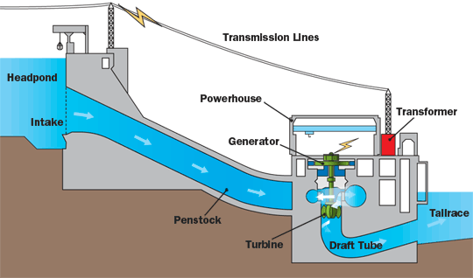
- In British Columbia the energy from water is used to generate most of our electric energy.

Review.
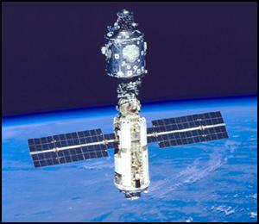
What do sources of electrical energy do these pictures represent?

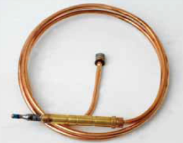
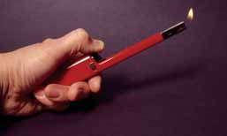

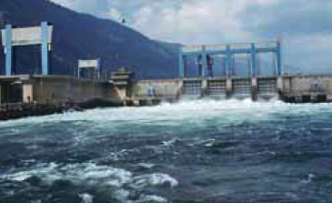

8.2 Electric Current.
- Current electricity is the ____________________________________ in a complete circuit. The unit of measuring electric current is the ______________________, which is defined as one coulomb of charge passing a given point per second.
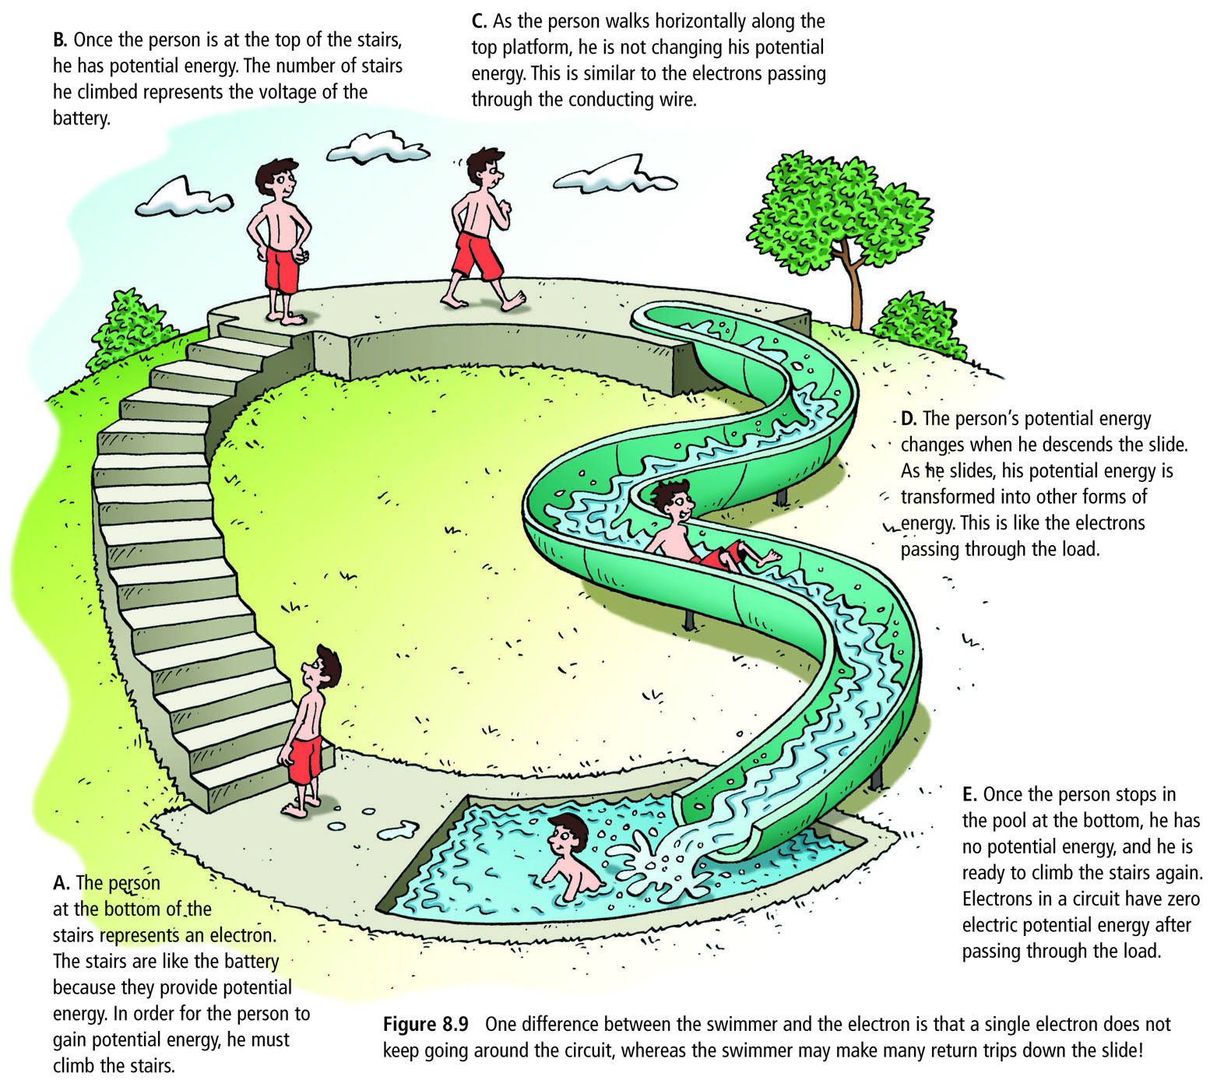
- An ____________________ is a device used to measure __________________.

Energy Around a Circuit.
- Any device that transforms electrical
energy into other forms of energy is called an
_____________________________.
- Some examples of a load are a
_______________________, a
______________, a _______________
and a ________________.
- A _________________________________
that allows electrons to flow is called an
_______________________.

Circuits Components and Diagrams.
- _________________ – the source of electric current
- _________________ – the wire carrying the electric current
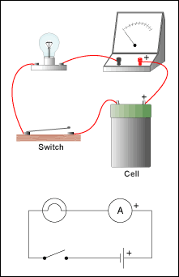
- _______________ – a device that transforms electrical energy into other forms of energy
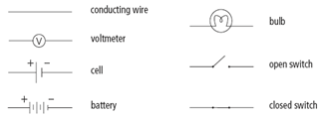
- ___________–a device used to turn the circuit on and off by opening or closing the circuit.

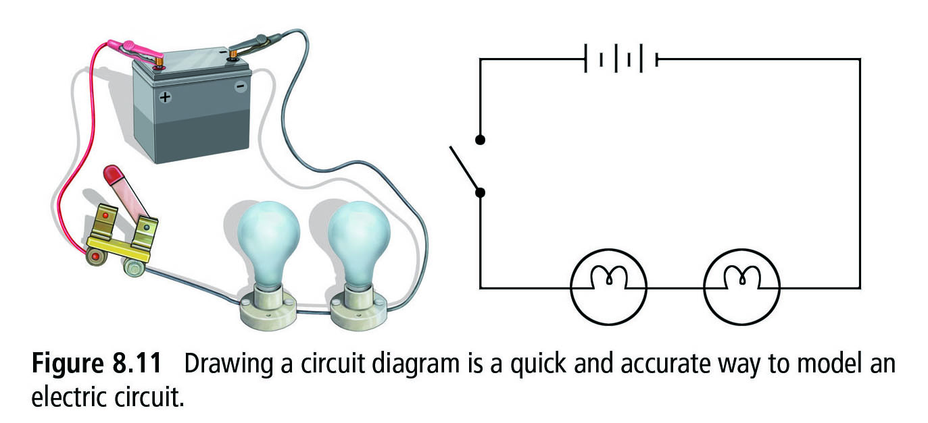

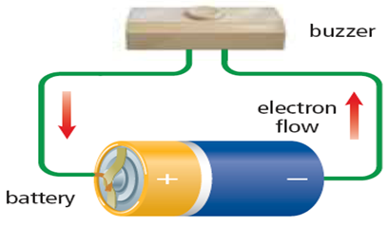
Electrons Are So Pushy.
- So far you have learned that a source like a battery
supplies the energy to ___________________________.
- Electrons are pushed ______________________________
of the battery, along conducting wires through the
load (light bulb), to _______________________________.
- Electrons apply an __________________________________________.

Current Electricity and Static Electricity.
- Unlike _________________________ where the ___________________________ ________________, in a battery the charge will flow the second the circuit is connected.
- Once the battery is connected to complete the ________________, ________________ ___________________ continuously through the circuit.
- This continuous flow of charge is called _______________________________.

Conventional Current.
- The flow of electricity is from ____________________________ (the flow of electrons).
- In the early days of electricity research, scientists ______________________ believed electricity flowed from positive to negative.
- Descriptions of this flow from ___________________________ still exists today, and is known as ______________________________.

8.3 Resistance and the Flow of Electrons.
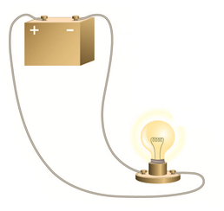
- Resistance is the property of any material that ____________________
the flow of electrons and transforms electrical energy into other forms of energy.
- A ________________________________ will slow down
the flow of electrons and convert it into __________ and _________.

Resistance and Current.
- ______________ is directly ______________________________.
- If a battery is connected to an electric circuit that has a large resistance, _____________________ will flow than if the same battery is connected to a lower resistance circuit.

Ohm's Law.
- Electrical resistance is the ratio of the __________________ to the _________________. The unit of measurement for electrical resistance is the ohm (Ω).
- Ohm’s law is written $$R=\frac{V}{I}$$
- Ohm’s law is more commonly written as :
V = IR
Example 1:
The current through a load in a circuit is 1.5A. If the potential difference across the load is 12 V, what is the resistance of the load?

Example 2:
The resistance of a car headlight is 15 Ω. If there is a current of 0.80 A through the headlight, what is the voltage across the headlight?

Example 3:
A 60 V potential difference is measured across a load that has a resistance of 15 Ω . What is the current through this load?
Converting Prefixes:
milli (m)
mA → A (÷ 1000)
A → mA (x 1000)
kilo (k)
kΩ → Ω (x 1000)
Ω → kΩ (÷ 1000)
mega (M)
MV → V (x 1 000 000)
V → MV (÷ 1 000 000)

Example 4:
A 15 mA current flows through a 400 Ω lamp. What is the voltage across the lamp?

Example 5:
A 12 kΩ load is connected to a 90 V power supply. What is the current thought the load in milliamperes?

Determining the Resistance.
Method 1
- Use a _____________________ to measure voltage and an _____________ to measure current. Using Ohm’s law you can _____________________ the load’s resistance.
Method 2
- Use a ______________________ to measure the resistance ________________.
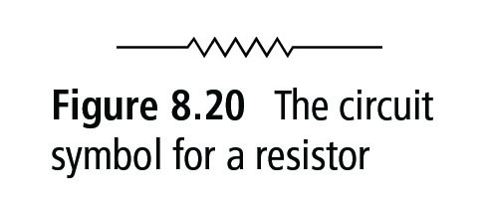
Resistors.
- A resistor is an electrical component that
has a ______________________________.
- Resistors can be used to _______________________ _______________________ in a circuit to provide the correct voltage and current to other components of the circuit.
Resistance.
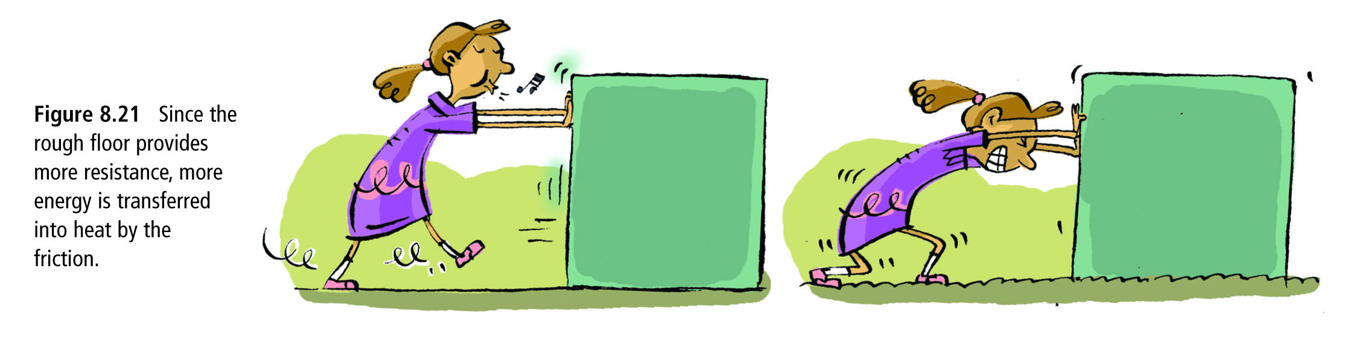
- Resistance is a big loser. When a charge encounters resistance, some of the electrical energy is converted to other forms of energy usually _______________.

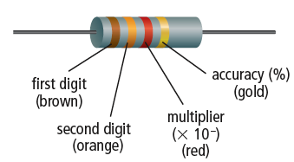

Resistors and Colour Codes.
