7.1 Static Electricity.
Static Charges.
In this chapter we will learn:
- Atoms with equal ____________ and _____________ charges are called _____________
- Atoms can become _______________ when electrons transfer in or out of a material
- _______________ do not allow electric charges to move easily
- __________________ is a material in which electric charges can move more easily
- The unit for measuring charge is the _______________.

- When you think of the word “__________________” you think of computers, televisions and other modern devices.
- The earliest studies of electricity had to do with static charges which refers to _______________________ that can be collected and ___________________________.
- Can you think of some instances when you have been affected by static charges?
- Clothes coming out of a dryer
- Rubbing your feet on the carpet
- Touching a lock with a key and seeing a spark
- Lightening is when a static charge builds up in the ground during a thunderstorm.

Early Theories of Electricity.
- Benjamin Franklin discovered a type of “_________________________” in certain objects when they were rubbed. He called a build up of this fluid __________________and a shortage ___________________________. Scientists still use these symbols to show the movement of electrical energy.

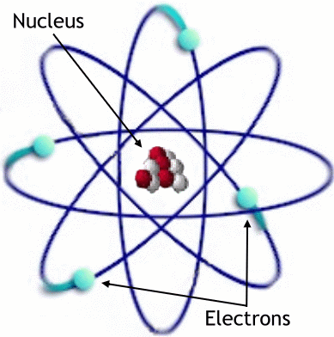
Positive and Negative Charge in Atoms.
- All matter is made of atoms - at their centre is a
nucleus _____________________________________ and _____________________________________. Surrounding
the nucleus are ______________________________________.
- Solid materials are charged due to the ____________________
_________________________ - when electrons are gained,
the object becomes ____________________. When electrons are lost,
the object becomes ____________________.
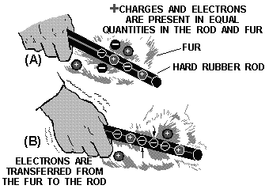
Friction and Electron Transfer.
- Electrons are most often _______________________
through friction, when objects rub against each other.
- Friction results in ______________________ or
___________________________.

Insulators and Conductors.
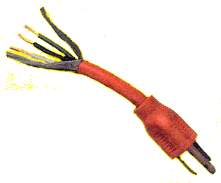
- Materials that _____________________________________________ are called electrical insulators.
- Some good INSULATORS are:
- plastic
- ceramics
- wood
- glass
- Only insulators are good at __________________________________.
- Materials that __________________________________________ are called electrical conductors.
- Some good conductors are:
- metals (ex. copper, zinc, cadmium)

Measuring Charge.
- Unit of electric charge is called a _______________________ , named after the French physicist Charles Augusin de Coulomb.
- 1 C of charge is equal to the removal or addition of ______________________________.
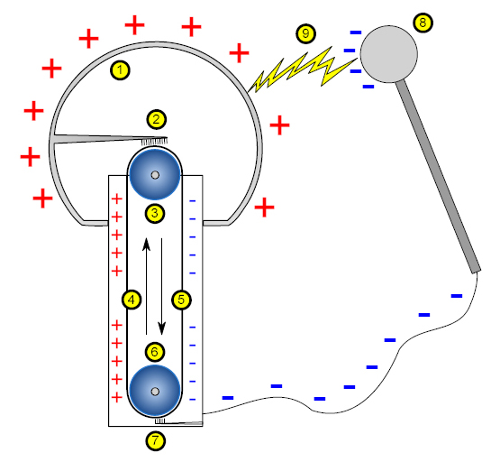
- A typical lightning bolt carries ______________.

Generating Static Charge.
- A ______________________________________
uses friction to produce a large static charge on a
metal dome. The moving belt produces a static
charge at the base and this is carried to the top of
the dome where it is collected.

Application of Static Electricity.
- ____________________________ clings due to static charges.
- Static devices are used in industry to ____________________________ from chimney stacks.
- _________________________ in homes.
- Static charges are used in ________________________________.

Dangers of Static Electricity.
- When static charge builds up it can discharge and cause serious _____________, ________________ or _____________.
- Those pumping flammables must ensure objects are ____________________ (connected to the Earth so that static charge is discharged).
- Lightning is especially dangerous - buildings can be protected with ___________________________.
7.2 Electric Force.
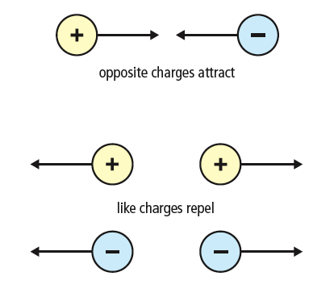
- Force is a push or pull - electric force can do both,
without touching the object - it is an
________________________________ force.
Laws of Static Charge
- Like charges _________
- Opposite charges _______________
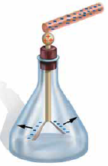
- Neutral objects are ___________________________.

Charging Objects.
- Charging By Conduction
- Charging through _____________________.
- Extra electrons will move to a location
where there is ______________________.
- Charging by Induction
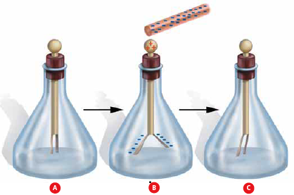
- Bringing a charged object nearby a
neutral object will cause charge
movement and separation in the
in the neutral object.

