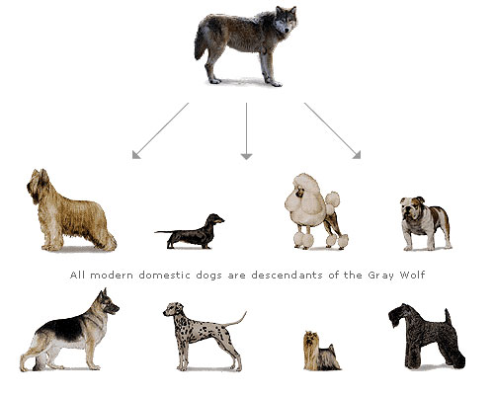
6.1 Meiosis and Sexual Reproduction.
Meiosis.
- Meiosis is an important aspect
of _________________________________.
- Sexual reproduction, through the shuffling
of DNA, produces ____________________________.
- This variation offspring produces individuals
that may have _________________________ over one another.
- “____________” is derived from the Greek word ___________, which means to reduce.
- The process of meiosis results in the production of special cells called _______________.
- Cell division occurs twice in meiosis: once at the end of ___________________ and again in ______________________.
- The process of meiosis shuffles genetic information and results in
variation in ______________.

Role of Gametes.
- Normal body cells have a __________________ chromosome
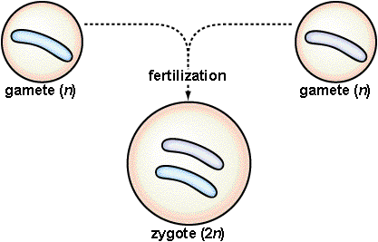
number, meaning chromosomes occur in ____________.
- In humans, the male and female each contribute
_______________________________.
- When _______________ takes place:
___________+__________________=________________________
- The zygote goes on to develop into an embryo,
and on into a complete individual. When the time comes, the cycle ___________________.
- Humans produce __________________ (either egg or sperm) that have ___________________________ the normal number of chromosomes.
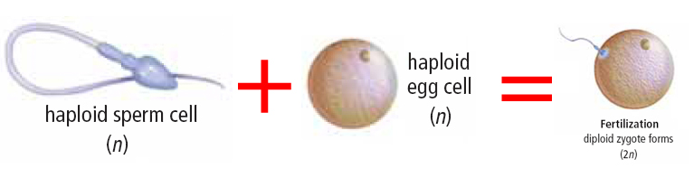

Meiosis.
- Meiosis produces gametes with __________________________________ compared to body cells: 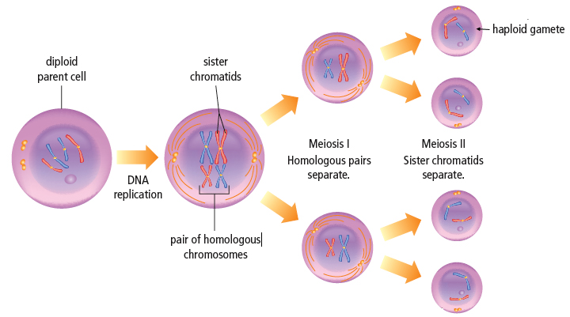

Meiosis I.
- During meiosis I, the ______________________ move to ________________________ of the cell.
- Meiosis I differs from mitosis because in meiosis I, ________________________________ lines up along the equator during metaphase.
- These matching chromosomes are called ______________________________________.
- ____________________________________________________ result from meiosis I.

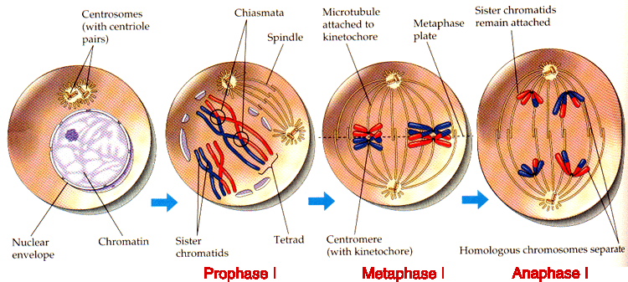
Meiosis II.
- DNA is _________________________ again before meiosis II begins.
- Meiosis II is like mitosis because in both processes the __________________________ of each chromosome are pulled to ____________________________.
- Each daughter cell inherits one chromatid from each chromosome resulting in _________________________________ each with ___________ the N of chromosomes.
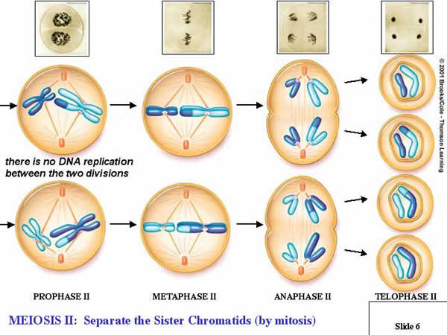

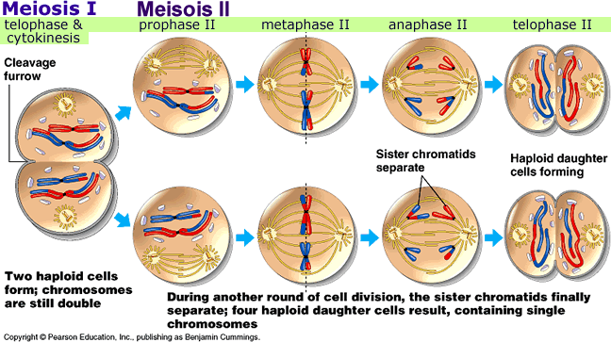

Crossing Over.
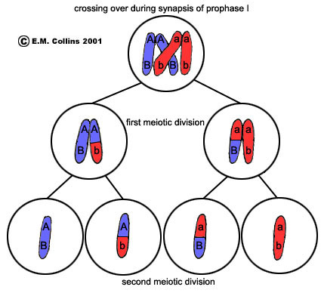
- Crossing over is important for the
_________________________________.
- Crossing over creates an infinite number
of _______________________________.

Independent Assortment.
- During meiosis I another event called “independent assortment” occurs which also leads to _____________________ in species.
- For each of the 23 homologous pairs there are _________ possibilities for how chromosomes will sort themselves into daughter cells.
- There are more than 8 million combinations possible for the 23 pairs in any egg or sperm cell.
- 70 trillion different zygotes are possible from one sperm and one egg cell.
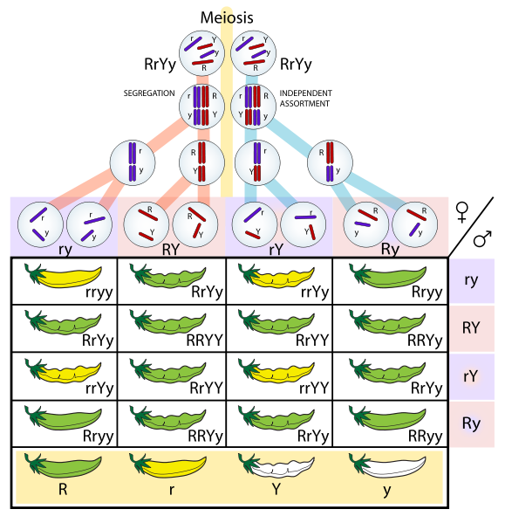

Gamete Formation.
- In males, all ____________ resulting from meiosis develop into sperm.
- In females, _____________ gets most of the cytoplasm and becomes the egg.

Chromosome Mutations.
- Sometimes changes in the organization of DNA and genes happen when pieces of chromosomes are ____________, _____________________, or __________________ within the chromosome.
- They may affect the genes that are responsible for making certain proteins in the cell.
- Chromosome changes can be cause by _______________ such as radiation or chemicals.

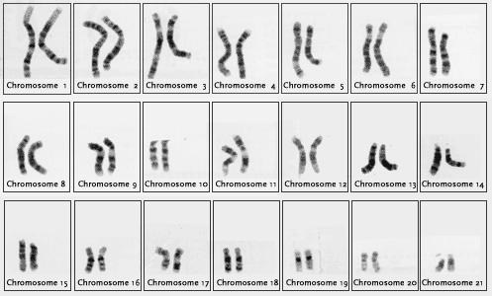
Genetic Disorders.
- Geneticists can get a picture of individuals by
looking at a person’s chromosomes.
- This is called a person's “_______________________.”
- Chromosomes are identified and paired by size,
centromere location and banding patterns.
- By analyzing karyotypes, geneticists can determine
when a whole chromosome mutation has occurred.
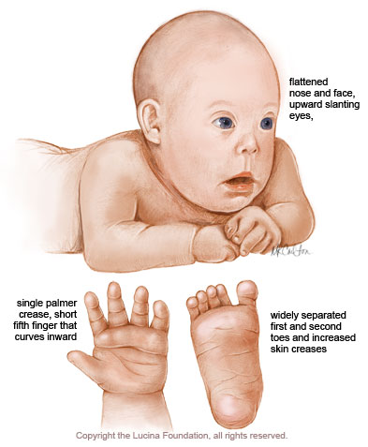
- Treatment of these disorders or “syndromes” can then take place. A good example of this is ___________________________ which occurs when a person has an extra ______________________________.
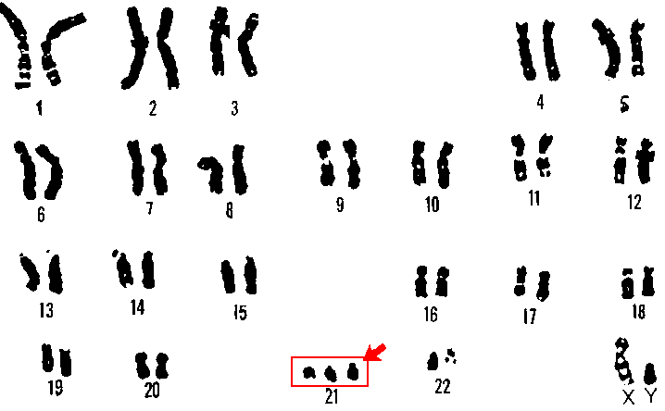
6.2 Sexual Reproduction.
Sexual reproduction brings non-identical gametes together to form a ______________________ - it occurs in ________ stages:
- ____________________ - the process by which gametes are brought together at same place and same time
- _____________________ - process by which egg and sperm join to form a new organism
- ________________________- the process by which an organism develops as an embryo

Methods of Fertilization.
- External or Internal Fertilization
In order for either of these methods to produce a successfully developing embryo, certain conditions must be met:
- Embryo must have enough _____________________.
- __________________________ must not be too cold or too hot.
- There must be enough _____________________ so that embryo does not dry out.
- Embryo must be _________________________ from predators and items in environment that can potentially harm it.

External Fertilization
In external fertilization, sperm and egg join_________________________.
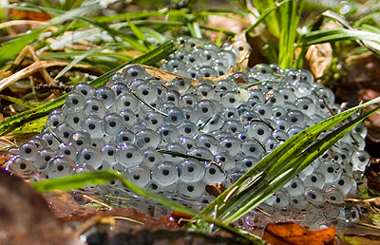
- Advantages
- Very little ______________ required to mate
_____________________ of offspring produced
- Offspring can be _______________________
in the environment - less competition between
each other and parents
- Disadvantages
- Many gametes will ________________
- Many eggs will __________________________
- Offspring are often _____________________________ by parents, so many of them die
Internal Fertilization.
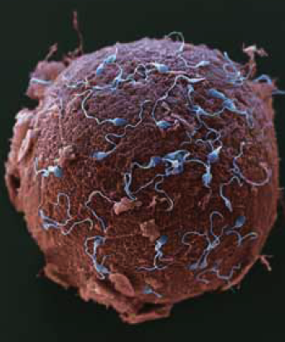
In internal fertilization, sperm and egg join _________________________, embryo is nourished inside mother.
- Advantages
- Embryo ______________________ from predators
- Offspring more likely to ________________, as
many species will protect their young while they mature
- Disadvantages
- Much __________________________ required to find mate
- Fewer zygotes produced, resulting in _______________________
- More energy required to _______________________ for offspring

Pollination.
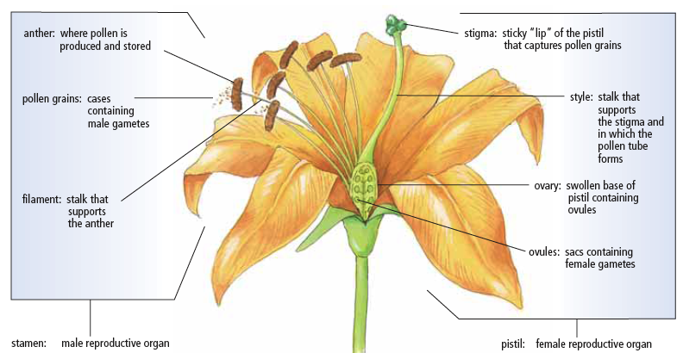
- Most plants transfer male gametes as ____________. Pollen can be carried by ____________________________________.

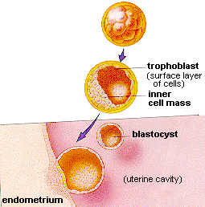
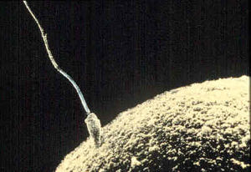
The Human Reproductive System.
- Fertilization
  - Occurs in the top one third of the
_______________________________.
  - Once ovulated, the egg is only viable for about
_________ hours if not fertilized.
- Implantation and Pregnancy
  - After fertilization, the zygote continues to move
down the fallopian tube.
  - As it does, _______________________ begins.
  - It takes the embryo ________________ days to
get to the uterus and __________________ in the endometrium.

Embryonic Development.
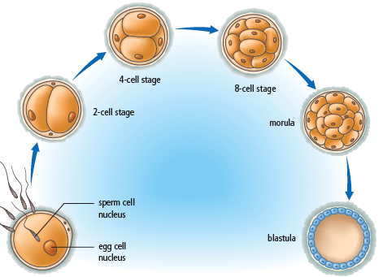
- Embryonic development is the early development of an organism - in humans, it is the first _______________________ after fertilization.
- Stages
  - End of the first week - ball of cells
called _____________.
  - By end of second week it is a hollow
ball called a _______________.
  - Cells at this stage are _________________,
and have the ability to develop into
any kind of cell.
  - In the next stage the embryo is known as a
_____________ and develops 3 layers:
- _________________ (skin, nerves)
- _________________ (muscles, bones)
- _________________ (lungs, liver, digestive system lining)

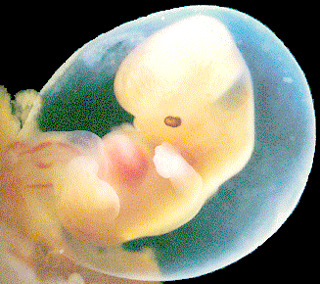
- Period of the Embryo
  - For the first three months, organogenesis
occurs and it is termed an embryo.
  - This is a 6 week embryo.

Fetal Development.
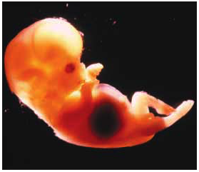
- The cell layers now differentiate into the organs and tissues of a baby - this is divided into 3 trimesters:
First Trimester (0-12 weeks)
- Organ systems begin to develop
and form. Bone cells form.
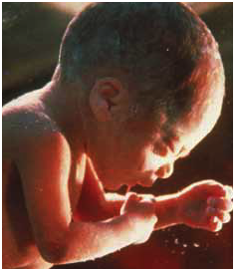
Second Trimester (12-24 weeks)
- Rapid growth from 12-16 weeks.
Third Trimester (24+ weeks)
- Continued growth, especially of brain.
- Fat begins to deposit at 32 weeks to keep baby warm.
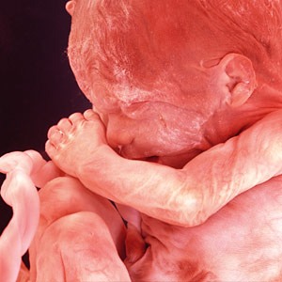
- Period of the Fetus
  - During the second trimester, _________ declines and the
placenta secretes its own _________________________.
  - This is the period of the fetus marked
by growth of all the ______________.
  - This is a 4 month fetus.
- Period of the Baby
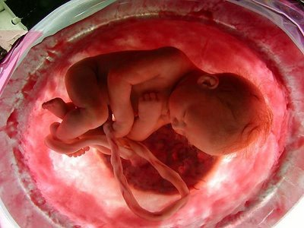
  - The third trimester, period of the baby,
is marked by ______________ and
__________________ of all ____________
and __________________________.
  - The baby is __________________________
outside the womb during this period.

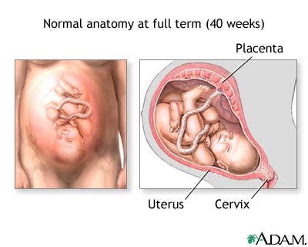
- Labor
  - Secretions of ____________________ from
the posterior pituitary cause the
________________ to contract and open.
  - When dilated to ________, the next phase begins.
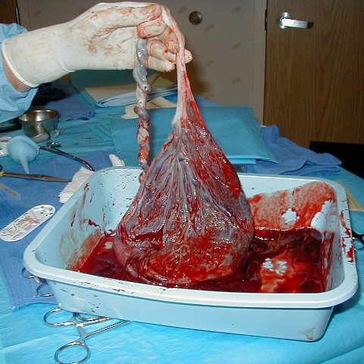
- Birth of the Baby
  - Typically delivered ___________________.
- Delivery of the Afterbirth
  - About half hour after the baby is born,
the uterus contracts again to expel
the _________________ and membranes.
  - The uterus then contracts tightly to
seal off all the broken capillaries.

6.3 Assisted Reproduction Technologies.
- Many couples can be infertile due to complications related to the reproductive system. It could be a _____________________________ or a _____________________________ (chemical imbalance).
- ____________________ is the inability of a couple to have a baby.
- Assisted reproductive technologies involve removing eggs from the woman, fertilizing them, and returning them to the uterus.
- Reproductive technologies help childless couples, but carry a higher risk of ________________. Also creates the problem of “______________” ______________. What should be done with them?

Types of Assisted Reproductive Technologies.
- Artificial Insemination.
- Donor sperm is collected and placed in the female.
- First developed for animals more than 200 years ago.
- Used with much success in humans when there are not enough sperm produced by males and sperm can be concentrated.
- Many couples may receive donated sperm from sperm banks.
- In Vitro Fertilization (IVF).
- Egg and sperm are collected and fertilization takes place in a dish. Embryo(s) then placed in female’s uterus.
- “In vitro” means “in glass” referring to technology using petri dishes.
- Used with females with blocked fallopian tubes.
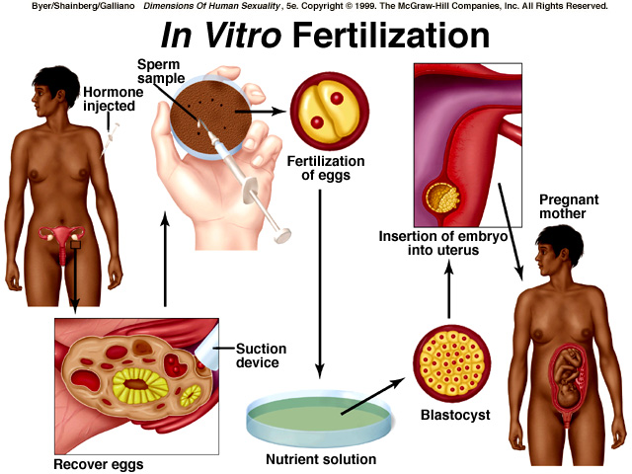
- Eggs and sperm are combined and after about 4 days the developing embryo is implanted into the female.

- Gamete Intrafallopian Transfer (GIFT)
- Eggs and sperm are collected, mixed, then injected into the woman’s fallopian tubes.
- The mixture of sperm and eggs are immediately injected into the woman’s fallopian tubes so fertilization takes place inside the woman.
- Intracytoplasmic Sperm Injection (ICSI)
- A single sperm is injected directly into an egg.
- This is done using very high tech equipment and is used when a male has a severe fertility problem with a very low sperm count.

Impact of Reproductive Technologies.
- Positive Impact
- _____________________________________ who would not otherwise be able to have children
- Improves ___________________
- Frozen embryos can be used in _____________________________
- Elimination of embryos that are _____________________________
- ____________________________________ is possible
- Negative Impact
- Data shows ________________________________ due to IVF
- Many more ____________________________
- Question of who _________ these embryos
- _______________________ of information
- Surrogate mothers may ________________________________
- Embryos getting _________________
- _______________________________

