5.1 Mitosis and Asexual Reproduction.
The Cell Cycle and Mitosis.
- Due to the ___________________________ of cells, the body must replace them.
- A good example of this is human skin cells:
- Each day ________________ are shed.
- The life of a cell is divided into _______________stages known as the cell cycle:
- _______________: cell carries out normal functions.
- _______________: nucleus contents duplicated and divide into two equal parts.
- _______________: separation of two nuclei and cell contents into two daughter cells.

Parts of the Cell Cycle.
Interphase.
- The _____________________ cell cycle stage, is when a cell
performs ______________________ and
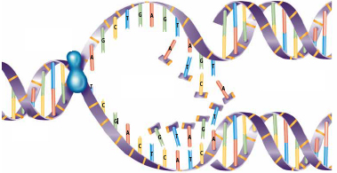
______________. For example, an intestinal lining cell absorbing nutrients.
- In _______________________, DNA copies itself in
the process of ________________. Replication involves several steps:
- The __________________________________________
with the help of an enzyme.
- New _________________________ with the
bases on the original DNA.
- Two new identical ___________________________
are produced.
- At the end of __________________, the cell continues to grow and
make proteins in preparation for mitosis and cytokinesis.
Mitosis.
- Mitosis is the ___________________ of the cell cycle where ________________________________, and two daughter nuclei are formed. It occurs in 4 stages: _______________, ________________, _______________, _______________.
- As the nucleus prepares to divide, replicated DNA in interphase joins to form sister _______________________, joined by a _____________________.
- __________________________ - nucleolus disappears and spindle fibres form
- __________________________ - spindle fibres attach to centromeres of chromosomes
- __________________________ - chromosomes align on equator of cell
- _____________________ - spindle fibres pull sister chromatids to opposite poles of cell
- __________________________ - in this final stage, spindle fibres disappear and a nuclear membrane forms around each separated set of chromosomes.
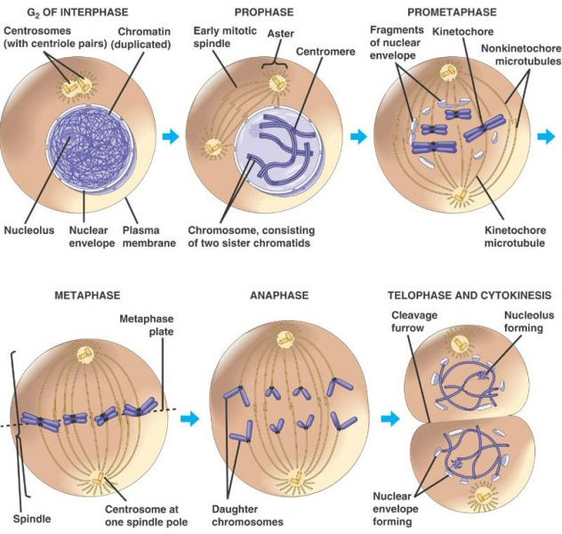
Nucleus
Nuclear Membrane

Cell Cycle Problems.
Checkpoints in the cell cycle will prevent division if:
- If the cell is ______________________
- If the ________ within the nucleus has ___________________________
- If the DNA is damaged
_____________________________________ involving checkpoints can result in an out-of-control cell cycle. The result can be uncontrolled cell division: ___________________.
Cancer.
- Cancer is ____________________________.
- Specifically, cancer is a loss of a cell’s ability to control its own rate of mitosis.
- This typically results from a mutation in the genetic control mechanism.
Cancer isn’t a disease in the conventional sense because:
- It isn’t caused by a specific pathogen (although viruses are suspect in some).
- Cancer isn’t characterized by one set of symptoms.
- In its simplest sense, cancer is ______________________________________________.
- The problem is that because these cells are reproducing so rapidly ( up to once every 3 hours,), they do not have a chance to ________________________ and become useful.
- They are like _________________________________.
- Despite being useless, they still must be fed and provided with the metabolites of life.
- They __________ at the ________________________________ that do have a function.
- This ultimately can lead to the death of the individual as so many normal cells become sacrificed to satisfy the __________________________________ of the cancer cells.
  - Characteristics of Cancer Cells:
- They _________________________
- Have _______________________________
- Form ______________
- Lack ________________________________
- Don’t stick to each other
- Can _____________
- Can stimulate _______________________

  - 7 Warning Signs of Cancer:
- Persistent __________
- ___________ under the skin
- ___________ in joints
- Persistent ___________________
- Blurred ___________
- Abnormal ___________________ of ___________________________
- Sore that won’t heal or change in _____________
  - The Common Cancers:
  - ______________
  - ______________
  - ____________________
  - _____________________________
  - ______________
  - _____________
Lung Cancer.
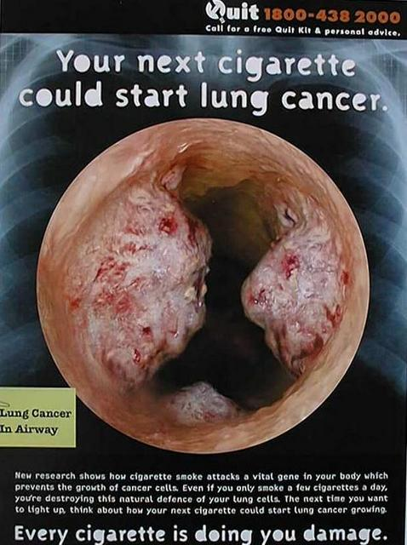
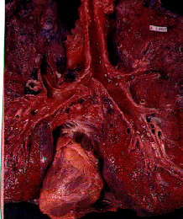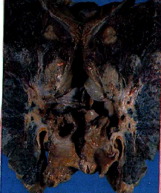

Smoking.
- Smoking is a very addictive habit, very difficult to break.
- It is the #1 cause of preventable death in BC, causing over 30% of all cancer deaths.

Prostate Cancer.
- 2,900 BC men will be diagnosed with prostate cancer in 2010, and 540 men will die from it
- 16,900 Canadian men will be diagnosed with prostate cancer, and 4,200 will die from it in 2010
- 1 in 8 Canadian men will develop prostate cancer

Skin Cancer.
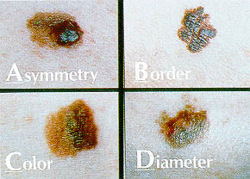

Asexual Reproduction.
- A __________ is an identical genetic copy of its parent.
- Many organisms naturally form clones via _____________________________________.
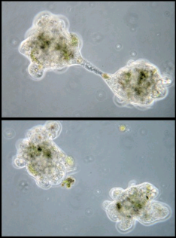
- Cloning is also used in ____________________________________________ to copy desired organisms, tissues and genes.

Types of Asexual Reproduction.
- ___________________________
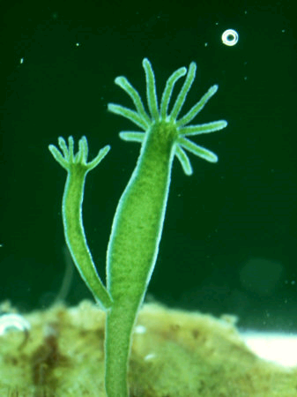
- When a single celled organism (ex. amoeba, paramecium) __________________________________________through the process of mitosis.
- ______________________________
- When areas of some multicellular organisms
(ex. hydra, sponge) undergo repeated mitosis to
form an identical organism. _________ sometimes
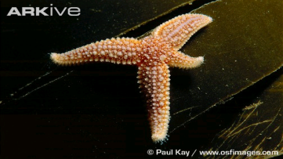
___________________ ______________________________________.
- __________________________________
- When a part of an organism _________________________,
and the part grows into a clone of the parent.
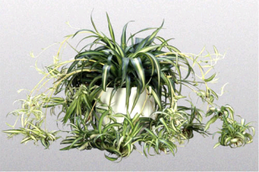
- _______________________ _________________________
- When ____________________________________
________________which remain attached for a
time and may break off to form new adult plants.
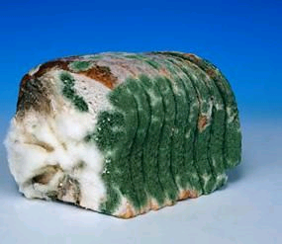
- ________________ ______________________
- When some bacteria, micro-organisms and
fungi can form ____________ - single cells that
can grow into a whole new organism.

Advantages & Disadvantages.
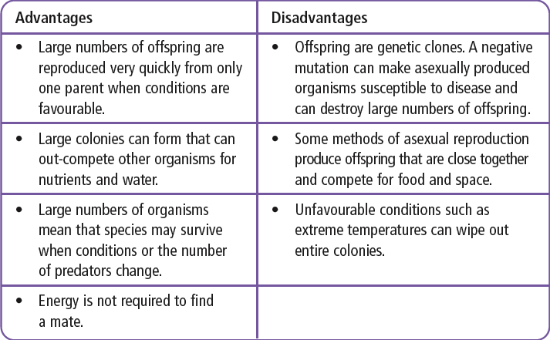

Human Assisted Cloning.
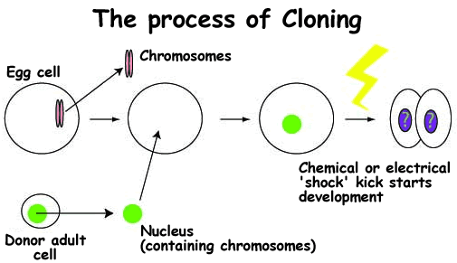
- Humans use all the asexual cloning methods in order to produce ______________________ with organisms. This is done in several ways.
- __________________________________ - purpose is
to produce a genetic duplicate of an existing or dead
organism. Steps involved:
  - Remove ___________ from an egg cell
  - A ____________________________________
is removed from an adult female
  - _____________________ fuses mammary and
egg cell
  - Fused cell begins _________________
  - Dividing embryo is inserted into ______________________ mother

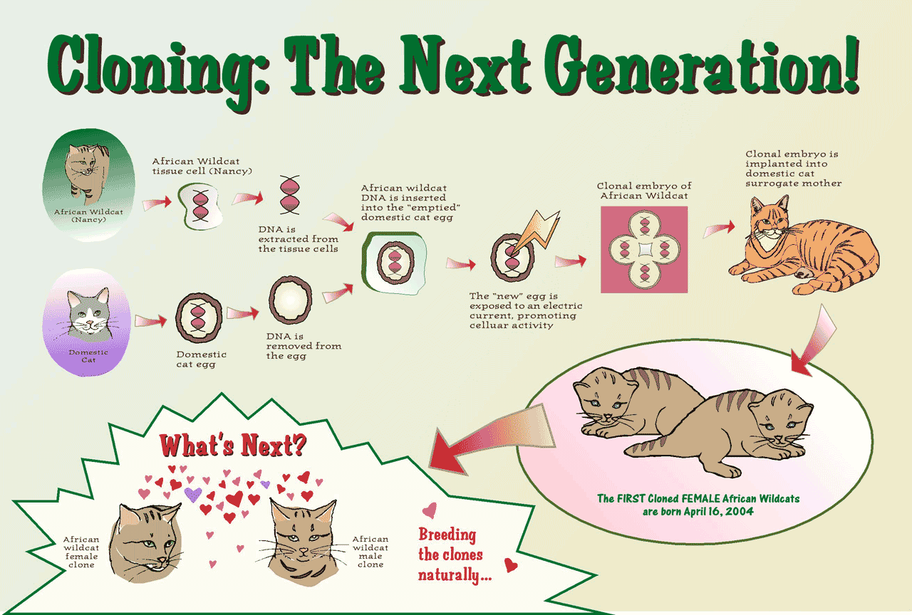

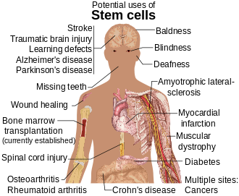
- _______________________________________ - purpose is to correct health problems
  - Very important to therapeutic cloning
are ___________________ - cells that can
become different types of cells
  - Stem cells can be used to replace cells
damaged from injuries or disease
  - _____________,____________________,
___________________________are only a
few that can benefit from stem cell therapy
  - Controversial because the best stem cells are
from embryos which are
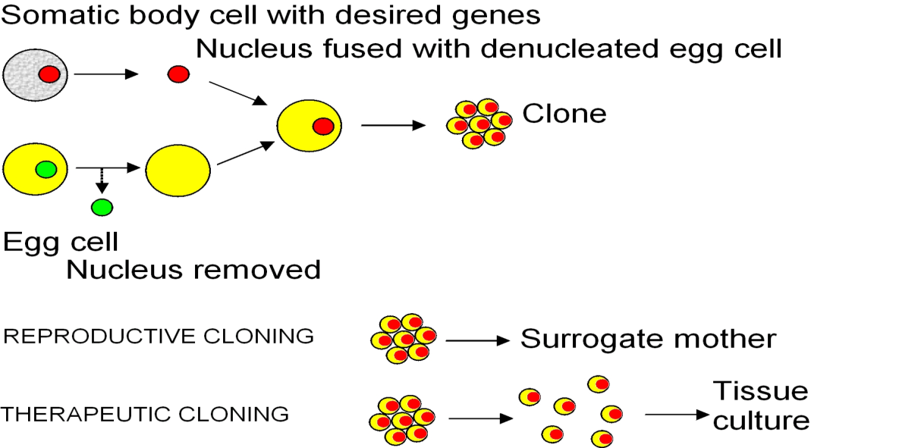
____________________ when harvesting cells.

