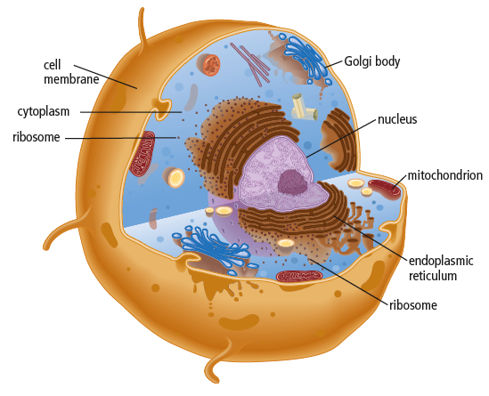
4.1 The Nucleus and Cell Functions.
Cell Parts and Organelles.
- Animal Cells
  - Animal cells are equipped with
many __________________ that allow
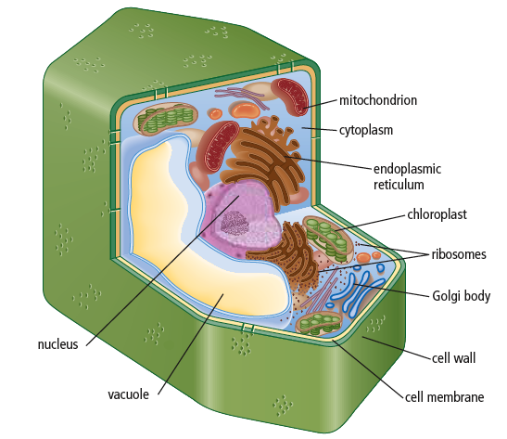
the cell to perform a variety of ____________________.
- Plant cells
  - Plant cells are equipped with some
structures that animal cells ______________
have. CAN YOU IDENTIFY HOW
PLANT CELLS _______________ FROM ANIMAL CELLS?
- Animal AND Plant cell parts
  - ________________ - controls all cell activities.
  - ________________ - membrane - free organelle that makes ribosomes.
  - ______________________________ - protects the contents of the nucleus.
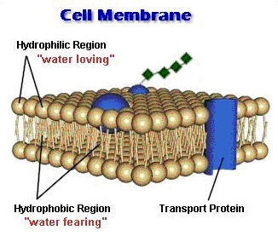
  - ______________________________ - openings in the nuclear membrane that allow only certain materials to pass.
  - ______________________________ -
thin covering that controls the flow of materials in and out of the cell.
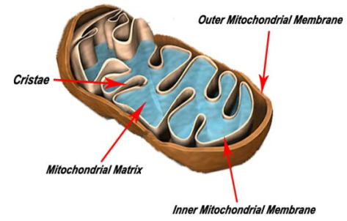
  - ________________________ - jelly-like substance contains the organelles (specialized cell parts).
  - ________________________ - provide energy for cells.
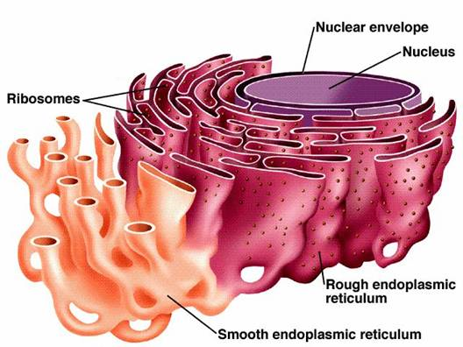
  - ______________________________ - membrane-covered channels that act as a transport system for materials made in the cell.
  - ________________________ - manufacturing plants for proteins.
  - ____________________ - vesicles transport new proteins to the Golgi body.
  - ____________________ - sorts and packages proteins for transport.
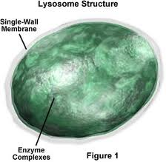
  - ______________ - membrane-bound storage containers.

- Animal organelles NOT found in Plants.
  - ________________ – small vesicles which
have enzymes and that are used for digestion.
  - ________________ - small structures use
to pull chromosomes apart during cell division.
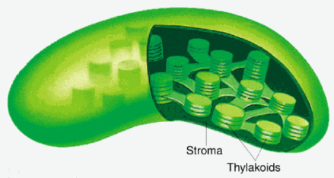
- Plant organelles NOT found in Animals.
  - ____________________ - trap energy from Sun
to make glucose, food for the plant.
  - ____________________ - tough, rigid structure
that surrounds cell membrane, provides protection and structural support.
  - ___________________________ - plant cells are equipped with a large vacuole for storing water.

The Nucleus and DNA.
- The nucleus contains ________________________________________. DNA is the molecule that has the master set of instructions for how cells function, what they will produce, and when they will die.
- Structure of DNA
- DNA looks like a _________________________ - two strands wrap around each other in a ______________________.
- The sides of the DNA ladder are made of ______________ and ____________________.
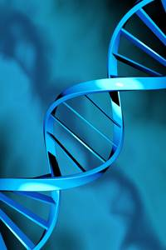
- The steps of the ladder are made of four nitrogen bases: _________________, ______________, ________________, _____________________.
- The bases join in a specific way
  - ____ always joins with ____
  - ____ always joins with ____
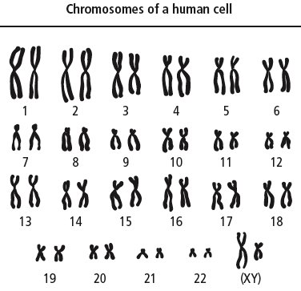
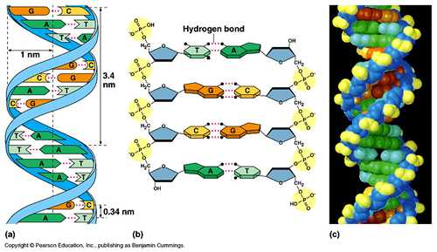
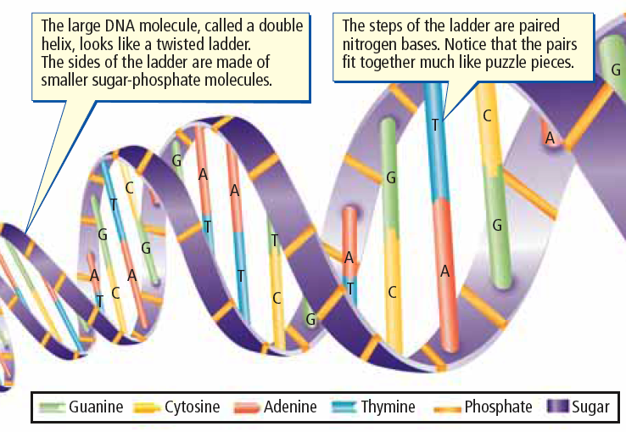
DNA in the Nucleus.
- Most of the time DNA is in the form of _____________________.
- Chromatin coils tightly into X-shaped ______________________.
- Every organism has a specific number of chromosomes.
- Human cells have ____________________ arranged in _______________.
- The 23rd pair determines sex; _______ for females and _____ for males.
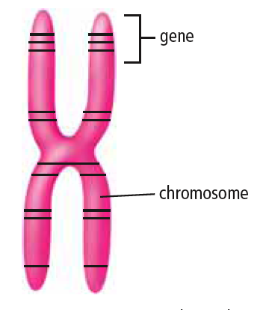
Genes.
- _________ are small segments of ______ located on
a _____________________.
- Genes ______________________________ needed
to __________________________.
- Each chromosome can carry thousands of genes.
- All your body cells have the same genes, but only
specific genes are “read” in each cell to produce specific proteins.
- Specialized _____________ called _______________
and ___________________ carry out important specific functions in the body.

Production of Proteins.
- Protein production in the cell involves several important steps:
  - The ____________ receives a ___________________ to make
a ____________________________.
  - The _______ message for the protein is ___________ into a small molecule called ____________.
  - RNA __________ the _______________ through a nuclear pore.
  - The RNA message is delivered to a ___________________, the ribosome ____________ the ________________.
  - The manufactured protein enters the _______________________________ (ER).
  - A ________________ forms at the end of the ER, and carries the protein to
the _____________________.
  - The _____________________ __________________ the protein for transport out of the cell.
  - A ______________ forms off the end of the Golgi body to __________________ to the ________________________.
  - The _________________ attaches to the ________________________, and its protein contents are released out of the cell.

Exporting the Protein
Making the Protein

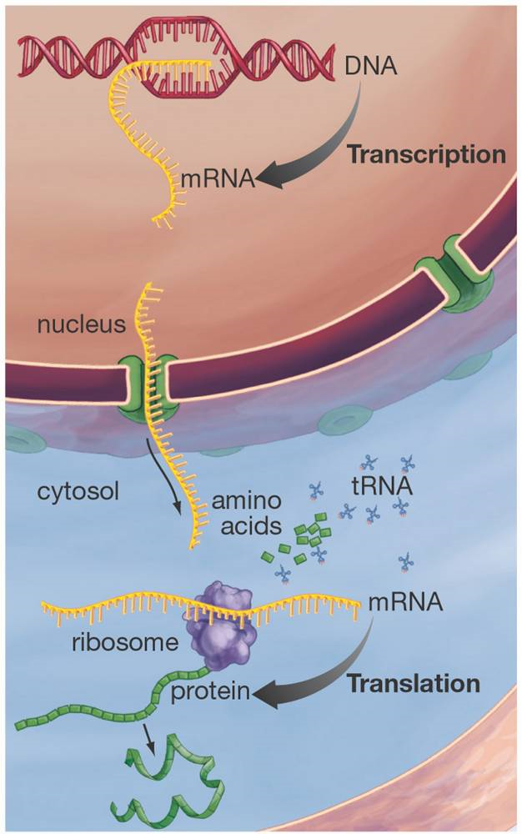
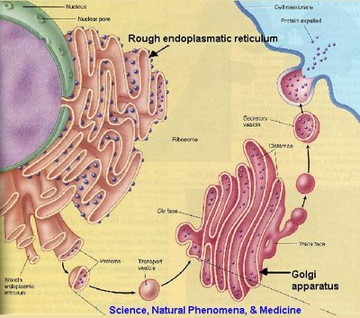
Why do we need Proteins?
- ________ of your _______________ is made of _________________
- Everything from ______, ______, ________, _____________, _____________, _______________, ______________, ________, and even _______________________.
- _________________________ are the building blocks of proteins and we get our amino acids from many different sources of protein.
  - Can you think of any good sources of protein in our diets?
Some Important Proteins in our Body.
Structural:
________________ under skin, _______________ in our skin, ______________ in our tendons, ________ and _____________ in muscles.
Functional:
_______________________________ to fight infection (antibodies), __________________ to carry oxygen, _____________________ like adrenalin and insulin, _____________ like maltase, trypsin, amylase for digesting food, ____________________ to make our skin darker (pigment) to protect from UV rays.
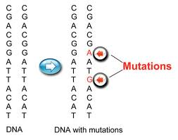
4.2 Mutations.
- A gene mutation involves a change in the
________________ (A,C,T,G) that make
up the gene. There are several types of gene mutation:
  - _______________ (base missing)
  - _______________ (extra base added)
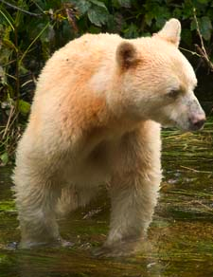
  - _______________ (base substituted for another)
- Gene mutations may produce proteins that
are ___________ or __________________
to the organism, or may have ______________ at all.
- Example: a particular mutated gene produces
white coat Kermode bears - they occur as only a
small percentage of the population (they are normally black in colour).
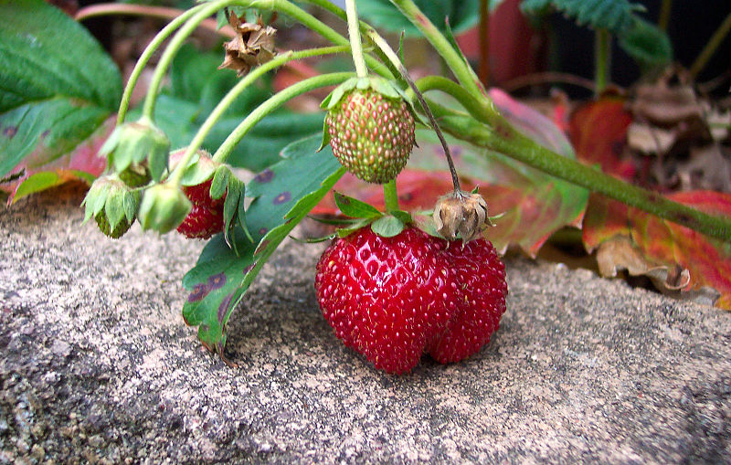
Effects of Mutations.
- Positive Mutations
  - When a gene mutation
____________________ the individual.
  - Example: Some plants have developed
resistance to bacterial and fungal infections.
- Negative Mutations
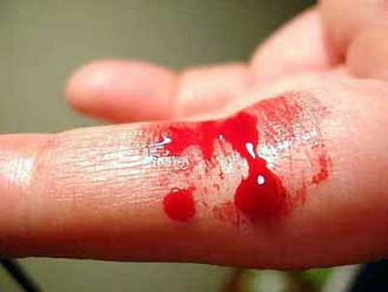
  - When a gene mutation _____________ the individual
  - Example: Sickle cell genes in affected humans
cause blood cells that are abnormally shaped.
  - Hemophilia disorder when clotting does not occur.
- Neutral Mutations
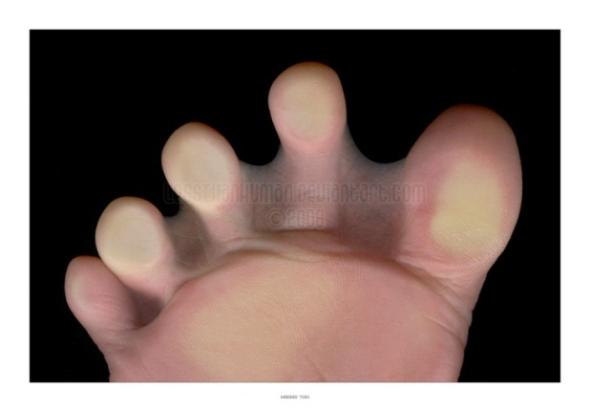
  - When a gene mutation has
  - ______________ on the individual
  - Example: The white Kermode bear or
frog with an extra leg, or humans with webbed toes.

Mutagens & Mutation Repair.
- ___________________ are substances or factors that cause mutations
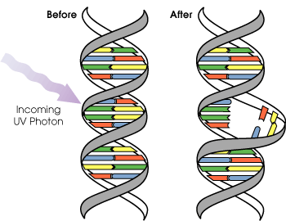
- Environmental mutagens such as ___________, ________________________, _______________________, and _________________________ can cause mutations.
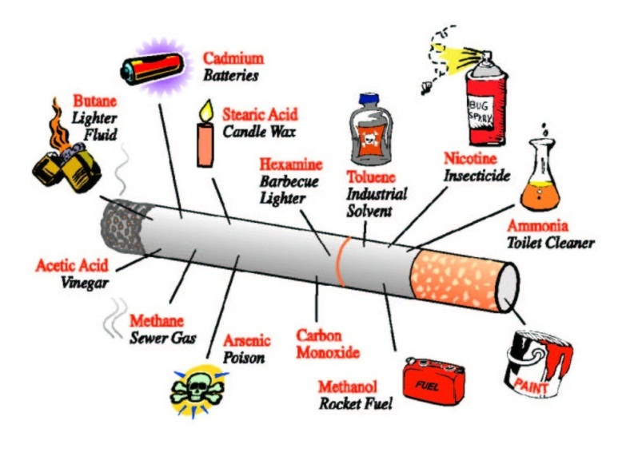

- Correcting mutations is difficult, but new techniques such as _________________________ offer hope.
- Gene therapy is complicated and experimental:
  - A ________ is engineered to carry a _____________________.
  - The normal gene must then ____________ the __________________________.
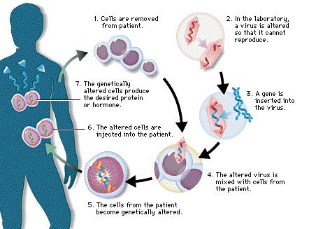
  - The normal gene must then be “____________________________” so that the replacement normal gene produces the proper _________________________. It is also important that the normal gene make the correct amount of healthy protein.

