3.1 Compounds
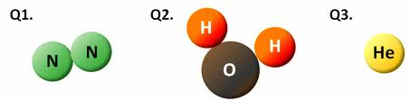
- Compounds are pure substances made _____________________________________ joined together. The atoms are held together with _____________________.
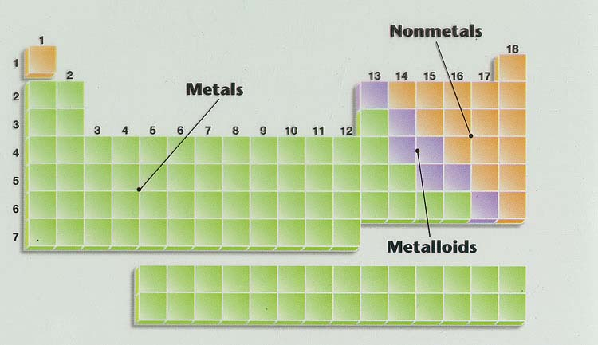
- Compounds come in two basic types:
___________________________________.
- To determine whether a compound is covalent
or ionic, the _________________________ is required.

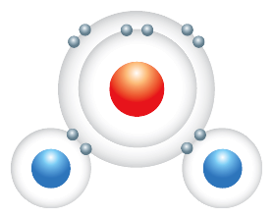
Covalent Compunds.
- Covalent compounds are
made up of two _____________________.
- Covalent compounds ___________________
to form molecules. Example: water.

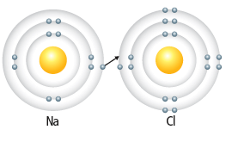
Ionic Compounds.
- Ionic compounds are made up
of a _______ and a __________________.
- In ionic compounds, atoms ____________ or
___________ to form ions. Example: NaCl.
- Ionic solids exist as a solid in the form of an _________________.
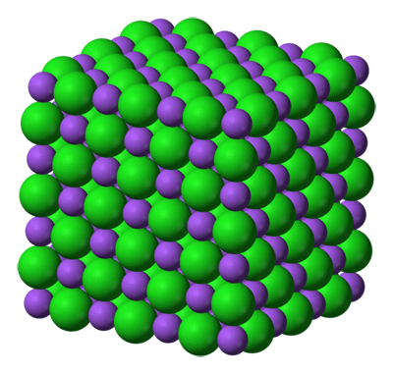
- The positive ions ______________ all of the negative ions, and vice versa. In the example of table salt (NaCl) the one-to-one ratio of ions results in a simple square-shaped ionic __________________:
Polyatomic Ions.
- Covalent and ionic bonds can occur ________________.
- A molecule can gain or lose electrons to become charged,
forming a ________________________.
- Polyatomic ions form __________________ like other ions.
  - Example: _______________________________

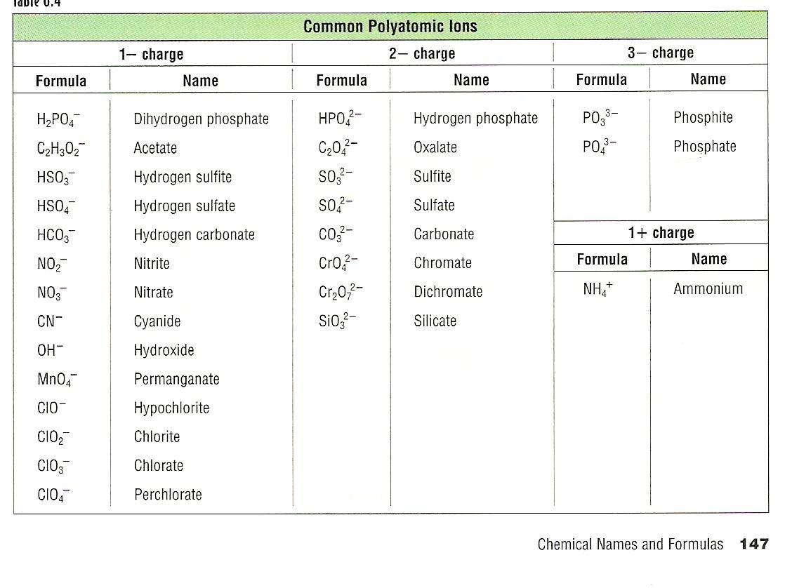

3.2 Names and Formulas of Ionic Compounds.
Naming Simple Ionic Compounds.
- Rules for naming simple ionic compounds:
  - Write the name of the _____________________________________.
  - Write the name of the _____________________________________________.
  - Change the ending of the non-metal ion to “_____________.”
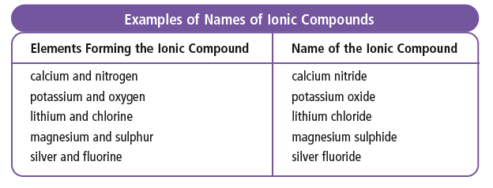
- Examples:
- Li₃N __________________________
- MgBr₂ __________________________
- Ag₂O __________________________
- CdS __________________________

Writing Formulas for Simple Ionic Compounds.
- Rules for writing formulas for ionic compounds:
STEP ONE: Write the ___________ for the more ___________________________. Then, write the symbol for the non-metallic element.
STEP TWO: Write the _________________________ for the elements. Ignore the + and – charges. *If there is ___________, the combining capacity is _____.
STEP THREE: _____________________ the combining capacities to get the subscripts.
- Examples:
- Barium phosphide __________________
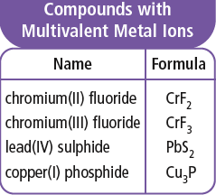
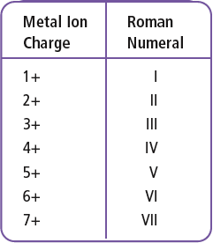
- Aluminum nitride __________________
- Zinc oxide __________________
- Rubidium bromide __________________

Multivalent Metal Compounds.
- Many metals are multivalent, meaning the metals form two or more __________________________ with different charges.
- For example, the atom iron forms two ions _____________________.
- To distinguish different ions for the same metal, ___________________ are
added to their name. For example, Fe³⁺ would be named “iron(III)”
Writing Formulas for Ionic Compounds Containing Multivalent Metals.
- It is __________ to __________________________ for multivalent ionic compounds, because they ___________________________________ so you don’t need to look on the periodic table.
- Examples:
  - Iron (II) phosphide ____________________
  - Manganese (II) oxide ____________________
  - Tin (II) sulfide ____________________
  - Lead (IV) chloride ____________________

Naming Ionic Compounds Containing Multivalent Metals.
- It is a little _____________________________ a multivalent ionic compound, because you have to _________________________ to figure out which combining capacity was used. Remember to use a __________________________.
- Examples:
  - Fe₂O₃ __________________________
  - PbF₄ __________________________
  - MnS __________________________
  - TiS₂ __________________________

Naming Ionic Compounds Containing Polyatomic Ions.
- When you are naming compounds with _____________________________________, you are dealing with a __________________. All you need to do is ________ it in the chart so you can name your compound.
- If the polyatomic ion group has a _____________________ (+) it acts like a _____________ and _____________________ in the name.
- If the polyatomic ion group has a _____________________ (-) it acts like a _____________ and ______________________ in the name.

- Examples:
- Fe(OH)₃ ________________________
- Mg₃(PO₄)₂ ________________________
- (NH₄)₃P ________________________
- Ca(CH₃COO)₂ ________________________

Writing Formulas for Ionic Compounds Containing Polyatomic Ions.
- Each polyatomic ion _______________________________ that should be used when writing a chemical formula.
- USE BRACKETS AROUND THE POLYATOMIC IONS!!
- Examples:
- Sodium chromate ____________________
- Ammonium nitrate ____________________
- Lead (II) perchlorate ____________________
- Tin (II) cyanide ____________________

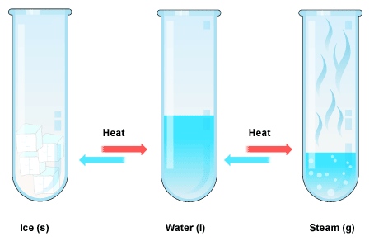
3.3 Physical and Chemical Changes.
- In ____________________________, the _______________ of a substance changes, but the ________________________ holding the substance together do not change.
  - Examples: _________________, ___________________, ___________________
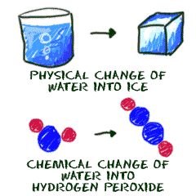
- In ________________________, new substances are produced in the process of ________________________________________and forming new ones.
- Evidence of chemical change:
- Colour change
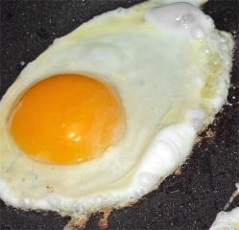
- Heat, light, sound produced or consumed
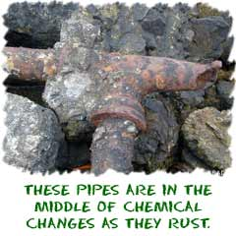
- Bubbles of gas form
- Formation of a precipitate
- The change is difficult to reverse

Energy Changes.
- In both physical and chemical changes,
_____________________ take place. This energy
change can mean ____________________________
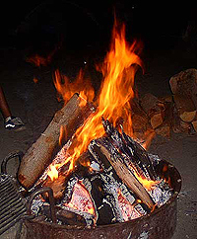
energy from the environment.
- ___________________________ involve the
overall _____________________ in the form of heat and light.
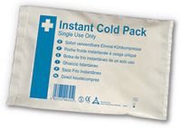
- ________________________________ involve the
overall ______________________________.

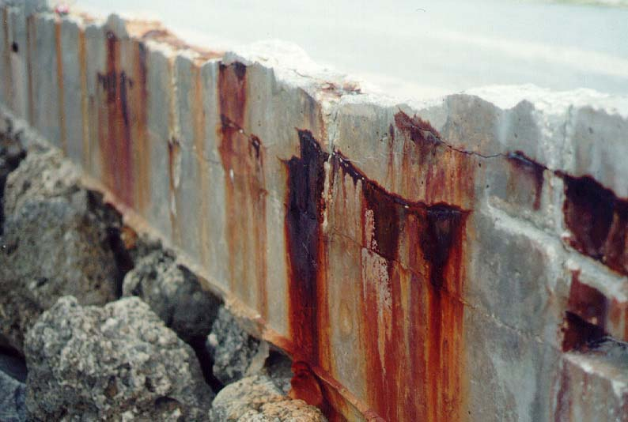
Applications of Chemical Changes.
- Some chemical changes present __________________,
while others provide _____________________
_______________________.
  - ________________ is a major problem for _____________________________.
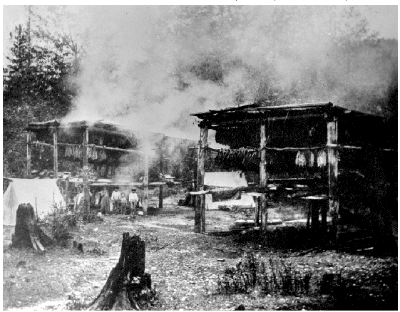
  - By protecting steel surfaces, the chemical reaction of iron with oxygen can be prevented.
- First nations people of the Pacific Coast have used smoking as a means
of ______________________. Smoke causes chemical changes in meat
that __________________________.

