2.1 Elements
- Why are elements studied in chemistry?
  - Chemistry is the study of _______________________________.
  - Elements make up an incredible variety of different ________________.
  - By studying elements, we can learn more about the _____________________________.
- An element is a pure substance that cannot be broken down or separated into simpler substances. Each element is __________________________.

Chemical Symbols.
- Element names and symbols
  - Because elements have different names in different languages, chemists use ____________________________ for them.
  - Chemical symbols consist of ________________________.
  - ___________________ are used as the source of many of the symbols.
    - Example: Mercury - Hg - Hydragyrum (Latin for liquid silver)
- All elements are represented by __________.
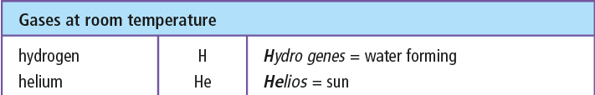
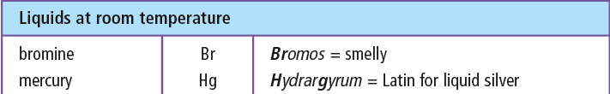
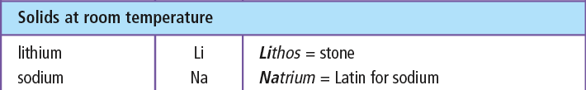

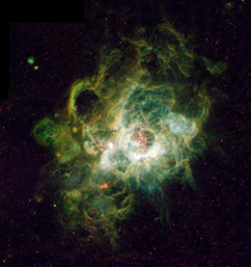
Common Elements.
- Hydrogen
  - Colourless, odourless, tasteless, and __________________ gas.
  - Makes up over ____ percent of the atoms in the universe
  - Used in producing _______________.
  - Lighter than _______.
  - Can be separated from water or gasoline and be used as a source of __________.
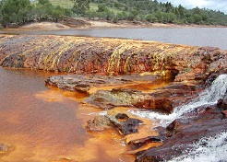
- ______________
  - Mixed with carbon to make _________.
  - Good structural material, but can _________ when mixed with water.
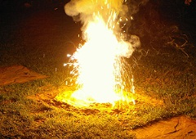
- ____________
  - Gaseous element we __________.
  - _____ % of the atmosphere.
  - Reacts with most other _____________.
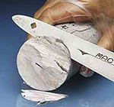
- _____________
  - soft metal that reacts with water
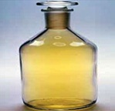
- _____________
  - yellow-green gas that is highly toxic
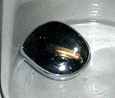
- _____________
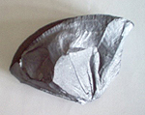
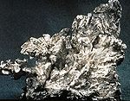
  - liquid at room temperature metal.
- _____________
  - precious metal mined in British Columbia
- _____________
  - brittle, grey, semiconductor that is second most common element in Earth’s crust.

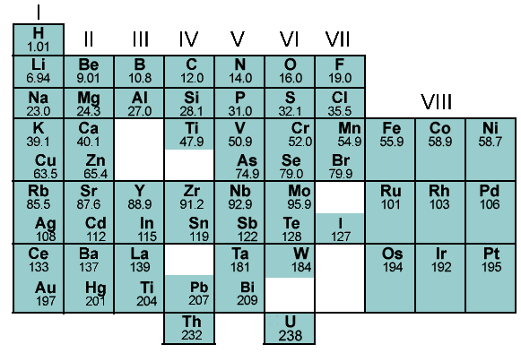
2.2 Periodic Table.
- Origin of The Periodic Table
  - Chemists in the 10th century wished to _______________________.
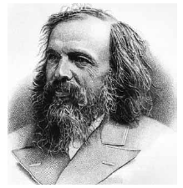
  - Attempts focused on grouping elements with __________________________.
  - In 1867, _______________________ found patterns in the elements and organized them into a table.
  - The resulting table had holes for elements not yet __________________.

Periodic Table.
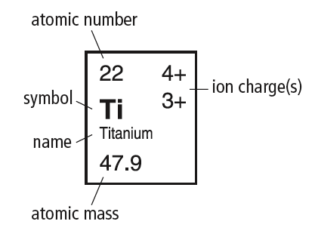
- The Periodic Table provides information on the _________________________ of elements.
Atomic Mass - mass of average atom
Atomic Number - number of protons
Ion Charge - electric charge that forms when an atom gains or loses electrons

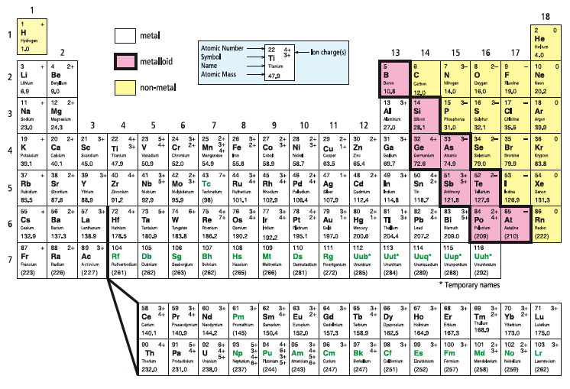
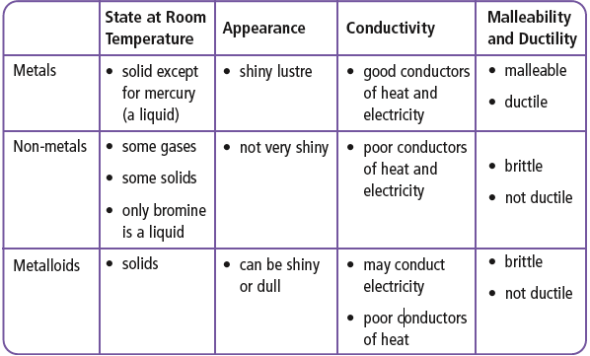
Metals, Non-metals, Metalloids.

Periods and Families.
- Each horizontal row in the periodic table is a __________.
- Vertical columns form _________ or ___________________________.
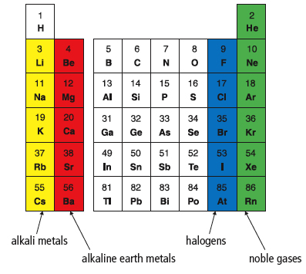
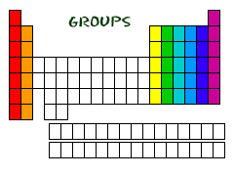
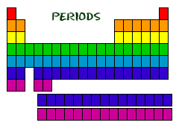
- Alkali metals - highly reactive group 1
- Alkaline earth metals - group 2, burn in air if heated
- Halogens - group 17, highly reactive non-metals
- Noble gases - group 18, stable and unreactive
non-metals
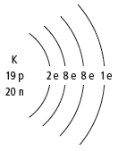
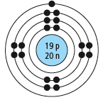
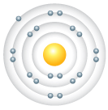
2.3 Periodic Table and Atomic Theory.
Bohr Model.
- __________________ show electron
arrangement in shells.
- Elements with similar properties have similar ________________________.
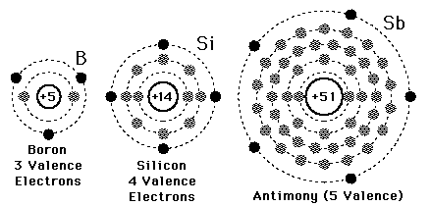
- Chemical families on the periodic table have the same number of ______________________.

Bohr Model Patterns.
- Elements in the ________________ have the _____________________________.
- _____________________ indicates the number of ____________________.
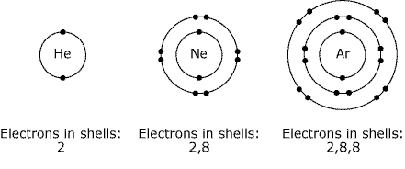
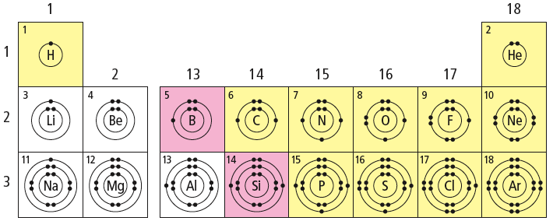
Atom Stability.
- Noble gases are very _______________ because their
have filled _____________________.
- Filled shells make ____________________.
- Atoms with filled shells do not easily trade or share __________________.
- Other atoms _________________________ in order to achieve the _______________of noble gases. Gaining or losing electrons makes atoms into ______________.
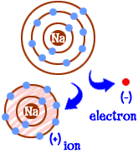
- _____________lose electrons to form _____________ ions.
- __________________ gain electrons to form _____________ ions.
- Ions have a similar electron arrangement to the nearest _______________.

