3.1 How Changes Occur Naturally in Ecosystems

Change in organisms
-the process that causes change in living things is called ____________________________________________________

-natural selection means that ______________________________
__________________________________________________________________________________________________________

Example:
#1

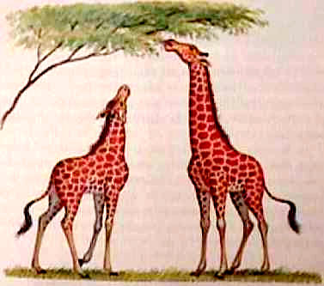
#1
#2

Giraffe #1 – shorter neck

Giraffe #2 – longer neck

Which giraffe will have the advantage if all the low-lying vegetation becomes grazed by a competing species?

-__________________ occurs when a common ancestor “diverges” into a number of different species over time
(e.g. Darwin’s Finches)
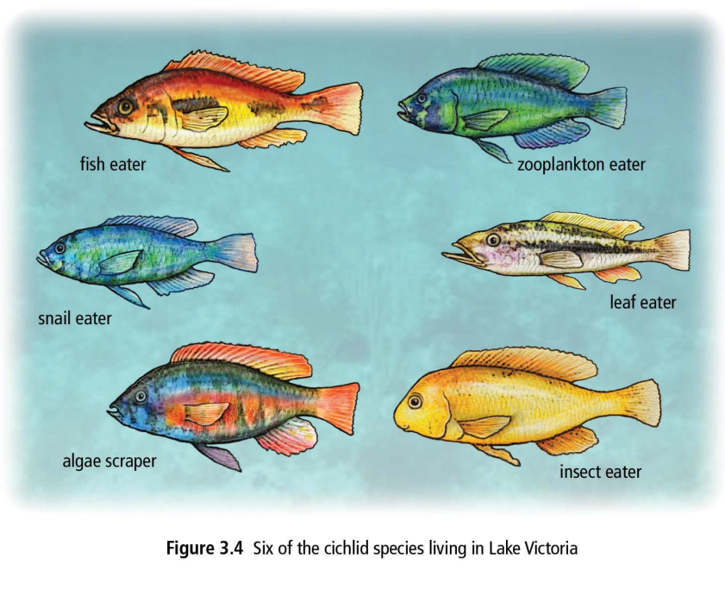
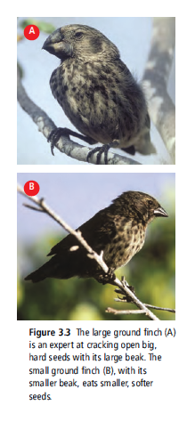

-The thirteen different finch species on the Galapagos Islands are descendants of a single ancestral finch from the mainland of South America
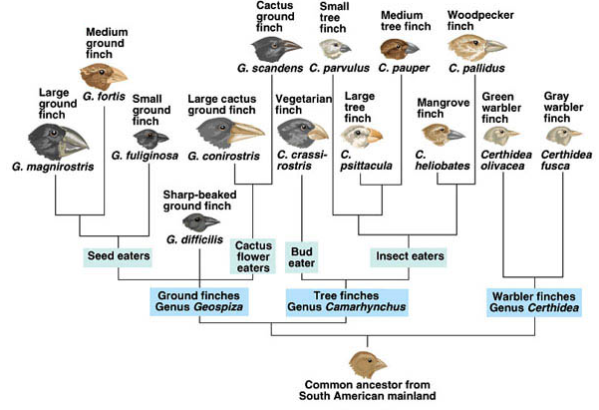

 | Species  Name | Common  name | Habitat  and  Niche  (food type) | Beak type:  -probing  -grasping  -crushing
1. | G. conirostis | Large cactus ground finch | Cactus flower eater | probing
2. | G. difficilis
3. | G. fortis
4. | G. fuliginosa
5. | G. magnirostris | Large ground finch | Seed eaters | crushing
6. | G. scandens
7. | C. crassirostris
8. | C. psittacula
9. | C. pauper
10. | C. parvulus | Medium tree finch | Insect eater | grasping
11. | C. pallidus
12. | C. heliobates
13. | C. olivacea  C. fusca

Ecological Succession
Ecological succession is __________________________________
__________________________________________________________________________________________________________

There are two types of ecological succession:

- ______________________ – occurs where no soil exists, such as bare rock (e.g. retreating glaciers, cooled lava).
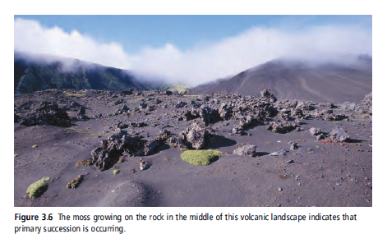

___________________
are the first organisms
to appear
(e.g. lichen).

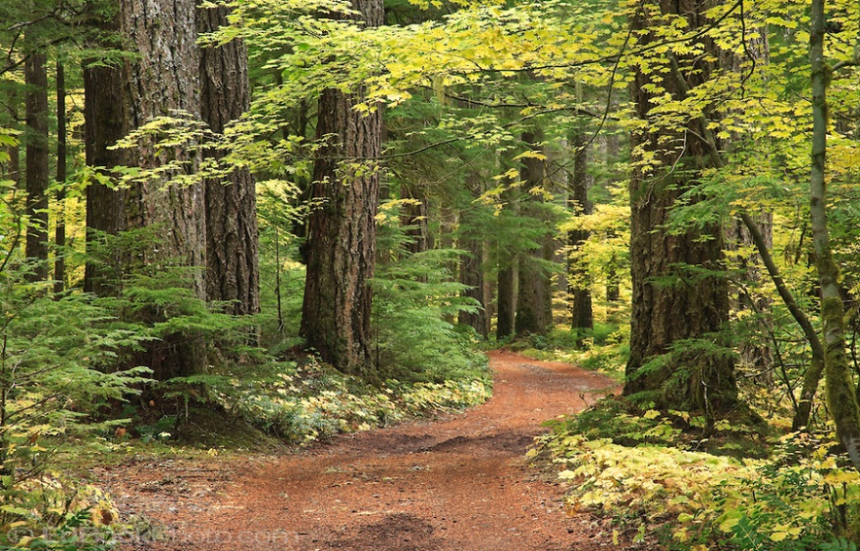
Succession ends with a stable

________________________
(e.g. old growth forest)

Stages of Primary Succession
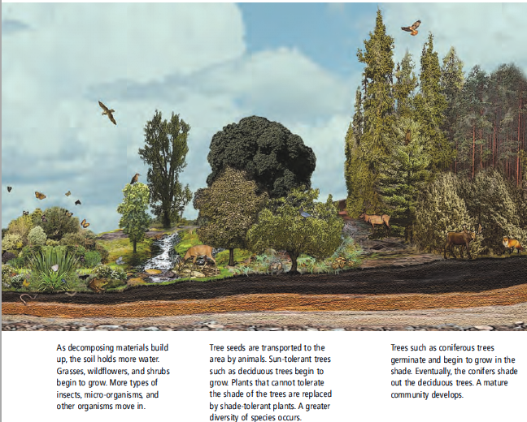
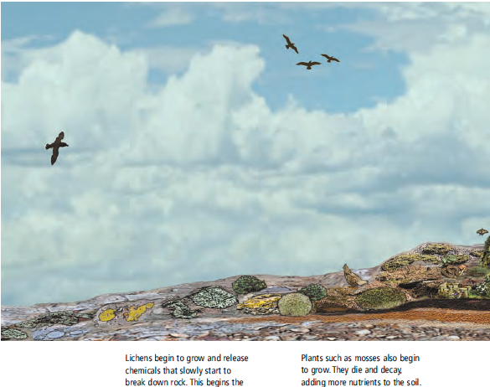

- Bare rock
- Pioneer species (e.g. Lichens)
- Mosses
- Insects, microorganisms, and other organisms move in.
- Grasses, wildflowers, shrubs
- Tree seeds brought in by animals. Sun-tolerant (deciduous) trees begin to grow.
- Coniferous trees begin to grow.
- Mature community develops

2) ___________________ – occurs after a disturbance takes place, but the soil remains intact (e.g. forest fire, clear-cut)
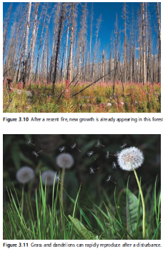

Natural events that harm ecosystems:
1)
2)
3)
4)
5)

3.2 How Humans Influence Ecosystems

Sustainability and Resource Exploitation
-the ability of an ecosystem to sustain ecological processes is called __________________.

-sustainability can be adversely affected through:

1) __________________________
(e.g. cities, roads, industry, agriculture, recreation)

2) __________________________
(e.g. obtaining and use of soil, wood, water, gas, oil, minerals)

Effects on ecosystem’s biodiversity and health:

Effect Example

1) _____________________ -destruction of bamboo forests in China, Panda’s food source

2) _____________________ -Three Gorges Dam on China's Yangtze River, dividing river

3) _____________________ -clear-cutting of Amazon rainforest

4) _____________________ -overworked land and drought created the “dust bowl” (1930s)

5) _____________________ -damage due to heavy modern tractors and farm equipment

6) _____________________ -BP oil disaster (Gulf of Mexico, 2010)

7) _____________________ -over-fishing of Atlantic cod lead to a ban in the 1990s

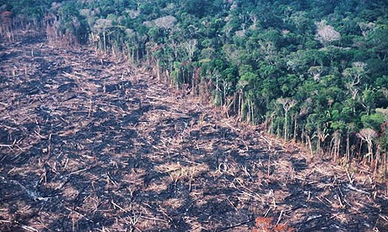
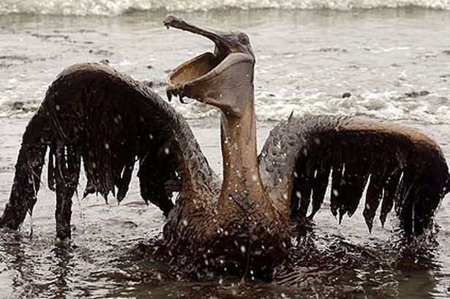
The 3 Gorges Dam in China is a major hydroelectric project that divides the Yangtze River.

An example of clear-cutting of the Amazon rainforest in Brazil.

Birds and aquatic life were greatly affected negatively by the BP oil disaster of 2010.

3.3 How Introduced Species Affect Ecosystems

-_________________________________ _____________ are called native species.

-ecosystems can be disturbed when _____________________________________

_____________________________________________________________________

Introduced species fall into three categories:
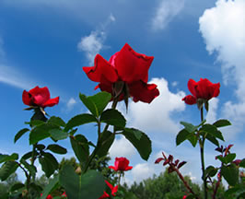
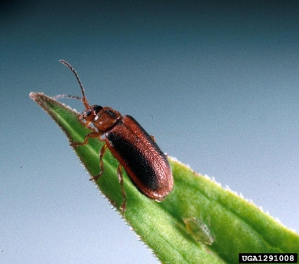
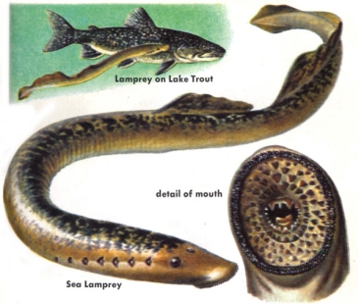

- Harmless 2. Beneficial 3. Invasive!

1) _________________________ – e.g. roses introduced into a garden

2) _________________________ – e.g. European leaf-feeding beetle eats the
invasive plant “purple loosestrife”

3) _________________________ – major cause of biodiversity loss, harm native
species in various ways.

5 Ways invasive species cause harm:

i) __________________– e.g. scotch broom competes with Garry Oak on Van. Island.

ii) _________________– e.g. American bullfrog eats native frogs

iii) _________________ –e.g. West Nile virus has spread to North America

iv) _________________ -e.g. sea lampreys parasitize fish in the Great Lakes

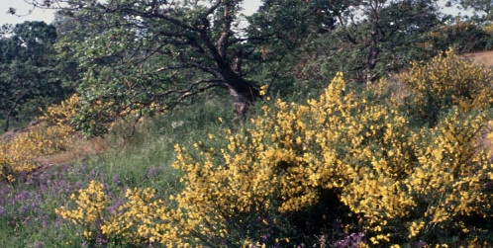
v) _________________– e.g. Eurasian milfoil forms dense mats on lake surfaces

Scotch broom plants (yellow bushes) are an invasive species that threatens the native Garry Oak on Vancouver Island.

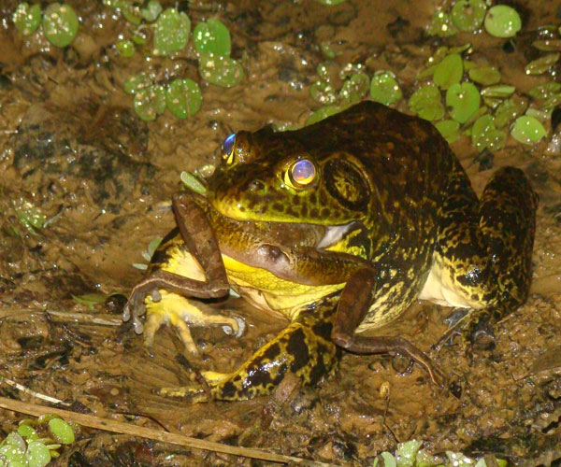
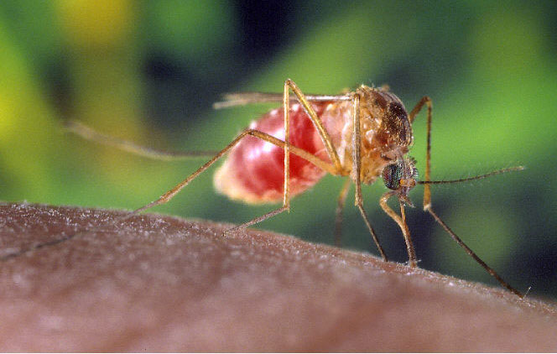
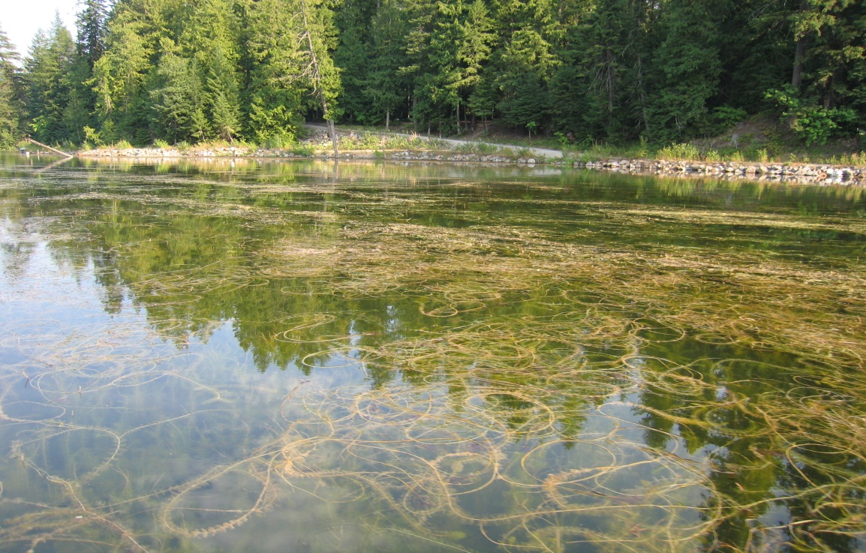

Eurasian milfoil threatens the lake ecosystems of Ontario rapidly changing its abiotic factors.

West Nile virus, originally from East Africa, spread to North America via birds and mosquitos.

American bullfrogs not only compete with other native frog species…they eat them!

