2.1 Energy Flow in Ecosystems

Food Chains and Food Webs

_______________ through an ecosystem is represented by arrows:

1) Sun –
2) Producers –
3) Consumers –
i) herbivores –
ii) carnivores –
iii) omnivores –
iv) detritivores –
v) decomposers –

__________________ show the one-way flow of energy through an ecosystem.

Each step is called a trophic level:
__________________= 1st trophic level
__________________= 2nd trophic level
__________________= 3rd trophic level
__________________= 4th trophic level
__________________= 5th trophic level
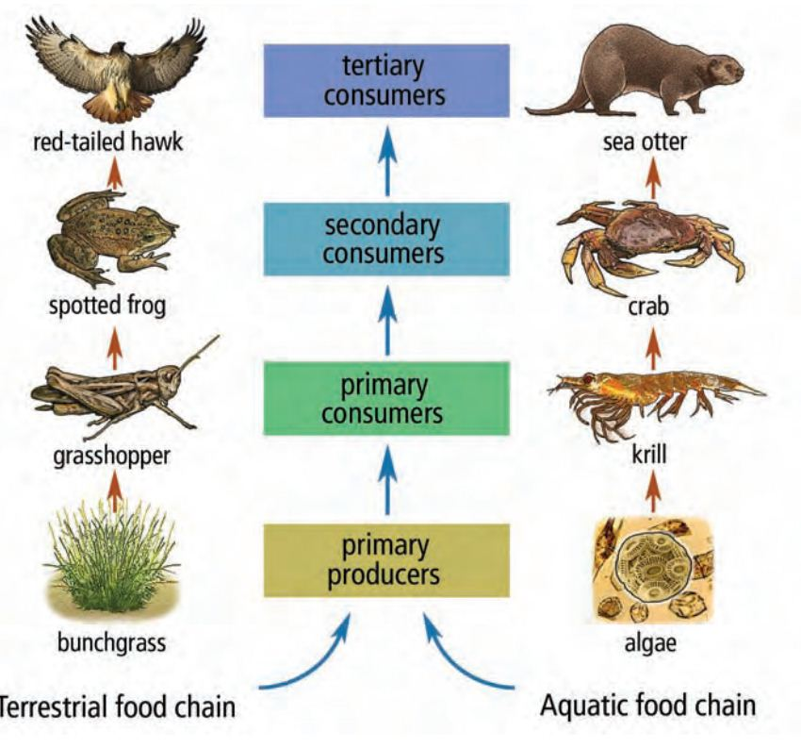
Example: terrestrial ecosystem

grass → grasshopper → mouse → snake → hawk

__________________ show interconnected food chains

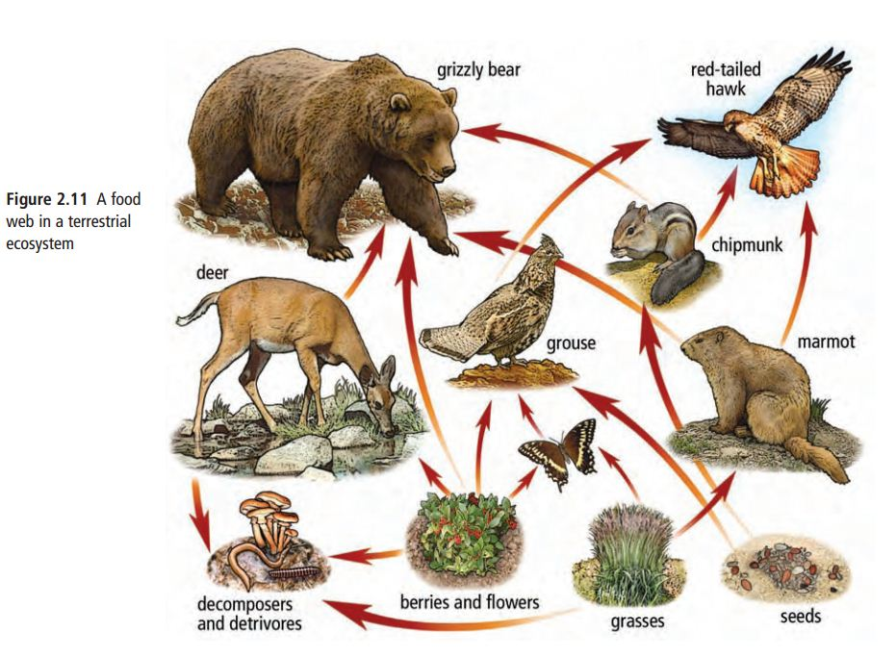

Food Pyramids
-food pyramids (= ecological pyramids) show the _______________________ from one trophic level to another

-approximately _______% of the energy taken in at each trophic level is used in chemical reactions and is lost as ___________

____ kJ

____ kJ

____ kJ

100 kJ

-there are three types of ecological pyramids:

1) Pyramid of Energy –

2) Pyramid of Biomass –

3) Pyramid of Numbers –
There are three types of ecological pyramids:

1) Pyramid of Energy
– shows the amount of energy available at each trophic level (in kcal/m²/year)

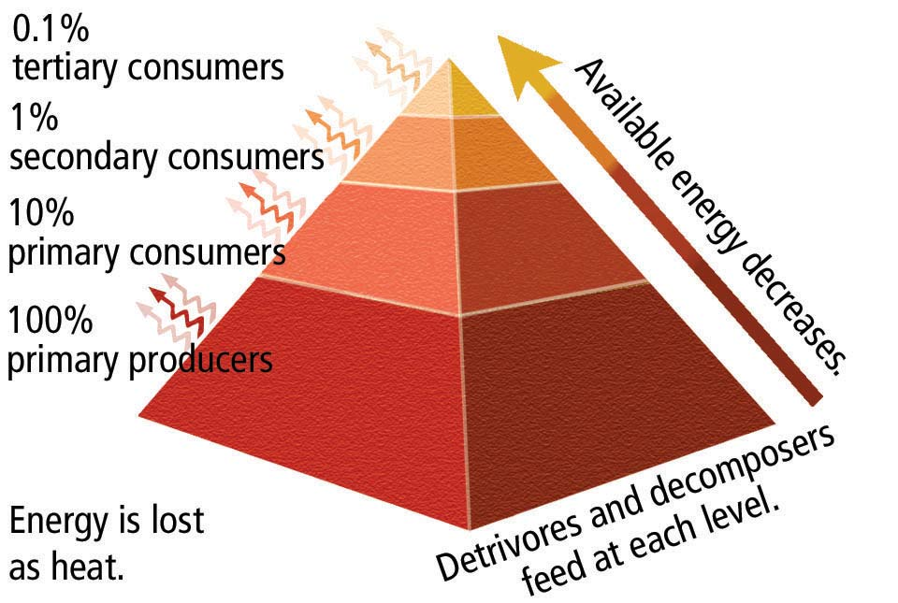

2) Pyramid of Biomass
– shows the amount of biomass (total mass of organisms in a given area) at each trophic level (in g/m²)
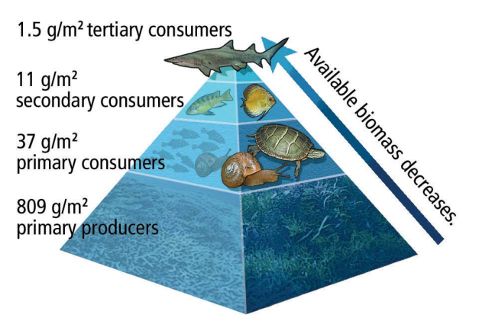

3) Pyramid of Numbers
– shows the number of individual organisms at each trophic level
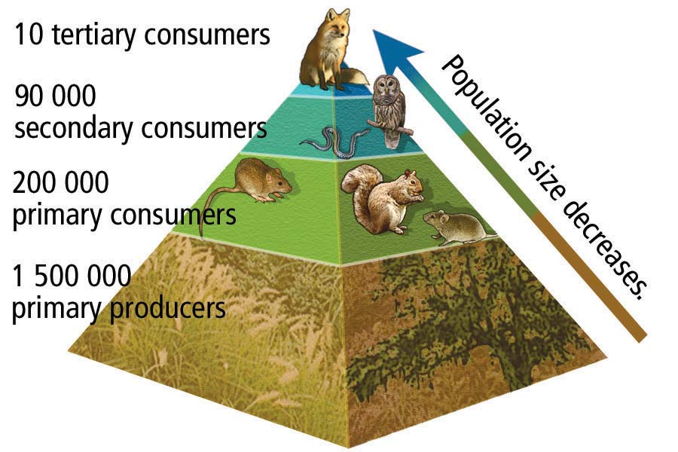
2.2 Nutrient Cycles in Ecosystems

Nutrients

-___________________ are chemicals required for plant and animal growth and other life processes

-nutrients are accumulated in _____________________

(e.g. living organisms, atmosphere, oceans, and land masses)

-the flow of nutrients in and out of stores is called a

_____________________

There are three main nutrient cycles:

1)

2)

3)

Carbon Cycle

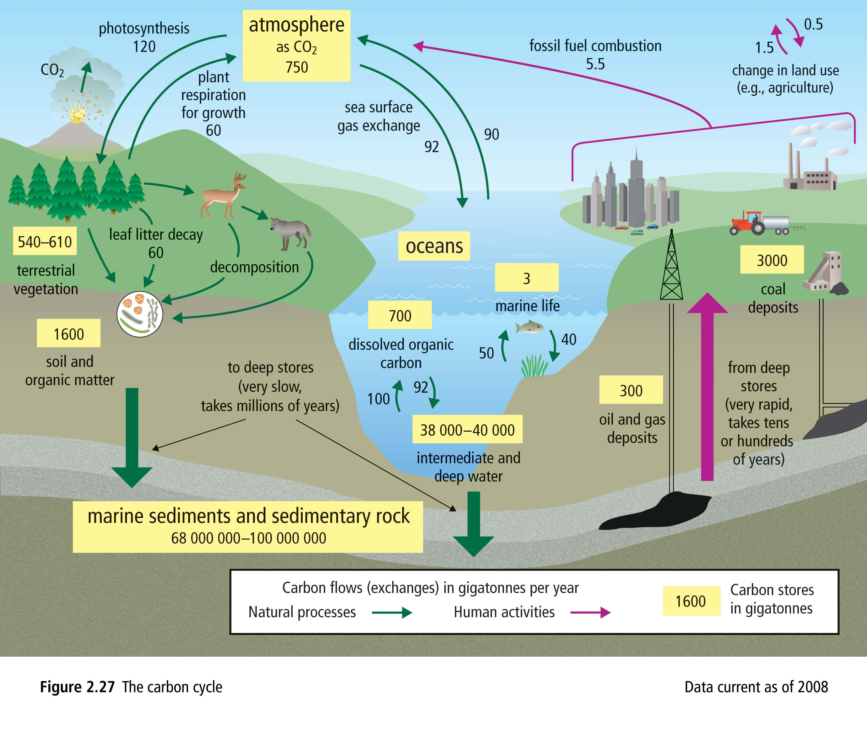

Nitrogen Cycle

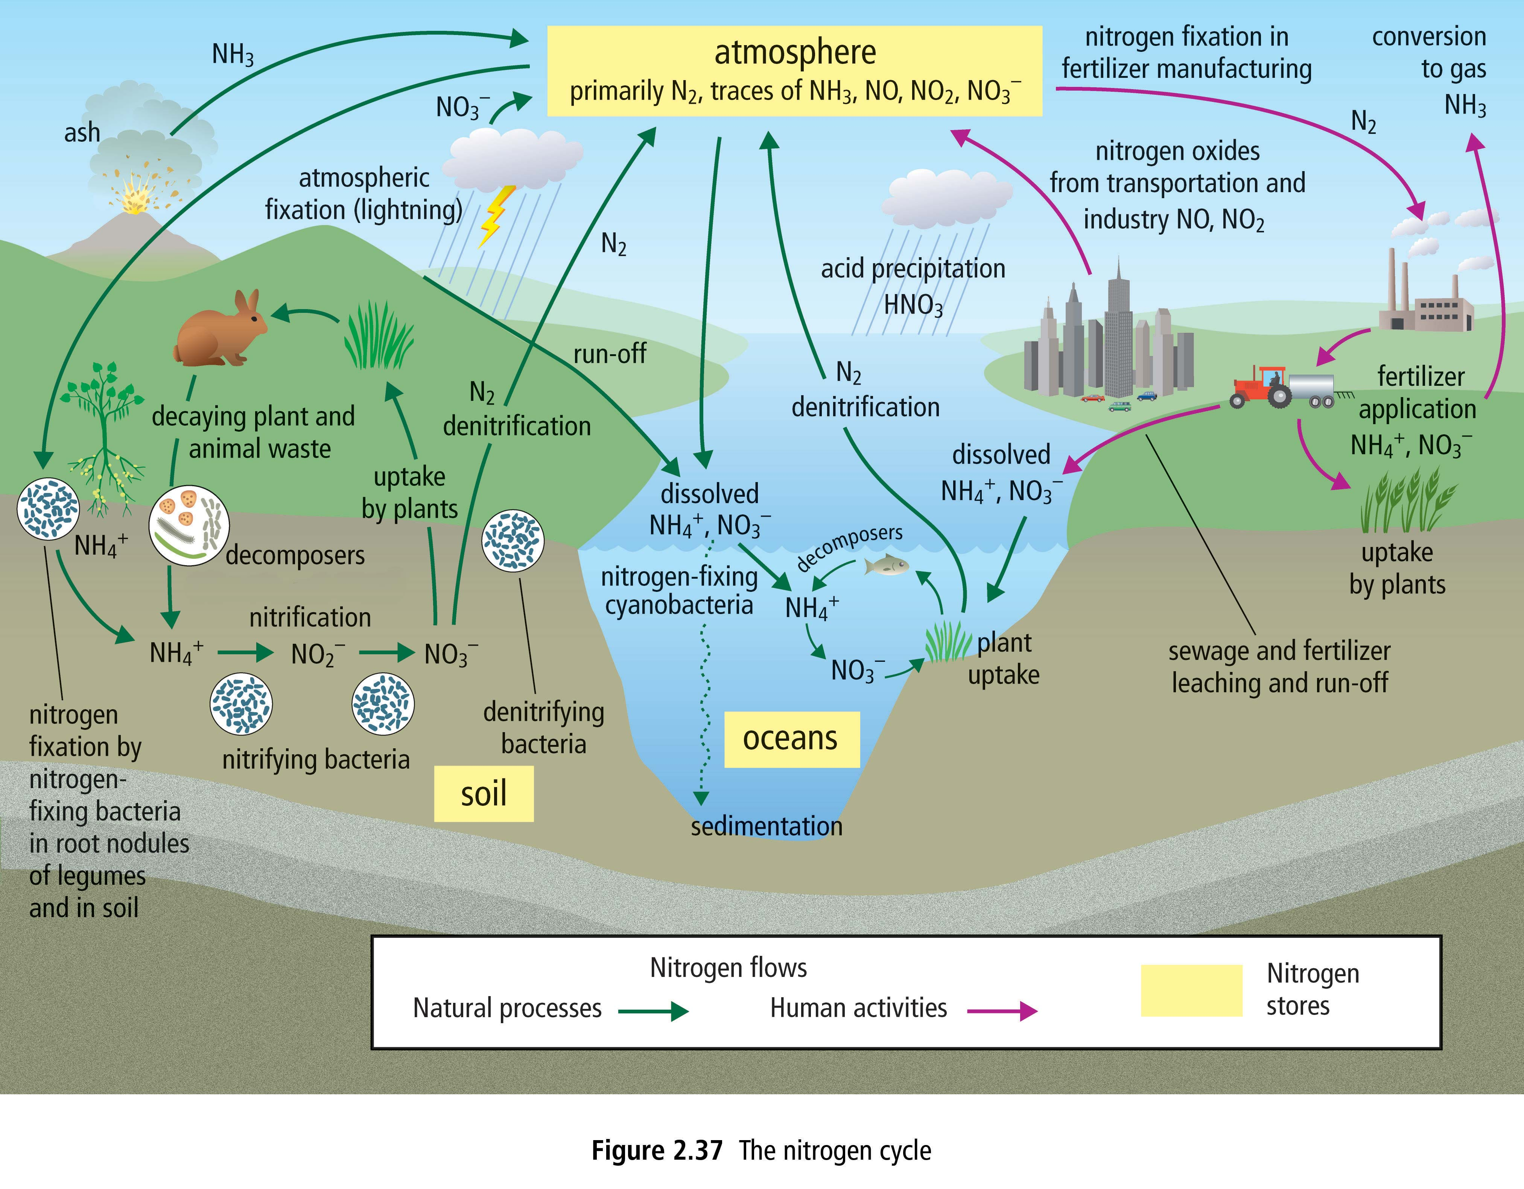

Phosphorus Cycle

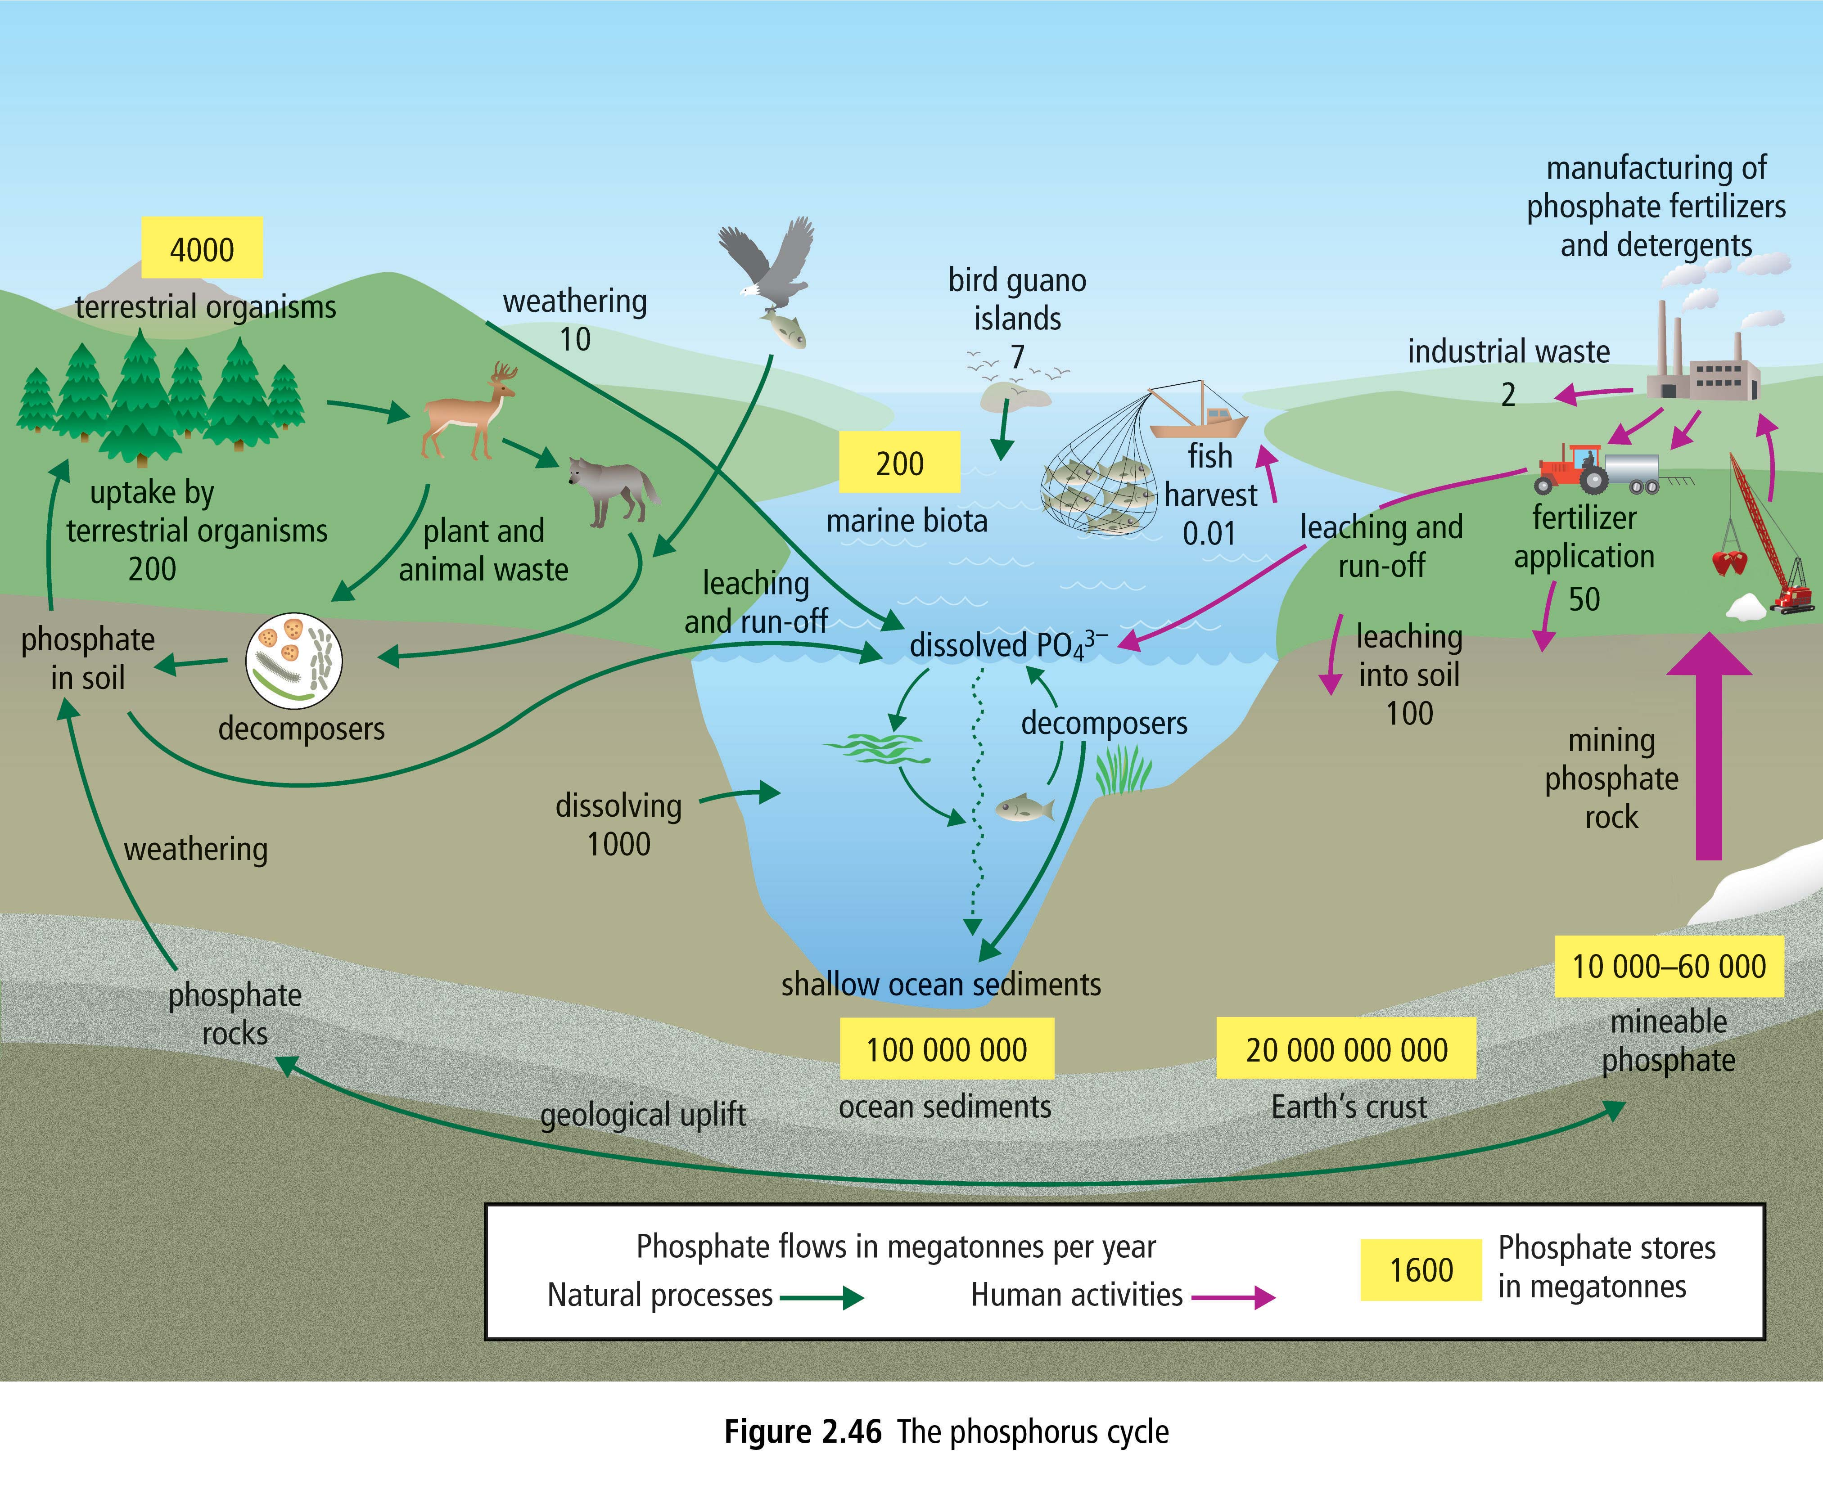

2.3 Effects of Biaccumulation on Ecosystems

Bioaccumulation

_____________________________________________________

-a ______________________ will affect the entire ecosystem

(e.g. contaminated salmon eaten by bears, wolves, eagles, otters, and humans)

Biomagnification
__________________________________________________________________________________________________________
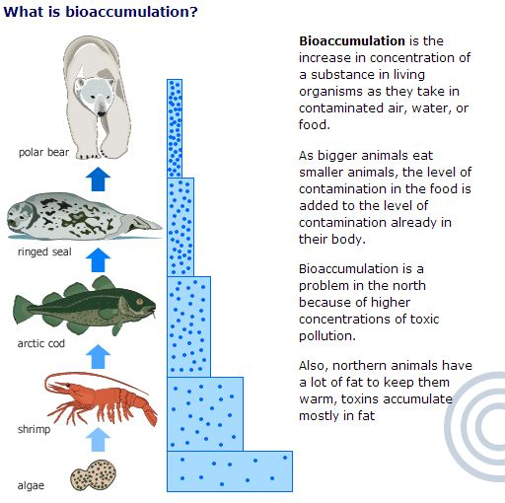
Synthetic pollutants
-synthetic pollutants or POPs (______________________) are carbon-containing compounds that have long half-lives

(e.g. ________________________)

- _______________ (polychlorinated biphenyls)

________________________________________________________________________________________________
________________________________________________

- _______________ (dichloro-diphenyl trichloroethane)

________________________________________________________________________________________________
________________________________________________
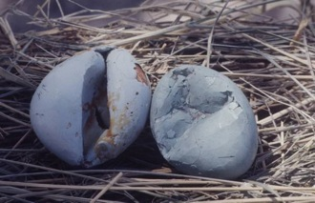
Figure 1 DDT severely weakens the egg shells of birds.

Heavy Metal pollutants
-_________________________________
-the three most polluting heavy metals are ________________, _______________, and ________________

1) ____________ – has been used in insecticides, paints, and gasoline, and currently in electronics

2)____________ – used in manufacturing of plastics, nickel-cadmium batteries, and is found in cigarette smoke

3) ___________– released through burning of fossil fuels and coal

There are several ways of reducing the effects of chemical pollution:

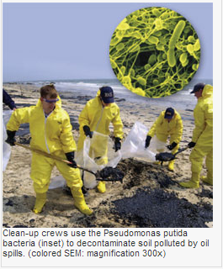
1) _____________ – make contaminants less harmful by treating them with chemicals (e.g. phosphate added to lead-contaminated soil)

2) _____________– use microorganisms to biodegrade contaminants
(e.g. bacteria used to clean up oil spills)

3) ____________________– plants can be used to take up contaminants
(e.g. hyacinth and bulrushes in wetlands)

