1.1 Biomes
Biological Hierarchies
Life can be studied at many different levels:

1. Biosphere
2.
3.
4.
5.
6.
7.
8. Organ System
9. Organ
10. Tissue
11. Cell
12. Organelle
13. Molecule
14. Atom

Components of an Ecosystem
-every ecosystem has living and non-living components

-biotic

(e.g. plants, animals, fungi, and bacteria)

-abiotic

(e.g. sunlight, soil, moisture, temperature)
Factors That Influence Biomes
The two most important abiotic factors that influence the characteristics and distribution of biomes are

1)

2)

The following factors determine temperature and precipitation:

1) _______________– distance measured in degrees north or
south from the equator

2) ________________ (altitude) – the height of a land mass above
sea level

3) ________________ – transport water and heat around the world

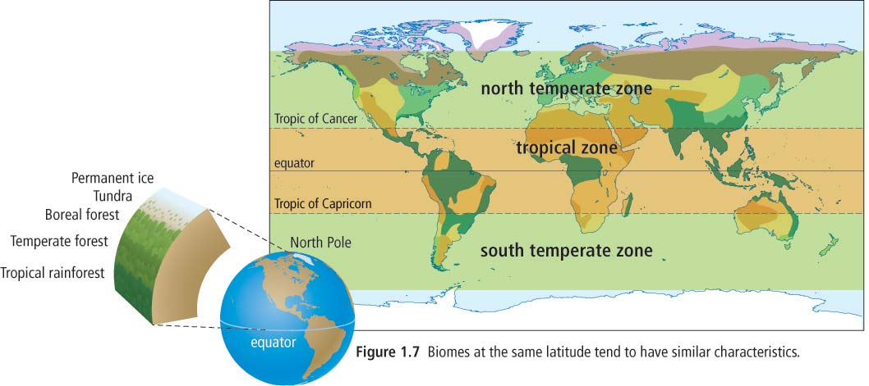
Factor | Effect on temperature | Effect on precipitation
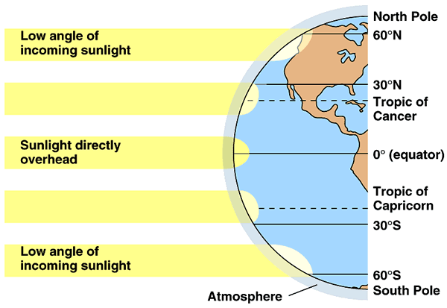  latitude | -equatorial regions are warmer because _________________  _________________  _________________  _________________  -regions farther from the equator are cooler because  _________________  _________________  _________________  _________________ | -equatorial regions receive more rain because  _________________  _________________  _________________  -polar regions receive less precipitation because _________________  _________________  _________________  _________________  -temperate regions experience seasonal rainfall patterns
elevation  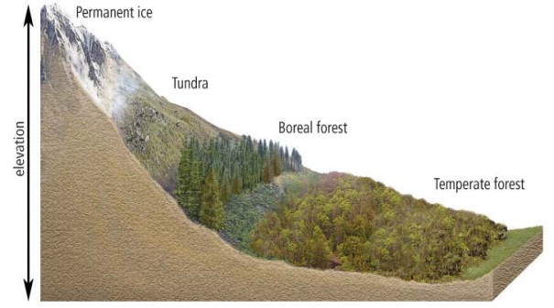 | -temperature decreases with increasing elevation because  _________________  _________________  _________________  _________________ | -windward sides of mountains receive precipitation because the air rises and cools  -leeward sides of mountains are dry because  _________________  _________________
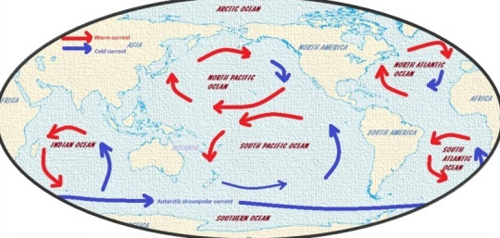  ocean currents | -e.g. warm currents in the Pacific Ocean bring heat energy to the coast of BC,  _________________  _________________ | _________________  _________________  _________________  _________________

Climatographs
-the average ___________________________________________

_______________________________________is called climate

(e.g. coastal B.C. has a mild climate = cool and wet)
Month | Average  Precipitation  (mm) | Average  Temperature  (°C)
J | 436 | 4
F | 382 | 5
M | 355 | 6
A | 249 | 8
M | 165 | 10
J | 138 | 12
J | 77 | 14
A | 94 | 15
S | 134 | 13
O | 340 | 10
N | 475 | 7
D | 462 | 5

-a climatograph is a _____________________________________

It shows average temperature and average precipitation for each month.
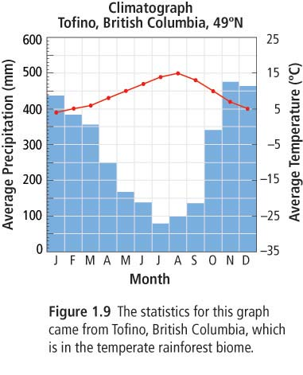

Set-up of Climatograph
x-axis: month
y-axis (right): average temperature (°C) (best fit, line graph)
y-axis (left): average precipitation (mm) (bar graph)
Adaptations

-adaptations are _____________________ that enable organisms to better _________________________________________.

There are three types of adaptations:

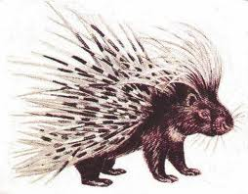
- ______________________ Adaptation

(e.g. the quills of a porcupine)

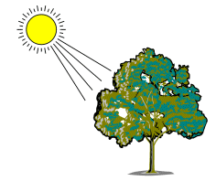
- ______________________ Adaptation

(e.g. photosynthesis in plants)

- ______________________ Adaptation

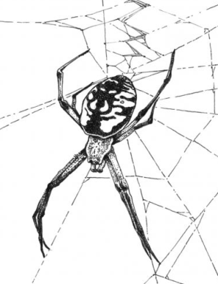

(e.g. a spider builds a web)
Biome characteristics
A biome is a region with similar biotic and abiotic components.

There are 8 terrestrial biomes:

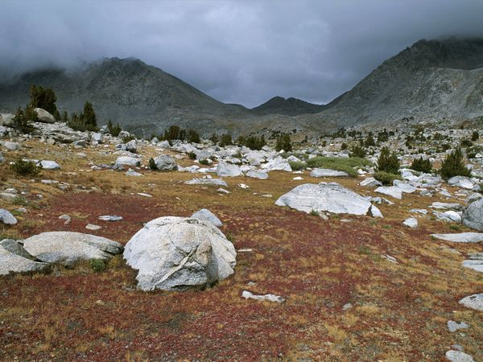
1) Tundra

______________________________________
______________________________________
______________________________________
______________________________________
______________________________________
2) Boreal Forest
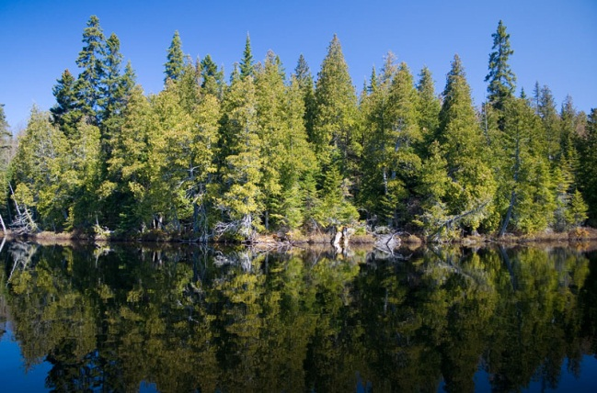
______________________________________
______________________________________
______________________________________
______________________________________
______________________________________

3) Temperate Deciduous Forest

______________________________________
______________________________________
______________________________________
______________________________________
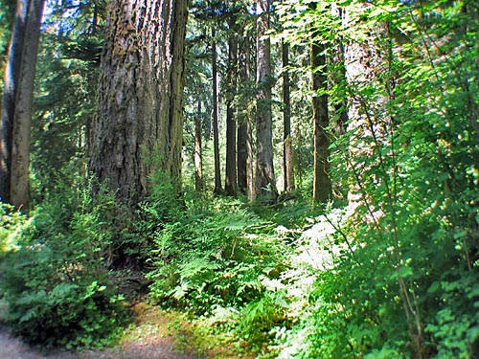
4) Temperate Rainforest

______________________________________
______________________________________
______________________________________
______________________________________
______________________________________

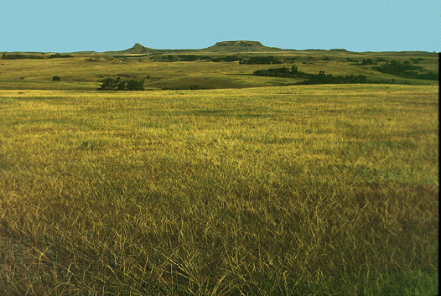
5) Grassland

______________________________________
______________________________________
______________________________________
______________________________________
______________________________________

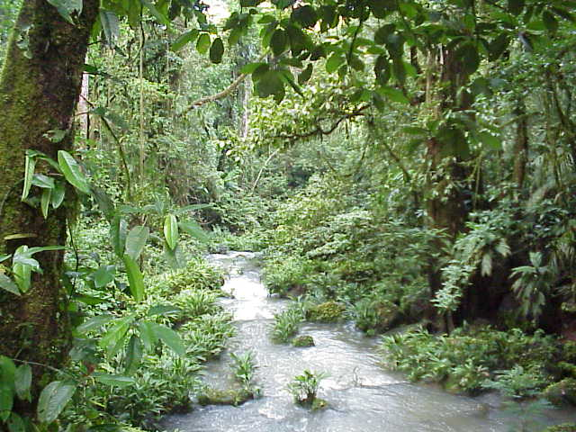
6) Tropical Rainforest

______________________________________
______________________________________
______________________________________
______________________________________
______________________________________

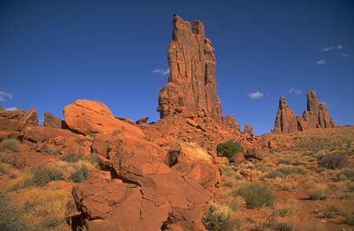
7) Desert

______________________________________
______________________________________
______________________________________
______________________________________
______________________________________
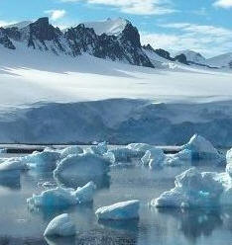
8) Permanent Ice

______________________________________
______________________________________
______________________________________
______________________________________
______________________________________

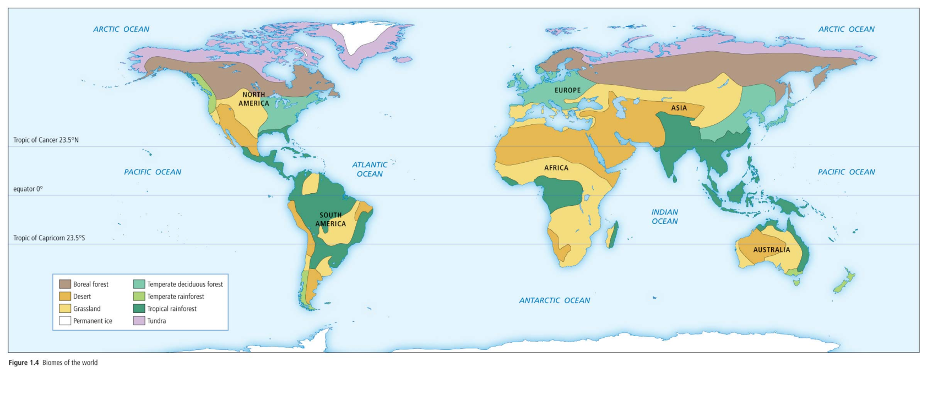
8 Terrestrial Biomes
1.2 Ecosystems
Ecosystems

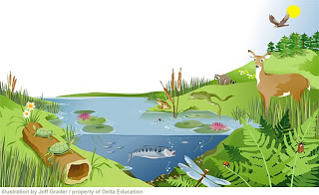
-an __________________ is a __________________________.
A Pond Ecosystem

(e.g. old growth forest ecosystem, pond ecosystem, beach ecosystem, dune ecosystem, etc.)
-____________________________________ is called a habitat

(e.g. phytoplankton live in the sunlit zone of the ocean)

-_____________________________________ is called a niche.

(e.g. phytoplankton photosynthesize and are food for zooplankton and small fish)
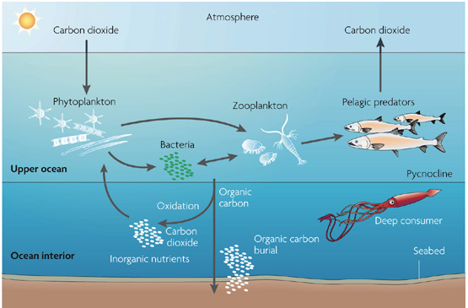

-interactions within ecosystems can be either abiotic or biotic.
Abiotic interactions
Organisms have five basic abiotic interactions:

1) ________________– plants and animals require O₂ for cellular respiration

2) ________________ – cells are approximately 90% water

3) ________________ – all plants and animals require nutrients for life

4) ________________ – plants require light for photosynthesis

5) ________________ – soil provides nutrients and habitat for many organisms

Biotic interactions
There are four basic types of biotic interactions:

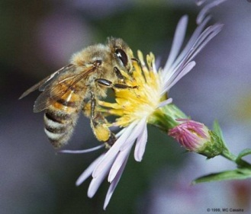
1) Symbiotic relationship

_________________________________________

(i) Mutualism

______________________________________
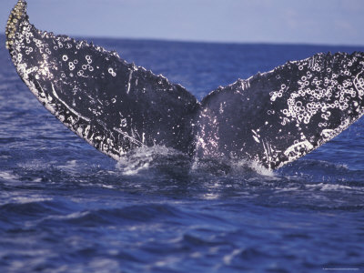
(e.g. bees gathering nectar from a flower)

(ii) Commensalism

______________________________________
(e.g. barnacles living on a whale)
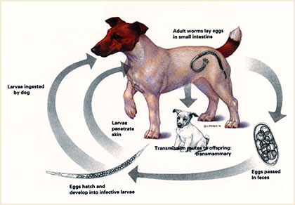
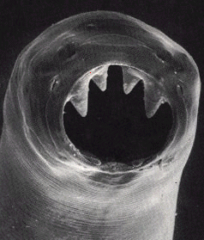
(iii) Parasitism

______________________________________
(e.g. hookworms living in a dog)
Hey pooch!
Thanks for letting me hangout in your gut!
2) Competition

____________________________________________________________

____________________________________________________________
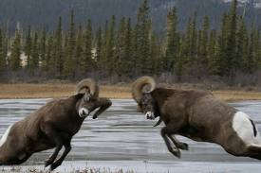
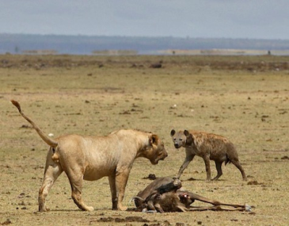

e.g. rams compete for territory by butting heads, lions and hyenas fight over food

3) Predation

____________________________________________________________
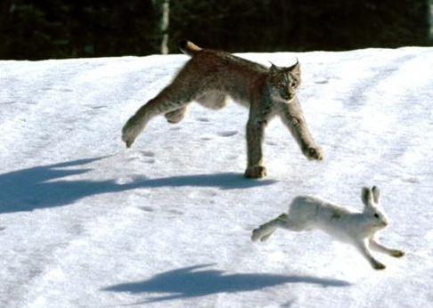

e.g. snowshoe hare are prey for lynx
4) Mimicry

____________________________________________________________

____________________________________________________________
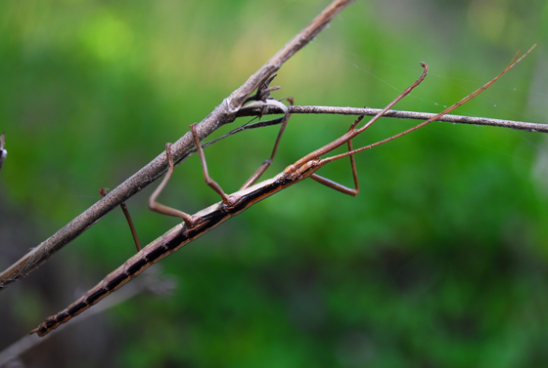

e.g. stickbugs look like twigs

