12.1 Evidence for Continental Drift

Continental Drift Theory

Evidence:

1) Jigsaw Puzzle Fit –

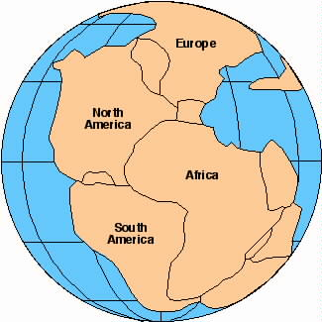

2) Matching Geological Structures

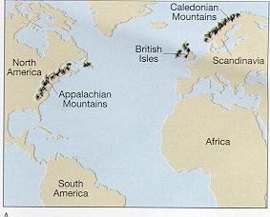

3) Matching Fossils

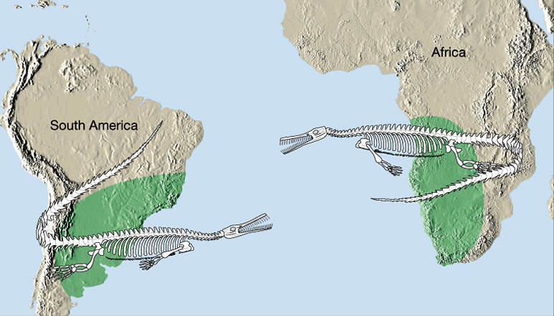

4) Paleoglaciation and Coal Deposits

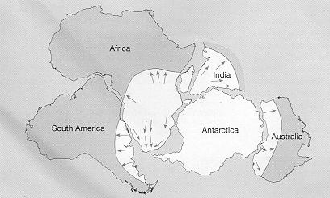

Plate Tectonic Theory

Evidence:

1) Location of Earthquakes and Volcanoes
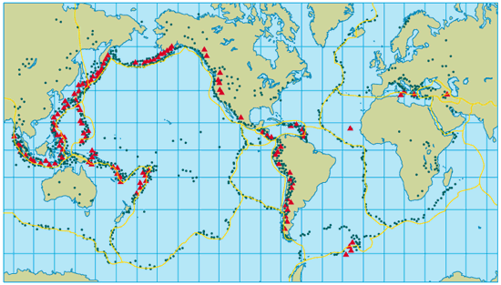

2) Sea Floor Spreading
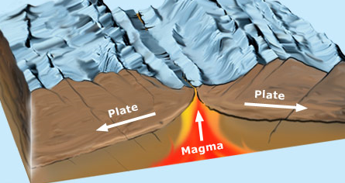

3) Magnetic Striping

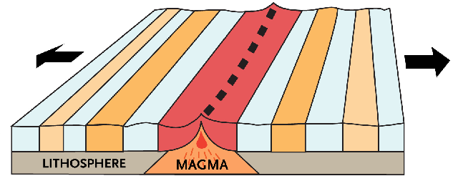

Reason: Earth’s magnetic poles reverse on average every _______________ years. As magma cools at spreading ridges, ________________________________________
____________________________________________________________________________________________

4) Hot Spots

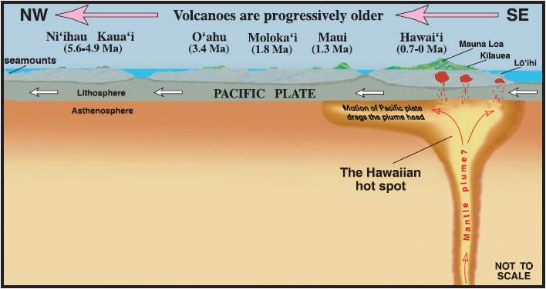

12.2 Features of Plate Tectonics

12.2 Evidence for Continental Drift

Earth’s Layers

1) The Crust

- Continental crust

- Oceanic crust

2) The Mantle

- Upper mantle

ii) asthenosphere – made of partly molten rock; convection currents move tectonic plates at a rate of approximately 2 cm/yr

b) Lower mantle

3) The Outer Core

4) The Inner Core
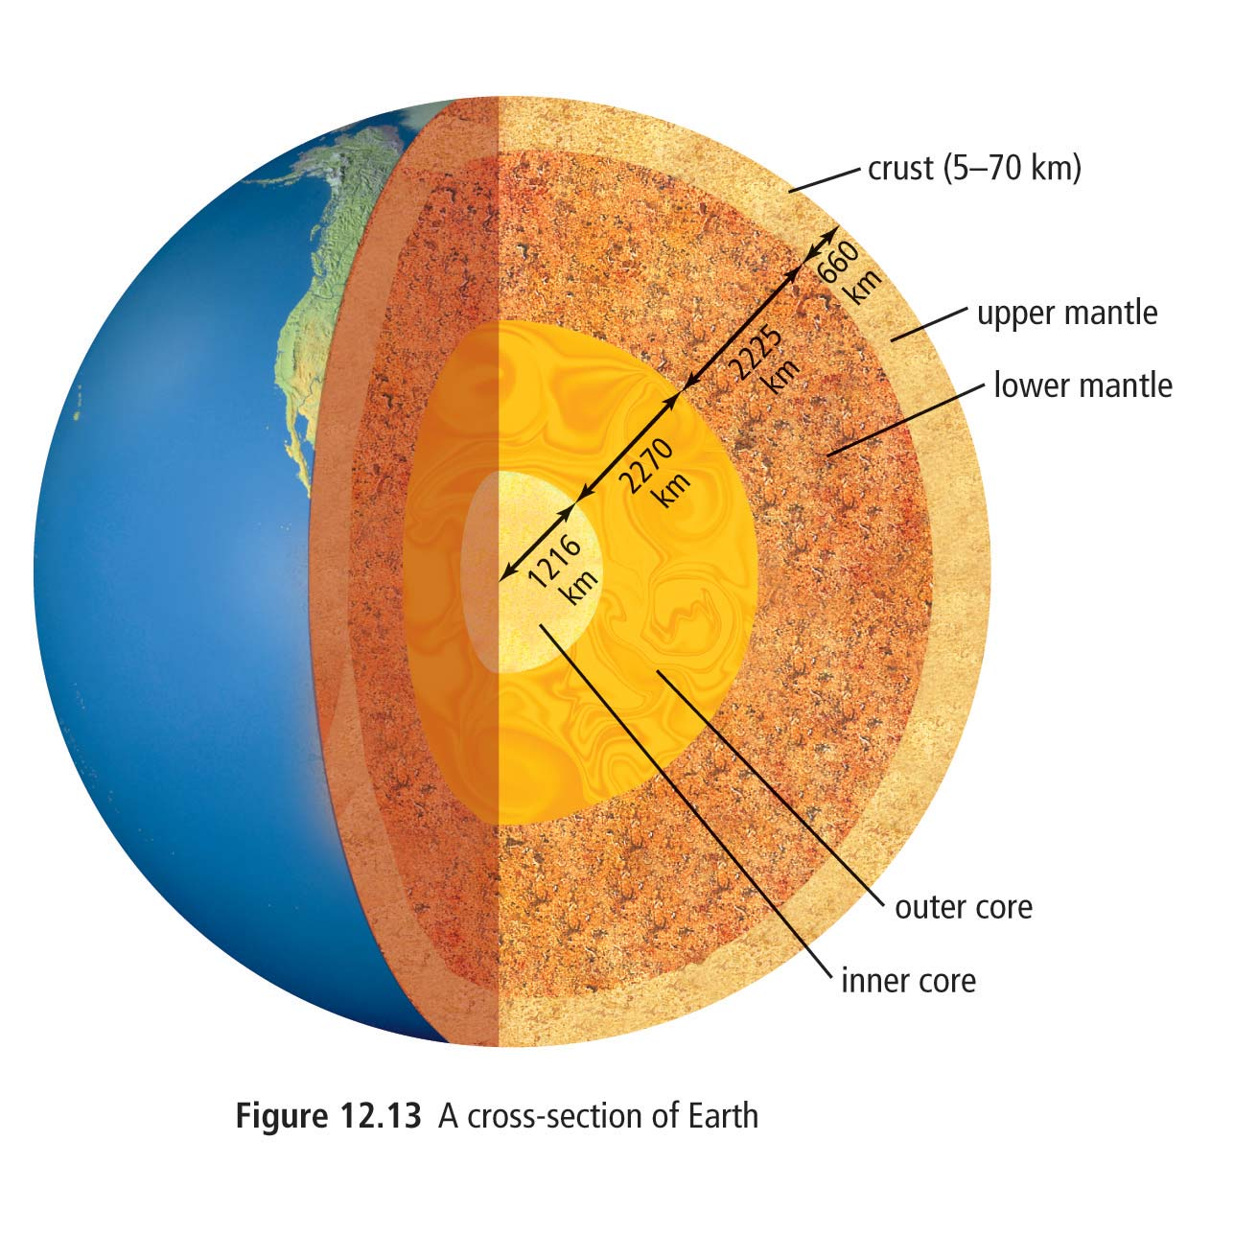
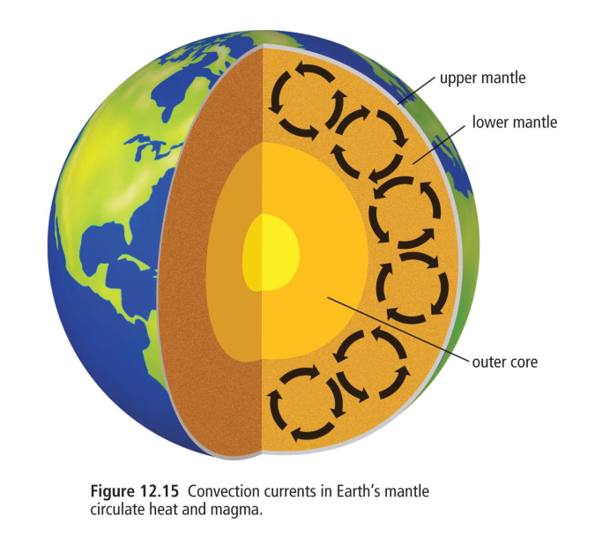
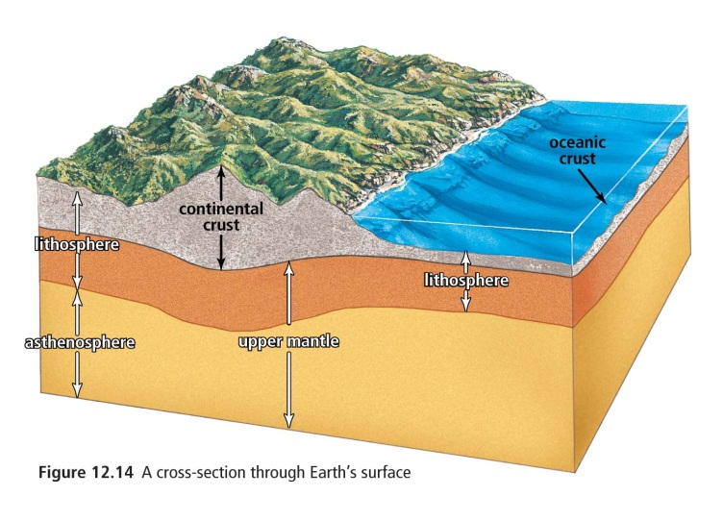
Ch 12.2 Earth’s Layers

Plate Interactions

There are three main types of plate interactions:

1) Divergent plate boundaries

a) _________________ – occurs on the ocean floor
(e.g. Mid-Atlantic Ridge)

b) __________________ – occurs on land
(e.g. East African Rift)

2) Convergent plate boundaries

- Oceanic-continental boundary

b) Oceanic-oceanic boundary

c) Continental-continental boundary

3) Transform plate boundaries – plates sliding past each other create transform faults (e.g. San Andreas Fault)

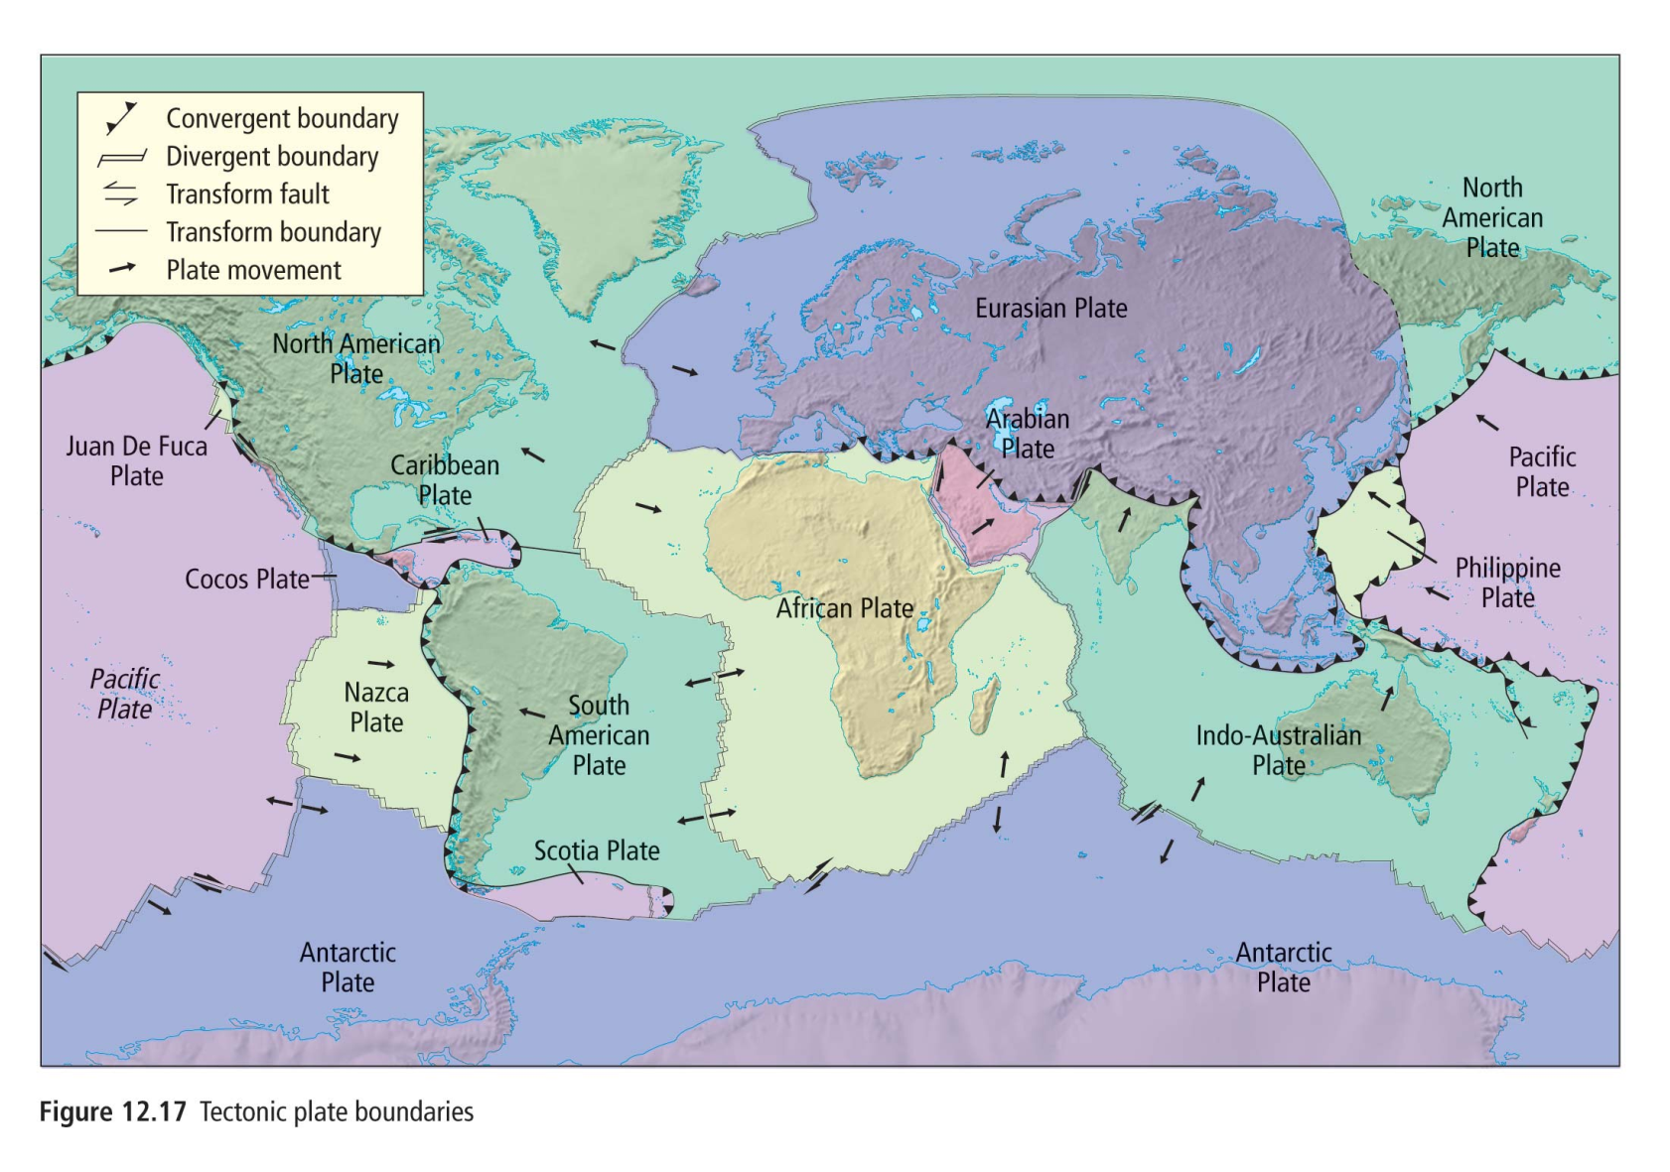
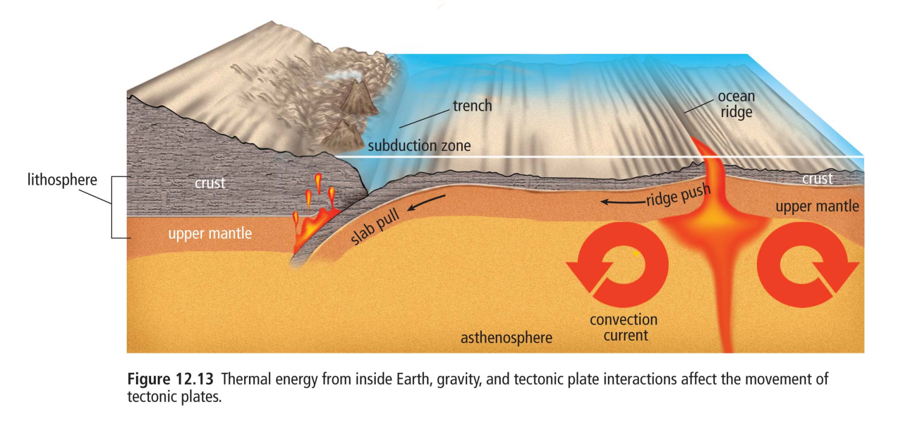
Ch 12.2 What Makes Tectonic Plates Move?
World Tectonic Plate Boundary Map

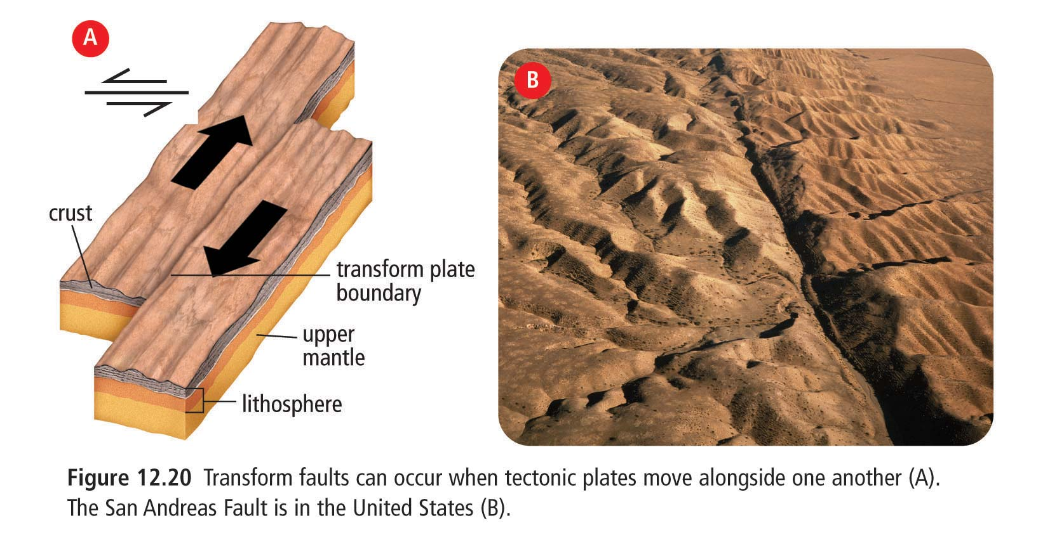
Ch 12.2 Tectonic Plate Interactions
Divergent Plate Boundary
Convergent Plate Boundary
Transform Plate Boundary
Ocean—Continental
Ocean-Ocean
Continent—Continent
Tectonic Plate Symbols

Divergent boundary | Convergent boundary
Transform boundary | Plate movement
Volcanoes | Mountains

Earthquakes

Earthquakes
-EQ’s are the

-the focus is the

-the epicentre is the

Seismic Waves

-there are three types:

Seismic Wave | Description | Motion
Primary
(P)
Secondary
(S)

Surface
(L)

Measuring Earthquakes
Ground motion of an earthquake is measured using a _________________________
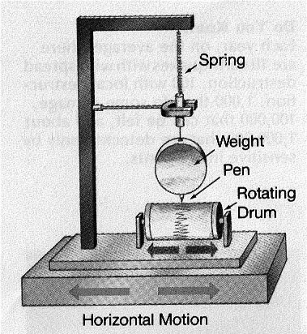

Seismographs produce a reading called a _____________
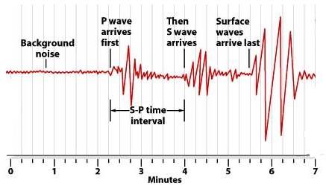

Interpreting a Seismogram:

1) Epicentre distance

2) Magnitude

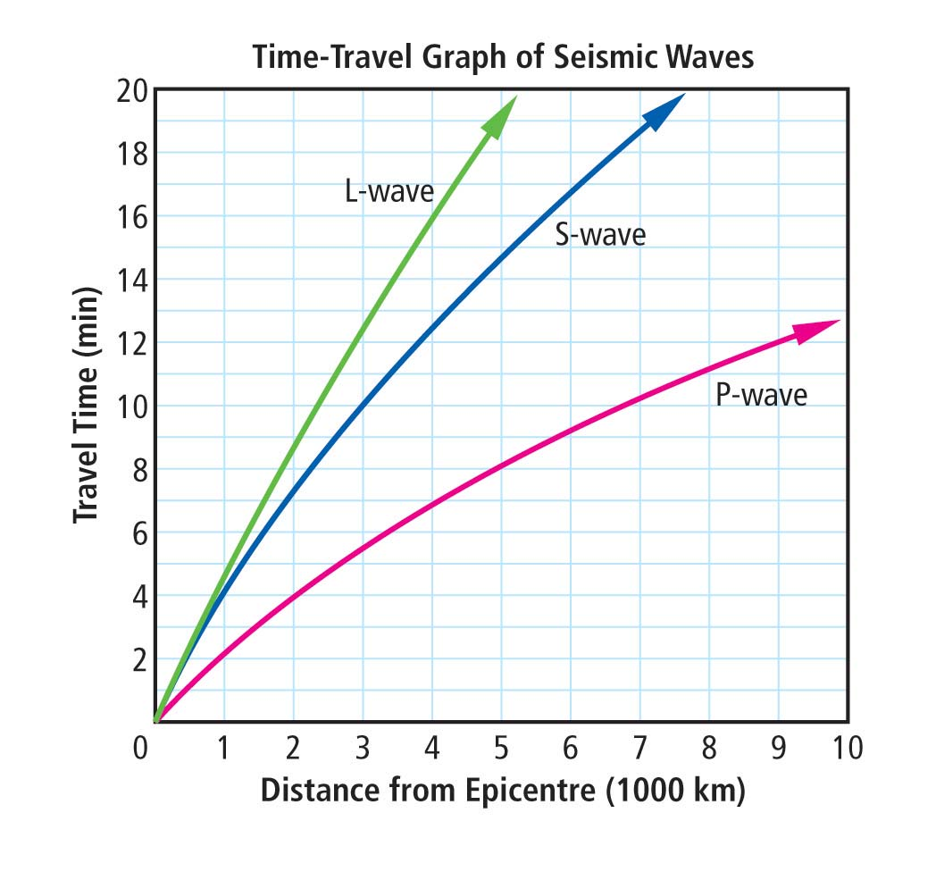
Volcanoes

-volcanoes

-there are three major types:

 | Description | Composition | Location | Example
Composite
Volcano

Shield
Volcano

Rift
Eruption

1) Composite volcano

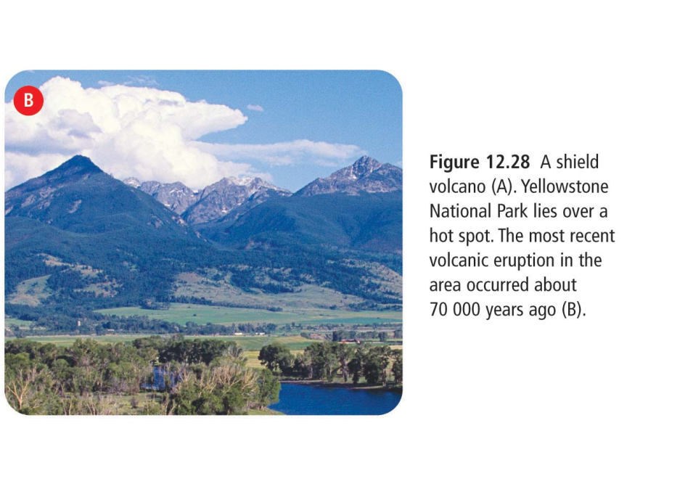
2) Shield volcano

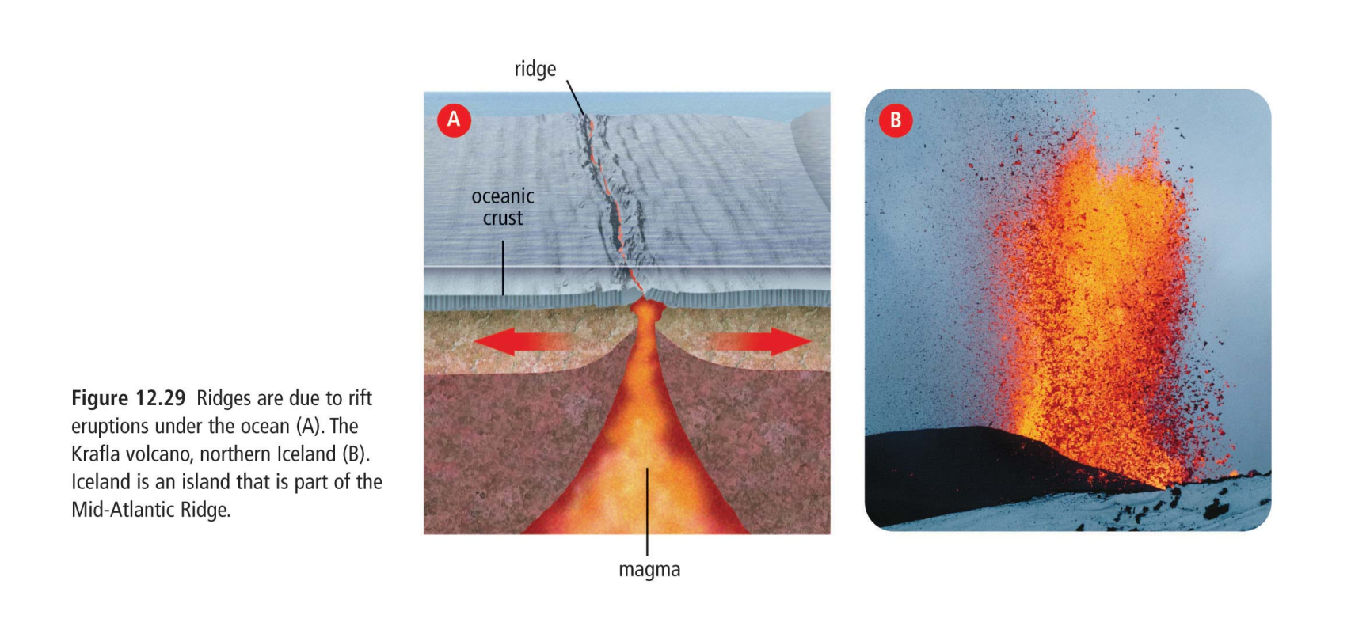
3) Rift Eruption

